Download Zoiper: <http://www.zoiper.com/en/voip-softphone/download/zoiper3>

Click Next. Then click the Free version.

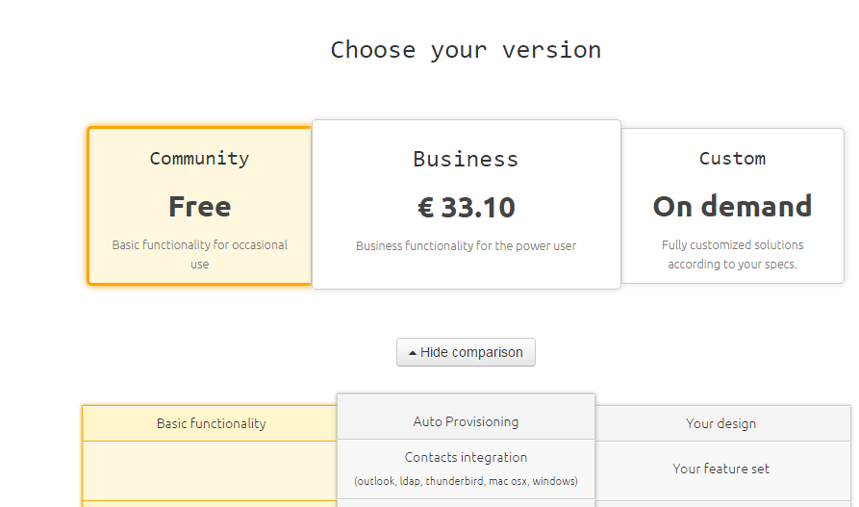

Your download will start. Run the Zoiper_3.9_Setup.exe file that was just downloaded.

Follow instructions to install.

Once you have Zoiper running, click on Settings.

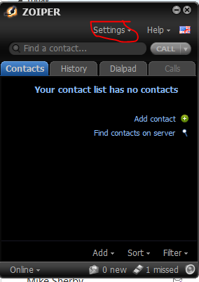

Click Preferences.

In the box that pops up, click Create Account.

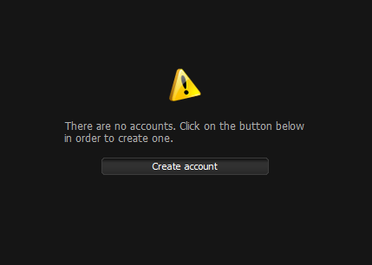

Click Next.

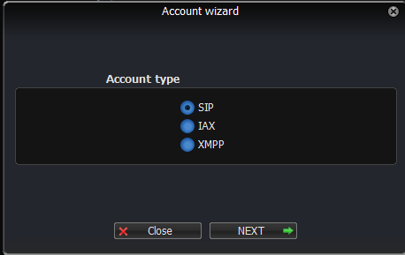

Type in [1082@97.93.171.182](mailto:1082@97.93.171.182) in the first box.

The Password is: 6LTiQfWcV6zYqn9

Click Next.

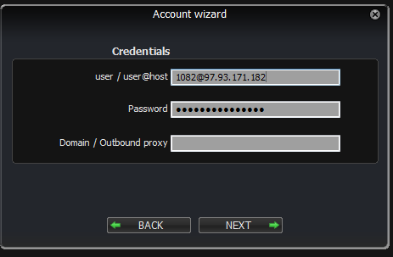

Click Next again.

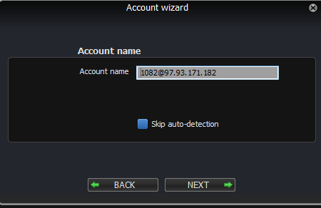

Click Close.

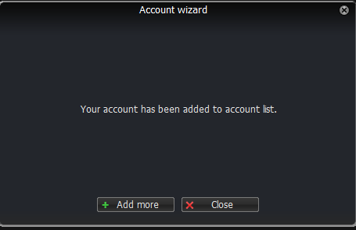

Now click Advanced.

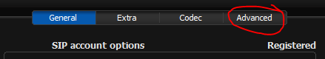

Make sure the settings look like the screenshot below, then click OK

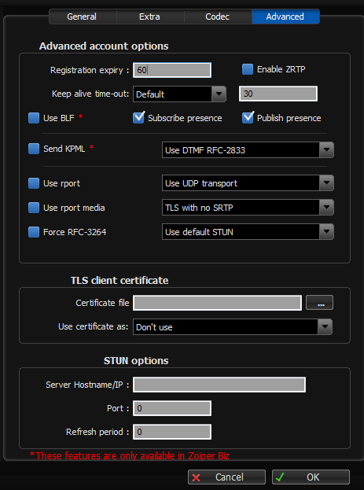

Make sure you close this out before you come back to the office.