MLIC
MachineLink Industrial Iot Cloud
Implementation Evidence Report

Student: Ankit Verma
Stack: Node.js · Express · MySQL · Docker · AWS EC2 · Jenkins · Terraform · Kubernetes
EC2: 13.60.64.13 (Public) · 172.31.34.231 (Private) · eu-north-1 Stockholm
OS: Ubuntu 26.04 LTS (x86_64-aws) · Docker 29.1.3 · Compose v2.30.3
Date: June 2026

This document contains only actual deployment screenshots with brief explanations.

Problem Statement
Manufacturing industries often face challenges in monitoring machine health, operational status, and performance metrics in real time. Traditional monitoring methods rely on manual inspection, which can lead to delayed fault detection, increased downtime, and reduced operational efficiency.
There is a need for a centralized cloud-based platform that can collect, store, and visualize machine information while providing remote accessibility and scalability. The system should allow operators and administrators to monitor machine conditions from anywhere through a web interface.

Proposed Solution
MachineLink Industrial IoT Cloud is a cloud-enabled monitoring platform designed to manage and track industrial machine information through a centralized dashboard.
The solution provides:
- Centralized machine management
- Cloud-hosted data storage
- Real-time machine status visibility
- Secure database integration
- Web-based user interface
- Scalable deployment using containerization
- Remote accessibility through AWS infrastructure
The platform leverages modern cloud and DevOps technologies including AWS EC2, Docker, MySQL, Node.js, React, and GitHub to provide a reliable and maintainable deployment architecture.

Project Objectives
The primary objectives of MachineLink Industrial IoT Cloud are:
- Develop a centralized platform for machine information management.
- Enable remote access to machine records through a cloud-hosted web application.
- Store and retrieve machine data using a structured relational database.
- Deploy the solution using containerized services.
- Demonstrate cloud deployment practices using AWS EC2.
- Implement DevOps concepts such as version control, containerization, and automated deployment workflows.
- Provide a scalable foundation for future Industrial IoT integrations.

Key Features
- Machine Registration and Management
- Temperature Monitoring Records
- RPM Tracking Records
- Machine Status Management
- MySQL Database Integration
- REST API Backend
- Responsive Web Interface
- Docker Containerization
- AWS Cloud Deployment
- Security Group Configuration
- Multi-Service Architecture

Scalable Deployment Design
System Architecture
The MachineLink Industrial IoT Cloud platform follows a three-tier architecture:
User Browser
↓
React Frontend
↓
Node.js / Express Backend API
↓
MySQL Database
Deployment Architecture:
GitHub Repository
↓
AWS EC2 Instance
↓
Docker Compose
├── Frontend Container
├── Backend Container
└── MySQL Container
The frontend provides the user interface for machine management. The backend exposes REST APIs for data operations, while MySQL stores machine information including machine name, temperature, RPM, and operational status.
Docker Compose orchestrates all services and enables simplified deployment on AWS EC2 infrastructure.

01 Project Structure & GitHub

MLIC Repository – VS Code File Explorer
Project root: app/ (HTML/CSS/JS), Dockerfile (nginx:stable-alpine), Jenkinsfile, terraform/, k8s/, monitoring/, security/, disaster-recovery/ — full DevOps scaffold in one repo.
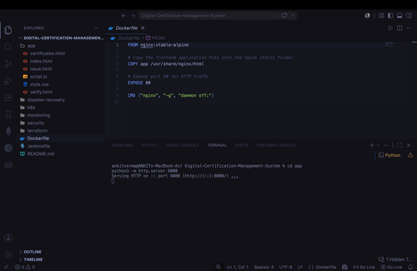
git clone on AWS EC2
Repository cloned onto EC2 via git clone. 1712 objects (2.13 MiB) transferred. All directories present including docker-compose.yml, schema.sql, backend/, frontend/.
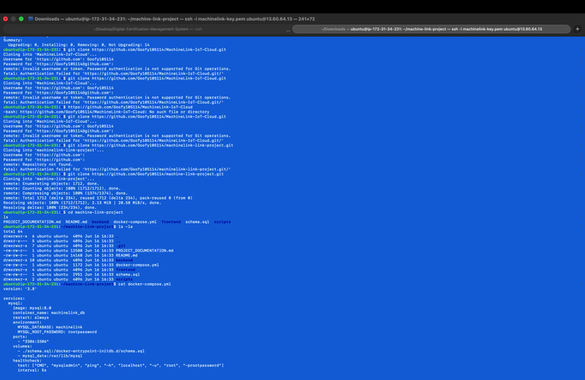

02 Local Development & API Testing

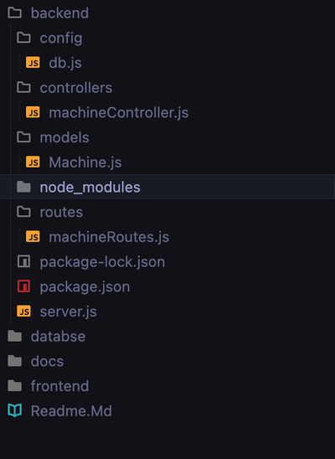  Backend folder structure | 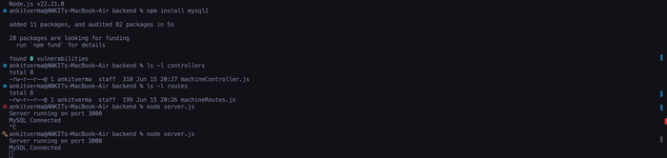  Node.js v22 · server on :3000 · MySQL Connected

Postman – POST /machines (200 OK, 56 ms)
JSON payload {machine_name, temperature, rpm, status} → response {"message":"Machine Added Successfully"}. Full read-write API cycle confirmed locally before cloud deployment.
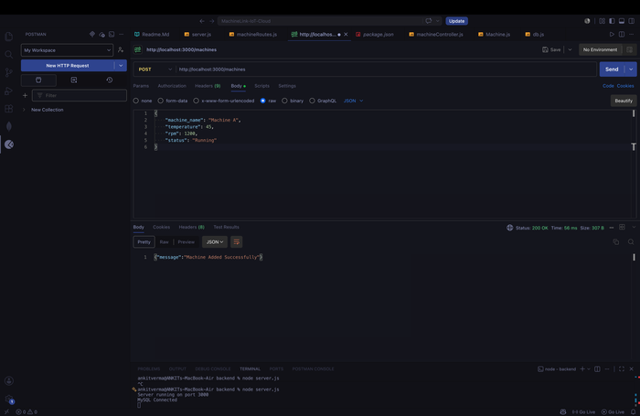
GET /machines – Before & After Insert
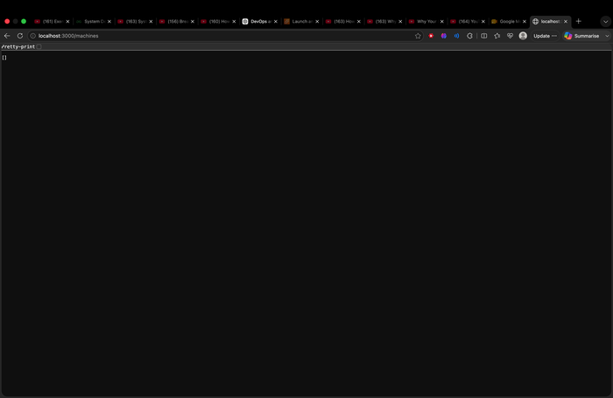  [] — empty before insert | 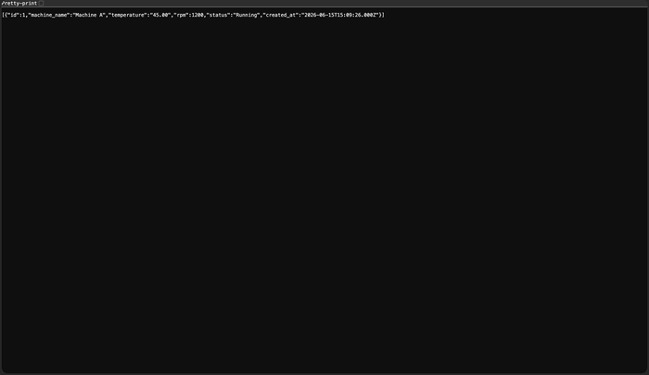  Record returned with id + created_at

03 MySQL – Local Schema Setup

CREATE DATABASE machinelink + CREATE TABLE machines + DESCRIBE
Schema: id (PK, AUTO_INCREMENT), machine_name VARCHAR(100), temperature DECIMAL(5,2), rpm INT, status VARCHAR(50), created_at TIMESTAMP DEFAULT CURRENT_TIMESTAMP.
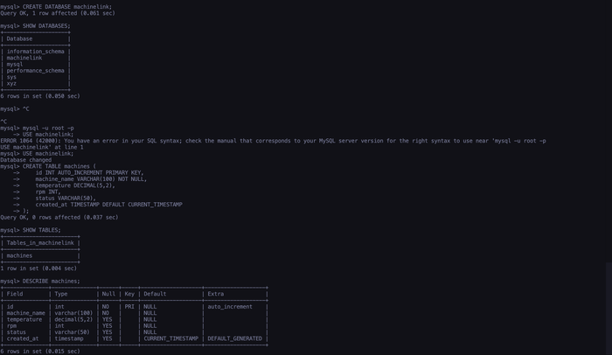
04 AWS EC2 Provisioning

SSH to EC2 (13.60.64.13) + AWS CloudShell System Info
Left: First SSH session using machinelink-key.pem. Right: CloudShell confirms Ubuntu 26.04 LTS, system load 0.72, memory 81%, Docker Compose 2.30.3 — instance ID i-0a47c31af60f38bcb.
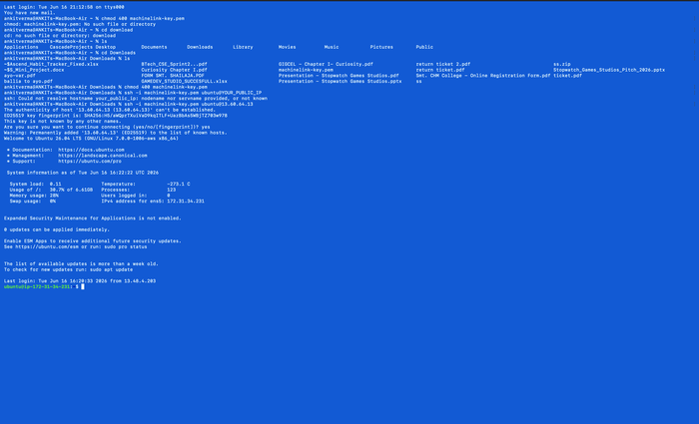  SSH login · ubuntu@13.60.64.13 | 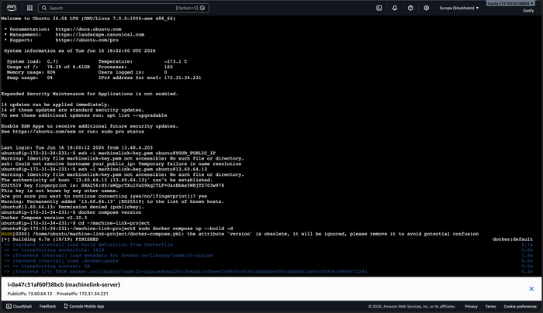  CloudShell · EC2 system info

05 Linux Server Administration

sudo apt install docker.io -y
Docker 29.1.3 installed. Dependencies: pigz, bridge-utils, runc, containerd, dnsmasq-base, ubuntu-fan. Download: 74 MB at 87.4 MB/s. Systemd symlinks created for docker.service and docker.socket.
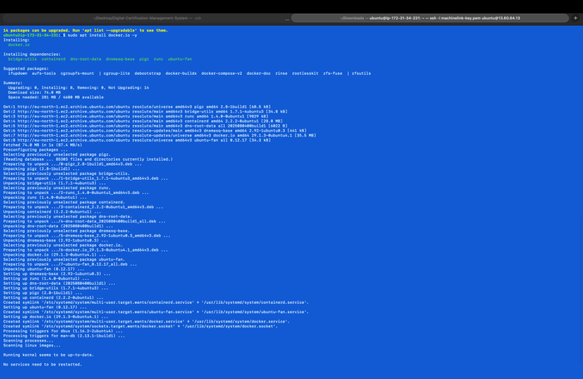
Docker Version + Service Status
Left: docker --version → 29.1.3, build 29.1.3-0ubuntu4.1. Right: systemctl status docker → active (running) since Jun 16 16:24:04 UTC 2026, PID 2288, 26.6 MB, API on /run/docker.sock.
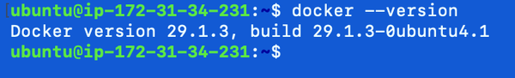  Docker 29.1.3 installed | 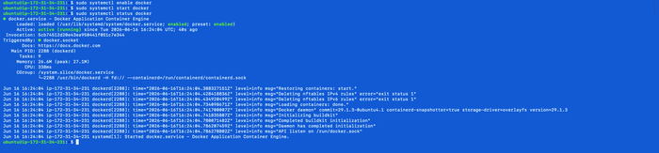  docker.service active (running)

06 Docker Containerisation

docker-compose.yml – Three-Service Stack
Services: mysql:8.0 (healthcheck, schema.sql init, mysql_data volume), backend node:20-alpine (port 5000, JWT env, depends_on mysql:service_healthy), frontend node:20-alpine (port 5173, VITE_API_URL, depends_on backend).
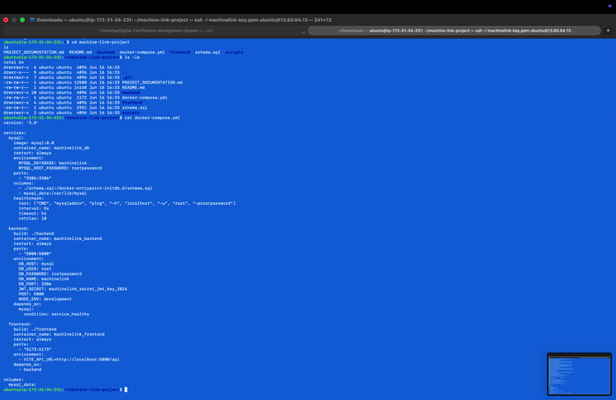
Backend & Frontend Dockerfiles
Backend: FROM node:20-alpine → COPY → npm install → EXPOSE 5000 → CMD npm run dev. Frontend: same base, EXPOSE 5173. DCMS-specific Dockerfile uses nginx:stable-alpine, copies app/ to /usr/share/nginx/html, EXPOSE 80.
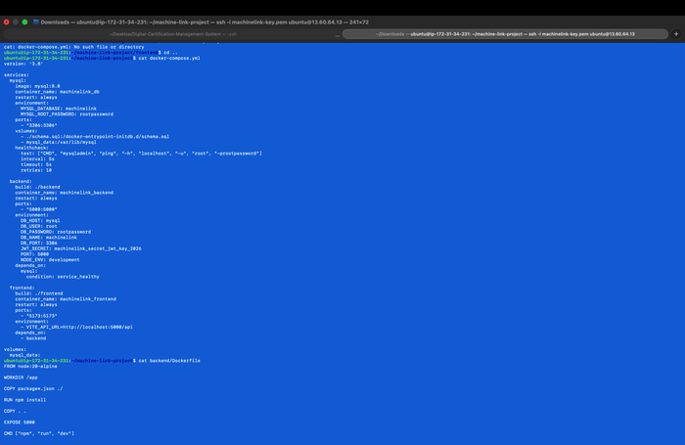

docker compose up --build -d (Build Output)
Full build: mysql:8.0 pulled (13 layers), node:20-alpine resolved, backend 5/5 steps + frontend 5/5 steps built and exported as machine-link-project-backend:latest and machine-link-project-frontend:latest. Build: ~49 s.
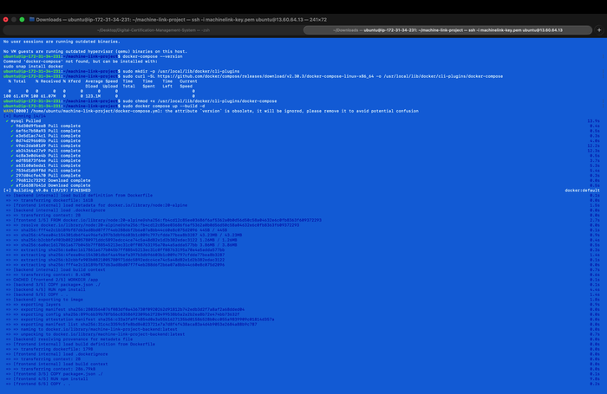
docker ps – All Containers Running
machinelink_frontend: Up 2 min, 0.0.0.0:5173. machinelink_backend: Up 2 min, 0.0.0.0:5000. machinelink_db (mysql:8.0): Up ~1 min (healthy), 0.0.0.0:3306. All services mapped and accessible.
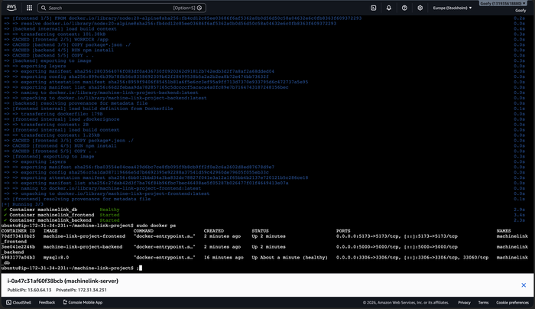

07 AWS Security Groups

sg-039ede31e25f917be – 5 Inbound Rules
Port 5173 (frontend), 22 (SSH), 5000 (backend API), 443 (HTTPS), 80 (HTTP) — all IPv4, source 0.0.0.0/0. Outbound: allow all. VPC: vpc-00b30fbaa751a48d1. Rules successfully modified (green banner confirmed).
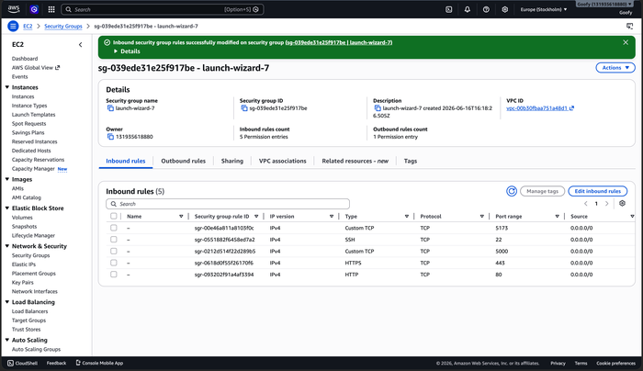
08 Database in Production

docker exec – MySQL Shell in machinelink_db + SHOW TABLES + SELECT users
Left: MySQL 8.0.46 Community Server inside container — SHOW DATABASES lists machinelink. Right: SHOW TABLES (alerts, machine_metrics, machines, users); SELECT * FROM users → admin with bcrypt hash, email, role, created 2026-06-16.
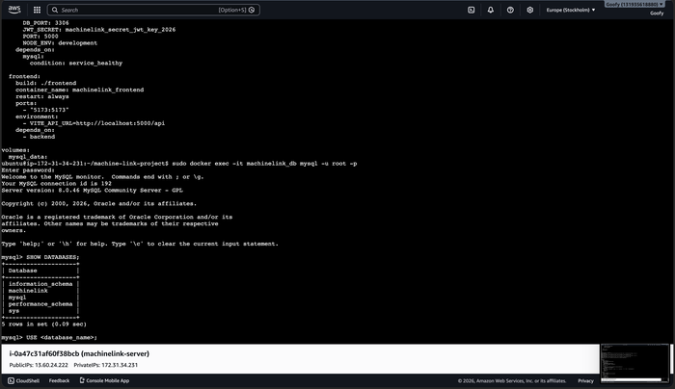  docker exec · SHOW DATABASES | 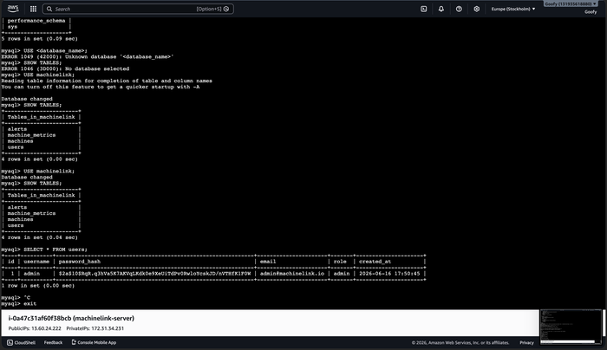  SHOW TABLES · admin user row

09 Deployed Application

DCMS Dashboard – localhost:8000 (Nginx)
Static frontend served by Nginx. Total Certificates: 5, Verified: 3, Pending: 2, Latest: DCMS-2026-005. Quick Navigation: Issue, Verify, Records, Documentation.
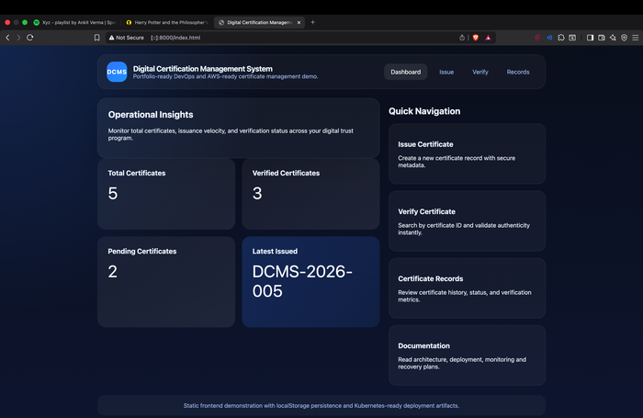
MachineLink – Live on AWS EC2 (13.60.64.13:5173)
Full-stack app at public EC2 IP:5173. 5 Machines Active, Avg Temp 79.68°C, Avg RPM 3455. Live alert: Packaging Conveyor Epsilon 91.4°C — CRITICAL. Admin session active.
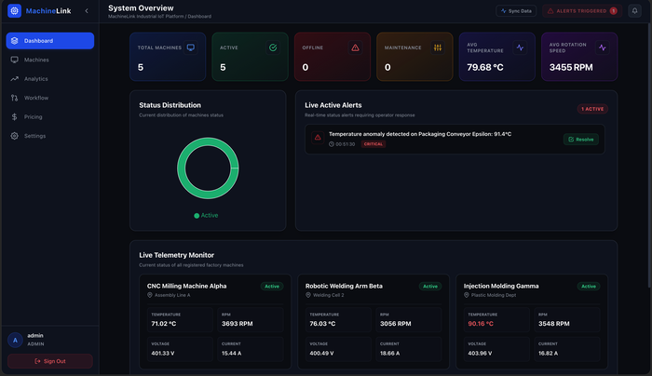

Machine Registry – 5 Active Entries
CNC Milling Alpha, Robotic Welding Beta, Injection Molding Gamma, Hydraulic Press Delta, Packaging Conveyor Epsilon — all Active, showing live temperature and RPM with edit/delete controls.
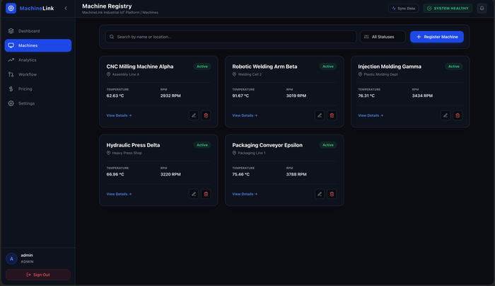
Telemetry Analytics + AWS Infrastructure Pricing
Left: Real-time Temperature Trend (°C) and Rotation Speed (RPM) charts over 1-min rolling window. Right: Pricing calculator — Dev ₹2,080/mo, Production ₹8,750/mo, Enterprise ₹26,650/mo (INR, ap-south-1).
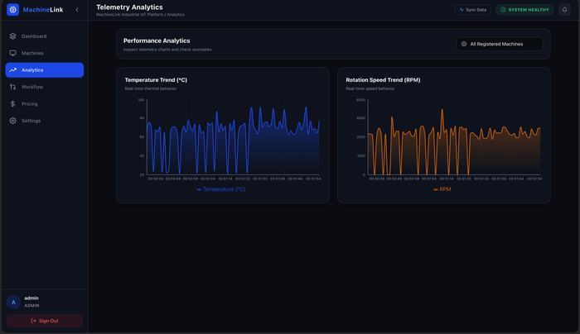  Real-time telemetry charts | 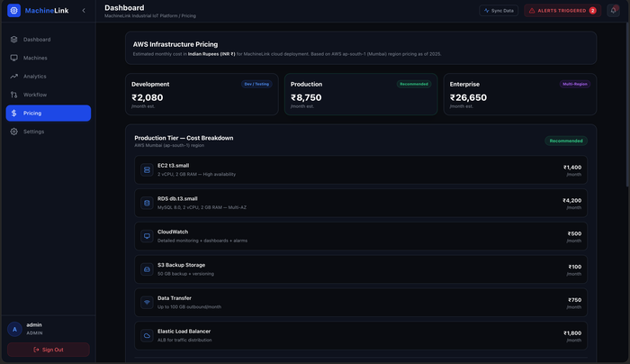  AWS cost tiers (INR)

10 Troubleshooting Log

Issue: docker-compose not found → Fix: docker-compose-v2
Ubuntu 26.04 ships without standalone docker-compose. Standalone binary and snap both failed. Fix: sudo apt install docker-compose pulled docker-compose-v2 (2.40.3+ds1, 14.8 MB). Also downloaded v2.30.3 binary manually via curl to /usr/local/lib/docker/cli-plugins/.
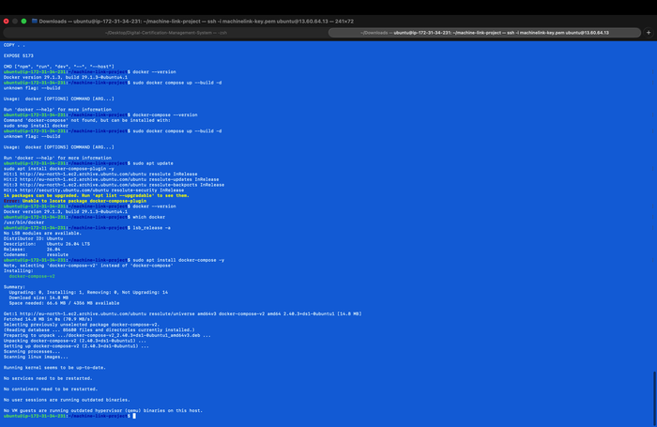
Issue: Docker socket permission denied → Fix: sudo prefix
Running docker compose as ubuntu user failed: "permission denied connecting to /var/run/docker.sock". Fix: all Docker commands prefixed with sudo. Long-term fix: usermod -aG docker ubuntu (requires re-login).
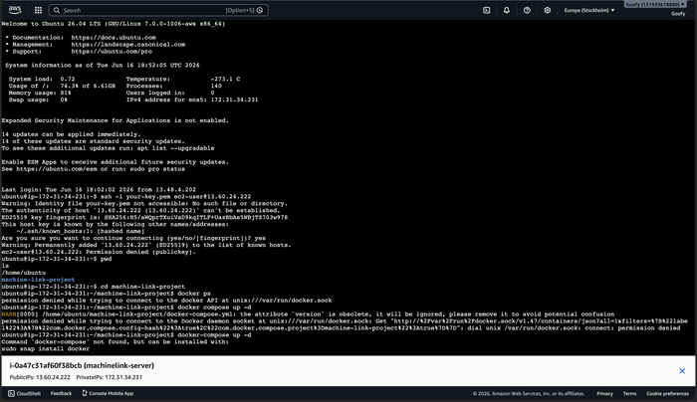

11 Final Deployment Verification

docker compose up --build (Rebuild after config fix) – All Healthy
After correcting VITE_API_URL to EC2 public IP and rebuilding: Network Created, machinelink_db Healthy (6.1 s), machinelink_backend Started (0.3 s), machinelink_frontend Started (6.5 s). Full rebuild in 2.1 s via Docker layer cache.
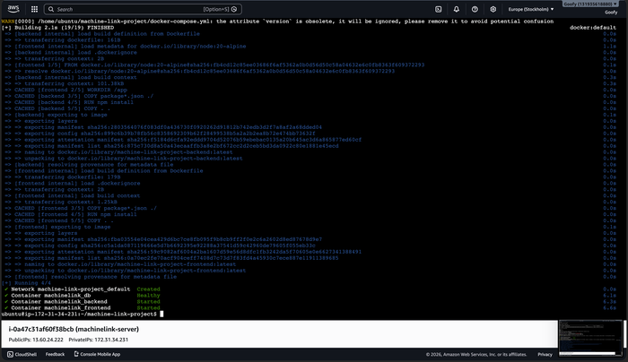
Initial Build Confirmation (AWS CloudShell)
First successful cold build: machinelink_db Healthy (2.9 s), machinelink_frontend Started (3.4 s), machinelink_backend Started (2.3 s). 3/3 containers running. App live at http://13.60.64.13:5173.
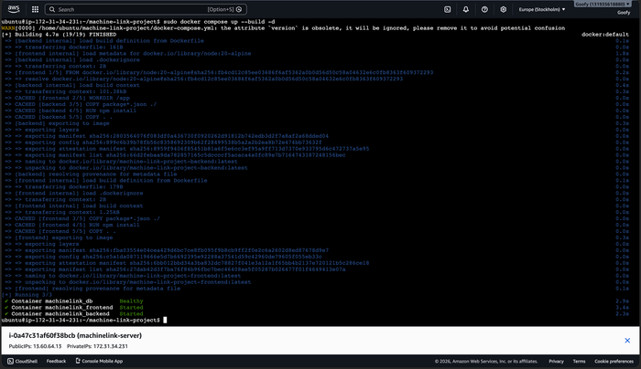

● DEPLOYMENT COMPLETE ●
machinelink_db ✓ machinelink_backend ✓ machinelink_frontend ✓
Frontend :5173 · Backend API :5000 · MySQL :3306 · Public IP 13.60.64.13

