New Zealand Real Estate Database Report

By: Jared Ross

ID: 10010010

Date: 3/11/18

Table of Contents

Introduction 3

Data volume map 3

Database 4

Sql table commands 4

Insert Commands 6

Index files 8

Database Diagram 9

Data dictionary 9

# Introduction

New Zealand Real Estate (NZRE) in Auckland requires a data base application to help automate the process of matching buyers to suitable properties So they want to move from there paper-based system to an automatic digital one. The main goal is to make the system match buyers and sellers automatically and do it efficiently process the client’s requests, the data will provide by Mr. Thomas Jones who maintains the details about all their clients.

# Data volume map

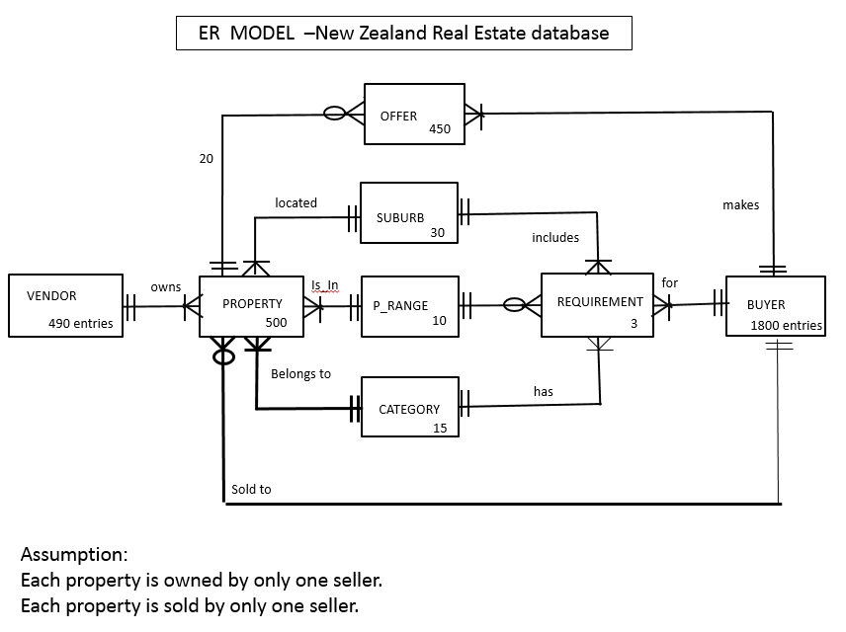

# Database

For the data base I have broken the components down into three key parts Table, insert and index.

# Sql table commands

create database COMP6212_A2_JaredR;

go

use COMP6212_A2_JaredR

create table Vendor(

v# int,

vFName varchar(25),

VLName varchar(25),

VStreet varchar(30),

VCity varchar(30),

ContactNo int,

CrStatus varchar(10),

CONSTRAINT vendor_pk PRIMARY KEY (v#)

);

create table Buyer(

B# int,

BFName varchar(25),

BLName varchar(25),

BStreet varchar(30),

BCity varchar(30),

ContactNo int,

CONSTRAINT Buyer_pk PRIMARY KEY (B#)

);

create table Category(

C# int,

CName varchar(20),

CONSTRAINT Category_pk PRIMARY KEY (C#)

);

create table suburb(

S# int,

SName varchar(20),

CONSTRAINT Suburb_pk PRIMARY KEY (S#)

);

create table Range(

R# int,

Range varchar(25),

CONSTRAINT Range_pk PRIMARY KEY (R#)

);

create table Property(

P# int,

Prop_Address varchar(30),

S# int,

R# int,

C# int,

B# int,

V# int,

CONSTRAINT Property_pk PRIMARY KEY (P#),

CONSTRAINT Suburb_Property_fk FOREIGN KEY(S#) REFERENCES Suburb(S#) ON DELETE CASCADE,

CONSTRAINT Range_Property_fk FOREIGN KEY(R#) REFERENCES Range(R#) ON DELETE CASCADE,

CONSTRAINT Category_Property_fk FOREIGN KEY(C#) REFERENCES Category(C#) ON DELETE CASCADE,

CONSTRAINT Buyer_Property_fk FOREIGN KEY(B#) REFERENCES Buyer(B#) ON DELETE CASCADE,

CONSTRAINT Vendor_Property_fk FOREIGN KEY(V#) REFERENCES Vendor(V#) ON DELETE CASCADE

);

create table Offer(

O# int,

B# int,

P# int,

amount_offered varchar(25),

CONSTRAINT Offer_pk PRIMARY KEY (O#),

CONSTRAINT Buyer_Offer_fk FOREIGN KEY (B#) REFERENCES Buyer(B#) ON DELETE CASCADE,

CONSTRAINT Property_Offer_fk FOREIGN KEY (P#) REFERENCES Property(P#)

);

create table Requirement(

Req# int,

B# int,

S# int,

R# int,

C# int,

CONSTRAINT Requirement_pk PRIMARY KEY (Req#),

CONSTRAINT Buyer_Requirement_fk FOREIGN KEY (B#) REFERENCES Buyer(B#) ON DELETE CASCADE ON UPDATE CASCADE,

CONSTRAINT Suburb_Requirement_fk FOREIGN KEY (S#) REFERENCES Suburb(S#) ON DELETE CASCADE ON UPDATE CASCADE,

CONSTRAINT Range_Requirement_fk FOREIGN KEY (R#) REFERENCES Range(R#) ON DELETE CASCADE ON UPDATE CASCADE,

CONSTRAINT Category_Requirement_fk FOREIGN KEY (C#) REFERENCES Category(C#) ON DELETE CASCADE ON UPDATE CASCADE

);

# Insert Commands

**-Vendor**

INSERT INTO Vendor(V#,vFName,VLName,Vstreet,ContactNo,CrStatus) VALUES(1,'Wynter','Tyler','2360 Leo. Road','41285187','good');

INSERT INTO Vendor(V#,vFName,VLName,Vstreet,ContactNo,CrStatus) VALUES(2,'Wynter','Tyler','2360 Leo. Road','41285187','bad');

INSERT INTO Vendor(V#,vFName,VLName,Vstreet,ContactNo,CrStatus) VALUES(3,'Slade','Coleman','3026 Lorem Rd.','18618967','good');

INSERT INTO Vendor(V#,vFName,VLName,Vstreet,ContactNo,CrStatus) VALUES(4,'Jelani','Zimmerman','P.O. Box 409, 1684 Et Rd.','66941676','good');

INSERT INTO Vendor(V#,vFName,VLName,Vstreet,ContactNo,CrStatus) VALUES(5,'Hayes','Woods','Ap #243-6549 Ante. Ave','52094123','good');

INSERT INTO Vendor(V#,vFName,VLName,Vstreet,ContactNo,CrStatus) VALUES(6,'Erica','Munoz','Ap #651-4775 At Road','20290706','good');

INSERT INTO Vendor(V#,vFName,VLName,Vstreet,ContactNo,CrStatus) VALUES(7,'Vivian','Harper','383-5805 Malesuada St.','17416959','bad');

INSERT INTO Vendor(V#,vFName,VLName,Vstreet,ContactNo,CrStatus) VALUES(8,'Ivory','Morrison','503-6927 Massa. Rd.','49780204','good');

INSERT INTO Vendor(V#,vFName,VLName,Vstreet,ContactNo,CrStatus) VALUES(9,'Teagan','Booker','5662 Ut Avenue','70856869','bad');

INSERT INTO Vendor(V#,vFName,VLName,Vstreet,ContactNo,CrStatus) VALUES(10,'Colt','Anderson','375-6215 Vitae, Avenue','67749699', 'bad');

**-Buyer**

INSERT INTO Buyer (B#,BFName,BLName,BStreet,BCity,ContactNo) VALUES ('1','Martina','Valenzuela','963-2093 Lorem Street','Palakkad','02638012');

INSERT INTO Buyer (B#,BFName,BLName,BStreet,BCity,ContactNo) VALUES (2,'Gray','Maddox','P.O. Box 197, 2351 Eu Rd.','Berwick','67199767');

INSERT INTO Buyer (B#,BFName,BLName,BStreet,BCity,ContactNo) VALUES (3,'Oscar','Castaneda','492 Sodales St.','Perth','76321439');

INSERT INTO Buyer (B#,BFName,BLName,BStreet,BCity,ContactNo) VALUES (4,'Chase','Cortez','231-9995 Ultricies Rd.','Nijkerk','93327817');

INSERT INTO Buyer (B#,BFName,BLName,BStreet,BCity,ContactNo) VALUES (5,'Howard','Bailey','7113 Vel, Rd.','Frankfurt','61274594');

INSERT INTO Buyer (B#,BFName,BLName,BStreet,BCity,ContactNo) VALUES (6,'Mufutau','Curtis','Ap 602 2665 Id, Road','Bihain','13623251');

INSERT INTO Buyer (B#,BFName,BLName,BStreet,BCity,ContactNo) VALUES (7,'Inga','Ryan','Ap 845 4910 Suspendisse Avenue','Petit-Thier','93198642');

INSERT INTO Buyer (B#,BFName,BLName,BStreet,BCity,ContactNo) VALUES (8,'Cooper','Guy','P.O. Box 585, 334 Duis Avenue','High Wycombe','28688255');

INSERT INTO Buyer (B#,BFName,BLName,BStreet,BCity,ContactNo) VALUES (9,'Erich','Franco','9137 Nonummy. Rd.','Saint-Louis','48484290');

INSERT INTO Buyer (B#,BFName,BLName,BStreet,BCity,ContactNo) VALUES (10,'Bree','Mathews','172-9330 Augue Road','Akron','23072707');

**-Category**

INSERT INTO Category (C#,CName) VALUES (1,'first');

INSERT INTO Category (C#,CName) VALUES (2,'first');

INSERT INTO Category (C#,CName) VALUES (3,'second');

INSERT INTO Category (C#,CName) VALUES (4,'second');

INSERT INTO Category (C#,CName) VALUES (5,'six');

INSERT INTO Category (C#,CName) VALUES (6,'six');

INSERT INTO Category (C#,CName) VALUES (7,'five');

INSERT INTO Category (C#,CName) VALUES (8,'third');

INSERT INTO Category (C#,CName) VALUES (9,'thrid');

INSERT INTO Category (C#,CName) VALUES (10,'third');

**-Suburb**

INSERT INTO Suburb (S#,SName) VALUES (1,'Errol');

INSERT INTO Suburb (S#,SName) VALUES (2,'Errol');

INSERT INTO Suburb (S#,SName) VALUES (3,'Errol');

INSERT INTO Suburb (S#,SName) VALUES (4,'Kersey');

INSERT INTO Suburb (S#,SName) VALUES (5,'Errol');

INSERT INTO Suburb (S#,SName) VALUES (6,'Saulsbury');

INSERT INTO Suburb (S#,SName) VALUES (7,'Kersey');

INSERT INTO Suburb (S#,SName) VALUES (8,'Saulsbury');

INSERT INTO Suburb (S#,SName) VALUES (9,'Kersey');

INSERT INTO Suburb (S#,SName) VALUES (10,'Saulsbury');

**-Range**

INSERT INTO Range (R#,Range) VALUES (1,566139);

INSERT INTO Range (R#,Range) VALUES (2,351094);

INSERT INTO Range (R#,Range) VALUES (3,513715);

INSERT INTO Range (R#,Range) VALUES (4,420396);

INSERT INTO Range (R#,Range) VALUES (5,969919);

INSERT INTO Range (R#,Range) VALUES (6,987062);

INSERT INTO Range (R#,Range) VALUES (7,479645);

INSERT INTO Range (R#,Range) VALUES (8,626243);

INSERT INTO Range (R#,Range) VALUES (9,664402);

INSERT INTO Range (R#,Range) VALUES (10,921270);

**-Offer**

INSERT INTO Offer (O#,Amount_offered,B#,P#) VALUES (1,806021,1,1);

INSERT INTO Offer (O#,Amount_offered,B#,P#) VALUES (2,723656,2,2);

INSERT INTO Offer (O#,Amount_offered,B#,P#) VALUES (3,139455,3,3);

INSERT INTO Offer (O#,Amount_offered,B#,P#) VALUES (4,831217,4,4);

INSERT INTO Offer (O#,Amount_offered,B#,P#) VALUES (5,525279,5,5);

INSERT INTO Offer (O#,Amount_offered,B#,P#) VALUES (6,366274,6,6);

INSERT INTO Offer (O#,Amount_offered,B#,P#) VALUES (7,734763,7,7);

INSERT INTO Offer (O#,Amount_offered,B#,P#) VALUES (8,711568,8,8);

INSERT INTO Offer (O#,Amount_offered,B#,P#) VALUES (9,550269,9,9);

INSERT INTO Offer (O#,Amount_offered,B#,P#) VALUES (10,960721,10,10);

**-Property**

INSERT INTO Property (P#,Prop_Address,S#,R#,C#,B#,V#) VALUES (1,'5904 Quis, Road',1,1,1,1,1);

INSERT INTO Property (P#,Prop_Address,S#,R#,C#,B#,V#) VALUES (2,'4898 Ipsum Av.',2,2,2,2,2);

INSERT INTO Property (P#,Prop_Address,S#,R#,C#,B#,V#) VALUES (3,'P.O. Box 522, 3464 Fringilla Avenue',3,3,3,3,3);

INSERT INTO Property (P#,Prop_Address,S#,R#,C#,B#,V#) VALUES (4,'1303 Dignissim. Ave',4,4,4,4,4);

INSERT INTO Property (P#,Prop_Address,S#,R#,C#,B#,V#) VALUES (5,'Ap #428-2212 Luctus Street',5,5,5,5,5);

INSERT INTO Property (P#,Prop_Address,S#,R#,C#,B#,V#) VALUES (6,'Ap #190-341 Elit Road',6,6,6,6,6);

INSERT INTO Property (P#,Prop_Address,S#,R#,C#,B#,V#) VALUES (7,'515-5991 Sollicitudin St.',7,7,7,7,7);

INSERT INTO Property (P#,Prop_Address,S#,R#,C#,B#,V#) VALUES (8,'Ap #495-6351 Et, Av.',8,8,8,8,8);

INSERT INTO Property (P#,Prop_Address,S#,R#,C#,B#,V#) VALUES (9,'P.O. Box 171, 6701 Elementum Ave',9,9,9,9,9);

INSERT INTO Property (P#,Prop_Address,S#,R#,C#,B#,V#) VALUES (10,'P.O. Box 260, 5929 Gravida Rd.',10,10,10,10,10);

**-Requirement**

INSERT INTO Requirement (Req#,B#,S#,R#,C#) VALUES (1,1,1,1,1);

INSERT INTO Requirement (Req#,B#,S#,R#,C#) VALUES (2,2,2,2,2);

INSERT INTO Requirement (Req#,B#,S#,R#,C#) VALUES (3,3,3,3,3);

INSERT INTO Requirement (Req#,B#,S#,R#,C#) VALUES (4,4,4,4,4);

INSERT INTO Requirement (Req#,B#,S#,R#,C#) VALUES (5,5,5,5,5);

INSERT INTO Requirement (Req#,B#,S#,R#,C#) VALUES (6,6,6,6,6);

INSERT INTO Requirement (Req#,B#,S#,R#,C#) VALUES (7,7,7,7,7);

INSERT INTO Requirement (Req#,B#,S#,R#,C#) VALUES (8,8,8,8,8);

INSERT INTO Requirement (Req#,B#,S#,R#,C#) VALUES (9,9,9,9,9);

INSERT INTO Requirement (Req#,B#,S#,R#,C#) VALUES (10,10,10,10,10);

# Index files

Use COMP6212_A2_JaredR

CREATE INDEX Index_Offer_Buyer

ON Offer (O#,B#);

Use COMP6212_A2_JaredR

CREATE INDEX Index_Property_Suburb

ON Property (P#,S#);

# Database Diagram

# 

# Data dictionary

List of tables containing details about data types, sizes, Primary keys and Foreign keys*

**-Vendor**: person who is selling

V# int 4 bytes

VFName varchar(25) 27 bytes

VLName varchar(25) 27 bytes

VStreet varchar(30) 32 bytes

VCity varchar(30) 32 bytes

ContactNo int 4 bytes

CrSatus varchar(10) 12 bytes

**-Buyer**: the clients that are looking to buy

B# 4 bytes

BFName varchar(25) 27 bytes

BLName varchar(25) 27 bytes

BStreet varchar(25) 27 bytes

BCity varchar(25) 27 bytes

ContactNo int 4 bytes

**-Category**: the category the property is under e.g. land, house, lease.

C# int 4 bytes

CName varchar(20) 22 bytes

**-Suburb**: the suburb of the property’s

S# int 4 bytes

SName varchar(20) 22 bytes

**-Range**: the price ranges

R# int 4 bytes

Range varchar(30) 32 bytes

**-Offer:** the offers that were made from buyers on a property

O# int 4 bytes

Amount_offered int 4 bytes

B#* int 4 bytes

P#* int 4 bytes

**-Property**: the property’s

P# int 4 bytes

Prop_Address varchar(30)

S#* int 4 bytes

R#* int 4 bytes

C#* int 4 bytes

B#* int 4 bytes

V#* int 4 bytes

**-Requirement**: the requirements that the buyer has

Req# int 4 bytes

B#* int 4 bytes

S#* int 4 bytes

R#* int 4 bytes

C#* int 4 bytes

V#* int 4 bytes