

Idiomatic Programmer

Handbook Primer: Fundamentals of Statistics

Andrew Ferlitsch, Google AI
Version July 2019

The Idiomatic Programmer - Statistics Primer

Handbook Primer - Fundamentals of Statistics

Part A - Basic Statistics
Part B - Linear/Logistic Regression
Part C - CART Analysis
Part D - Conditional Probabilities

Part A - Basic Statistics
As a Googler, one of my duties is to educate software engineers on how to use machine learning. I already had experience creating online tutorials, meetups, conference presentations, and coursework for coding school, but I am always looking for new ways to effectively teach.
Welcome to my latest approach, the idiomatic programmer. My audience are software engineers who are proficient in non-AI frameworks, such as Angular, React, Django, etc. You should know at least the basics of Python. It's okay if you still struggle with what is a compression, what is a generator; you still have some confusion with the weird multi-dimensional array slicing, and this thing about which objects are mutable and non-mutable on the heap. For this tutorial it’s okay.
You have a desire (or requirement) to become a machine learning engineer. What does that mean? A machine learning engineer (MLE) is an applied engineer. You don't need to know statistics (really you don't!), you don't need to know computational theory. If you fell asleep in your college calculus class on what a derivative is, that's okay, and if somebody asks you to do a dot product between two matrices you'd look them in the eyes and say why?
Your job is to learn the knobs and levers of a framework, and apply your skills and experience to produce solutions for real world problems. That's what I am going to help you with.

Overview
In this part, we will cover basic statistics, which form one of the foundational paths behind modern artificial intelligence. When studying machine learning we often hear the terms such as softmax, linear regression, probability, feature engineering etc. This handbook will help clarify what these terminology means, by covering the fundamentals of statistics.
Traditionally, statistics were mostly not a cornerstone of AI, but the providence of statisticians, bioinformatics, data analysts, etc. Traditional AI, also referred to as “semantic AI” focused on mimicking human intelligence by injecting the expertise of domain experts (rule-based) and learning through exploration (search heuristics, game play, semantic graphs, Markov principles, Bellman equations, Bayesian networks, language corpus and distributions).
As the use of statistics advanced in business, referred to as “business intelligence”, the development of tools and frameworks, both open source and commercial, for statistics and big data paved the way for working with more complex structured data and involved into “predictive analytics”. The convergence of big data and statistical analysis using logistic/linear regression and CART analysis and development of best practices for feature engineering lead the way into defining the term and role of a data scientist.
Subsequently with the rapid advancements in deep learning that occurred in the mid 2010s, the fields of artificial intelligence and data science converged into modern AI, referred to as “statistical AI”.

Numerical vs. Categorical

In statistics, we categorize a value as either numerical or categorical. A numerical value is a unit of measurement. That unit may be an integer or real (floating point) value. For example, the price of your house is a numerical value, a person’s age is a numerical value.

A categorical value is a unique identifier within a set of values, where one typically maps each unique identifier to a cardinal integer range, typically starting at zero. For example, the set consisting representing the fifty states of the United States are categorical values, which would be mapped to the cardinal integer range 0 .. 49. Unlike a numerical value, a categorical value has no numerical relationship to the other categorical values in the set, e.g., the categorical values of California and New York do not express any numerical relationships such as greater or less than. Instead they have set relationships, such as contains, does not contain.

When we group ranges of numerical values into bins, the bins become categorical values. For instance, if one group age into bins 0-5 (toddler), 6-12(child), 13-17 (teen), 18-25 (young adult), etc, these bins are now categorical values.

Discrete vs. Continuous

In statistics, we categorize sets or ranges of values as either being discrete or continuous, typically in the context of a population or sampling distribution. While we will discuss distributions in more detail subsequently, it is suffice to know that a population are all the instances in something we are measuring (e.g., all shoe sizes of men in North America), and a sample is one or more instances chosen at random from the population to form a statistic about the population.

Values are categorized as discrete if the values in a sample or population are from a finite set of values. Values are categorized as continuous if the values are from an infinite set of values. For example, if we defined our set of values to be a person’s age in whole numbers (0, 1, 2, 3, etc) this would be categorized as discrete. First, we can enumerate each value in the set and make an assumption of an upper limit, even though that upper limit may vary in interpretation (e.g., 100 vs. 125). In this example of age, if the upper limit is 125, then the entire set can be enumerated as 126 values.

Values are categorized as continuous if the values are from an infinite set of values - if either there is no theoretical upper (or lower) limit, or between any two values are an infinite number of values. As an example, let’s consider wealth, while we may say that the maximum wealth that any person has obtained to-date is 1 trillion (USD), we don’t know what that number will be tomorrow, next year, etc. Since we can’t bound the upper limit, the value is categorized as continuous.

Mean, Median and Mode
The mean, median and mode and the most fundamental measurements in statistics.
The mean is the average value of samples over a distribution, such as a population or sampling distribution. A simple way of thinking of it, is by adding up the values of all the samples and then dividing by the number of samples. Adding up all the values across a set of values is also known as a summation. The mean is denoted with the greek symbol µ (mu) or μ_{x} when referring to a population distribution. The equation for calculating the mean µ is denoted as:
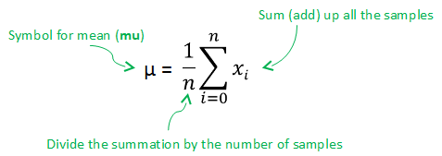
In the above, the summation portion of the equation is read as follows: for a set denoted by x of size n, we add (sum) up each instance within x between 1 and n, denoted by x_{i}.
For example, if we had seven values in a set, we add up (summation) the seven values and then divide by seven, such as in the example below:
Samples = { 1, 2, 2.5, 2.5, 3, 3, 3.5 }
1 + 2 + 2.5 + 2.5 + 3 + 3 + 3.5
-------------------------------------- = 2.5 (µ)
7
When referring to a sampling distribution (i.e., random subset of a population distribution), the mean is denoted by the symbol x̅ (x-bar).
The median is the midpoint in a sorted distribution, such as a population or sampling distribution. The median is denoted by the symbol x̃ (x-tilde). If the number of elements in the set is odd, then the median will be the midpoint (center) of the sorted set. Below is an example:
Sorted Set of Seven Samples = { 1, 2, 2.5, 2.5, 3, 3, 3.5 }
midpoint = 2.5 (x̃)
If the number of elements in the set is even, then the median is the average of the two samples in the midpoint (center) of the sorted set. Below is an example:
Sorted Set of Eight Samples = { 1, 2, 2.5, 2.5, 3, 3, 3.5, 4 }
midpoints = (2.5 + 3)/2 = 2.75 (x̃)

The mode is the value in a set that occurs the most frequently. For example, when plotting a bar chart, the tallest bar would be the mode. The mode is interpreted differently whether the values are discrete or continuous. In the case of discrete, it is the value that occurs with the most frequency. For example, if the values are a person’s age in whole numbers, then the age that occurs the most frequently is the mode, as in the example below:
Sorted Set of Samples = { 20, 21, 21, 32, 32, 32, 36, 37, 37, 40 }
mode = 32
If the values are continuous, it is the range that occurs the most frequently, where we group values into bins. For example of wealth, one might group wealth into bins of <$1K, <$10K, <$100K, <$250K, >$1M. The bin with the highest frequency would be the mode.

Standard Deviation

The standard deviation is a measurement to quantify the amount of variation, also called dispersion, in a population or sampling distribution. The standard deviation for a population distribution is denoted by the greek symbol (sigma) or σ_{x.} For a sampling distribution it is denoted by the latin letter s. The equation for calculating the standard deviation is denoted as:

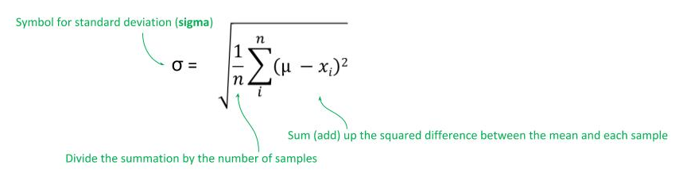
In the above, the summation portion of the equation is read as follows:
- Calculate the mean µ.
- For a set denoted by x of size n, add (sum) up the square of the difference between each instance x_{i} in the set x from the mean of the set x ( (µ - x_{i})² ).
- Then divide the summation by the number of instances (examples), and then take the square root of the result.
Below is an example computation of the standard deviation:
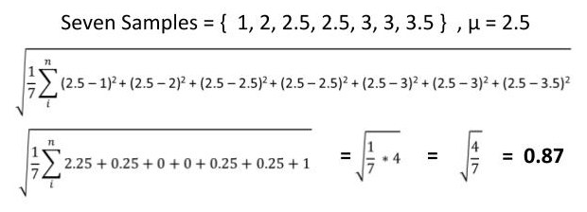

Normal Distribution
A normal distribution, also known as a Guassian distribution, is a distribution used in propabilities for the expected random distribution of samples within a population. The distribution is based on observations of variability in the natural world of naturally occurring things, such as shoe sizes, eye color, height, etc. In a normal distribution, we expect samples to be:
- 68.2% of the samples should be within one standard deviation of the mean.
- 95.4% of the samples should be within two standard deviations of the mean.
- 99.8% of the samples should be within three standard deviations of the mean.

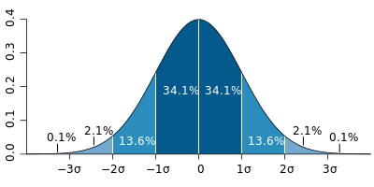
Normal Distribution - License
So what does this mean? It’s interpreted as follows, if we could measure every instance (sample) within a population of something naturally occurring, we expect that 34.1% of them to be less than the mean (average) value within one standard deviation and conversely 34.1% to be greater than the mean within one standard deviation. And likewise for the second and third standard deviation.
Let’s say our population was a bird specifies consisting of 1000 samples and that the average weight (mean) of the 1000 birds is 500 grams with a standard deviation of 100 grams. We would then expect that 68.2% of the birds have their weight within the range of 400 to 600 grams, and expect 95.4% to have their weights in the range 300 to 700 grams, and finally 99.8% of the birds to have their weights in the range 200 to 800 grams.

Population vs. Sample
Let’s now cover the difference between a population and a sample. A population is all the instances of something we are measuring, such as all male shoe sizes in North America. If one had the entire enumeration of male shoe sizes in North America, we would refer to that enumeration as a population. Given a population, we can define parameters for it, such as the mean, standard deviation and size, as depicted below. These values are not statistical since the actual values are known by enumeration of the entire population.
In most cases, we don’t have the ability to measure an enumeration of an entire population. Instead, we take samples, where a sample consists of some plurality of instances within the population. From that sample we calculate the probability of it being representative of the population, if the population was known. This is what is meant by a statistic.
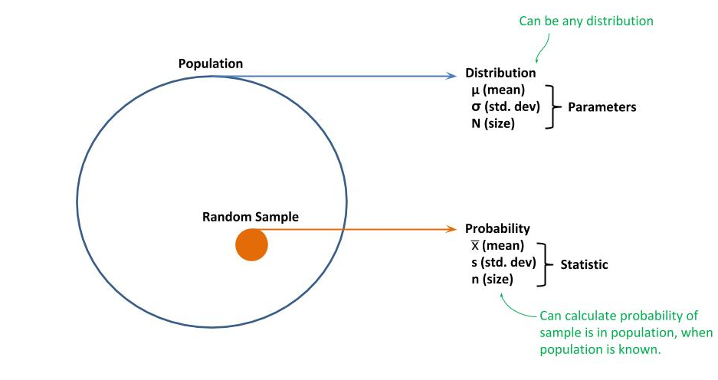

Sampling Distribution

So far, we have described a population and a sample within a population. If we now take a random set of samples, also referred to as a draw, from the population, those random samples form a sampling distribution. As more samples are drawn at random, the sampling distribution will exhibit more of the characteristics of the population.

While there is no predetermined way to know with certainty on how many random samples to draw to be representative of the population, it is a common practice to set that threshold at 30 samples chosen at random. For example, if I polled 30 people at random within a voting district on who they would vote for, it is likely the sampling distribution would be representative of the actual distribution within the voting district.
If we calculate the mean of each sample, denoted by the symbol x̅, as a set and then calculated the mean of the set of sample means, denoted by the symbol µ_{x̅} , we expect the sample means to approximate that of the population mean µ :
µ_{x̅} = µ

If we calculate the standard deviation for the set of sampling means, denoted by the symbol _{x̅} , we expect the standard deviation of the sample means to approximate the standard deviation of the population divided by the square root of the size (number of instances) of a sample: _{x̅} = /
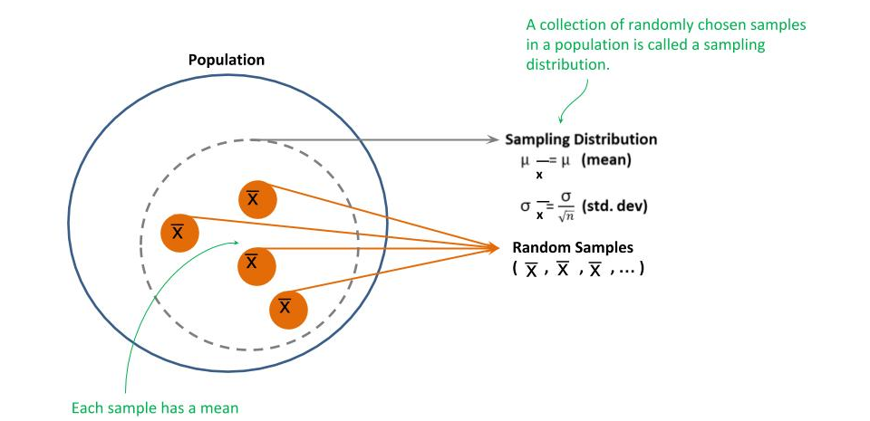

Central Limit Theorem

You might question that all natural occurring events follow this distribution. Yes, there are many factors that could result in a distribution other than the normal distribution. But even in those distributions, if one draws random samples from the population and plot the mean of each sample, that the plots of the sample means will follow a normal distribution. This is known as the central limit theorem. This can then be used to approximate what is the population mean and standard deviation, without having enumerated the entire population.
Typically, the first sample means one plots, one will not yet see a normal (Gaussian) distribution. But as more samples are drawn and the sample means plotted, the plot will gradually form a normal distribution, as depicted below:

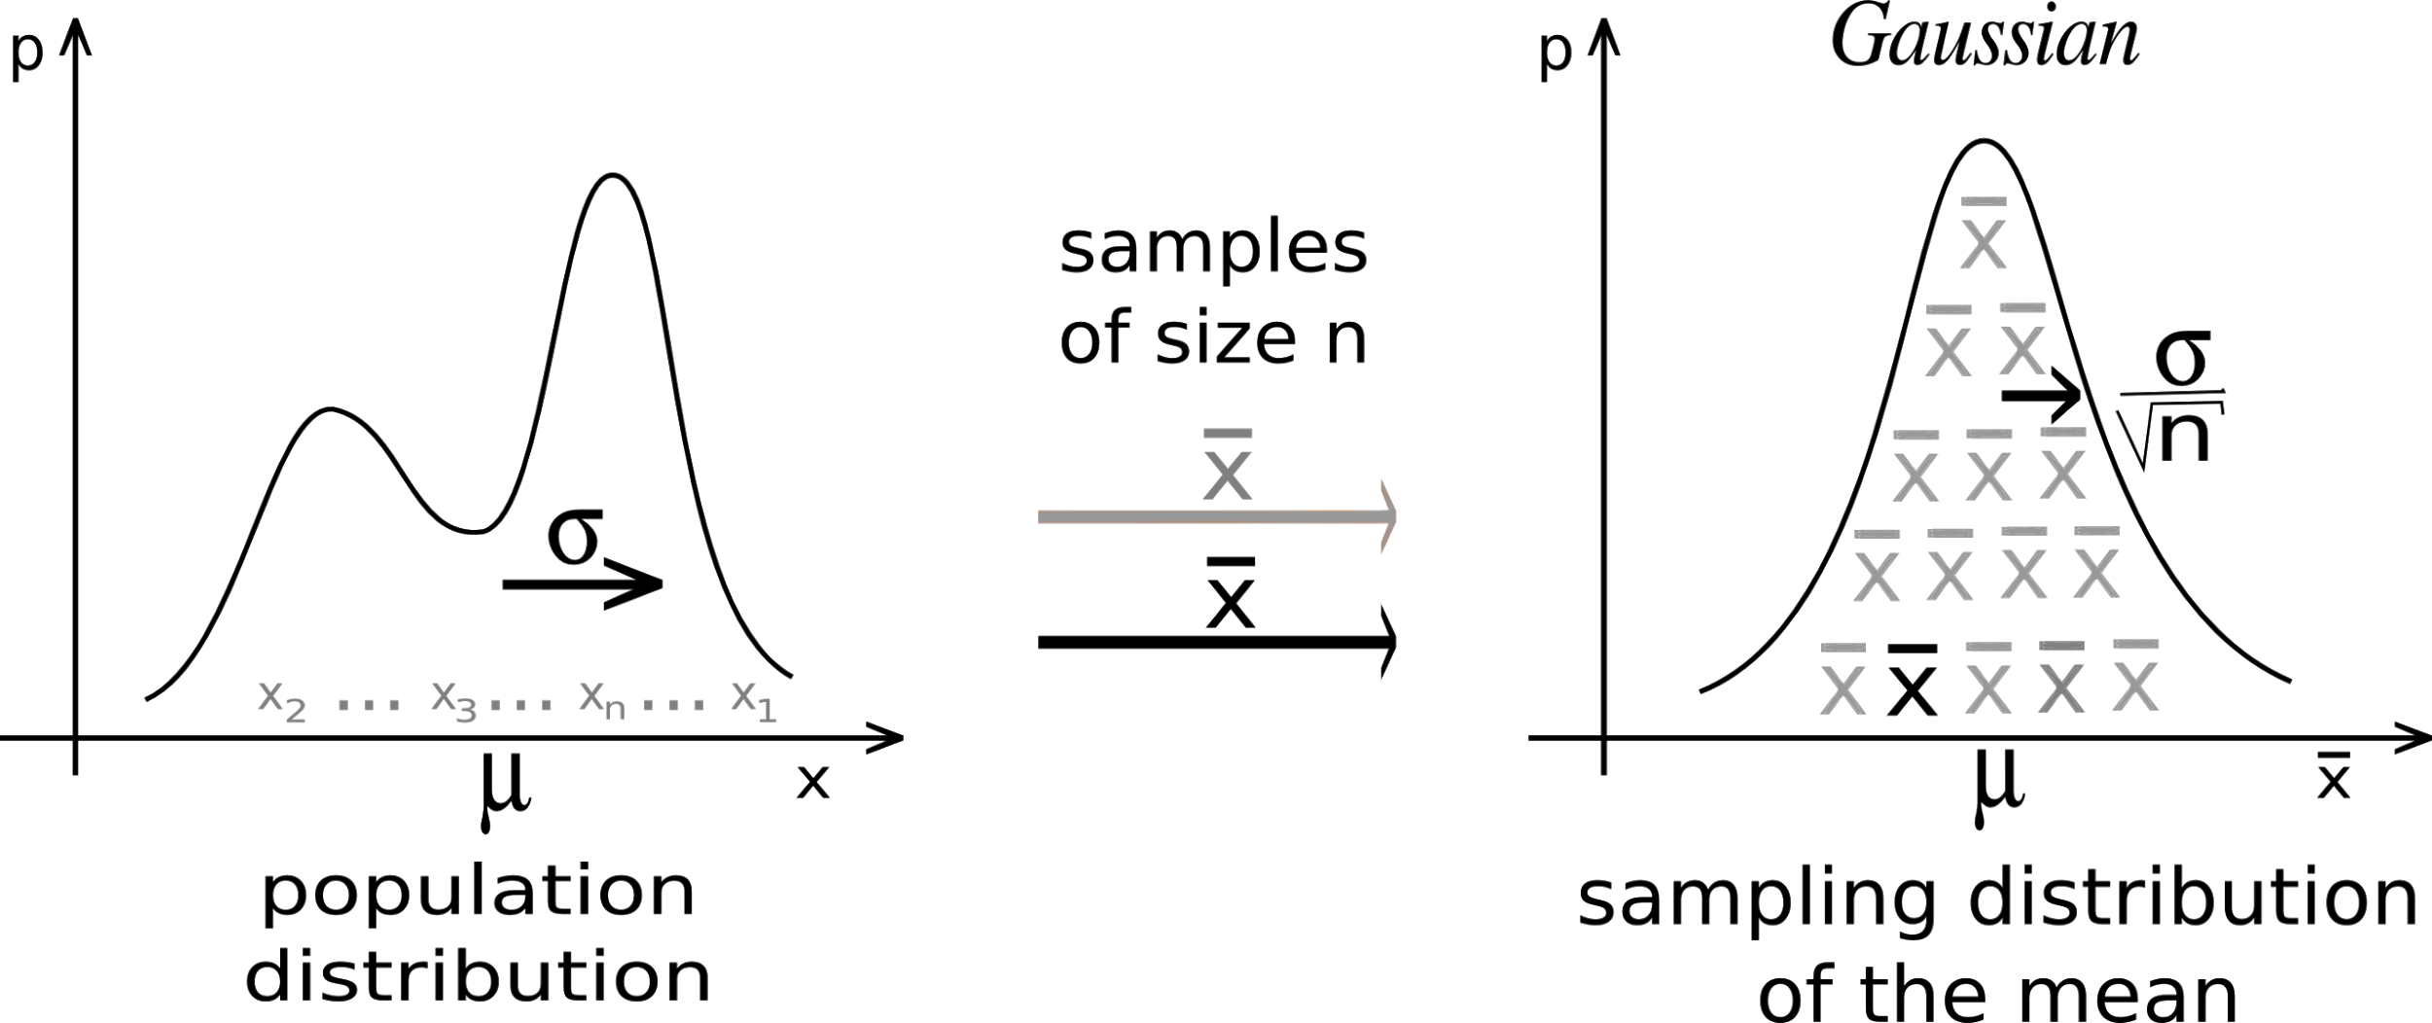
Central Limit Theorem - License
Z-Score
The term Z-score is used in statistics to measure how far a sample or instance is from the population mean. Z-score are equal to standard deviations. Thus a Z-score of 1 is the same as one standard deviation from the mean.
Z-scores are used in statistics to calculate the probability of an instance occurring within a normal distribution. It also provides a method for comparing scores from different distributions. For example, assume a student has scored 70% and 80% on two different tests. Since the two tests are different distributions in results, knowing the percentages does not tell us how the student did across the two tests.
Instead, we determine the student’s Z-score for each test based on the distribution of results for each test. Using our example above, if the Z-score on the first test was 1 and on the second test was 0.9, one could say that the student did worse on the second test, even though the percentage was higher. Using Z-scores provides a method to normalize the results between different distributions for comparison.

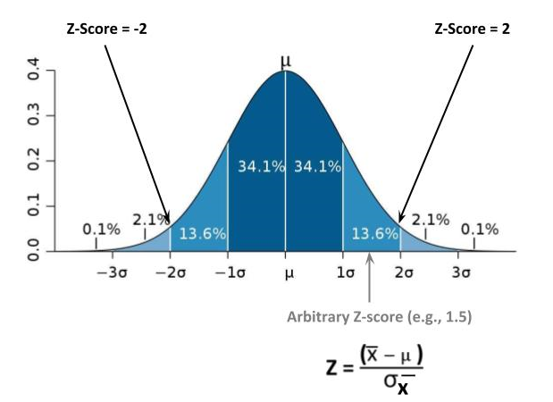\
Standard Normal Probabilities Table
The standard normal probability tells you the probability that a Z-score falls within an area of the normal distribution. These probabilities can be looked up in the Standard Normal Probabilities Table.
Using a student’s test score as an example, if there Z-score for the test was -1.0, then using the table we find that 15.87% of the students scored the same or less on the test. If the Z-score was 1.0, we find that 84.13% of the students scored the same or less; or in other words the student scored in the 84 percentile.
An Example - Robotic ForkLift
Let’s demonstrate how to use all the terms and equations we’ve discussed. In our example, we will calculate the probability of a robotic forklift picking up a pallet of unknown weight without tipping over. Let’s assume the following are the known facts:
- Warehouse: The historical data for boxes in the warehouse (population) is a mean weight of 50 lbs and a standard deviation of 10 lbs.
- Robotic Forklift: Has a weight lifting limit of 560 lbs.
Let’s assume the following scenario:
- Pallet of Boxes: We have a pallet of ten boxes of unknown weights.
- Question: What is the probability that the robotic forklift can lift the pallet?
Let’s do some initial calculations. We know the population mean is 50 lbs. We know that given sufficient random samples in a sampling distribution, the mean across random samples of ten pallets should be the same as the population mean.
µ _{(population)} = 10
µ_{x̅} = µ = 10
We also know that the standard deviation for our random samples will be the standard deviation of the population (warehouse) divided by the size of our random sample:
_{(population)} = 10
_{x̅} = / = 10 / = 3.16
Next we calculate the maximum mean for a random sample (pallet of ten boxes), denoted by the symbol x̅_{max}. We know that the maximum weight the robotic forklift can lift is 560 lbs. Given that our pallet size is ten boxes, then the maximum mean will be the maximum weight (560 lbs) divided by the size of the pallet (10 boxes):
X̅_{max} = 560 / 10 = 56
Next, we calculate a Z-score so we can determine the probability that this pallet of unknown weight can be lifted by the robotic forklift. We use the above computations to calculate the Z-score for the probability that a pallet of ten boxes of unknown weight will be a maximum of 560 lbs. Using the equation for a Z-score, we get the difference between the maximum mean (56 lbs) and the population mean (6 lbs) and divide it by the sampling standard deviation (3.16), which gives a Z-score of 1.9.
Z = ( X̅_{max} - µ ) / _{x̅} = (56 - 50) / 3.16 = 1.9
We now look up the Z-score of 1.9 in the Standard Normal Probabilities Table, which gives a probability of 97.13% likelihood that this pallet of ten boxes of unknown weight can be lifted by the robotic forklift.
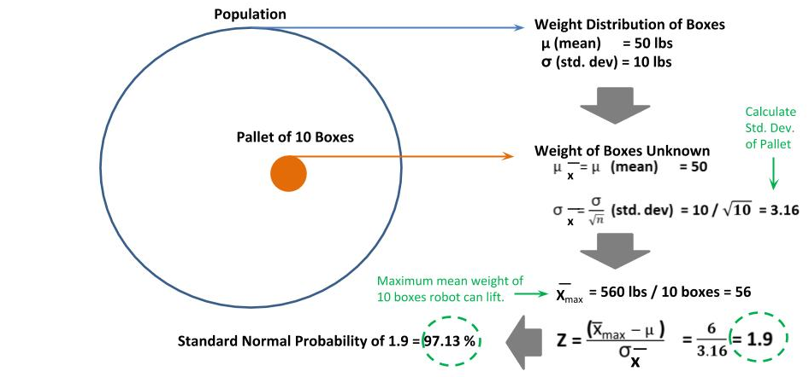

Null Hypothesis
Another basic methodology in statistics is the null hypothesis. This methodology is used when one has a hypothesis, but can’t directly prove it. So instead, one determines the opposite of the hypothesis (i.e., would be true if hypothesis is false), referred to as the null hypothesis, and then proves instead that the null hypothesis is false within a statistical level of confidence. The null hypothesis to disprove and the hypothesis to prove are denoted by H₀ and H₁, respectively.
Let’s use as an example of a population which is the transaction history for a store. Let’s assume we have the following known facts, that the population mean for a transaction is $25 with a standard deviation of $5.
µ _{(population)} = $25
_{(population)} = 10
Let’s assume a new set of transactions, such as all the transactions for today, which will be our transaction sample, and that the transaction sample mean is $26.50.
X̅ _{(sample)} = $26.50
Let’s define the hypothesis H₁ (what we want to prove) and the opposite, the null hypothesis H₀:
- H₀: The mean price of a transaction has increased (µ > $25)
- H₁: The mean price of a transaction has not increased (µ $25)
In other words, we will prove that nothing (the mean) has changed by disproving that the population mean has increased within a significant level of confidence. In this example, we assume an average size (n) of a transaction is 10 items. First, we calculate the sample standard deviation:
_{(population)} = 5
_{x̅} = / = 5 / = 1.58
Next, we calculate the Z-score and then look it up in the Standard Normal Probabilities Table:
Z = ( X̅ - µ ) / _{x̅} = (26.5 - 25) / 1.58 = 0.95
Standard Normal Probability for 0.95 is 82.18%
We interpret the above probability that there is a 82.18% likelihood that this sample is within the existing population. In other words, we have a 82.18% confidence that the population mean (transaction mean) has not gone up, and only a 17.82% that it has.
Let’s now show the effect of the sample size. We will use the same example, except now we assume an average size (n) of a transaction is 100 items. We calculate the sample standard deviation:
_{(population)} = 5
_{x̅} = / = 5 / = 0.5
Now we calculate the Z-score and then look it up in the Standard Normal Probabilities Table:
Z = ( X̅ - µ ) / _{x̅} = (26.5 - 25) / 0.5 = 3
Standard Normal Probability for 3 is 99.97%
At a transaction sample size of 100, we would have the probability (confidence) of 99.97% that the sample is within the existing population, and that the population mean has not increased.
ArgMax & SoftMax
The argmax and softmax functions appear frequently in statistics and deep learning. First, let’s define what the max(x₁ .. x_{n} x) function is. It’s a function, given some set of values x, consisting of elements x₁ to x_{n}, it returns the element x_{j} which is the largest value of all the elements.
One can define the max function as being the condition where the instance x_{j} is greater than or equal to all other instances in the set x, which can be described as the equation:
x_{j} ≥ x_{i} , x ∈ S
Let’s cover some of the symbols we use here to describe the max function:
S : Set of discrete values.
∈ : Symbol for an element of a set.
x_{i} : An Instance of an element of a set.
≥ : Greater than or equal to for all elements in a set.

ArgMax
The argmax function instead returns a value x_{i} from a set x, which maximizes the result of a function, denoted by f(x).The argmax takes as arguments the function and the set of values, which is represented as:
argmax(f(x₁ .. x_{n} x))
The condition is met when the output of the function f(x) for at least one instance x_{j} is greater than or equal to all outputs for x S. This equation can be expressed as:
f(xj₎ f(x_{i}), x S
Let’s explain this equation. There is some instance x_{j} within all elements of the set S that is greater than or equal to all other instances x_{i}.
For an example, let’s assume of f(x) is the function x*(x-10), which can be expressed as:
f(x) = x *(x-10)
Below is the evaluation of the function for discrete integer numbers between 0 and 10:
f(x = 0) = 0 * (10 - 0) = 0
f(x = 1) = 1 * (10 - 1) = 9
f(x = 2) = 2 * (10 - 2) = 16
f(x = 3) = 3 * (10 - 3) = 21
f(x = 4) = 4 * (10 - 4) = 24
f(x = 5) = 5 * (10 -5 ) = 25 ← maximizes the function
f(x = 6) = 6 * (10 - 6 ) = 24
f(x = 7) = 7 * (10 - 7) = 21
f(x = 8) = 8 * (10 -8) = 16
f(x = 9) = 9 * (10 - 9) = 9
f(x = 10) = 10 * (10 -10) = 0
In the above example, the value 5 maximizes the result of the function. Thus, argmax( x * (x-10) ) is 5.

SoftMax
The softmax function, also referred to as a boltzmann function in physics, is used when predicting a probability distribution, such as in classification (e.g., type of fruit) and each predict makes an independent prediction. For simplicity image you have three algorithms, one predicts if something is an apple, another a pear, and the other a peach, as depicted below.
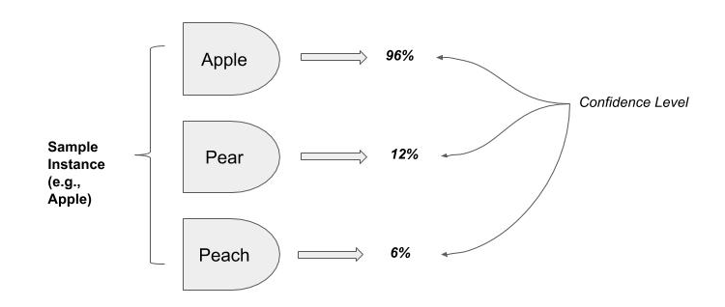
The above example, since each prediction (percent confidence level) is independent, that there is no reason to expect the sum of all the predictions to add up to 100%. That’s a problem when in statistics when each prediction is independent of the other. This problem is solved using the softmax function. The softmax function takes a set of any real values and squashes them into a normalized probability distribution that will sum up to one.
In neural networks which perform classification, each output node from the neural network makes an independent prediction of the associated class. Since each prediction is independent, all the output predictions are passed through a softmax function, such that the resulting set of predictions sums up to one (i.e., 100%), as depicted below:
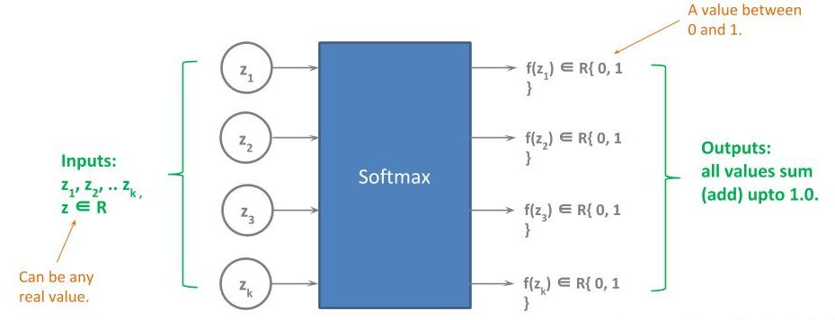
Below is the equation for a softmax function:
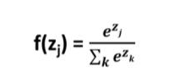
Let’s cover some of the symbols we use here to describe the softmax function:
R : Set of real values.
∈ : Symbol for an element of a set.
z : The set of input values.
z_{j} : An instance in the set of input values.
k : The number of inputs.
e : The natural number, also known as Euler’s number (2.718…)
Below is an example of applying the softmax function to the input set {8, 4, 2}:
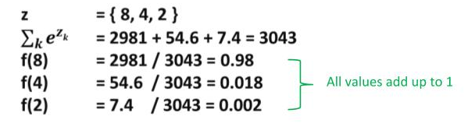
Next
In the next part we will cover the fundamental principles of linear and logistic regression.

Part B - Linear/Logistic Regression
In this part, we will start by covering the most fundamental model in traditional machine learning, a simple linear regression, and then advance to multiple linear regression, logistic regression and the principles behind feature engineering.
Simple Linear Regression
A linear regression is a method to predict a correlation between one or more independent variables, also referred to as features, and a dependent variable, also referred to as the label. A linear regression performs well when there is a strong linear relationship between the independent variables and the dependent variable.
In a simple linear regression, we have one independent variable (feature) and one dependent variable (label). As an example of a simple linear regression would be to model how speeding is correlated with traffic deaths.
If the independent variable is highly correlated with the dependent variable, it will appear as a (near) straight line relationship when plotted.
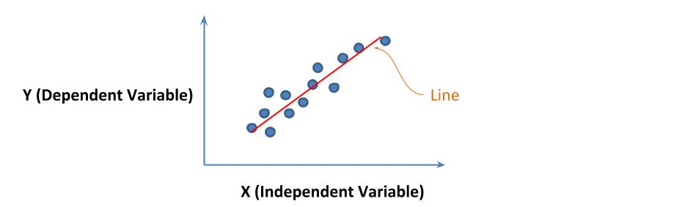
In a simple linear regression, one finds a linear approximate relationship (line) relationship between the independent and dependant variables. In machine learning, the independent variable is commonly referred to as a feature and denoted by x, and the dependent variable is commonly referred to as the label and denoted by y.
It’s likely you are already familiar with a simple linear regression from high school or college math, and is known by several names. We will cover several example representations next.
In elementary geometry, a simple linear regression is the same as the definition of a line, which is represented by the equation:
y = mx + b
y : dependent variable
x : independent variable
m : slope of the line
b : y-intercept
In the above, the slope (m) is a coefficient which determines the angle of the line when plotted on a 2D graph. The y-intercept (b) is the value on the y axis that the line crosses.
In linear algebra, a simple linear regression is represented by the equation:
y = a + bx
y : dependent variable
x : independent variable
a: y-intercept
b: coefficient (i.e., slope)
In machine learning, a simple linear regression is represented by the equation:
y = b + w₁x₁
y : dependent variable
x₁ : independent variable
b : bias (i.e., y-intercept)
w₁ : weight (i.e., slope)
In linear algebra method, we have a set of x values (i.e., data) where we plot each value on a x-axis/y-axis 2D graph, which is referred to as a scatter plot. We then attempt to find the best fitting line through the plotted points, as depicted below:
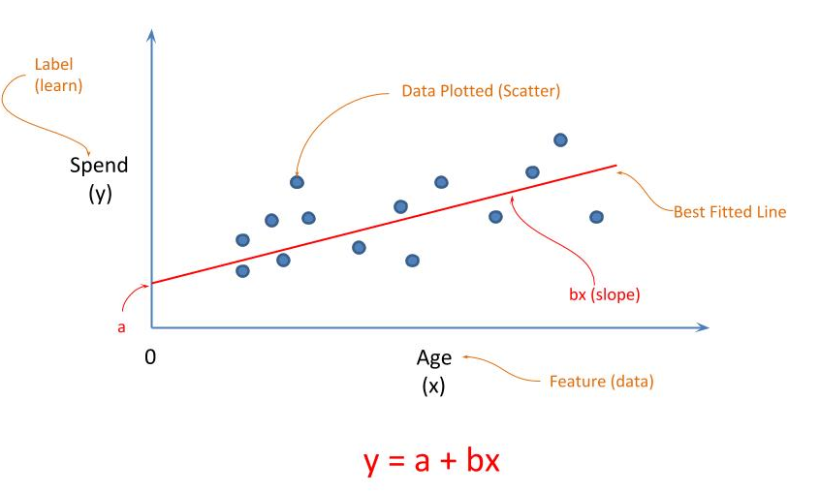
What is meant by best fitted line, is a line that can be drawn through the plotted points that has the least amount of accumulated error between the actual plot point (y) and the point predicted by the line, commonly referred to as ŷ (y-hat).
This accumulated error is referred to as a cost function. In a cost function, one uses a function to calculate the difference between the actual points (y) and the predicted points (ŷ), commonly referred to as a loss function. A summation of the losses is then done and divided by the number of points. The objective of fitting the best line is to minimize the resulting value of the cost function. In other words, the best fitting line is the line that results in the least value of the cost function.
In a simple linear regression, the common practice for a loss function is the mean square error (mse) method. In the mean square error method, we sum up the squared difference between the actual and predicted points (y - ŷ)² and then divide by the number of points.
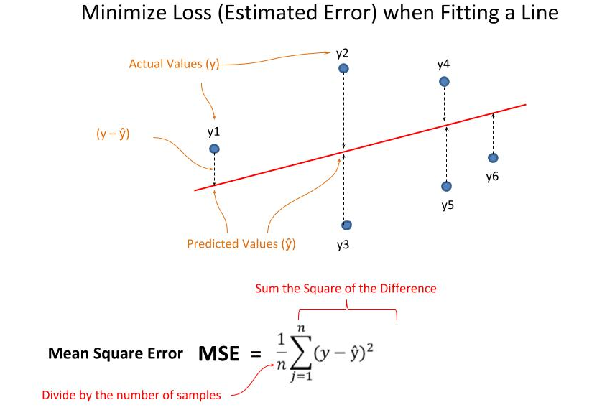
Why would we square the difference? The purpose of squaring the difference is that it penalizes points that are farther away from the predicted points, as well as making error always a positive value.
The solution to a simple linear regression for a mean square error loss function can be factored and computed as:
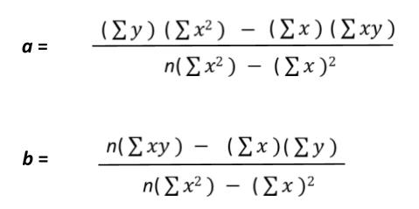
: sum of all values of x.
: sum of all values of y.
: sum of all values x * y.
x² : sum of all values x².
Other common loss functions used in a linear regression are the mean absolute error (mae) and root mean square error (rmse). In the mean absolute error, the summation is absolute difference between the actual value and predicted value, which as in mse, always results in a positive error value.
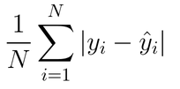
In the root mean square error, we take the square root of the mean square error.
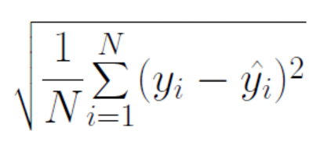
The reason one calls the variable we are predicting the dependent variable, is that the value of the dependent variable is dependent on the values of other (independent) variables, while the converse is not true. Given the earlier example of using Age to predict Income. The variable Income is the dependent variable because it’s value is dependent on Age. But conversely, the variable Age is an independent variable because its value is not dependent on Income.
Multiple Linear (Multivariate) Regression
In a multiple linear regression, we have two or more independent variables (features) and one is finding a correlation between multiple independent variables and the dependent variable (label), for example how age and income correlates with spending. If there is (or near) linear correlation, we expect that when the data is plotted on a graph, there is a hyperplane relationship between the multiple independent variables (features) and the dependent variable (label).
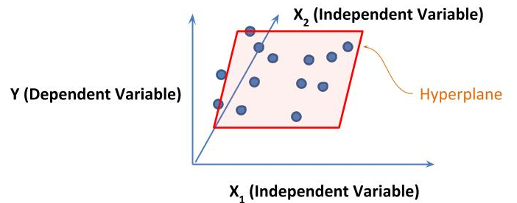
In machine learning, a multiple linear regression is represented by the equation:
y = b + w₁x₁ + w₂x₂ + … w_{n}x_{n}
w₁, w₂, … w_{n}: weights for n independent variables.
x₁, x₂, … x_{n :} data for n independent variables.
A multiple linear regression is also referred to as a multivariate regression.

Logistic Regression
In logistic regression, also referred to as a logistic classifier, is a regression whose result is a binary value (not a real value). A logistic regression is used when predicting if something is true or false, such as whether someone would default on a loan. A logistic regression can also be used for a binary classification (i.e., two classes), by reducing to predicting whether one class is true or false; and if false then it’s implied the other class is true.
In a linear regression, the dependent variable is always a continuous value. That is, it’s a real number vs. a discrete value. In a logistic regression, the dependent variable is a discrete value, where a binary value is an example of a discrete value.
In machine learning, a logistic regression is represented by the equation:
log() = c + w₁x₁ + w₂x₂ + … w_{n}x_{n}
c : the probability of y being true independently of the independent
variables x₁ … x_{n}.
y : the probability of y being true.
1 - y : the probability of y not being true.
Sometimes, one will see the above equation where a P is used in place of y. It is common in statistics to denote the probability of an event with the symbol P.
log() = c + w₁x₁ + w₂x₂ + … w_{n}x_{n}
The symbol c is a constant value that represents the portion of the probability distribution that the event (Y) could be true independently of the values (existence) of the independent variables. For an example, let’s assume our dependent variable is to classify whether an email is either spam or not spam. In this example, the constant c would be the portion of emails that are spam, but could not be predicted by the independent variables.
The expressions Y and 1 - Y, and conversely P and 1 - P, represent the probability of the event happening (true) and not happening (false). Since probabilities is a percentage represented in the range 0 to 1, then the probability of something not being true is 1 minus the probability of being true, hence the term 1 - Y (or 1 - P).
The expression log( Y / (1 - Y) ) when plotted for a continuous range of values for Y between 0 and 1 will be an S-curve between 0 and 1. When training using a logistic regression, the objective is to find the best fitting S-curve to the data, vs. best fitting line in a linear regression. There are numerous forms of S-curves in statistics. Some common ones are the logistic function (shown below), the error function, the sigmoid and the hyperbolic tangent.
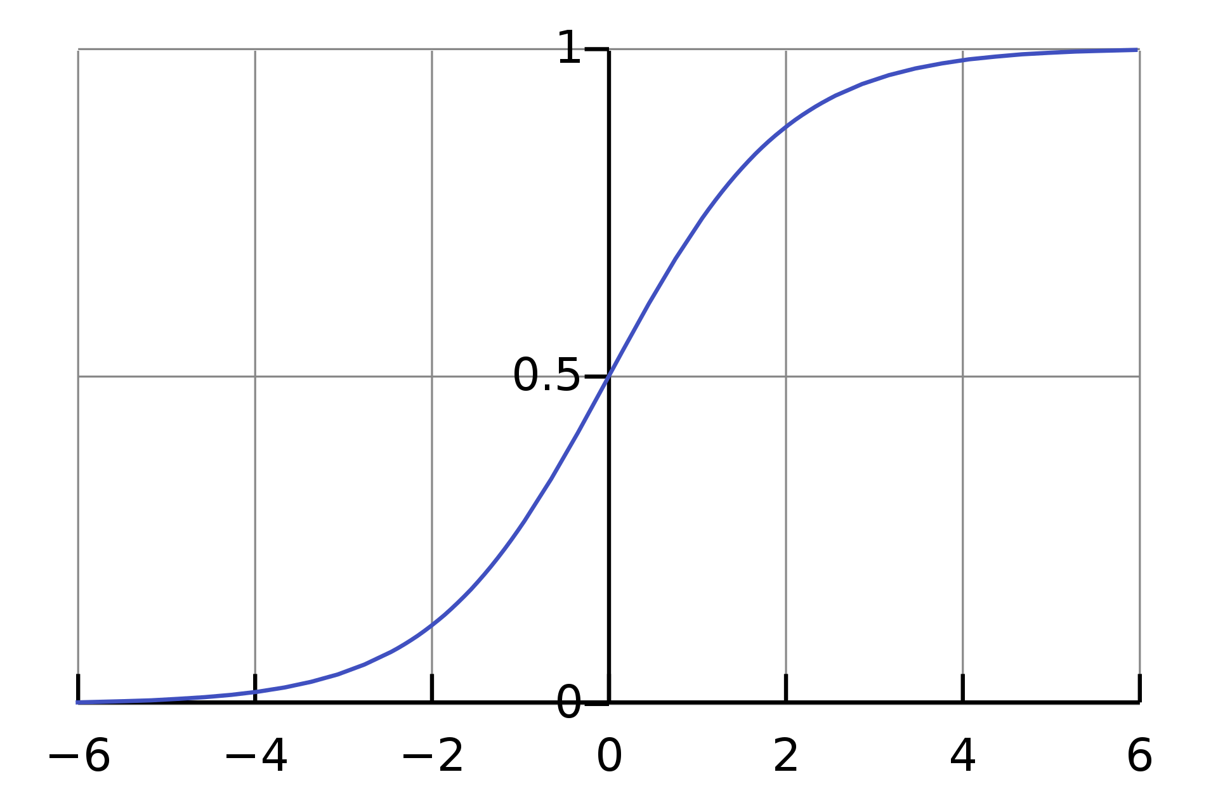
Logistic Function (S-curve) - License
Since we are fitting a S-curve, the cost function used to calculate the error between the predicted ŷ and actual y is the log loss function, also referred to as cross entropy. The log loss function is represented by the equation:
-(y * log_{e}(ŷ) + (1 - y)log_{e}(1 - ŷ))
log_{e} : natural logarithm (also denoted by ln)
y : actual value (0 or 1)
ŷ : predicted probability between 0 and 1.

The loss function for a logistic regression is the summation of the log loss between the predicted and actual values, divided by the number of values, as represented below:
-(y_{i} * log_{e}(ŷ_{i}) + (1 - y_{i})log_{e}(1 - ŷ_{i}))
For prediction, one picks a threshold within the 0 to 1 range to predict when the example is or is not true (e.g., spam or not spam). By default, this would be 0.5. Values below 0.5 are considered false and values above are considered true.
Once the logistic regression is trained, one may choose to slightly modify the threshold value for prediction, based on the results of the test data (holdout set), which comes from the same distribution as the training set but was not used in training. One may find that changing the threshold += a small amount, like to 0.52 may give a better result in accuracy on the test data.
A good or acceptable accuracy may not necessarily mean that we have learned completely the correlation between the independent variables and the dependent variables. Since we are using an S-curve to fit the data, values within 0 and 1 quickly move to the limits of 0 and 1, which is also referred to as the asymptotes, where the distance between the S-curve and limit approach zero. We would want the values near the asymptotes to have high accuracy, while we would presume lessor accuracy for values around the threshold.
Generally, when analyzing the accuracy of a logistic regression, one splits the results to the accuracy around the asymptotes and around the threshold, and the corresponding distribution between the two groups.
First, one would want most of the predicted values to be in the group near the asymptotes vs. the threshold. If not, then while one may have done well with the test data, it’s probably with future data that the accuracy may go through wild swings.
Second, one would want a low false positive rate near the one-horizontal asymptote and low false negative rate near the zero-horizontal asymptote. The term “false positive” refers to when a model wrongfully predicts true, and false negative is when the model wrongfully predicts false. If one finds an unusual error rate at the above asymptotes, it may be indicative of outlier values (i.e., instances that differs significantly from other observations), that have a greater amount of non-linearity in the correlation, and either can’t be reliably predicted with the current type of model or the one is missing some other independent feature(s) necessary to learn the correlation.
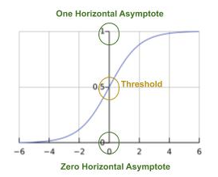
Feature Removal
Data sources used in linear/logistic regressions typically are in the form of structured data, also known as tabular, which originated from a database. The dataset will consist of rows, each example, and columns, where one column is the label and the remaining are the features.
It’s not unusual when data comes from a database that it contains columns which are not useful, or may even inhibit the training of the model, and these types of columns need to be eliminated (removed) prior to training. This is especially the case, if one used a SELECT * in an SQL query, which would retrieve all columns.
Some typical examples of columns (features) we want to eliminate either at the time the dataset is extracted from the database or after it’s extracted:
- It’s common for each entry (row) in a database table to have a unique identifier, which may be a cardinal ordering like 1, 2, 3, etc., and typically is named something like “Id”. This column is not otherwise part of the data and needs to be removed.
- It’s somewhat common for each entry to have a timestamp on when the entry was added to the database, and is typically named something like “created” or “updated”. This column is not otherwise part of the data and needs to be removed.
- Sometimes a database table has a text column for a note or other commentary, that is typically added by a person whom either created the data or entered it. While the column (field) potentially may have information relating to the data, for regression analysis one typically discards all textual data that is not categorical in nature.

Feature Transformation
Linear/logistic regression analysis take datasets that consist of numbers, specifically real numbers. Datasets therefore need to be prepared prior to being used for training. This preparation maybe part of a preprocessing phase, hand done, or automated in an extract transform load (ETL) process.
In linear/logistic regressions, the independent variables (features) must be either continuous or discrete, which are also referred to as numeric and categorical, respectively. In some cases, the (representational) format of the independent variable is neither, and must be transformed into either a continuous or discrete value.
Sometimes it may not be obvious when an independent variable is continuous. Take the measurement of time, and assume it’s format is MM-DD-YY:hh:mm:ss. As is, we can’t use it. If we convert the time into an ordinal representation, such as the number of seconds since Jan 1, 1970, we then have a continuous value. This is an example of a feature transformation.
It’s also common for independent variables that are meant to be a discrete value to be in a format that is not a representation for a discrete value, and will require a feature transformation. In most cases, discrete variables will fall into one of the following types:
- Binary
- Multi-Categorical
- Bins
A binary value needs to be transformed into the value 0 and 1, respectively. Thus, if the format of the value is textual such as True and False, it will have to be transformed into it’s discrete value representation.
In the past, it was not uncommon for a categorical value which only had two categories (i.e., distinct labels) to transform it into a binary discrete representation (i.e., 0 or 1). For example, this was once a common practice for gender, where male was transformed into 0 and female into 1. I am sure you see the potential problem. What happens if in the future the definition for the independent variable goes from two categories to multiple categories. As in our example, it’s now a common practice to represent gender as a multiple categorical representation, which we discussed next.
A multi-categorical, commonly shortened to categorical, value has two or more categories. For example, a value which can be one of: blue, green or brown (e.g., eye color) would be categorical, or a value which could be one of the 50 USA states. Categorical values are transformed into binary values, one per category. Using our example of eye color, one would transform the single feature into three binary features:
eye_color { blue, green, brown } => eye_color_blue { 0, 1 },
eye_color_green { 0, 1},
eye_color_brown { 0, 1}
The transformation of a categorical feature into a set of binary features is also referred to as dummy variable conversion. The term dummy is used to indicate that the transformed binary values are replacements of the non-numeric values, representing the presence or absence of the categorical value. Recall, that linear/logistic regressions take as input real numbers, so if we use categorical features, we must transform them.
It is also a common practice that when transforming the categorical values to a set of binary values, to drop one category to avoid multicollinearity, which is where one feature perfectly predicts another. This is also referred to as the dummy variable trap.
For example, if the categorical feature gender was the values male and female, and we converted into binary features male and female, then the value of either one will perfectly predict the value of the other. By dropping one category from the transformation, one eliminates multicollinearity, and the drop categorical value is implicitly represented by all the remaining transformed binary features being false. That is, if all the explicit binary features are false, then the implicit binary feature is true.
Using the earlier example for eye color and dropping one category, such as brown, we would have for a transformation:
eye_color { blue, green, brown } => eye_color_blue { 0, 1 },
eye_color_green { 0, 1}
where eye_color_brown = (eye_color_blue == 0 and eye_color_green == 0)
A bin, also referred to as a bucket, are ranges of real values, which might appear initially continuous, but are actually discrete values because their relevance is when they are grouped together, also referred to as bucketization. That is, all the values within a bin (group) have multicollinearity, in that they predict each other, and are replaced by a single discrete value. For example, presume we are trying to find the correlation between the independent variable a person’s age and the dependent variable what the person spent. One would break age into bins for the following reason:
infant (~0 .. 2): they don’t know meaning of money so spending ~0.
preschool (~3 .. 5): they spend the pocket change parents give them.
elementary (6..11): they spend money earned from allowance and chores.
secondary(12..17): they spend money earned from chores and odd jobs.

Feature Normalization
The process of feature normalization occurs once all feature transformations, and feature engineering (not discussed in primer) are completed. Feature normalization is performed on the features that are continuous, also referred to as numeric. The purpose of normalization is to prevent the numeric range and distribution of one feature to overly dominate other features with smaller ranges and narrower distributions. Without normalizations, training may take longer and may not converge (not discussed in primer).
Let’s start with an example. Let’s assume we are doing a multiple linear regression where one will predict spending (dependent variable), and the independent variables are years of education, and employment income (not investment). From exploring the data prior to performing the analysis (training), we find the following range, the minimum and maximum values, of the two independent variables:
years_of_education : 8 ... 27
income : 12,000 .. 1,500,000
If your wondering why we chose 27 for the maximum value of years of education, we choose it due to doctors in the USA typically do 4 years undergraduate, 4 years in medical school and 3 to 7 years residency.
Here’s the problem, the range for income way over dominates that of years of education. We have 1500 and 55K times greater than on the minimum and maximum, respectively. During training, one will want to gradually learn the best fitted weights for w₁ (years of education) and w₂ (income). When training starts, we don’t know what the final value of the weights will be, so they are initialized by some algorithm to typically a very small value. After feeding a batch of examples (not discussed in primer), the loss is calculated and the weights are updated to reduce the loss on the next batch, also referred to as minimizing.
In our example, as is, the contribution to the loss function from the feature income will dominate that of the years of education, disportionality influencing the updating (learning) of the weights. The multiple linear regression will spend a considering amount of time learning the correct correlation between years of education and income before being able to learn the correct weights (contribution). If it does not learn the former, the training will never converge --i.e., won’t be able to fit a correlation between the independent variables and dependent variables.
We approach this problem using feature normalization (also referred to as feature scaling), where we squash the range of each continuous (numeric) feature into the same range, typically between 0 and 1. The equation below performs a scaling between 0 and 1:

x_{i}’ =
x_{i} : the unscaled value of an instance (example) in feature set x.
x_{i}’ : the scaled value of an instance in feature set x.
min(x) : the minimum value of all instances in feature set x.
max(x): the maximum value of all instances in feature set x.
Once the continuous features have been normalized, we do not need to first learn the correlation between the features, and simply now just learn how the features correlate to the dependent variable. The training will more likely converge and in shorter amount of time.
Beyond the method described above, there are other methods for feature normalization. Another method, which is the common practice is feature standardization. In feature standardization, we first scale the values within a range (like -1 and 1), and then from within the range we use the distribution of the values to redistribute the values centered on a mean of zero and standard deviation of one.
The objective here is to improve convergence and further lessen the time to train a linear/logistic regression (and other types of models) by making all the independent features share a similar distribution in values. We accomplish this using a principle from the central limit theorem, that regardless of the population distribution, if we plotted the mean of random samples, the means would form a normal distribution.
The method of feature standardization remaps the scaled values into a normalized distribution, for each independent continuous feature. The equation below performs a standardization:
x_{i}’ =
x_{i} : the unstandardized value of an instance (example) in feature set x.
x_{i}’ : the standardized value of an instance in feature set x.
: the mean of all instances in feature set x.
: the standard deviation of all instances in feature set x.

Part C - CART Analysis
CART is an acronym for Classification and Regression Trees. The term is attributed to a publication of the book by Brieman, et. al, in 1984 titled Classification and Regression Trees. The objective of CART is to find methods to model non-linearity of features that contribute to the predicted outcome. As we discussed earlier, the linear regression and logistic regression models predict well when the independent variables are correlated to the predicted value (real value or classification), and the independent variables have a linear or logistic relationship to the dependent variable.
CART analysis introduced a methodology to predictive modeling to address independent features which contributed significantly to the prediction (outcome) but did not correlate to the dependent variable in a linear or logistic relationship. What CART addressed is the assumption that in these cases, the independent variables did exhibit linear or logistic relationships but in segments over their discrete or continuous value ranges vs. across the entire range.
CART addresses this type of relationship between the independent variable(s) and the dependent variable through decision trees. Unlike a linear/logistic regression which learns weights for how an independent variable is correlated to the dependent variable in a linear or logistic manner, it learns thresholds to segment the correlations into subsets of linear or logistic correlations.
Let’s take the example of age and spending. As discussed previously, we can segment age into ranges that do not have a linear/logistic relationship across the segments, but do have such a relationship within the segmented age range. The premise behind CART is to learn these “decision boundaries” to segment the independent variables, such that within the segment the relationship to the dependent variable continues to be linear or logistic.
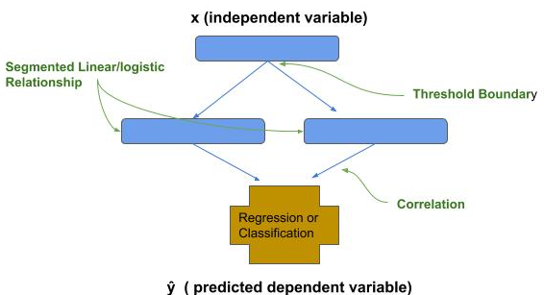
The above depiction illustrates an example where the range of values for the independent variable x does not have a linear/logistic relationship to the dependent variable y. In the example, a threshold is learned that splits the range of values, referred to as a decision split, into two groups; whereby within each group the values of the independent variable does have a linear or logistic relationship to the dependent variable.
Since CART analysis does not assume a linear/logistic relationship, it is a useful technique when the relationship between the independent variables and dependent variable is not linear/logistic.
Decision Trees
CART analysis is based on building decision trees. Decision trees consist of nodes, threshold, branches and leaves. Each node is associated with a single independent variable. The threshold is a value within the range of the independent variable (or function applied to independent variable) that separates the data into two independent groups; whereby each of the two groups has higher homogeneity individually than combined. Higher homogeneity means that the values have higher correlation to the dependent variable. The branches direct the splitting to the next node in the decision tree. A leaf is a node that has no further split. The leaf is either a final predictor or part of a set of predictors, such as in an ensemble method (to be discussed subsequently).
Decision trees are assembled as either regression trees or classification trees, where a regression tree predicts a continuous value (i.e., regressor) and a classification tree predicts a discrete (categorical) value (i.e., classifier).
The basic method for making a decision tree nobody does anymore, so we will cover it very briefly. One takes the set of independent variables (features) and ranks order them according to how well the independent variable is correlated to the dependent variable. Then you make a tree where the root is the highest correlating feature. At the next level down (level 2), you add a decision node on both branches which is the next highest correlating feature, at the next level all the decision nodes use the next highest correlating feature of the remaining features, and so forth. For example, if there were 10 features, the highest correlating feature would appear as a single node at the root and the lowest correlating feature would have 4096 decision nodes at the leaves of the tree, where the number of nodes is 2^{n-1}, where n is the number of features, such as depicted below:
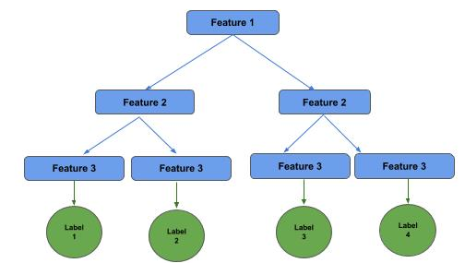
Popular methods of the time for ranking ordering the features were using information gain (not discussed in this primer) for features that are categorical and gini index (not discussed in this primer) for features that are continuous.
Due to the enormous amount of training required and exposure to overfitting, decision trees fell out of favor for a period of time. In the last ten years, several new techniques have been developed that substantially reduce tree size, reduce training and increase accuracy, including ensemble, bagging and boosting. As a result, CART analysis re-emerged as part of modern machine learning.
Ensemble (Weak Learners)
Decision trees became popular again when the ensemble method was applied to constructing decision trees. An ensemble is not a single model (e.g., decision tree), but a collection of computationally smaller models; whereby, each model is assumed to be 50% or better in accuracy. These smaller models are also referred to as weak learners. The assumption is that as we combine more weak learners, then the combined decision (e.g., majority voting in logistic classification), the more accurate the prediction will be. This concept is based on the seminole work in 1785 on jury systems by French mathematician Marquis de Condorcet, titled Essay on the Application of Analysis to the Probability of Majority Decisions. In his essay, Condorcet proposed a mathematical proof that if each person in a jury is 50% or better at the correct decision, then the more people added to the jury, the probability of the correct decision increases. Likewise, his mathematical proof also demonstrated that if each person in a jury is less than 50% at getting the correct decision, then the more people added to the jury, the probability of the correct decision decreases.
For example, if the ensemble is for a logistic classifier, then the method for a combined decision maybe a majority vote. If the ensemble is for a linear regressor, then the method maybe the mean.
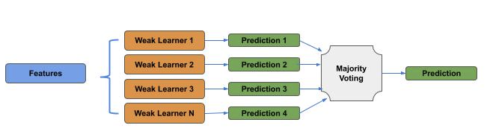

Bootstrapping
Bootstrapping is a method for improving the estimate of the mean of a population distribution from a single sampling. For example, let’s assume our population are shoe sizes of men in North America, and we have a single sample of 10,000 random instances (examples). We can calculate the mean of the single sample, but since it was a single sample, we cannot create a sampling distribution and use the central limit theorem to approximate the actual mean and standard deviation.
To better improve our approximation from a single sample, we randomly resample from our sample to create new samples. That is, if our sample size was N, we make new samples of size N, but randomly draw instances (examples) from the original sample. Since the draws are random, we are likely to have some duplicated instances in the resampled sets, but with sufficient size N, each resampled set is likely to be unique. Below is an example:
Sample = [1, 2, 3, 4, 5]
Resample 1 = [2, 4, 2, 5, 1]
Resample 2 = [5, 5, 1, 4, 3]
The principle here is that each resample has a 50% or better chance of being an actual sample in the population, and as such, using ensemble, the more samples we generate through resampling, the more accurate our calculation of the mean and standard deviation of the population will be.

Bagging
Bagging (short for Bootstrap Aggregation) is an ensemble method, which uses an ensemble of models, trained on smaller resampled training data, where the resampling is based on bootstrapping, and the aggregation refers to the combined decision method, e.g., majority voting if logistic classifier.
For example, assume a training dataset has 10,000 instances, where we refer to the size of the training data as n. We first choose a resampling size n’ (n prime), which is smaller than n, such as 60% in size. We then select the number of resampled training sets as m, where each resampled training set is referred to as a bag. We then train m models, one per resampled training set, and then combine the prediction of each model in an ensemble method, where the assumption is each model trained on the smaller resampled dataset is a weak learner (i.e., 50% or better accuracy).
For example, in a categorical classifier, one would combine (additive) the probability distribution of the predicted classes (labels) prior to passing through a softmax activation function for an aggregated probability distribution.
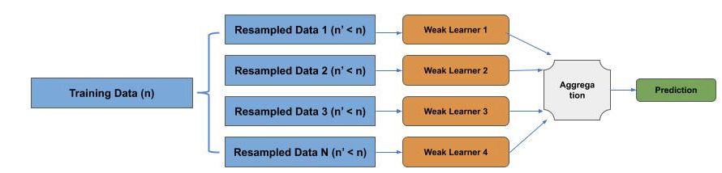
Random Forest
A state-of-the-art application of the bagging method to decision trees is the Random Forests (trademarked) method. In Random Forests, instead of resampling the training data, the features (independent variables) are resampled, which is also referred to as feature bagging. Assuming we have p features, then each resampled feature set is of size p’, where p’ is smaller than p.
For example, assume our training set has 16 features, which we refer to as p. We then choose a feature resampling size, such as 4, which we refer to as p’, where p’ is the general practice. Next, we select the number of models as k.
For each model (decision tree), we randomly select the p’ features from the set of p features. Each model has a random distribution of features, but are likely to have overlap of some features with one or more models.
The random selection of features is used to prevent the models from being highly correlated. That is, the more similar the models are, then any model becomes a predictor of the other models. Instead, we want each model to be an independent predictor (uncorrelated).
Finally, for each model (decision tree), we generate a resampled dataset from the training set using bootstrapping. That is, the size of the resampled datasets are the same size as the training set, but each decision tree is trained on a randomly chosen resampling. Each model is a decision tree, and the ensemble of decision trees is a forest.
Finally, we combine the prediction of each model in an ensemble method, where the assumption is each feature bagged model trained on a resampled dataset is a weak learner (i.e., 50% or better accuracy).
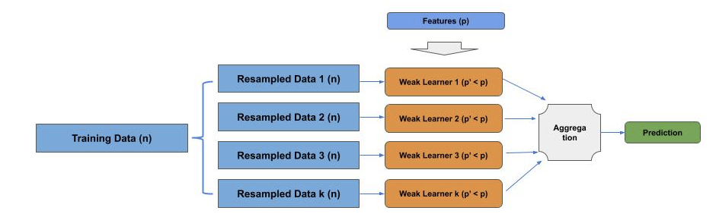
Boosting
Boosting is a method for turning weak learners into stronger learners (i.e., boosting a weak learner into a stronger learner). In this method, one takes an ensemble of weak learners, whose prediction accuracy is otherwise only slightly better than random guess, and then boost each weak learner to be more correlated with the correct predictions.
Boosting algorithms use some form of re-weighting of the models and/or training data. In earlier non-adaptive versions of boosting, the general practice was to weight the contribution to the final prediction by its accuracy on the test data. For example, if one had models A, B and C with corresponding accuracies on the test data of 51%, 54% and 57%, then the prediction of model A would contribute 51% to the final prediction, model B would contribute 54% and finally model C would contribute 57%.
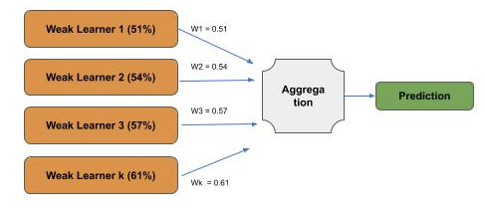
Conventional boosting methods use some form of adaptive boosting. The principle is that each new weak learner focuses on improving on training data that was misclassified by the previous weak learner; which is typically referred to as reweighting the training data.
For example, after training a first weak learner, we would identify the training data examples which were misclassified. In the next weak learner, the misclassified examples in the (resampled) training data are given a higher weight, such that they have a higher loss (i.e., greater penalty) then the previous correctly classified training examples. This causes the adjustments to the new weak learner to focus (be biased towards) the previous misclassified training examples. The process is then repeated for the next weak learner.
There are a variety of methods to re-weighting the training data. In one method, we bias the resampling to cause an increase in the number of occurrences of the misclassified training examples from the training dataset.
AdaBoost
In a second example, referred to as AdaBoost,we add a weight (i.e., greater than one) to the misclassified examples which is applied to the cost calculation when the predicted value does not equal the actual value. For example, if the weight is 1.2, then the cost calculation on misclassification is multiplied by a factor of 1.2.
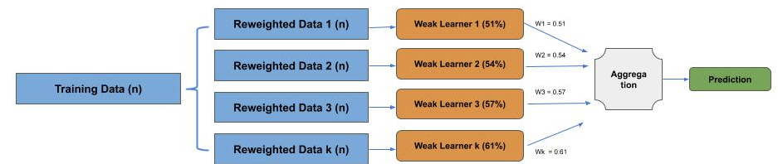

Part D - Probabilities
In this part, we cover the fundamentals of independent and conditional probabilities.
Independent Probabilities
An independent probability is when the probability of any instance of an event has no dependence on a prior event. A common example of an independent probability is a coin toss for heads vs. tails. We know that on any given coin toss, the probability of heads (A) is 50%, and conversely the probability of tails (B) is 50%. We can represent this with the following formulazitation:
P(A) = 0.5
P(B) = 1 - p(A)
In the above P() represents a probability of an event specified by the parameter. Thus, P(A) reads as the probability of event A (e.g., coin toss is heads) being true. In an independent probability, the inverse of the event is directly correlated to the event. So in the case of a coin toss which has just two outcomes (heads or tails). The probability of the inverse of the event, where P(B) is the probability of event B being true (e.g., tails), is 1 - the probability of the event.
In an alternate notation, P() is denoted as P[], where the above would be represented as:
P[A] = 0.5
P[B] = 1 - P[A]
In an independent probability, if we keep repeating the event, the aggregation of the events will eventually equal that of a single instance of an event. For example, if we toss the coin ten times, the average of the results maybe 60% heads, 40% tails (i.e., 60/40). But as we continue to toss the coins, we increase the likelihood that the aggregation will approach and equal that of a single event.
In other words, each instance of the event is uncorrelated from every other instance. Thus, each individual instance of the event (coin toss) will be an independent probability, but the aggregation of increasing events will approach or equal the probability of a single event.

Random Walk
A random walk is a probability method based on independent probabilities. A random walk is a random process of equal length steps, which is typically represented by integers. The sequence starts at an origin labeled 0, followed by a sequence of steps. At each step, there is a set of equal length actions that can be selected from. For example, if the random walk is along a line, at each step one can go either negative distance (left) or positive (right). On a 2D space, one might define the steps as the Manhattan distance (up, down, left, right). At each step, a random choice is made from the set of actions.
Line
Let’s look at an example when the random walk is along a line. Assume we have a random number generator which produces a uniform random distribution of choices of -1 and 1, and produced the following ten step distribution:
[1, -1, -1, 1, -1, 1, -1, -1, -1, 1]
If we plot this as steps, we have the following location on the line at each step:
Step 1: 1
Step 2: 0
Step 3: -1
Step 4: 0
Step 5: -1,
Step 6: 0,
Step 7: -1,
Step 8: -2,
Step 9: -3
Step 10: -2
We repeat several times using the same uniform random number generator for 1000 steps, and have the following position at the last step, and the greatest distance at any step:
Last Position Absolute Greatest Distance
-12, 39
28, 51
4, 9
As you can see, given a uniform random distribution, we never venture that far from the origin.

Manhattan Distance
Let’s assume a 2D grid and at each step we can move up, down (vertical) or left, right (horizontal). We will represent the horizontal and vertical movements as x and y, respectively. At each step, we can randomly choose to take one step from the four choices -- this is sometimes known as the “drunken man walk in city streets”.
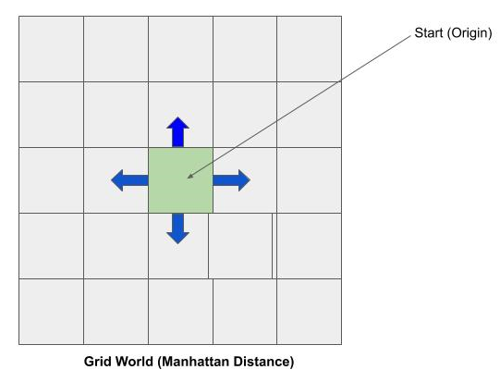
We repeat this three times using a uniform random number generator for 1000 steps, and have the following x, y position at the last step:
(-6, -42)
(16, 6)
(-30, -28)
Again, notice that after a 1000 steps, we have not moved far from the origin. Random walks are used for modeling stochastic movements using a random distribution, such as modeling a molecule moving through a liquid or gas, fluctuations in a stock price, etc.
Gaming
Random walks are also used in gaming. For example, let’s design a game that consists of a box of four walls, and within the four walls is a grid. You start at some origin zero, and at each step you must make a choice to move up, down, left or right. If you don’t move you are incinerated by an alien ray gun. At the same time, a lion is randomly moving through the grid. If you move into a block where the lion is, you are eaten. Using the random walk principle, it’s likely at any move you won’t stray too far from the origin or otherwise return to the origin. If I program the lion to do a grid walk in a smaller grid area around the origin, chances are it won’t be long before you’re eaten --game over.
When I was in grad school, I wrote a computer game for HP scientific calculator called Gunboat Diplomacy. The overall rules were simple. There were six sets of islands, the first and last set had one island and the sets between had three islands. You started at the first island and the goal was to make it to the last island. You started with and could carry a maximum of three ammo packs. On each turn, you had a reconnaissance where you could choose to see the number of enemies on one island only, either forward, backward or laterally. It took one ammo pack to kill an enemy and an island never had more than two enemies. You could move backwards to refresh your ammo packs. Seems simple, easy to beat. My grad friends played the game for days, weeks and months and never won. I could play the game and show you can win. My super-brainy friends could not figure out why --I never told them it was based on random walks. You figure the rest out.

Part D - Conditional Probabilities

A conditional probability is where the probability of an event is dependent on a past event, or existence of another event. This form of a probability is denoted as:

P(A|B)
In the above, the event A is the event we are determining a probability for being true, and B is the existence of an event B. This can be read as: what is the probability of A being true, when B is true. The above is sometimes denoted as:

P[A|B]
For example, one might predict the probability of missing the bus when the alarm clock does not go off. In this example, the event A (what we are predicting) would be “missing the bus”, and event B (what is true) would be “alarm clock does not go off”. We could write this as:

P(miss the bus | alarm clock does not go off)
For another example, let’s look at predicting if someone has cancer. First, we could look at it as an independent probability --i.e.., not dependent on any other event or information. We could represent this as:

P(has cancer)

Now let’s change this and add that you took a cancer test. The test is not perfect. For some people it will predict you have cancer when you don’t (false positive) and at other times it will predict you don’t have cancer when you do (false negative), and there is a known probability distribution for the false positive and false negative. In this case, we now have a conditional probability where we predict if you have cancer when your cancer test is positive, which can be denoted as:

P(has cancer | test is positive)
Monty Hall Game Show Paradox

The Monty Hall Game Show Paradox is one of my favorite ways to demonstrate the difference between an independent and conditional probability. I like it, in that to the general public, inclusive of PhDs, they assume it’s an independent probability and get the wrong answer. It is a conditional probability.

The problem (or puzzle) is based on the game show Let’s Make a Deal, originally hosted by Monty Hall. The problem was first posed and solved by the statistician Steve Selvin in a letter to the American Statistician in 1975. It became famous in a readers letter to Marilyn vos Savant's "Ask Marilyn" column in Parade magazine in 1990:

Suppose you're on a game show, and you're given the choice of three doors: Behind one door is a car; behind the others, goats. You pick a door, say No. 1, and the host, who knows what's behind the doors, opens another door, say No. 3, which has a goat. He then says to you, "Do you want to pick door No. 2?" Is it to your advantage to switch your choice?

Marilyn vos Savant’s answer was that it was better to pick another door, in that you’d have a ⅔ chance of winning the car, and only ⅓ chance if you stuck with the same door. After Marilyn vos Savant’s response was published in Parade magazine, the magazine received 10,000 responses that she was wrong, with nearly 1000 with PhDs, where the responders argued that the probability did not change --that is, in both cases the probability of winning the car was ⅓.

Vos Savant was correct, because the problem (puzzle) is a conditional probability, while the respondents presumed it was an independent probability. The respondents viewed the problem that each door had a ⅓ chance of having the car, and that there was no dependency between the doors; therefore, changing to the other remaining door should have the same ⅓ chance.

The respondents looked a dependency, which was not missed by vos Savant. She correctly say that by the host (i.e., Monty Hall) eliminating a door which he knew did not have the winning car, created a conditional dependency. Had the problem been stated that the host opened one of the two remaining doors without knowing if they had the winning car, and thus could end up opening a door with the winning car, it would’ve then been an independent probability, as the respondents argued.
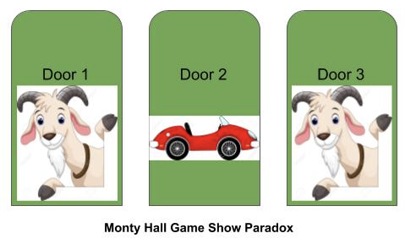
Goat License - Car License
,
Let’s look a little closer now at the problem. At the start, the contestant does not know which door has the car; so irregardless of the door they first selected, it has a ⅓ chance of being the car --hence without any other event, this is an independent probability. While the contestant’s door has ⅓ chance of the car, the remaining two doors combined have the remaining ⅔ chance.

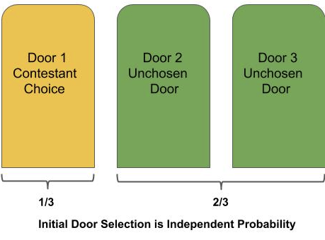
Now, while the contestant doesn’t know what’s behind each door, the host (Monty Hall) does know. Regardless of whether the contestant first chance is the winning choice, at least one of the remaining two doors is a non-winning door. That is, if the first choice is the winning door, both the remaining doors are non-winning doors, and if the first choice is not the winning door, then one of the remaining doors is the winning door and the other is a non-winning door.

Since the host has the knowledge, and will open only one of the remaining doors that is a non-winning door, the selection is conditionally dependent on the host’s knowledge. Thus, the probability of the two remaining doors combined, a non-winning door which has been opened and the other unopened door is still a ⅔ chance of winning. But since a non-winning door of the two remaining doors were opened, the ⅔ chance of winning is transferred to the other unopened door.
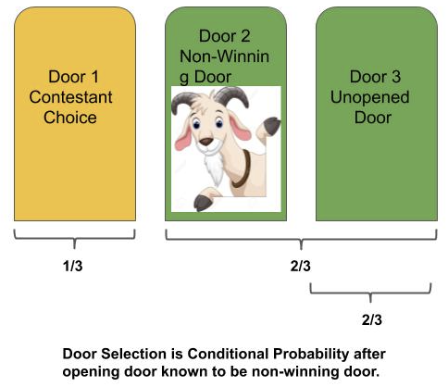
If your still skeptic, then you can prove it empirical. Use a spreadsheet. You will have nine rows, three for each door, one for the for the door being the winner, and the other two rows for each of the other two doors being the winner. Add one column for sticking with the door, and one column for choosing the remaining unopened door. Calculate the probability for each cell. Then aggregate the probability for sticking with the initial selection, which will be ⅓, and aggregate the probability for switching choice to the unopened door, which will be ⅔. I will leave it up to you to build the spreadsheet and prove to yourself empirically if you’re still skeptical.
Bayes Theorem

Bayes theorem is the defacto standard for conditional probabilities. In the base form, the theorem is represented as:

P(A|B) =
The above can be expressed as follows, if we know the independent probabilities of the events A and B being independently true, P(A) and P(B), then we can determine the conditional probability of A being true when B is true -- P(A|B), if we know the inverse conditional probability of B being true when A is true -- P(B|A).

In the above P(A) and P(B) are referred to as the prior (i.e., your prior knowledge). Let’s demonstrate with an example. Assume we want to determine the probability of an email being spam (A) given the presence of some specific text sequence (B), which we represent as:

P(A|B) = P(spam|specific text sequence)

Let’s say we have the prior knowledge of knowing the percentage of emails that are spam, independent of the contents of the email. We will call that the P(A), which in our example we denote as P(spam) and say that it is 1 in 100 emails, or 0.01. Let’s say that we know the probability that the specific text sequence occurs in an email, We will call that P(B), which in our example we denote as P(specific text sequence) and say that it is 1 in 1000 emails or 0.001:

P(A) = P(spam) = 0.01 “
P(B) = P(specific text sequence) = 0.001
Now let’s say we know the probability of an email that is spam contains the specific text sequence. We will call that P(B|A), which in our example we denote as P(specific text sequence|spam) and say that it is 1 in 50 spam emails, or 0.02.
P(B|A) = P(specific text sequence|spam) = 0.02
Let’s now calculate the probability that an email is spam given the presence of the specific text sequence. Putting it altogether, we have:
= 0.20

That’s Bayes, we hope you enjoyed our statistics primer, and look further into our AI Primer and NLP Primer.

