

# Islamic University of Technology

Lab-1 Report: Relational Model

# Submitted by:

Name : Mashrur Ahsan

ID 200042115

Program : SWE Department : CSE Course Code : CSE 4410

The Scenario:

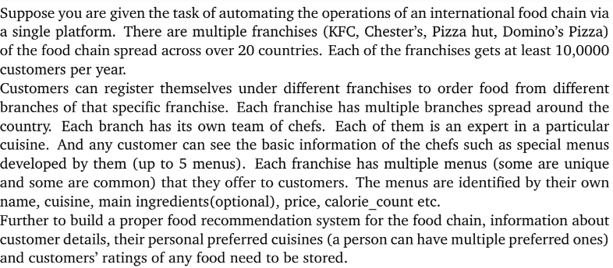

Problem Statements



Here’s the “franchise”, “customer” and the “franchise_customer_list” table. The last has two attributes which are acting as a single primary key.

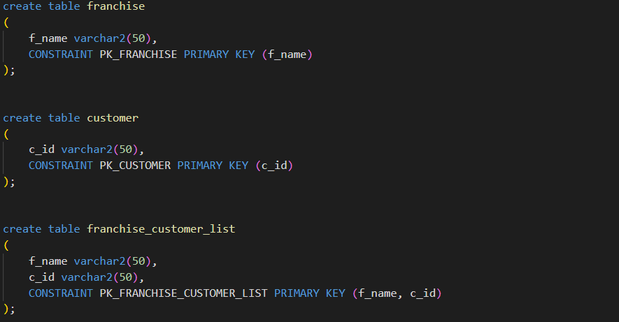

These are the “menu” and the “rating” table.

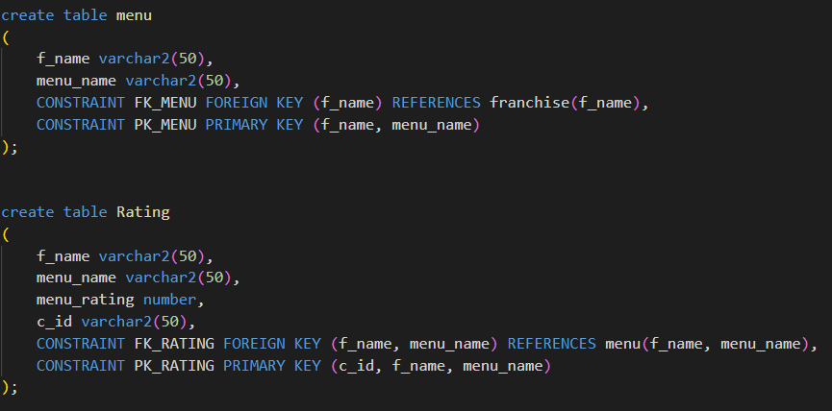

And these are the “orders” and the “preference” table.

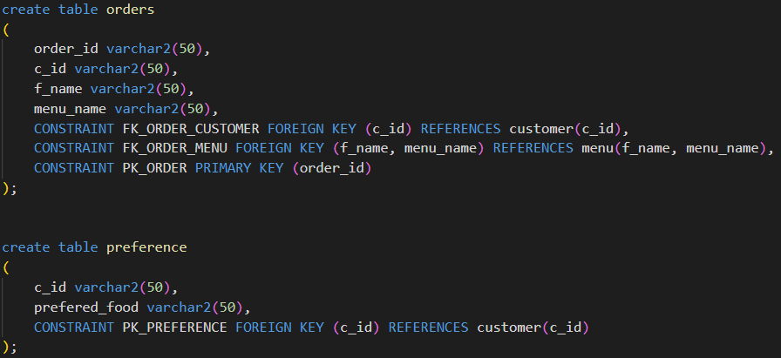

Explanation and Analysis:

The “customer” entity will contain the customer details, customer_id being the primary key. The “franchise” table will contain information about the different franchises where the name of the franchise is the primary key.

There’s another entity that stores the data regarding the customers going to different franchises. One customer can order food from multiple franchises. Whenever someone orders a food from a food store, they will be enlisted in the table. So, the table will store the customer id’s and the store’s name from where they are purchasing the food from.

The “menu” table stores the data about a cuisine or a food item from different stores. Multiple stores can offer the same food item or cuisine. To avoid inconsistent data the franchise name and the menu name together will act as the primary for this entity.

The “rating” table will store data regarding a food item’s rating