1, A Boolean value is either true or false.

Eg :-(1/2)==0.5  
 -2!=5

-100<=1000

2.1, A flow chart is a type of diagram that represents an algorithm, workflow or process. The flowchart shows the steps as boxes of various kinds, and their order by connecting the boxes with arrows.

2.2,

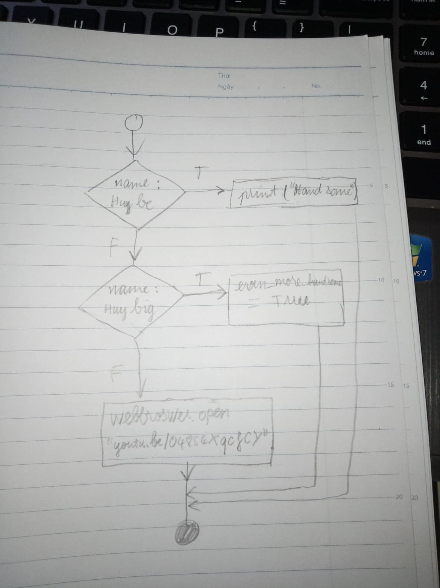

3, Nested conditionals is one conditional can also be nested within another.

Eg:

if navi>astralis:

print(“gg ez”)

else:

if navi<astralis:

print(“welcome to the cave”)

else:

print(“madness”)