This course assignment has been challenging, but I feel I have learned a lot! It´s like learning new languages, but a bit easier due to the fact that they are a bit more self describing and use an international language that is easy to understand. I have played a bit around with swift in a learning program but this is very different from that, in html and css markup you can make beautiful layouts and web-designs. Swift as far as I have come is more of making actions happen, but I can see some similarities.

I started out researching web-pages that had a similar service using google.com and got some inspiration though I thought some of the pages were a bit cluttered. I like web-pages that are easy on the eyes and that they don't give information overload. So getting into creating the mockups I tried to make pages that were clear and concise. As instructed in the CA overview I started with the mockup for smartphones:

I started working with the logo and wanted to incorporate something that could remind about eco friendliness and bicycling. So I started playing around with a bicycle wheel and worked out from that, creating the C and Y into a bicycle wheel and dividing them with colors so they would differ a bit from each other. Then I thought of what colors represent eco friendliness and used Adobe Color to make the color palettes that I use throughout the webpage. Using #00614D as the background color of the header and footer and #A1DDE3 for the body of the webpage to give it a feel of nature. Then using #8CC63F and #FFFFFF for h1, h2,h3 and button-links and black for paragraph text. I decided to highlight button-links with a color, in that way users of the page would know which page they were on.
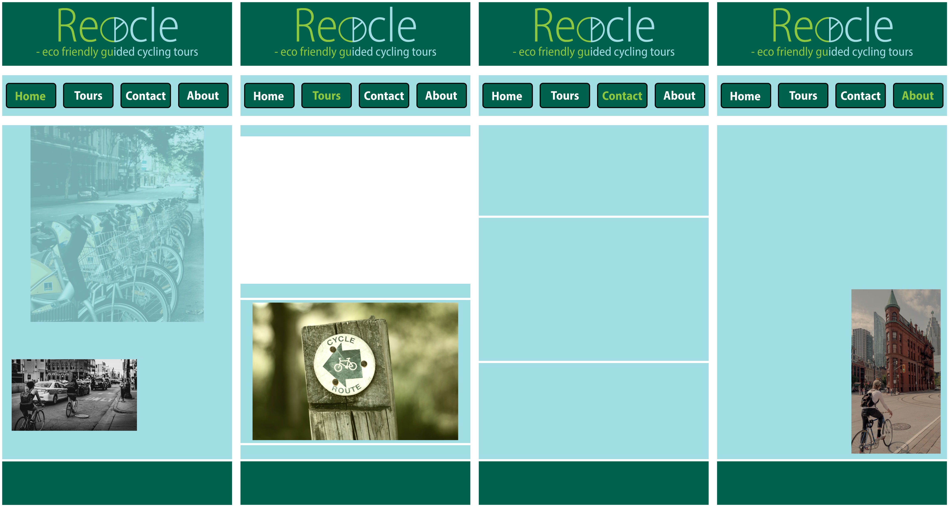
Then continuing to find out how I wanted the page layout to be I divided the vertical space into three horizontal columns that could hold the content and be responsive in markup. I tested out using images from unsplash.com on some of the pages, but ended up making a collage to be used in the about section. To make the webpages easier to load on mobile devices I created images and the header image in small sizes and input them via css so as to have better control over them and faster loading pages. The button-links were also made responsive and they are clickable oner the entire surface to make it easier for mobile users to press down on. I filled in with text on the different pages trying to give the best impression of how it would look in real life. I feel it was really helpful that we had worked with almost all of the elements that was going in the CA before and therefore had a good responsive model to work out from.

I then moved on to the desktop version of the page and made a bigger header so as to match better with the width of the page. This image was then also put in by css to make it more responsive and easier to load. I also added some text behind the header to make the header clickable and hid the text with the use of css. I feel there probably is a better method of doing this in the future, but for now this is what I managed. I hope to learn more on that later. But I feel the interactivity of the page is much better when the header is clickable and take you to the home page so I had to add it.
I then moved on to make the full mockup of the desktop version, which also was used in the tablet version of the site:
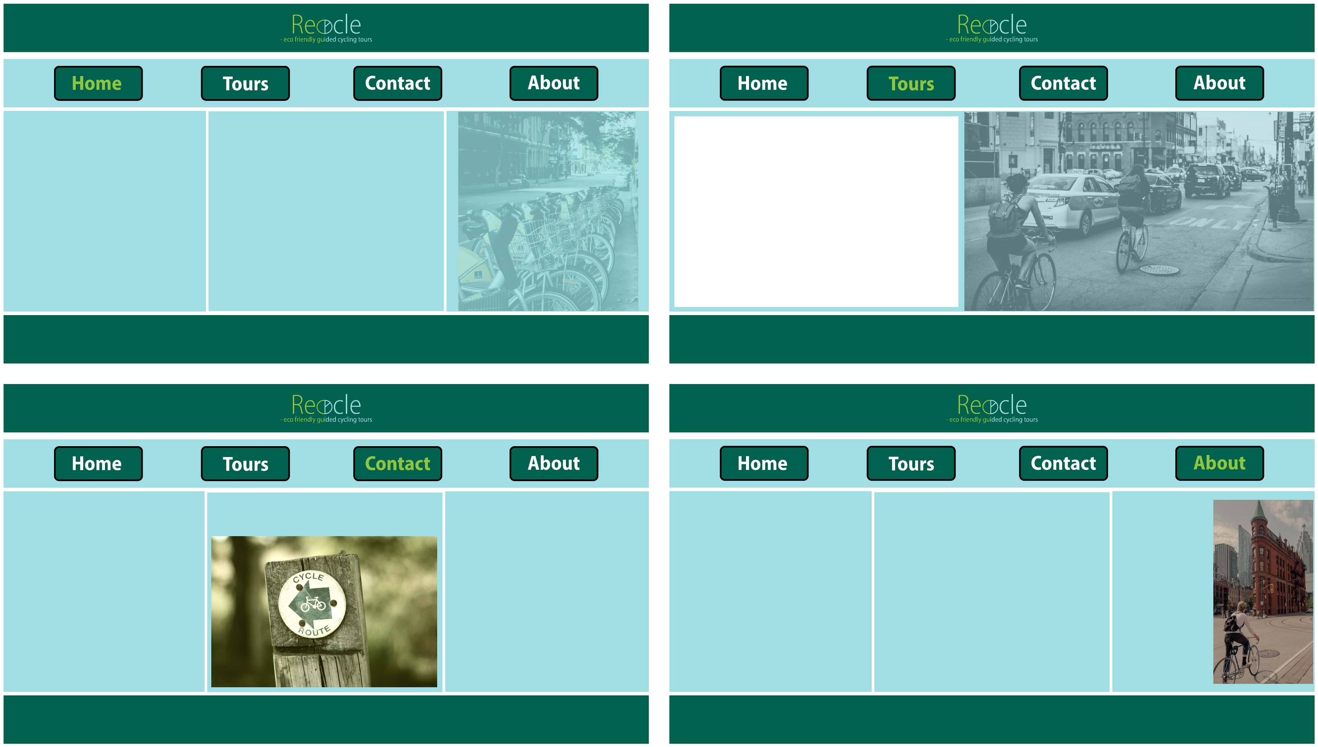
Almost the same process as with the mobile version, only with a vertical three column layout. After this it was time to begin with the markup to build the page.
The markup process was the most time consuming but also the most valuable learning experience. I started building the frame of the index/home page and worked out from that at the beginning. I then copied the index page into three more pages to make the four page total. Then I begun writing the css to make the responsive layout for mobile, after I was happy with the mobile version I started making the rules for the tablet version and desktop version. It took some time an fine tuning, but I am really happy with the result!
Conclusion:
I feel this task was very interesting and also demanding, I've had to extend my capabilities and make use of everything I learned during the html and css modules. But I am so happy with my own progress and what I've learned during this course. Its really good to see that I'm learning and evolving skills I didn't have before. I now feel that I have a good basic understanding of html and css, but I am very eager to learn more and evolve my skills. I especially look forward to making webpages more interactive and pop a bit more.

