Sample Output 1
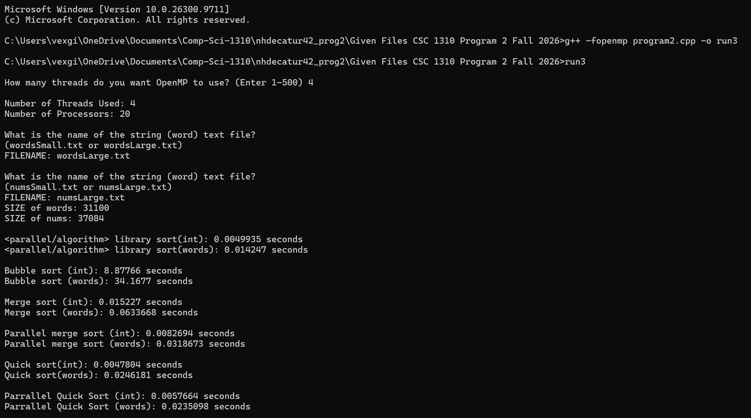

- I think I got the results that I did because I have more processors (20) rather than the 14 in the sample output. So I was able to get faster times.
- I would say Quick sort but it’s very close.
- Bubble Sort.
- It took less time to sort everything unlike the sample output.

Sample Output 2
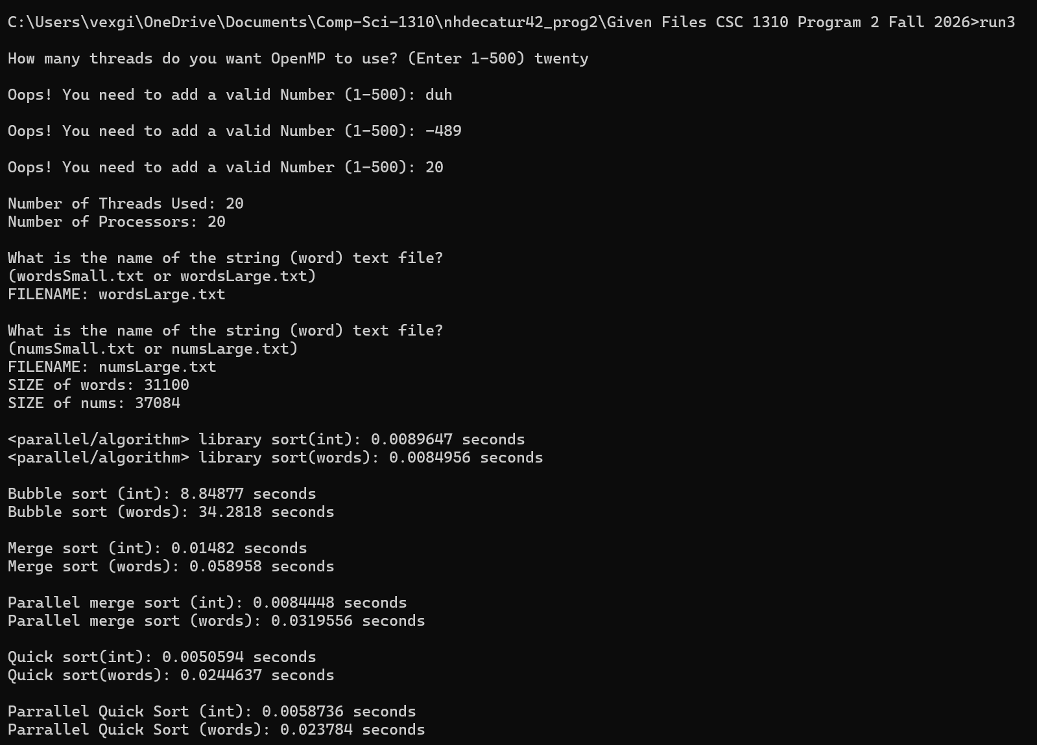

- Because the laptop I use is a gaming laptop and it can probubly can sort just a little faster than what was used for the sample output even though both were run with 20 processors.
- The checking for user error matches and the sorting time was faster than the output sample.

Sample Output 3
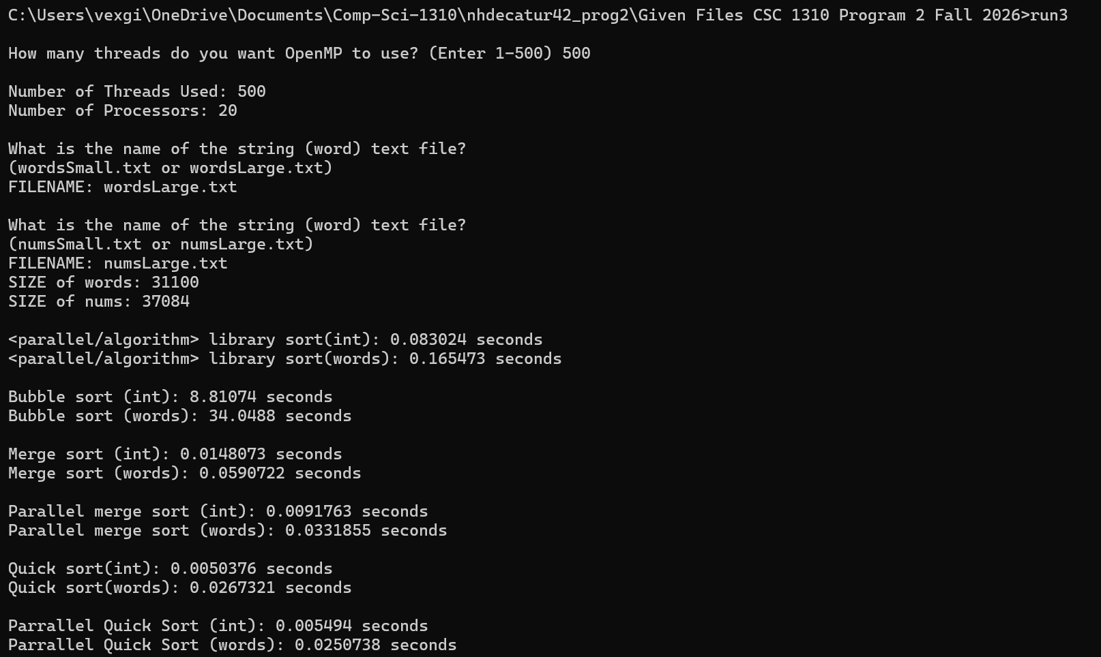

- My laptop got through the sorting faster than the sample outputs even though it has the same amount of processors it could just be the machine that we were running it on. I have a gaming laptop so mine might process it faster.
- I got virtually the same results as the other outputs with just a few differences in decimals. It also differs from the sample in that it sorts faster.

