**INTRODUCTION:**

**This lab is a step forward towards the MIPS32 microprocessor. In this lab we will create the Execution unit, which will execute the given values according to the control signals. Its a arithmetic logic unit which will perform task as per control unit guide it.**

**PRE-LAB TASKS:**

**Task 1:**

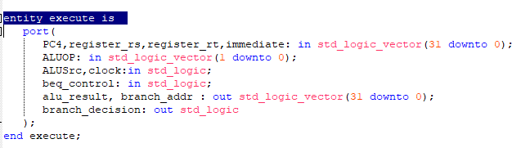

This is the entity of the execute unit. These are the Input/output of this unit. **In this task we have to understand the functionality of control unit in the MIPS32 and write the pseudocode of it which will be later converted into the VHDL code.**

**Task 2:**

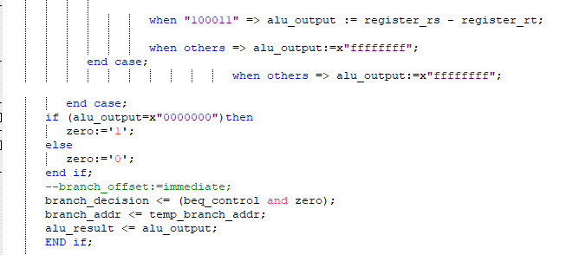

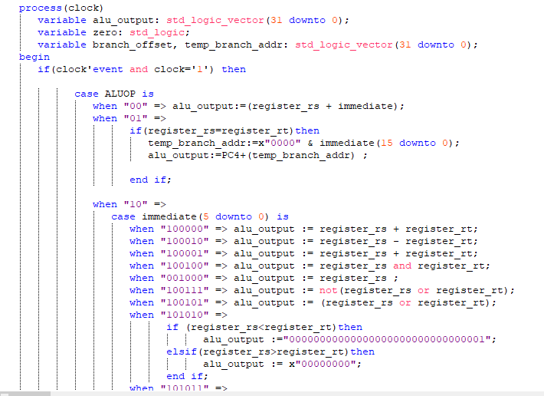

This is the entity of the Data Memory. These are the Input/output of this unit**. In this task we have to understand the functionality of memory module in the MIPS32 and write the pseudocode of it which will be later converted into the VHDL code.**

**LAB TASKS: Task 1:**

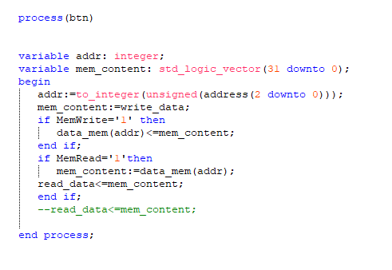

**LAB TASKS: Task 2:**

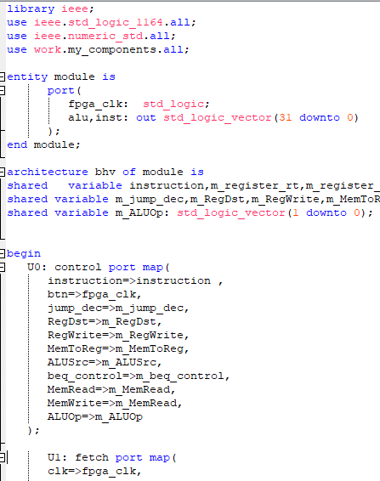 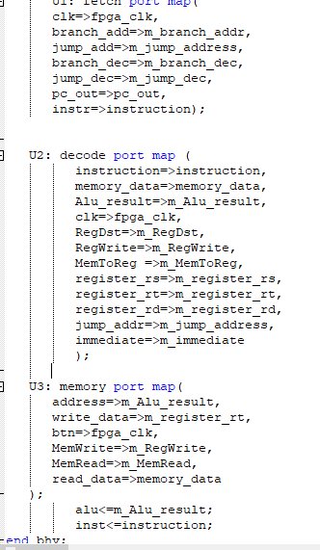

# CONCLUSION:

In this lab we created the whole model of the processor. All of the outputs of the control module are connected to the specified locations.. And all the previse labs are included in this lab to complete the task.