**INTRODUCTION:**

**This lab is the one step forward towards the MIPS32 microprocessor. In this lab we will create the decoder module, which will decode the instruction which is fetch from the fetch module. It will convert the 32 binary bits into different value which will make sense for the processor.**

**Some control signal are given to the module but in the initial stages we will fix them by ourselves but later on it will be handle by other unit.**

**Main work it do , it is that it takes the names of the register and take out there values from the memory.**

**PRE-LAB TASKS:**

**Task 1:**

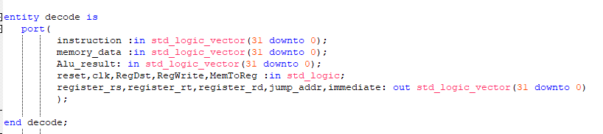

This is the entity of the decode module. This are the Input/output of this unit.

**Task 2:**

**In this task we have to understand the functionality of decode module in the MIPS32 and write the pseudocode of it which will be later converted into the VHDL code.**

**LAB TASKS:**

**Task 1:**

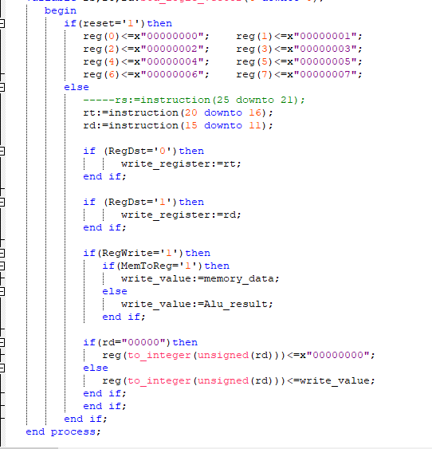

We connected the decode and fetch module and futher in coming labs we will use it.

# CONCLUSION:

In this lab we created the decode module. It deals with the instruction and convert it into the meaningful values which the processor and user can understand. And connected this and previse lab.