**INTRODUCTION:**

The expansion of LCD is Liquid Crystal Display which is used to display the character. The character is represented as the ASCII value (American Standard Code for Information Interchange). To display the character only the ASCII values are sent to LCD. The ASCII is 8bit**.**

**Pre lab:** In pre lab I have constructed a code to use lcd of FPGA.

**Task 1:** Push button was implemented on the lcd, it will show the results when button was pressed.

**Task 2:** Function is created which takes 8 bit hex value and returns 16 bit ASCII characters.

**Task 3:**Memory array is created when the button is pressed it shows 2 instruction on LCD which are stored in memory.

**PRE-LAB TASKS And LAB TASK combined:**

1. VHDL Code

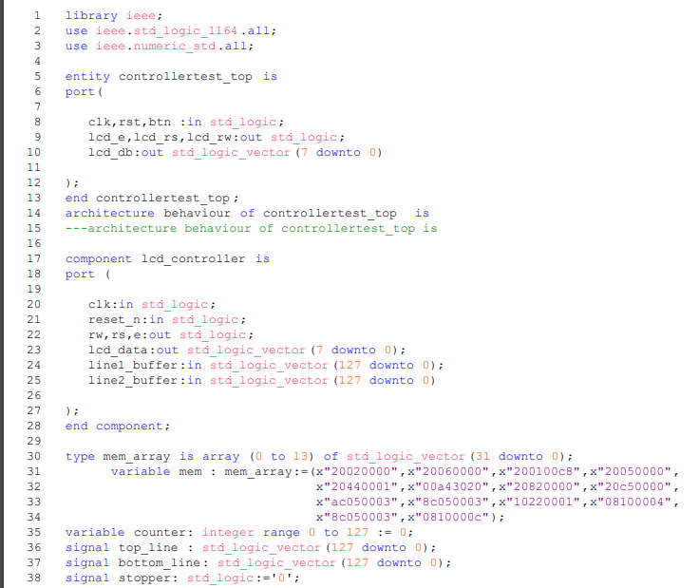

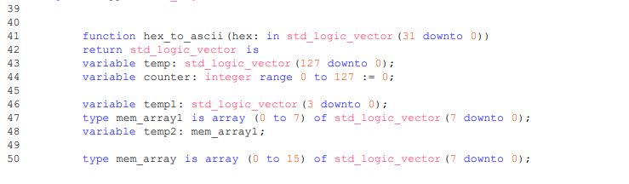

# CONCLUSION:

In this lab I learned how to use lcd display and to to use it as given in tasks.