Table of contents

1. What is spring boot
2. Quick start
3. Spring REST
4. Spring data
5. Spring Web application
6. Spring Boot Others
   1. Interceptors
   2. Security
   3. Actuator
   4. Message produce & Consume
   5. Properties externalization
   6. Spring profiles & environment
   7. Spring boot command line tools
   8. Exception handling
   9. Scheduling and background jobs
   10. Caching
7. References
8. Extra topics (Optional)
   1. Running spring boot application with docker
   2. Introduction to Spring Cloud and micro services

**What is spring boot:**

1. Conversional project creation process and its drawbacks.
   1. Library configurations
   2. Dependency managements
   3. Configuration managements
   4. Architecture/design adoptions
2. Advantages of boot
   1. Spring Vs Spring boot
   2. It creates standalone spring application
   3. It manages the dependency management
   4. It manages auto configuration
   5. Production ready Architecture, metrics, health checks.
   6. Embedded tomcat or jet

**Quick start:** This module is to demonstrate on how to start on spring boot application. Project setup and code walk through, architecture walk through and other important aspects of Spring boot

1. <https://start.spring.io/>

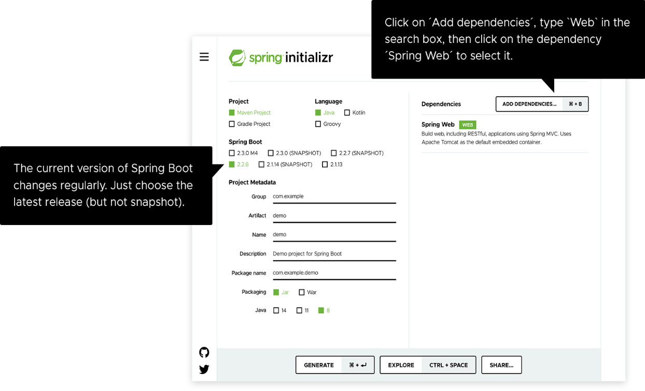

1. Create Hello World Application
2. Application Walk through
   1. @SpringBootApplication: triggers auto-configuration and component scanning. It is equal to @Configuration, @EnableAutoConfiguration and @ComponentScan annotations
   2. Explore pom.xml on starter dependencies
   3. Explore project libraries to demonstrate how spring boot manages the dependency libraries
3. Using Application. Properties
4. Using Application. yaml

**Spring REST:** This module to explore the REST API development using spring boot

1. Add Web Starter dependency
2. @RestController
3. Create web service using spring boot

**Spring Data:** This module to explore the data connectivity with spring boot.

1. Add JPA data dependency to pom.xml
2. Add h2 in Memory DB dependency to pom.xml
3. H2 DB Console demonstration
4. Create an app with Curd operations
5. Connect to mySQL

**Spring Web Application:** This module to explore the web application creation using the spring boot

1. Add thyme leaf template dependency
2. Create a web application using template and connecting to DB