Financial Performance Analysis
Executive Summary · Jan 2022 – Dec 2023 · 10,400 Transactions · 5 Linked Datasets
Two years of financial transactions, budget, headcount, customer, and vendor data were validated (Excel), loaded into a relational schema (MySQL), and analyzed (Python: pandas, SciPy) to assess whether revenue and cost are on track, where budgets are slipping, and who the most valuable customers and costliest vendors are. Findings below feed the accompanying Power BI dashboard and slide deck.

Key Financial KPIs
Total Revenue  ₹864.6M | Total Expense  ₹167.7M | Net Profit  ₹696.9M | Gross Margin  80.6%

Budget Variance
- Revenue exceeded budget by +536.6% (₹728.8M above target) — consistent across all three business units (Retail +551.7%, Enterprise +529.9%, Online +529.0%).  - Expense exceeded budget by +60.9% — real cost growth, but far more modest than revenue growth.  - Reading: budgets were set conservatively relative to what the business actually delivered. This is a planning-process finding, not a performance problem. | 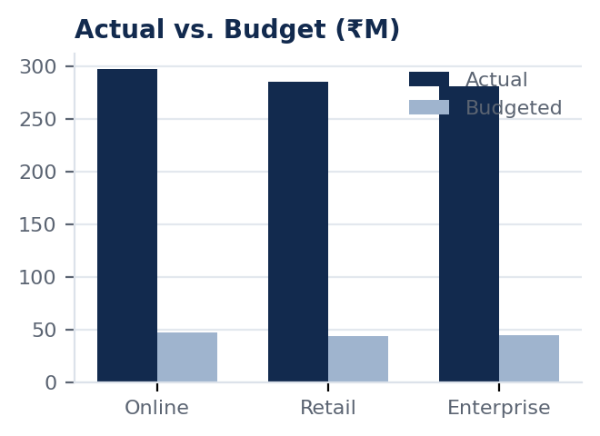

Statistical Testing
Three business hypotheses were tested at the 95% confidence level (α = 0.05). None reached significance — performance is genuinely consistent, not driven by a single unit, region, or segment:
Test | Hypothesis | Result
ANOVA | Expense differs across business units | F = 0.235, p = 0.791 — not significant
t-test | Revenue differs between regions (East vs. West) | t = 0.746, p = 0.456 — not significant
Chi-square | Customer segment is associated with purchase category | χ² = 2.206, df = 4, p = 0.698 — not significant

Revenue & Expense Trend
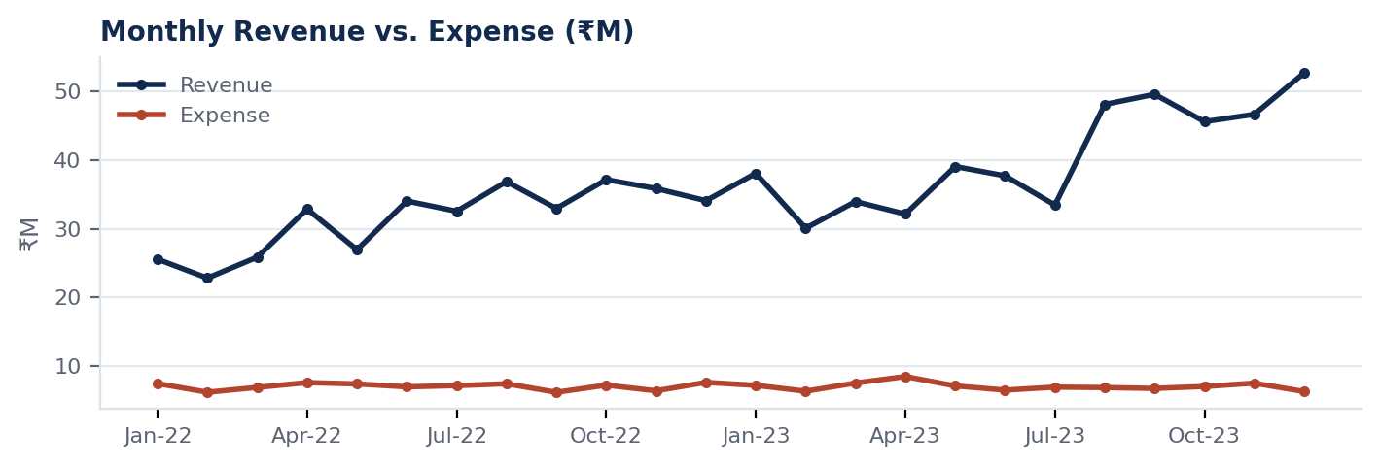
Revenue is noisy month to month — normal for transaction-level data — but trends upward overall with a step-up from mid-2023. Expense stays flat and low by comparison, consistent with an 80.6% gross margin held every month, not just at the yearly total.

Customer, Vendor & Headcount
- Customer base is low-risk: the top 10 customers = 4.44% of total revenue across 400 active accounts. The single largest customer (Gonzalez, Barton and Robles) is only ₹4.2M — under 0.5% of revenue.
- Vendor spend is more concentrated: the top 10 vendors = 15.23% of total expense across 120 active vendors, ~3.4× more concentrated than the customer side. The largest single vendor (Crawford, Solis and Jackson) is ₹2.8M.
- 186 active employees, ₹207.1M total annual cost, ₹1.11M average cost per employee. Enterprise's slightly thinner gross margin (79.7% vs. 80.6–81.4% elsewhere) is not statistically significant per the ANOVA result above.

Recommendations
- Rebuild the budgeting baseline using 2022–2023 actuals, not the original conservative targets, as the starting point for next year's budget.
- Maintain the current operating structure — hypothesis testing found no statistically significant variance by unit, region, or segment, so no structural reallocation is currently justified.
- Reduce vendor concentration risk by diversifying or renegotiating terms with the top 10 vendors representing 15.23% of spend.
- Formalize the data-validation process — turn the PK/FK, category, and range checks used here into a recurring monthly routine.

Future Scope
Predictive forecasting (regression/time-series) as more periods accumulate; a live Power BI refresh directly against MySQL instead of static CSVs; interaction-effect testing (region × business unit); automated anomaly alerts on outlier transactions; and entity-level profitability beyond aggregate top-10 concentration.

