**Project – 3**

**Name – Gopal Gupta Roll number – 20CH30008**

**Question 1:**

**Ans:** From the figure – 1 we can say that the stimulus is not totally Gaussian in nature because it does contain some necessary data that triggers spike. The autocorrelation function of the stimulus R(τ) for τ = -50 to +50 ms in steps of 1 ms gives it’s peak at 0 lags. Its peak is at variance of the stimulus.

**Question 2:**

**Ans:** Obtain the PSTHs of the neurons (in spikes/sec) in response to the stimulus and plot them which can be seen in the figure – 2. We average out the spikes of 1000 ms in a second and plotted it for all the four neurons.

**Question 3:**

**Ans:** From a scatter plot of mean and variance (obtained from 50 repeats) we can be seen in figure 3-8. From the figures we see that:

For 10 ms – All neuron shows Poisson nature of the spiking (figure - 3); For 20 ms – All neuron shows Poisson nature of the spiking (figure - 4);

For 50 ms – Neuron 2 and 3 shows Poisson nature of the spiking (figure - 5);

For 100 ms – Neuron 2 shows Poisson nature of the spiking (figure - 6);

For 200 ms – No Neuron shows Poisson nature of the spiking (figure - 7);

For 500 ms – No Neuron shows Poisson nature of the spiking (figure - 8);

**Question 4:**

**Ans:** From the figure – 9 we see that for neuron 1 and 4 does show any significant result but the for neuron 2 and 3, the filter work as high pass filter. Since the Stimulus is non gaussian in nature so we need the correction factor. After correction factor without the use of the non-linearity we get filter as shown in the figure – 10.

**Question 5:**

**Ans:** If we use the filter to estimate the firing without the use of the non-linearity and if we plot the estimated and actual firing rate only 15 sec of trained data on the scatter plot, we see that since the data points are very large so it shows skewed result but other approach is making a mean plot for λ(t) for binned y(t) values which can be seen in the figure – 11, we can estimate the non-linear function. Using Create Fit we can estimate the non-linear function which is sigmoidal in nature. As we can see in the figure – 12, for the neuron 1 and 4 data points are random and doesn’t follow any pattern but for the neuron 2 and 3 we see a sigmoidal non-linear function.

**Question 6:**

**Ans:** When you use the over fitted model to predict data that has not been used in fitting an over fitted model fails which can be seen in the figure -13. The calculated r^2 values for the Neuron 1 and 4 are very low so we can ignore them and pruned the filter of the neuron 2 and 3 such that we see significant decrease in the prediction performance. The plot of the prediction performance and number of times filter is changed can be seen in the figure – 14 and figure – 15 of neuron 2 and 3 respectively. The pruned filter is plotted and can be seen in the figure – 16. The magnitude Fourier transform of the filter corresponds the filter work as High pass filter passing the high frequency only and can be seen in the figure 17. The predicted vs Actual is plotted after pruning of the filter which can be seen in figure – 18.

**Question 7:**

**Ans:** A plot of the mean MI(q) from the 100 cases with 90% confidence intervals can be seen in the figure – 19. We get the peak at q = 10 or 1/q = 0.1 for all the Neuron. If we choose the STA of 100 ms long then the mutual information is maximum.

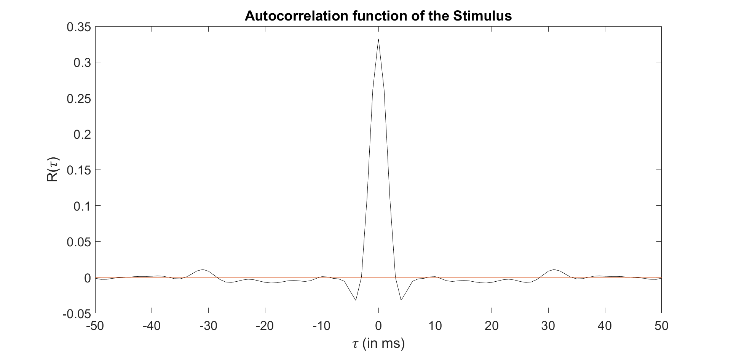

**Figure – 1 Autocorrelation Function of Stimulus**

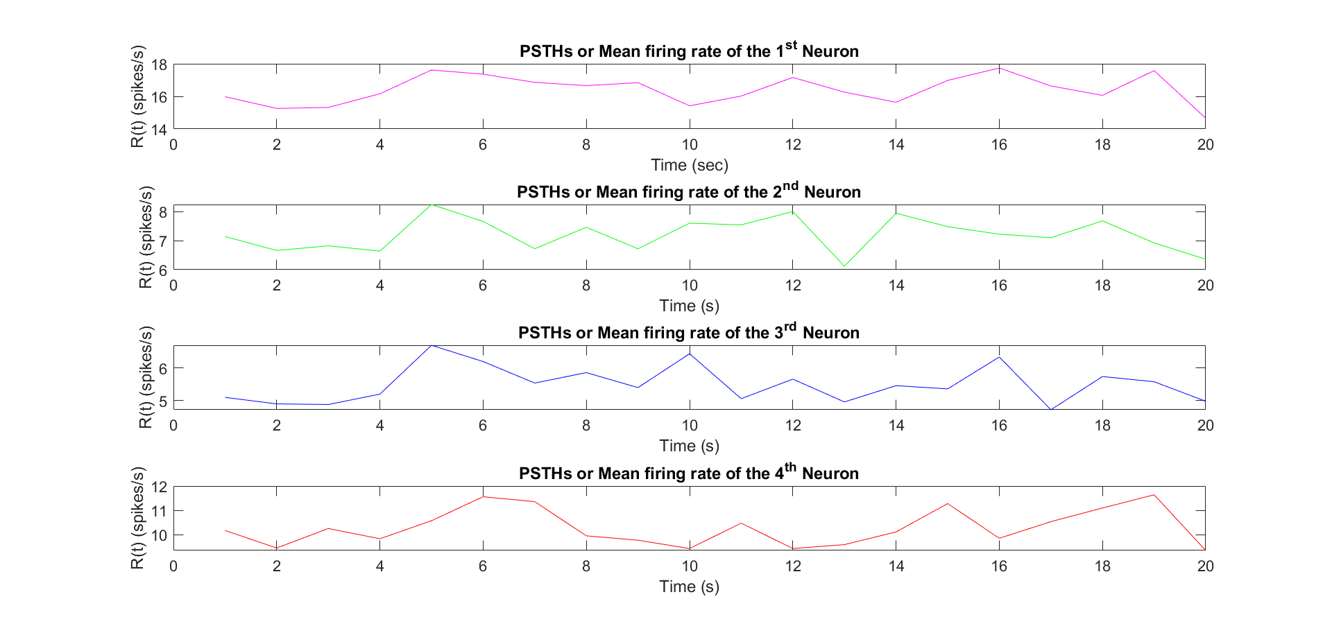

**Figure – 2 PSTH or Mean Firing rate**

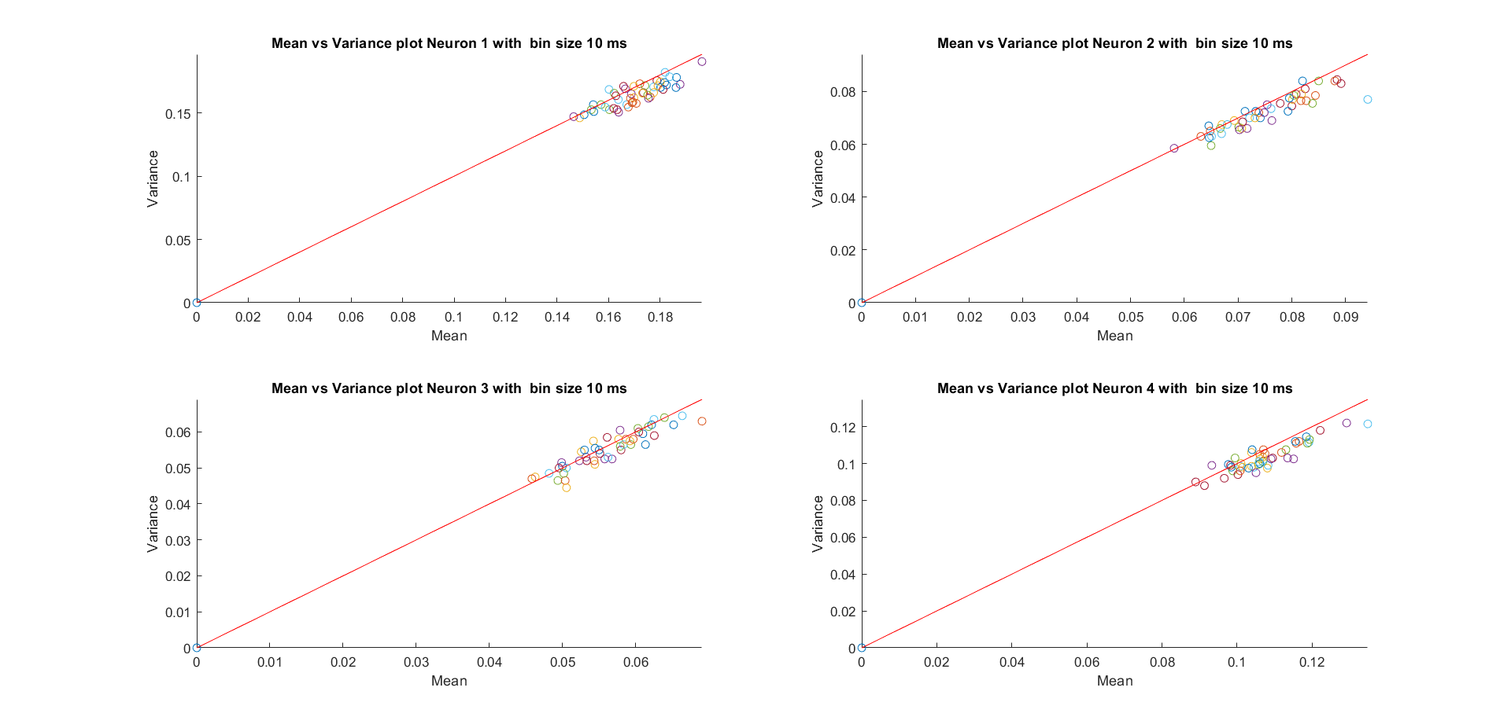

**Figure – 3 Mean vs Variance plot for 10 ms Bin**

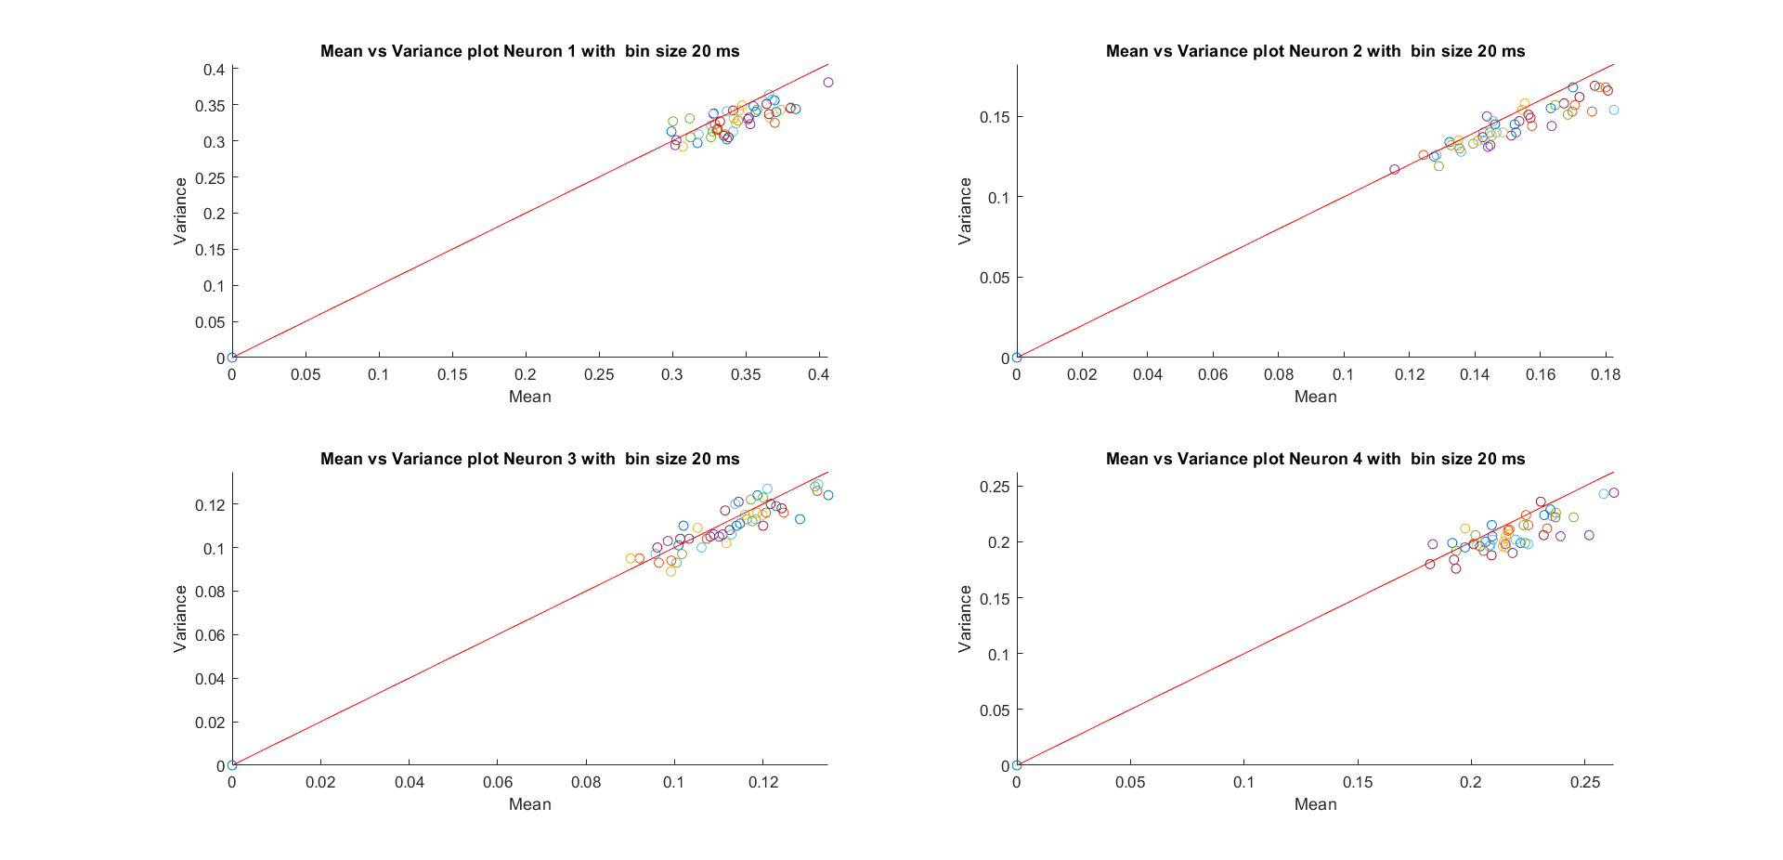

**Figure – 4 Mean vs Variance plot for 20 ms Bin**

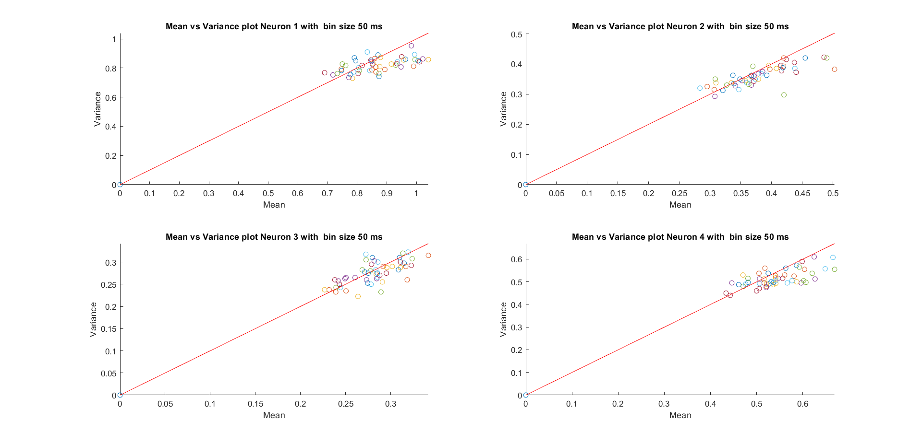

**Figure – 5 Mean vs Variance plot for 50 ms Bin**

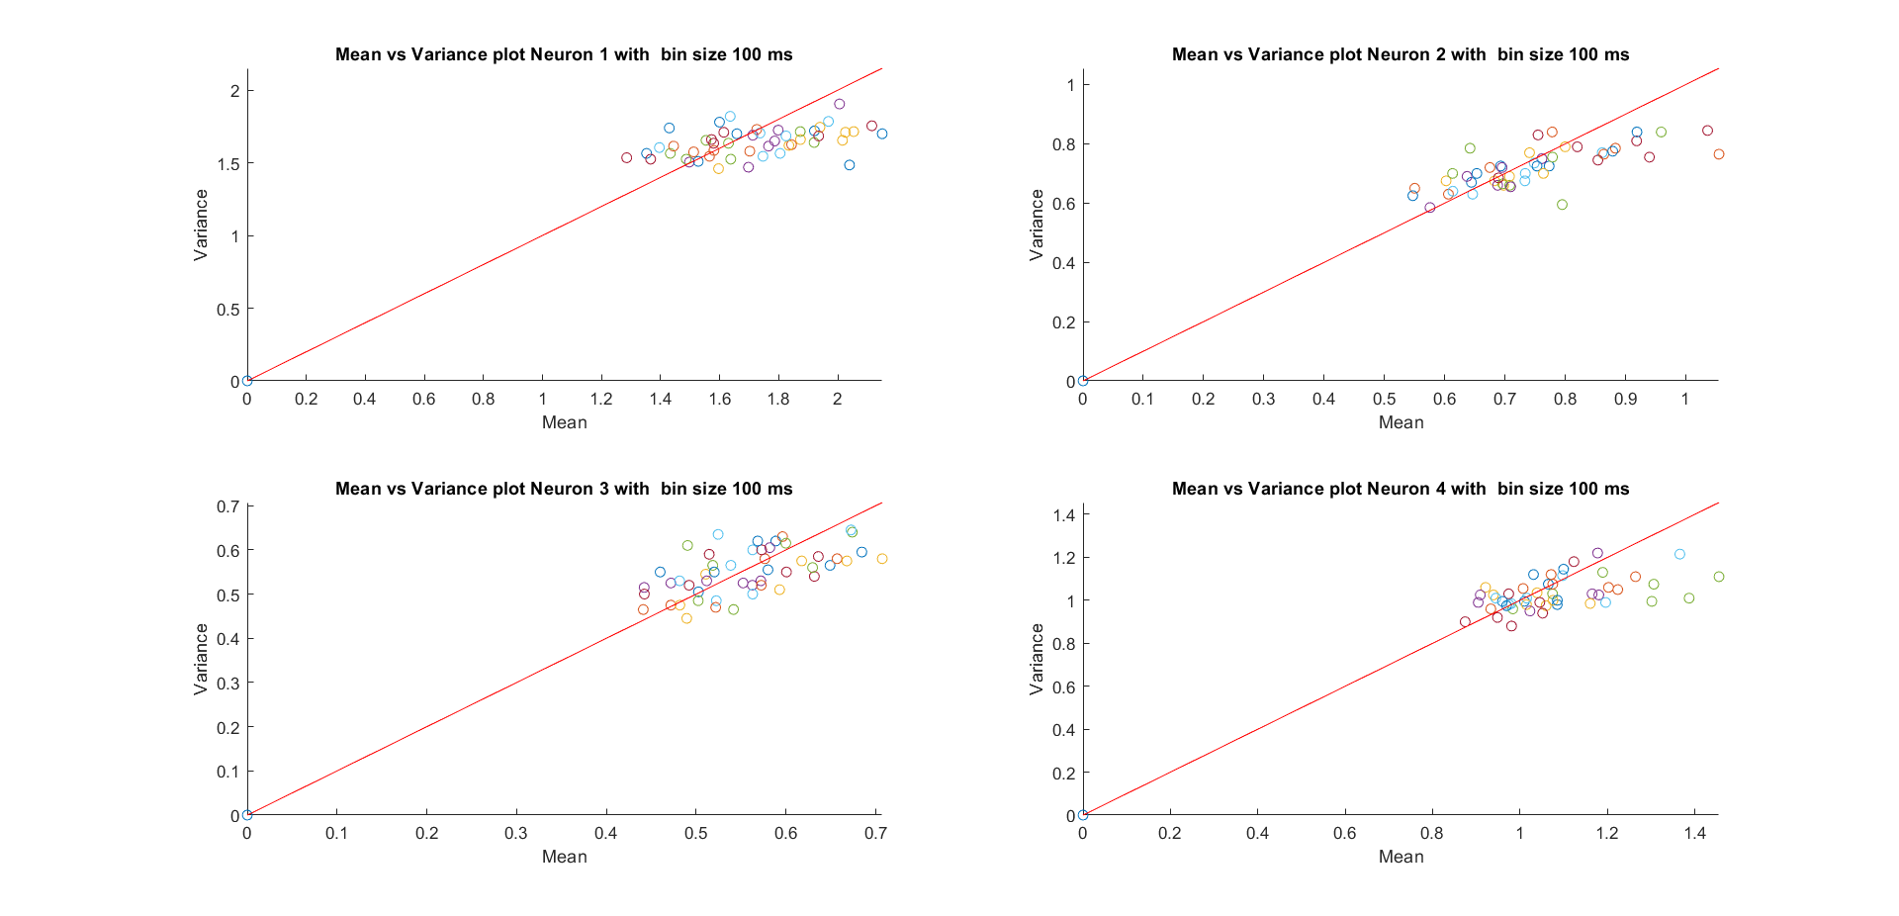

**Figure – 6 Mean vs Variance plot for 100 ms Bin**

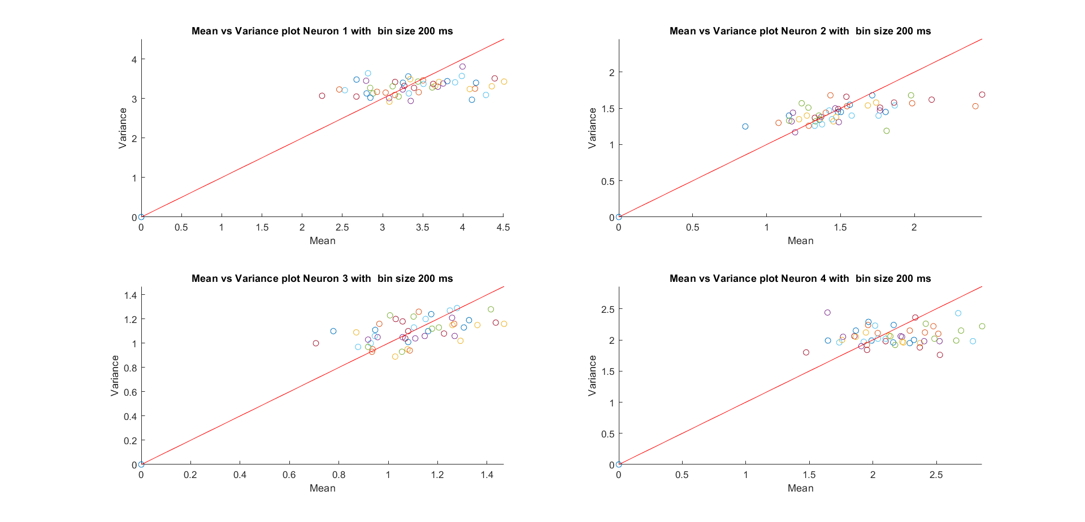

**Figure – 7 Mean vs Variance plot for 200 ms Bin**

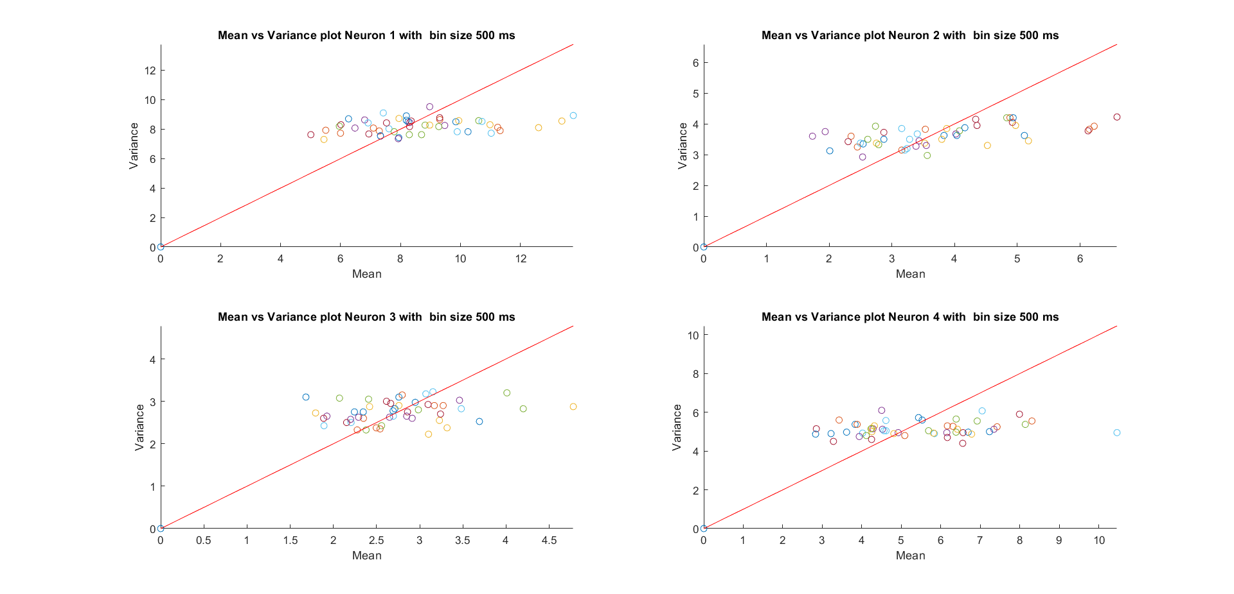

**Figure – 8 Mean vs Variance plot for 500 ms Bin**

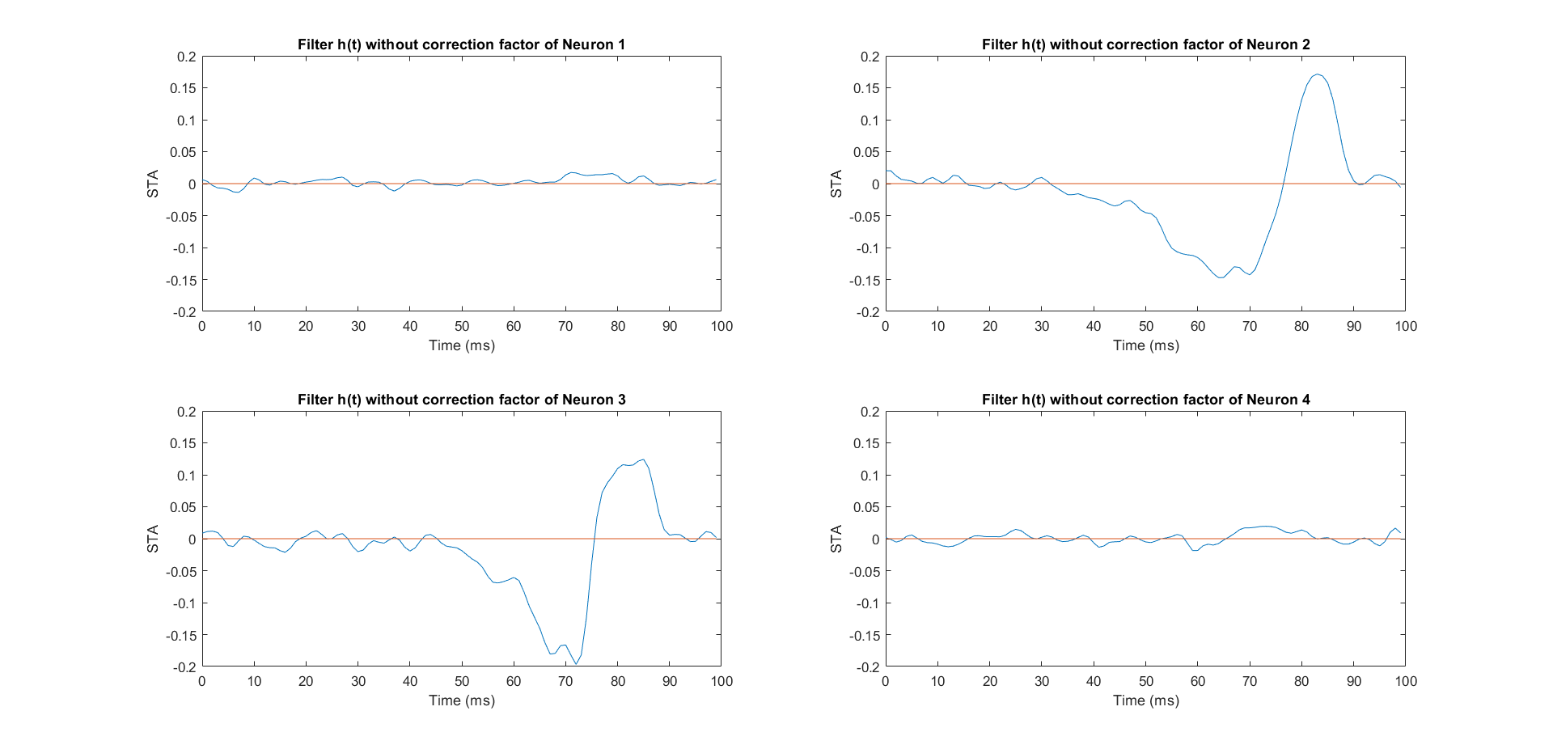

**Figure – 9 Filter (STA) without correction Factor**

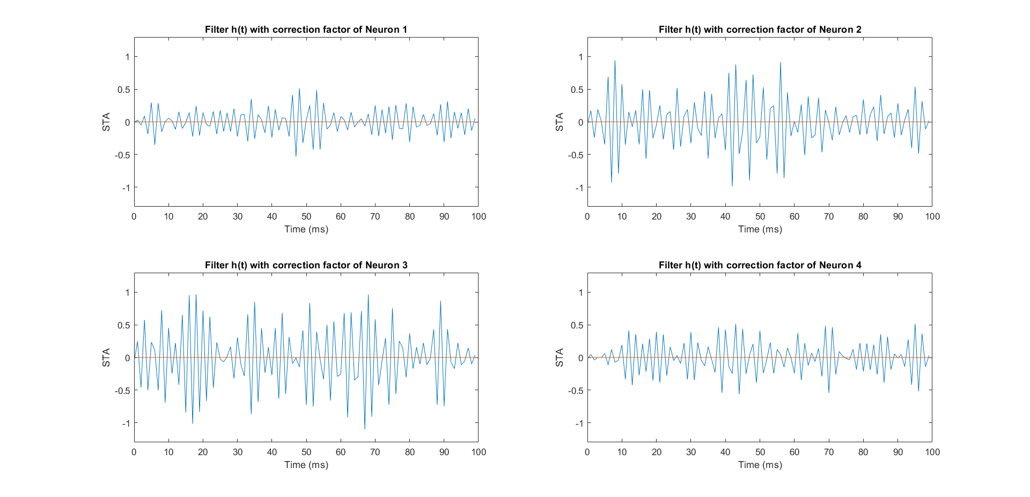

**Figure – 10 Filter with correction Factor**

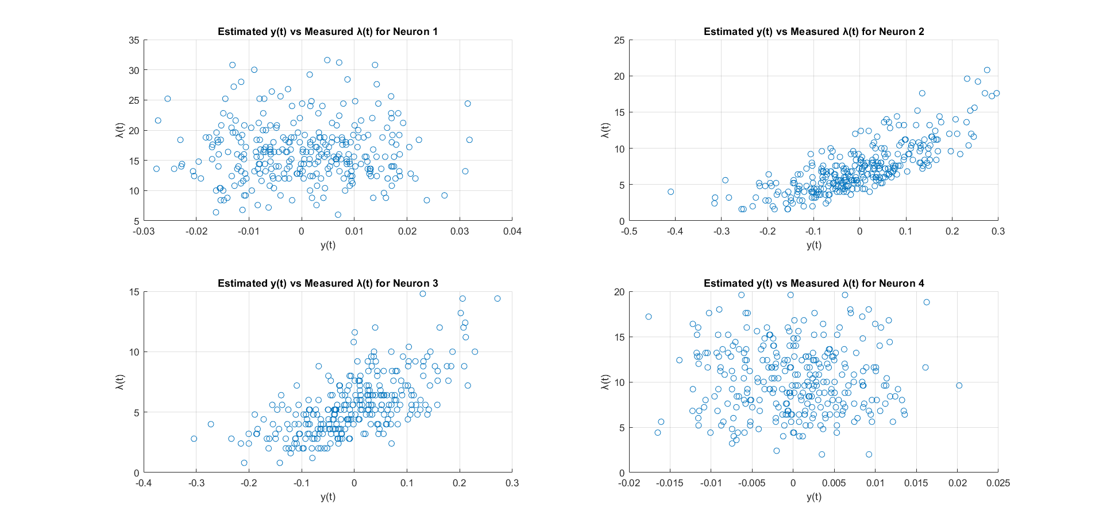

**Figure – 11 Estimated y(t) vs Measured λ(t)**

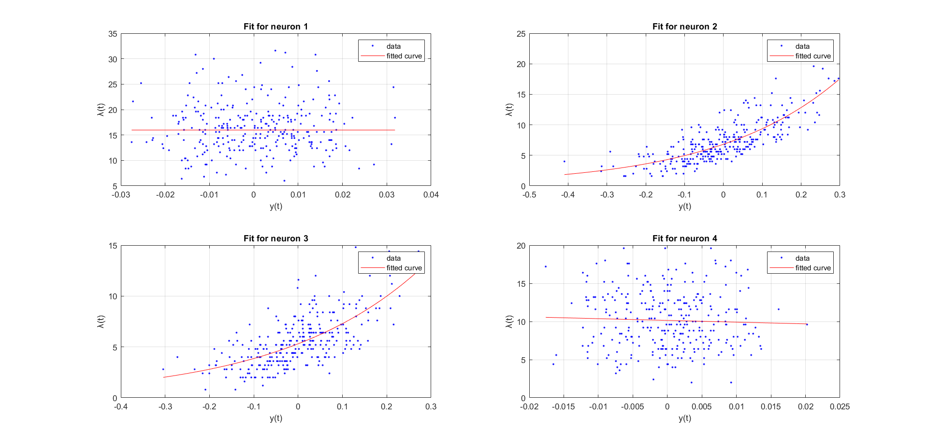

**Figure – 12 Fit of the Non-linear function**

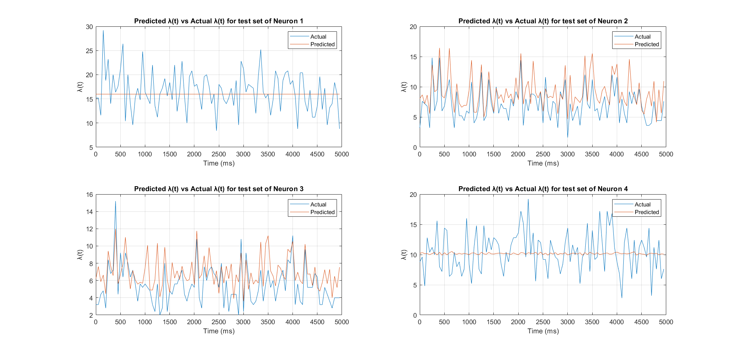

**Figure – 13 Predicted λ(t) vs Actual λ(t) before Pruning**

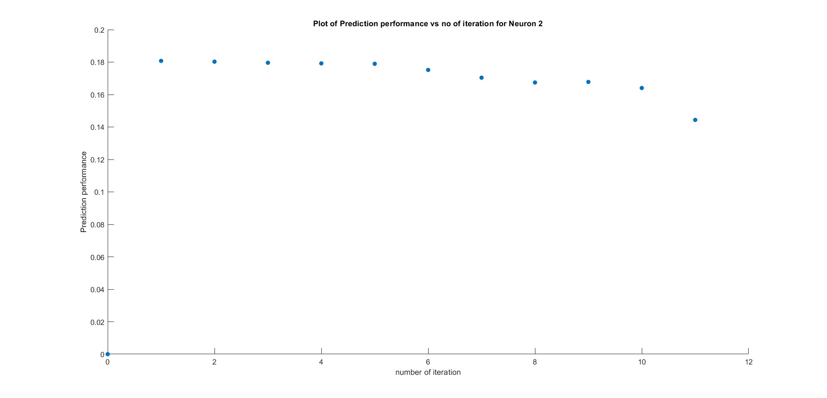

**Figure – 14 Prediction performance vs Parameter Number for Neuron 2**

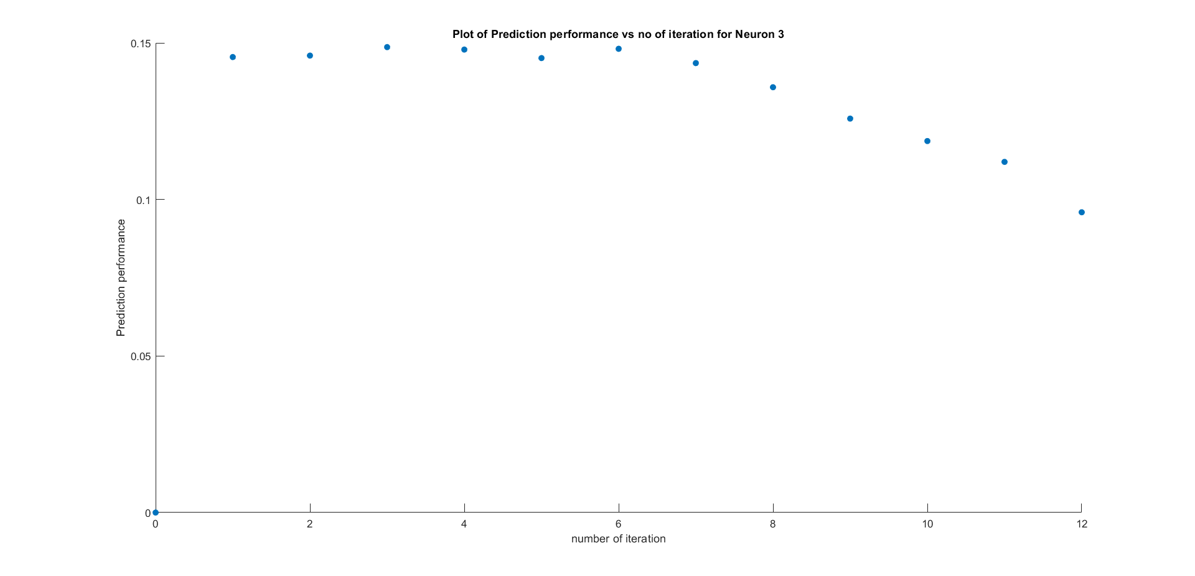

**Figure – 15 Prediction performance vs Parameter Number for Neuron 3**

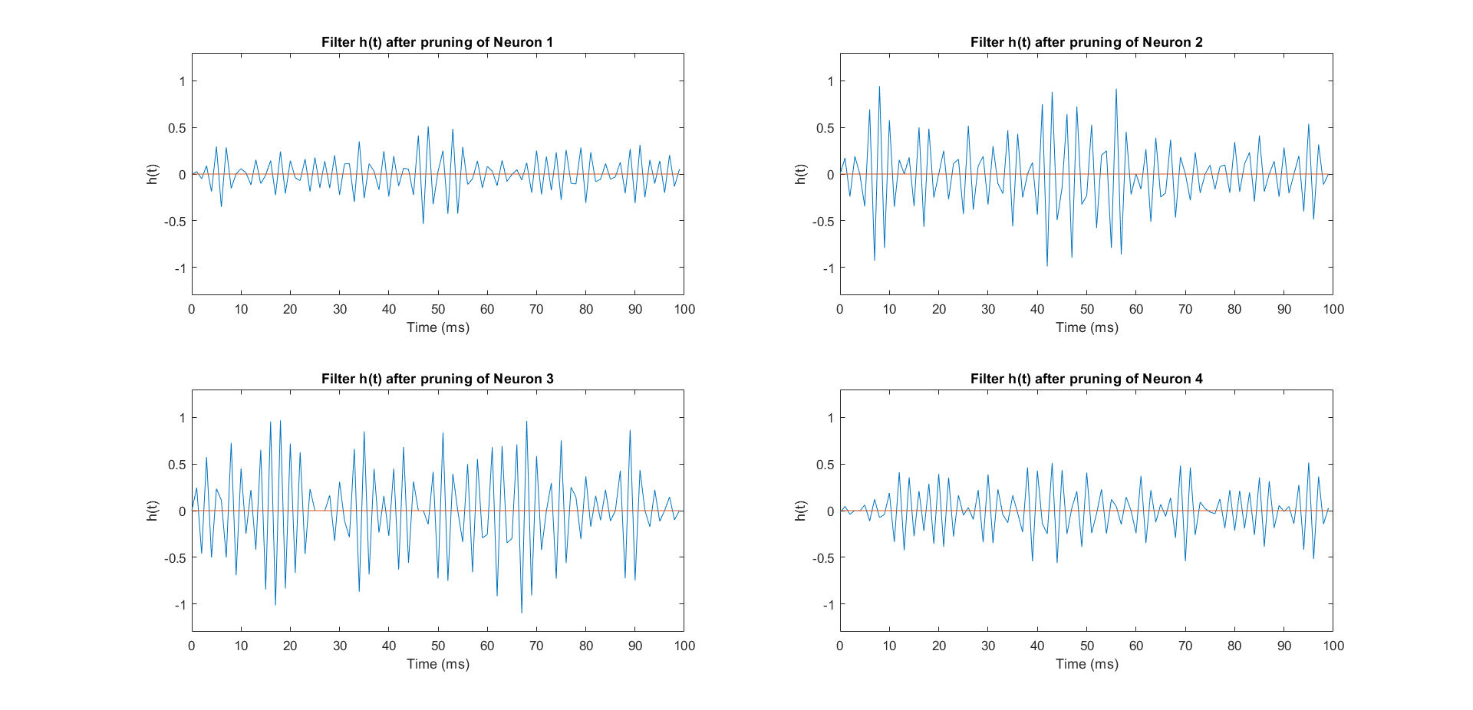

**Figure – 16 Filter after Pruning**

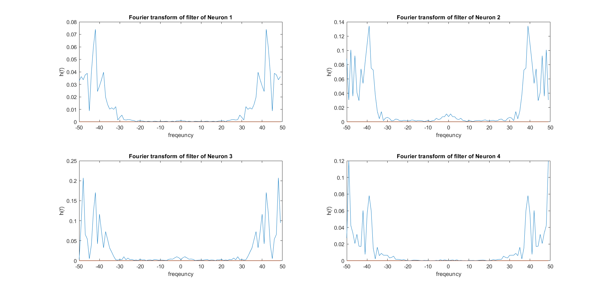

**Figure – 17 Fourier Transform of the filter**

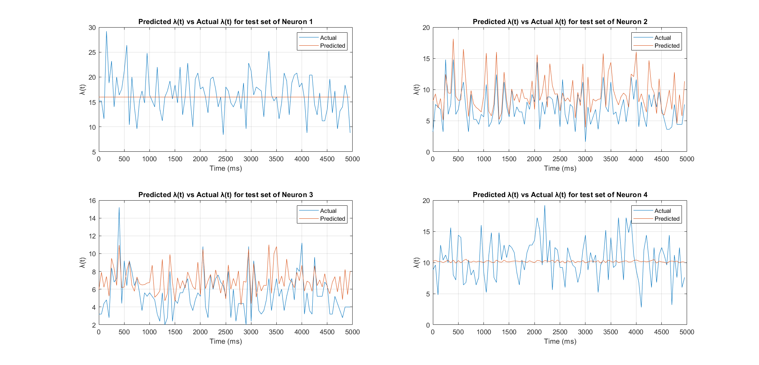

**Figure – 18 Predicted λ(t) vs Actual λ(t) after Pruning**

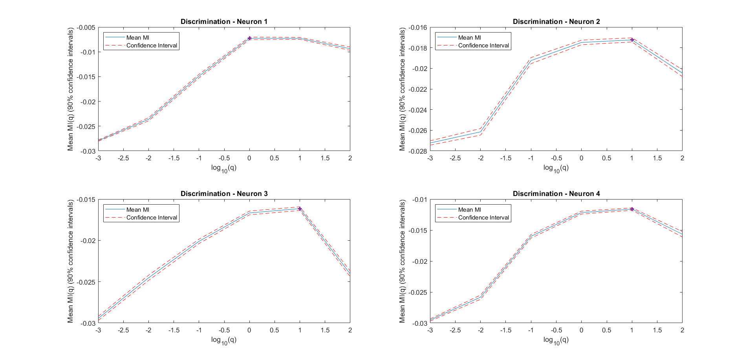

**Figure – 19 Mean MI(q) vs log_10(q)**