🎮 Tutorial Documentation: Teaching Behavior Tree AI in Unreal Engine
By: Gopal Anil Pillai

TABLE OF CONTENTS
- Introduction
- Theoretical Foundations
  - 2.1 What Is Game AI?
  - 2.2 Behavior Trees (BTs)
  - 2.3 Blackboard Memory System
  - 2.4 AI Controllers
  - 2.5 Navigation (NavMesh)
- System Architecture Overview
- Step-By-Step Implementation Guide
  - 4.1 Setting Up the Blackboard
  - 4.2 Building the Behavior Tree
  - 4.3 Creating the AI Controller Blueprint
  - 4.4 Connecting Enemy Character to the AI
  - 4.5 Testing & Visualization
- Behavior Tree Execution Flow Diagram
- Blackboard/AIController Communication Diagram
- Teaching Notes & Pedagogical Commentary
- Exercises (With Difficulty Levels)
- Solutions to Exercises
- Debugging Guide
- Extension Ideas for Students
- Conclusion

1. INTRODUCTION
This tutorial teaches one of the most important artificial intelligence techniques in modern game development: Behavior Trees integrated with a Blackboard and an AI Controller, inside Unreal Engine.
This system is used in real professional titles for:
- Enemy chasing logic
- Patrol systems
- Combat decision-making
- NPC interaction
- Boss behavioral phases
The goal of this document is to guide students from theory to implementation, while also explaining why each component exists.
By the end, learners will understand:
✔ How AI stores and retrieves memory
✔ How a Behavior Tree makes decisions
✔ How the AI Controller executes logic
✔ How Unreal’s navigation system moves characters
✔ How to expand the system for combat, patrol, or detection
This document accompanies a step-by-step live teaching video.

2. THEORETICAL FOUNDATIONS
2.1 What Is Game AI?
Game AI is not “true” artificial intelligence.
Instead, it is structured decision-making designed to simulate intelligent behavior.
Typical needs include:
- Knowing where the player is
- Knowing when to chase
- Choosing between multiple actions
- Remembering previous states
- Transitioning between logical branches
Behavior Trees provide a clean, modular framework for this.

2.2 What Are Behavior Trees?
A Behavior Tree (BT) is a hierarchical, node-based system for AI decision-making.
It consists of:
● Root Node
The starting point.
● Composites (Selector, Sequence)
- Selector: Choose the first valid branch.
- Sequence: Execute all children in order; stop if one fails.
● Tasks
Actions the AI performs (Move To, Attack, Wait, etc.)
● Decorators
Conditions that control when a branch is allowed to run
(e.g., “CanSeePlayer == true”).
● Services (optional)
Checks run periodically (e.g., perception updates).
⭐ WHY BEHAVIOR TREES ARE GREAT FOR TEACHING
BTs clearly illustrate:
- Flow of decision-making
- Reactive AI behavior
- Modular logic
- Clean separation of actions and conditions

2.3 What Is the Blackboard?
A Blackboard is the AI’s memory system.
It stores:
- Object references (PlayerActor)
- Vectors (LastKnownLocation)
- Booleans (CanSeePlayer)
- Floats (Health, Range thresholds)
Behavior Trees constantly read and write to the Blackboard.
In this project we use:
● PlayerActor
Stores the player pawn so AI can chase.
● CanSeePlayer (optional)
Boolean that decorators can check to change behavior.

2.4 What Is the AI Controller?
AI Controllers are specialized controllers that:
✔ Possess AI characters
✔ Run Behavior Trees
✔ Initialize the Blackboard
✔ Set Blackboard values programmatically
In this project, the AI Controller:
- Starts the Blackboard
- Starts the Behavior Tree
- Sets the PlayerActor key at BeginPlay
This gives the BT the data it needs to start decision-making.

2.5 Navigation Mesh (NavMesh)
NavMesh determines where the AI can walk.
You visualize it by pressing P.
AI movement nodes like “Move To” only work on the NavMesh.

3. SYSTEM ARCHITECTURE OVERVIEW
Here’s how the three major systems communicate:
Player Character
↓
AI Controller (code)
↓ (writes)
Blackboard (memory)
↓ (reads)
Behavior Tree (logic)
↓ (sends commands)
Enemy Character (movement)
This clear separation makes debugging and teaching much easier.

4. STEP-BY-STEP IMPLEMENTATION GUIDE
This is the core practical tutorial.

4.1 Create the Blackboard
- Right-click → Artificial Intelligence → Blackboard
- Name it BB_Enemy
- Add a new key:
Name | Type | Purpose
PlayerActor | Object | Stores the player to chase
(Optional) Add Boolean key:
Name | Type | Purpose
CanSeePlayer | Bool | Future perception logic
Save.

4.2 Create the Behavior Tree
- Right-click → Artificial Intelligence → Behavior Tree
- Name it BT_Enemy
- Assign its Blackboard to BB_Enemy
Build the structure:
Root
└── Selector
└── Sequence: Chase Player
├── (Optional decorator) CanSeePlayer == true
└── MoveTo: PlayerActor
This is the simplest functional BT for chasing behavior.

4.3 Create the AI Controller Blueprint
- Right-click → Blueprint Class → AIController
- Name: BP_EnemyAIController
Open Event Graph:
Pseudocode version:
Event BeginPlay
UseBlackboard(BB_Enemy)
RunBehaviorTree(BT_Enemy)
SetValueAsObject (KeyName: PlayerActor, Value: GetPlayerPawn(0))
This ensures:
- Blackboard memory exists
- Behavior Tree executes
- PlayerActor key is filled automatically

4.4 Connect the Enemy Character to AI
- Open your enemy Character BP
- In Class Defaults:
- AI Controller Class → BP_EnemyAIController
- Auto Possess AI → Placed in World or Spawned
- Make sure your level has a NavMeshBoundsVolume
- Press P → area must turn green

4.5 Testing & Visualization
Behavior Tree Debugger
- Play in editor
- Select the AI character
- Click Behavior Tree
- You can now watch:
- Blackboard values update
- Active nodes light up green
- Movement tasks run live
This is perfect for teaching.

5. BEHAVIOR TREE EXECUTION FLOW DIAGRAM
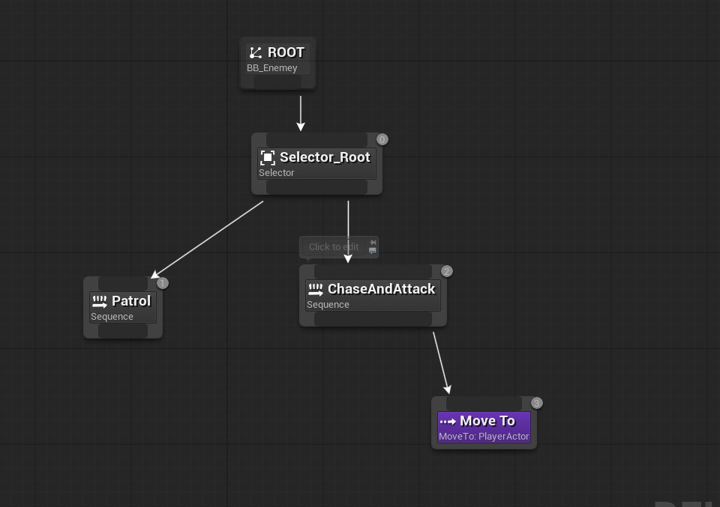

6. BLACKBOARD / AI CONTROLLER COMMUNICATION DIAGRAM
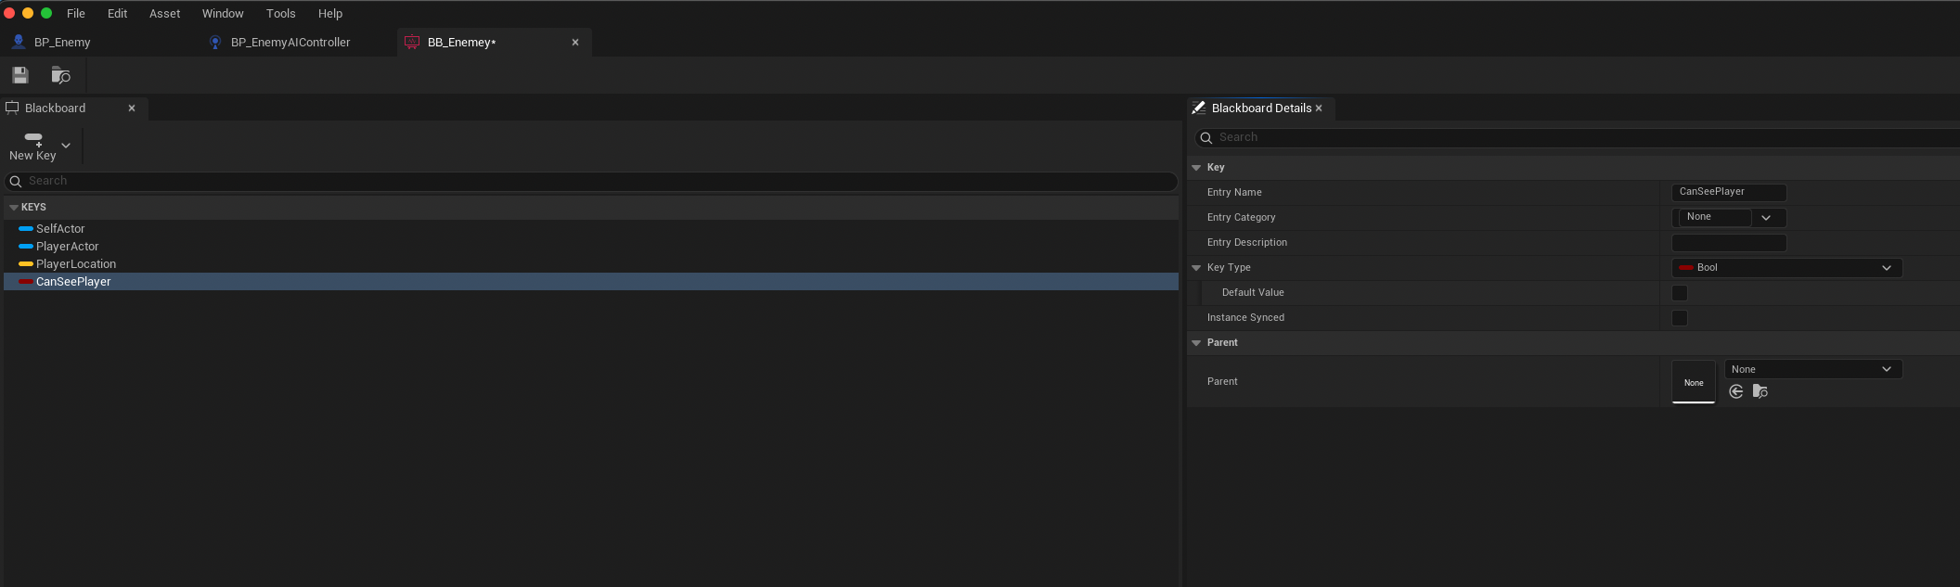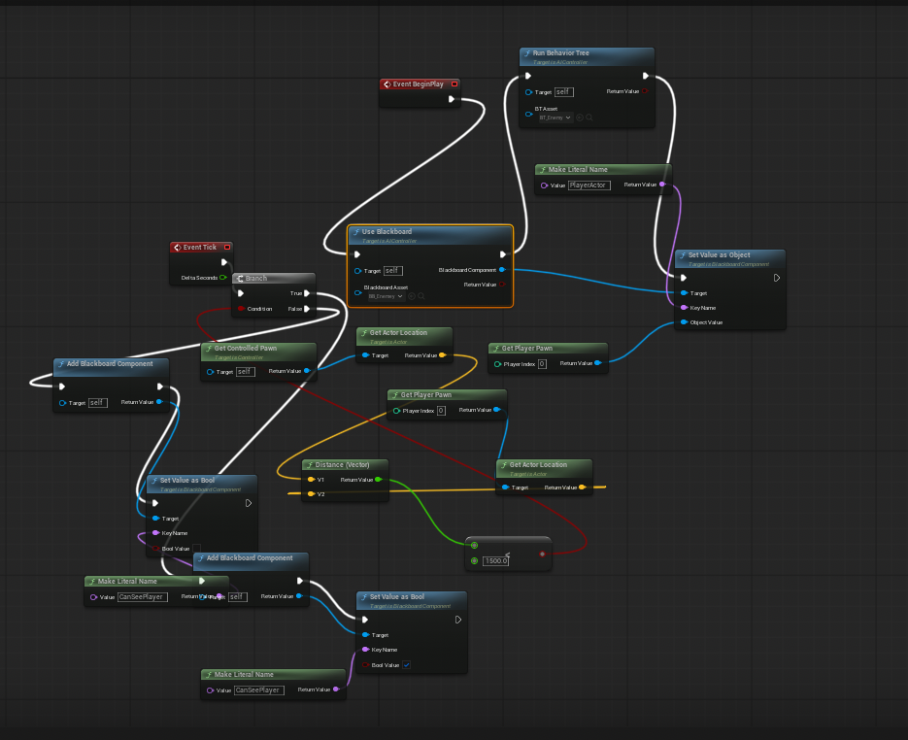

7. TEACHING NOTES & PEDAGOGICAL COMMENTARY
This system is excellent for teaching because:
✔ Clear separation of logic
Students see how:
- Memory is stored
- Decisions are made
- Actions are executed
✔ Visual debugging
BT highlights nodes in green, making flow easy to teach.
✔ Immediate feedback
Changing one key in the Blackboard can change the AI’s behavior.
✔ Scalable
You can add:
- Patrol states
- Combat
- Investigations
- Flee logic
This rewards experimentation.

8. EXERCISES (FOR STUDENTS)
Exercise 1 — Add Patrol Behavior
Difficulty: ★☆☆
Add two Vector keys to the Blackboard: PatrolPoint1 and PatrolPoint2.
Switch between them using a Sequence node.

Exercise 2 — Add “Only Chase If Close Enough”
Difficulty: ★★☆
Add a float key “ChaseRadius”.
Write a simple Blackboard-based decorator to check distance.

Exercise 3 — Add “Return to Patrol” When Player Out of Sight
Difficulty: ★★★
Use a Selector:
Selector
├── Sequence: Chase
└── Sequence: Patrol
Activate Patrol only if the chase sequence fails.

Exercise 4 — Add Attack Range Behavior
Difficulty: ★★★
Use another decorator: Distance < AttackRange.
Replace MoveTo with custom attack logic.

Exercise 5 — Add a Perception-Based “CanSeePlayer”
Difficulty: ★★★★
Use AI Perception → Sight
Set Blackboard key automatically through event callback.

9. SOLUTIONS TO EXERCISES
Exercise 1 Solution Summary
Add MoveTo nodes with PatrolPoint1 and PatrolPoint2.
Use a Sequence + Wait node to alternate.

Exercise 2 Solution Summary
Inside AIController:
GetPlayerPawn → GetDistanceTo(self)
If Distance < ChaseRadius: Set CanSeePlayer = true
Else: Set CanSeePlayer = false
Decorator checks this.

Exercise 3 Solution Summary
Return to patrol when Chase branch fails.
Selector automatically switches.

Exercise 4 Solution Summary
Replace MoveTo with a Blueprint Task:
Play montage
Apply damage
Wait

Exercise 5 Solution Summary
Use AI Perception component:
OnTargetPerceptionUpdated event sets Blackboard keys.

10. DEBUGGING GUIDE
Problem: AI does not move
Checklist:
- Is NavMesh placed?
- Press P → is it green?
- Is AIController assigned?
- Is Behavior Tree running?
- Does PlayerActor exist in Blackboard?
- Does MoveTo have a valid target?

Problem: Behavior Tree runs but MoveTo fails
- Target is off NavMesh
- PlayerActor is not being set
- Wrong key type (must be Object)

Problem: Decorations do not work
- Blackboard key spelling mismatch
- Decorator set to “Observer Aborts: None”
- Boolean not being set in controller

Problem: AI slides instead of walking
- No Animation Blueprint assigned
- CharacterMovement → Orient Rotation to Movement is false

11. EXTENSION IDEAS
- Add a combat branch
- Add search patterns
- Add dynamic difficulty
- Add sound-based detection
- Add team-based communication between AI units
- Add cooldown-based skills

12. CONCLUSION
This tutorial teaches the complete pipeline of AI development in Unreal Engine using Behavior Trees, Blackboards, and AI Controllers.
The system is:
- Modular
- Extensible
- Ideal for both beginners and professionals
- Used in real games
- Perfect for classroom demonstrations
With this foundation, students can expand into advanced AI such as perception systems, utility AI, state machines, or reinforcement learning.

