Example Outputs

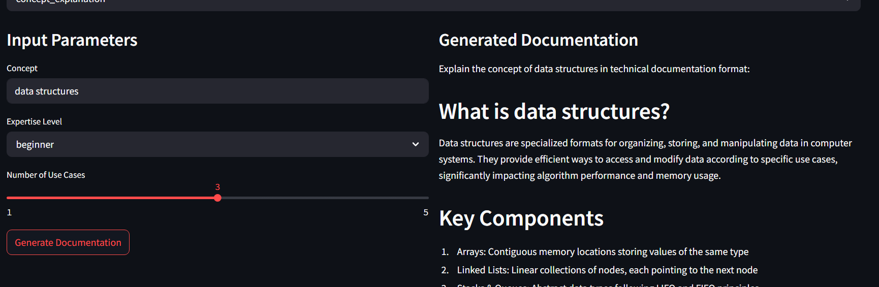  
  
Here I aseked about data structures, it uses the fallback and gives the provided answer, if I ask something different, it gives the following –

  
  
first it analyses, and sends the information to the models

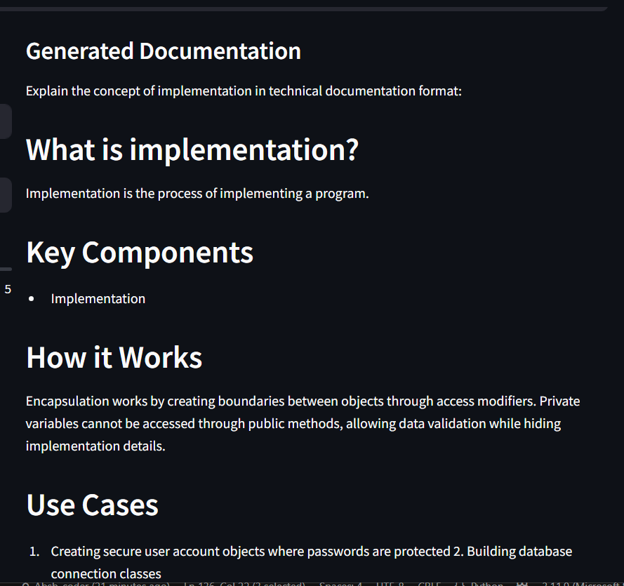

As you can see, it starts out right, but gets buggy and nonsensical answers, this is the limitation of the model used, if we use a bigger database and stronger model, we will get much more accurate answers, but here we can see that it is giving some type of answers because of the fine tuning and prompt engineering code.