|  |  |  |  |  |
| --- | --- | --- | --- | --- |
| **Sr. No** | **Particulars** | **Page No** | **Sign** | **Remark** |
| **1** | **Introduction** |  |  |  |
| **2** | **Objective** |  |  |  |
| **3** | **Existing system limitation** |  |  |  |
| **4** | **Case study** |  |  |  |
| **5** | **Proposed system** |  |  |  |
| **6** | **System requirement**  **\* Hardware**  **\*Software** |  |  |  |
| **7** | **Detailed system analysis**  **\* Data flow diagram**  **\* Modules**  **\* ER-diagram**  **\* Use case diagram**  **\* Schema diagram**  **\*State transaction diagram** |  |  |  |
| **8** | **System design**  **\*Frontend**  **\*Backend** |  |  |  |
| **9** | **Testing and validation checks** |  |  |  |
| **11** | **Future scope** |  |  |  |
| **12** | **Conclusion** |  |  |  |
| **13** | **References** |  |  |  |
|  |  |  |  |  |
|  |  |  |  |  |
|  | |  |

**Introduction:**

“Student Management System” has been developed to override the problems prevailing in the practicing manual system. This software is supported to eliminate and, in some cases, reduce the hardships faced by this existing system. Moreover, this system is designed for the particular need of the institutes to carry out operation in a smooth and effective manner.

The application is reduced as much as possible to avoid errors while entering the data. In an era where education plays a pivotal role in shaping the future, managing student information, academic records, and administrative tasks can become overwhelming and time consuming for educational institutions.

The “Student Management System” steps in, offering a comprehensive and user friendly platform to revolutionize the way educational institutes operate.

**Objective:**

The main objective of the project on “Student Management System“ is to manage the details of student, like name, age, course, personal details, and all student related records etc.

List of the objectives:

1. User friendly system
2. Easy to use
3. Student management system is user to make software fast in processing, it should be used for a long time without error and maintenance.
4. SMS is used to provide synchronized and centralized student database.
5. GUI (Graphical User Interface) is used.
6. Less chances of information leakage, provides security using login and password method
7. Provides immediate storage retrieval of data and information and reduce the paperwork.

**Limitation:**

1. Time consumption in data entry as the records are manually maintained faculties a lot of time
2. Lot of paper work is involved as the records in the files and registers.
3. Storage requires as files and registers are used the storage space requirement is increased.
4. Less reliable use of papers for storing valuable data information is not at all reliable.

**Case Study:**

The success of any organization such as school, college and university on its ability to acquire accurate and timely data about its operation, to manage this data effectively, and to use it to analyze and guide its activities. Integrated student database system offers users (Student, Registrar, HOD) with a unified view of data from multiple sources.

The main objective of this project is to build a rigid and robust integrated database system that will track and store records of students.

The system is developed using technologies such as, HTML CSS JS and MySQL. Python-Flask, HTML and CSS are used to build the user interface and database was build using the MySQL. The system is free of errors and very efficient and less time consuming.

**Proposed System:**

While there has been no consensus on the definition of Student Management in the literature they have proposed that researchers adopt the below definition to allow for the coherent development of theory in the colleges. In order to have a successful student management, we need to make many decisions related to the flow of marks, attendance, and data. Each records should be added in a way to increase the scalability. Student management is more complex in colleges and other universities because of the impact on people’s number requiring adequate and accurate information of students need.

**System Requirement Specification:**

**Hardware requirement:**

Hardware is a term that refers to all the physical parts that make up a computer. The internal hardware devices that make up the computer. Various devices which are essentials to form a hardware is called as components.

* Computer with a 1.1 GHz or faster processor
* Minimum 2GB of RAM or more
* 1366 * 786 or higher-resolution display

**Software requirement:**

Computer software, or simply software, is a collection of data or computer instructions that tell the computer how to work. This is in contrast to physical hardware, from which the is build and actually performs the work

* Frontend – HTML, CSS, JS, Bootstrap
* Backend – Python-Flask,
  + Operation system: Windows-10
  + Google Chrome / Internet Explorer
  + XAMM
  + Python main editor(VS-Code)

**Detailed System Analysis**

1. Data flow diagram:

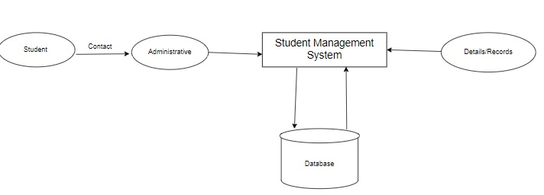

2)Modules used in project:

# This are the all modules requred imported

from flask import Flask,render_template,request,session,redirect,url_for,flash

from flask_sqlalchemy import SQLAlchemy

from flask_login import UserMixin

from werkzeug.security import generate_password_hash,check_password_hash

from flask_login import login_user,logout_user,login_manager,LoginManager

from flask_login import login_required,current_user

import json

3)Entity Relationship diagram:

ER-Diagram for the Student Management System:

N- Number of entity connected to the

M – Many number of entity is connected

1 – Singe number of entity is connected

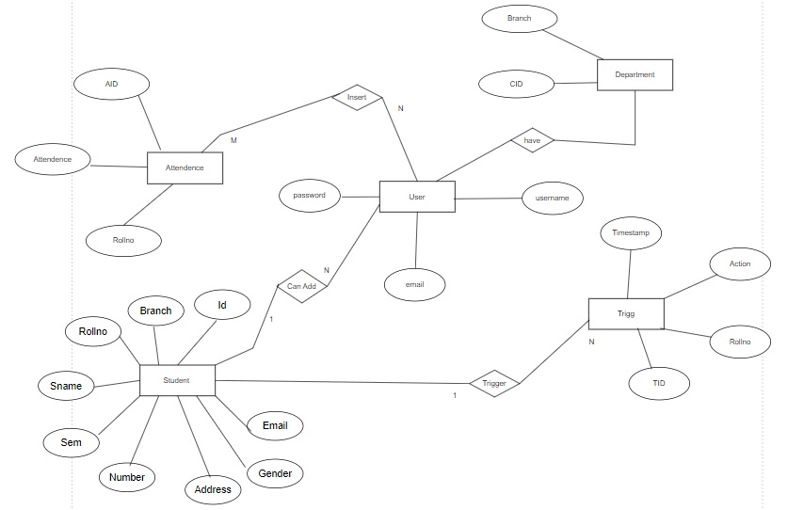

4) Activity diagram:

Activity diagram for the Student Management System

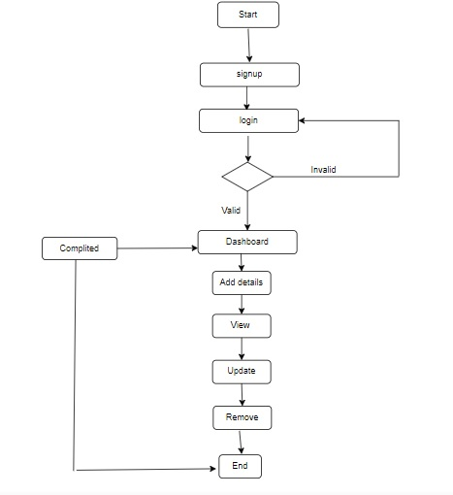

5)Use case diagram:

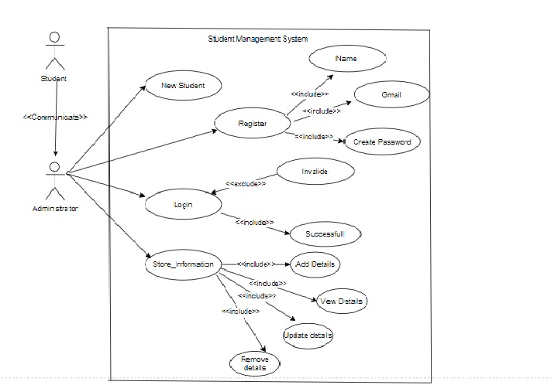

1. Schema diagram:

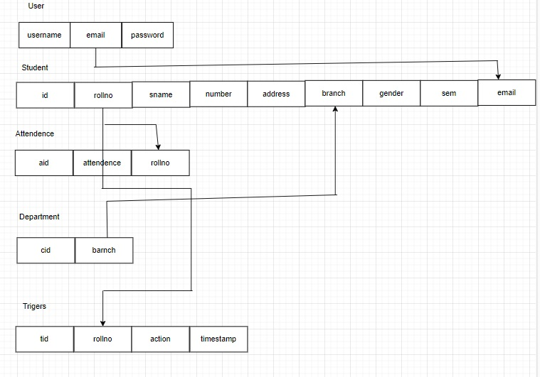

**System Design:**

1)Frontend:

In “Student Management System” frontend is developed with help of the following frameworks and languages,

Frontend- HTML, CSS, Java Script, Bootstrap

1. HTML:

HTML stands for Hyper Test Markup Language. It is a standard mark-up language for web page creation. It allows the creation and structure of selections, paragraphs, and links using HTML element (the building blocks of a web page)

1. CSS:

Cascading Style Sheets(CSS) is a stylesheet language used to describe the presentation of a document written in HTML. CSS describes how elements should be rendered on screen, on paper, in speech or on other media.

1. BOOTSTRAP:

1)Bootstrap is a free, open source front-end development framework for the creation of websites and web apps.

2) Bootstrap is the most popular HTML, CSS and JavaScript framework for developing a responsive and mobile friendly website

**User interface Screenshots:**

**1)**Login page:

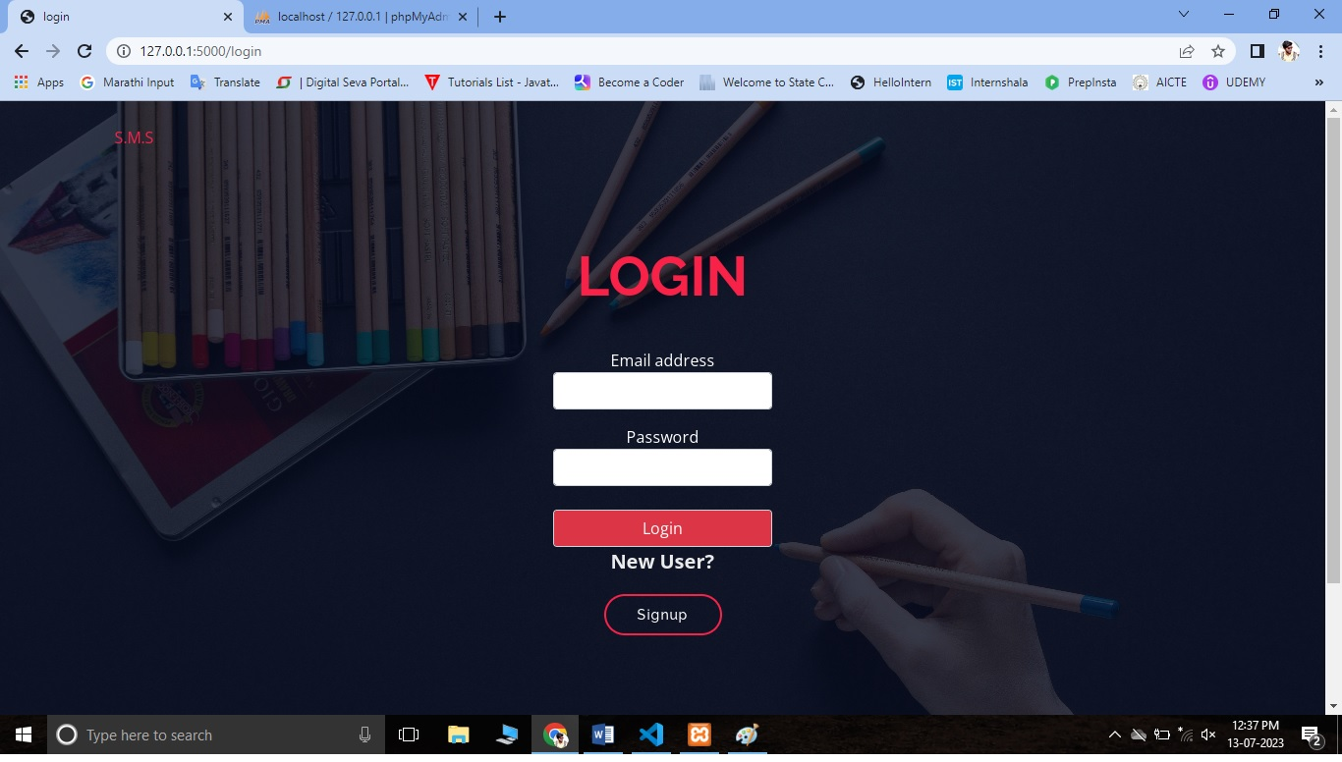

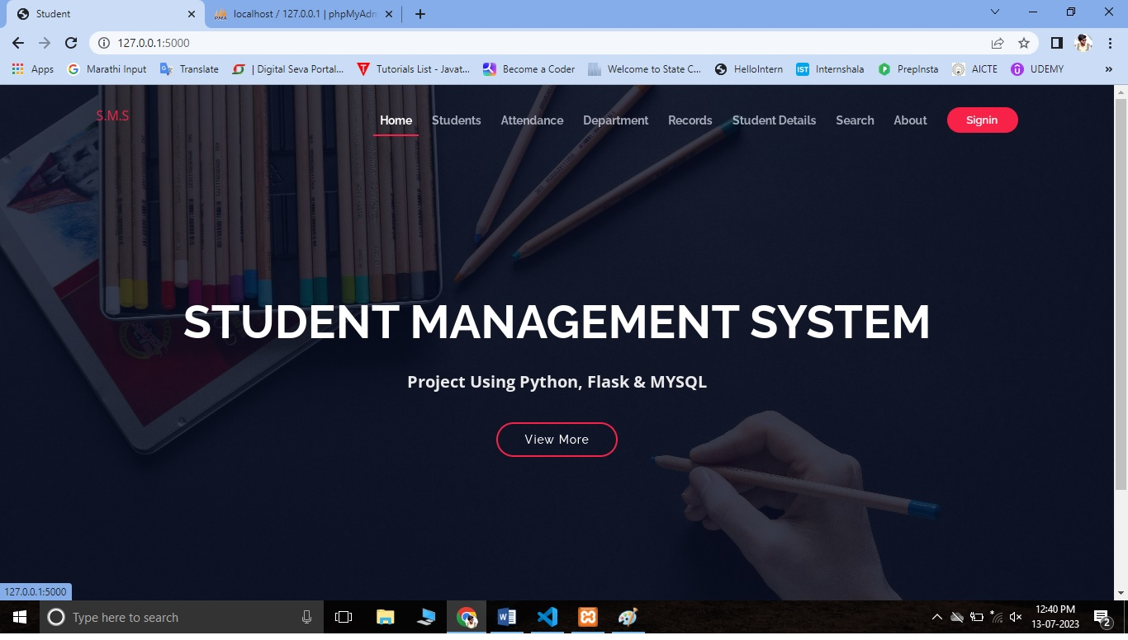

1. **Add student Information:**

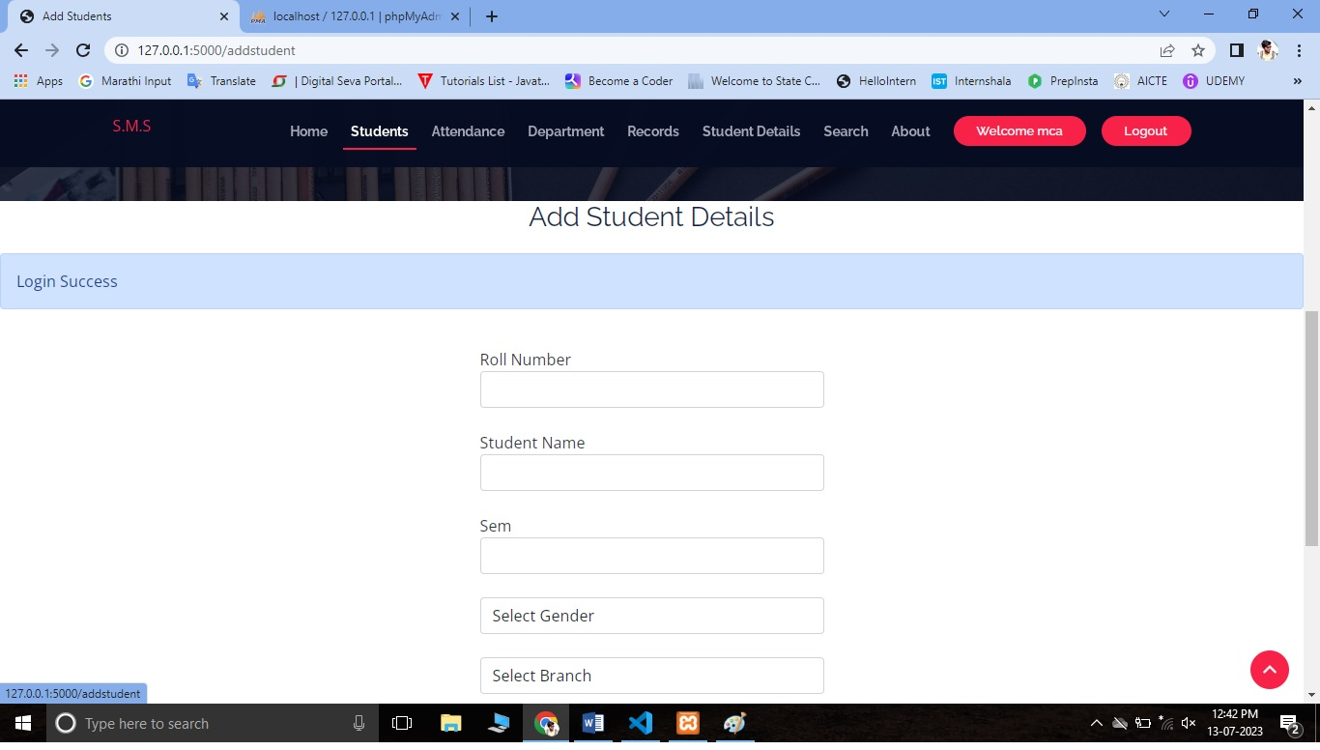

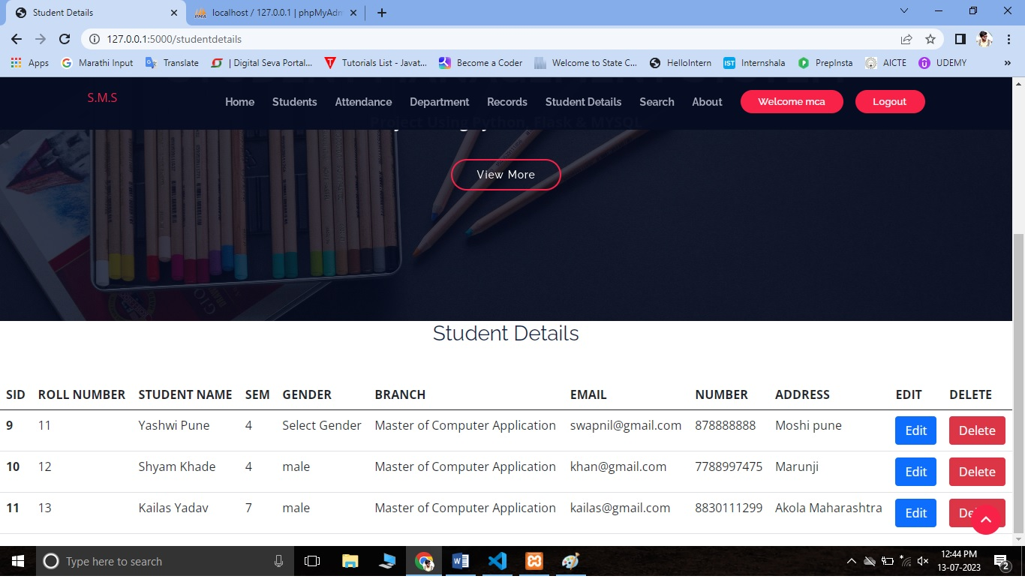

**3)Trigger record:**

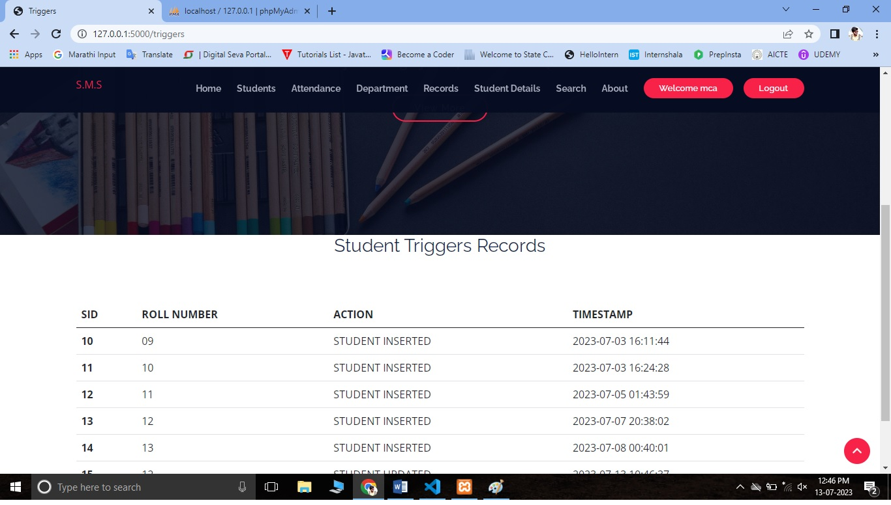

**4)Search student:**

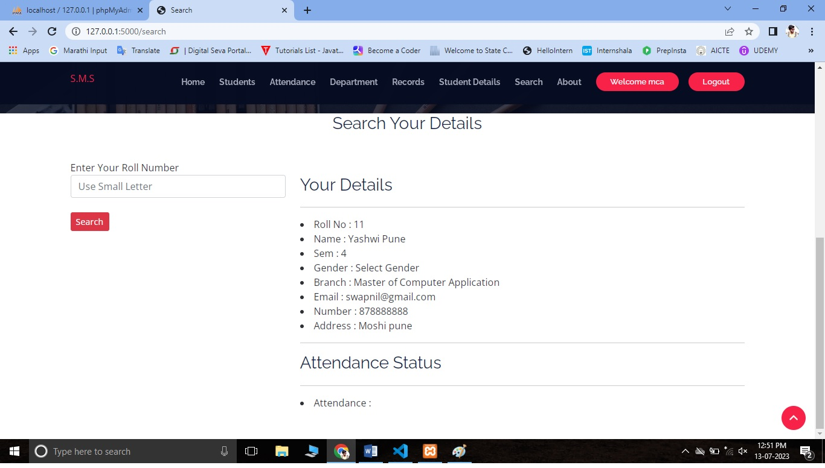

**Backend:**

In “Student Management System” the backend is created using the

Following language and databases.

Backend-Python flask and MySQL

Python flask:

Flask is a web framework, it’s a Python module that lets you develop web applications easily. It’s has a small and easy-to-extend core: it’s a micro framework that doesn’t include an ORM (Object Relational Manager) or such features.

MySQL:

A Database Management System (DBMS) is computer software designed for the purpose of managing databases, a large set of structured data, and run operations on the data requested by numerous users. Typical examples of DBMSs include Oracle, DB2, Microsoft Access, Microsoft SQL Server, Firebird, PostgreSQL, MySQL, SQLite, FileMaker and Sybase Adaptive Server Enterprise. DBMSs are typically used by Database administrators in the creation of Database systems.

SQL:

Structured Query Language (SQL) is the language used to manipulate relational databases. SQL is tied very closely with the relational model.

SQL statements are issued for the purpose of:

Data definition: Defining tables and structures in the database (DDL used to create, alter and drop schema objects such as tables and indexes)

Database dashboard:

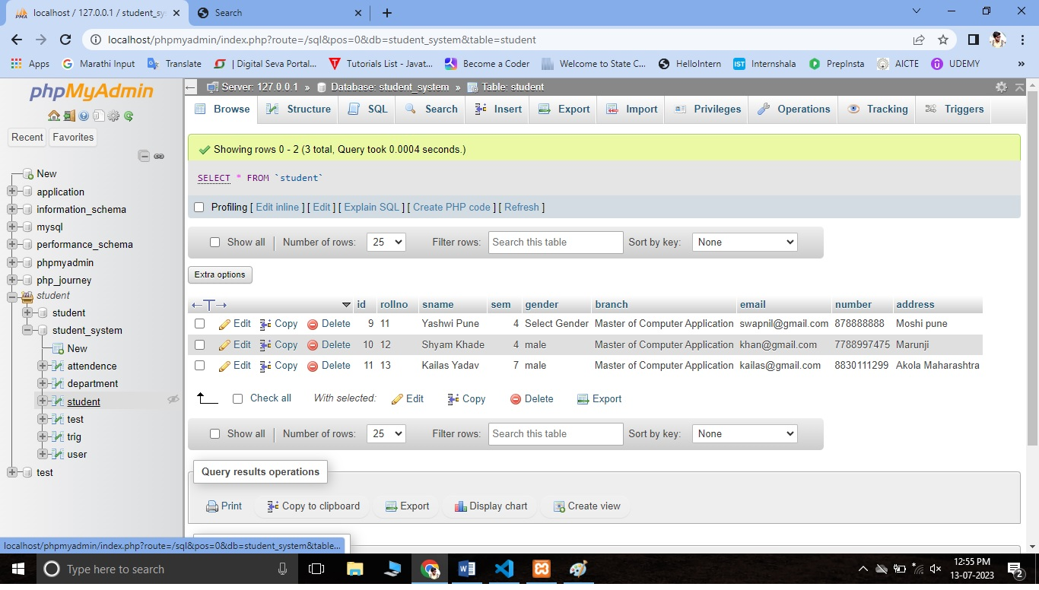

Student database image:



User database:

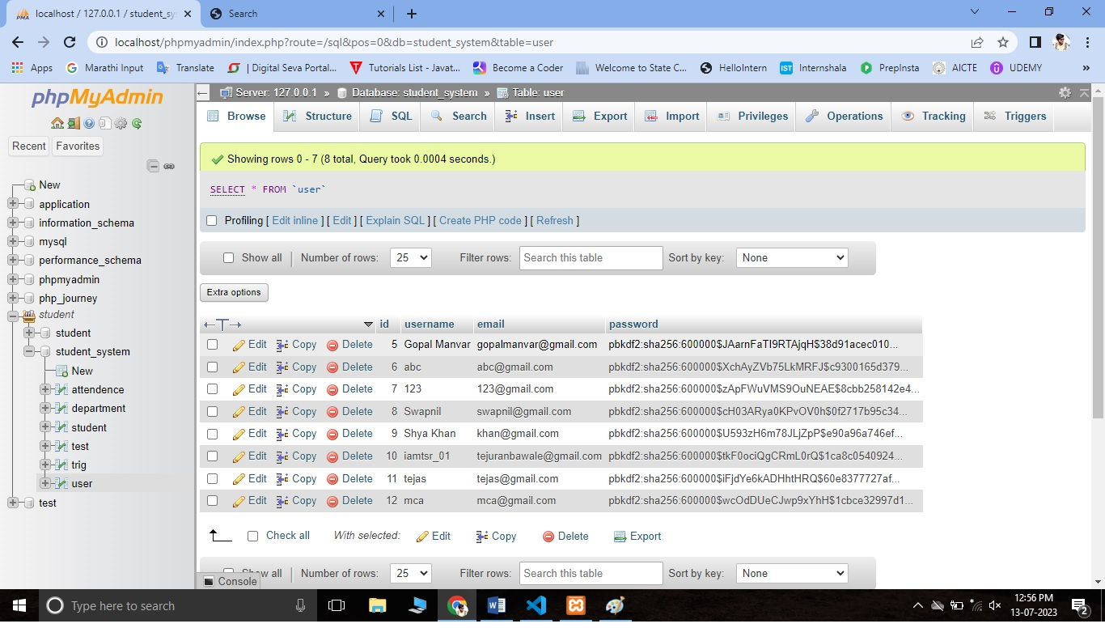

**Testing and Validation check:**

**Testing:**

System testing of software or hardware is testing conducted on a complete, integrated system to evaluate the system's compliance with its specified requirements. System testing falls within the scope of black-box testing, and as such, should require no knowledge of the inner design of the code or logic. As a rule, system testing takes, as its input, all of the "integrated" software components that have passed integration testing and also the software system itself integrated with any applicable hardware system(s). The purpose of integration testing is to detect any inconsistencies between the software units that are integrated together (called assemblages) or between any of the assemblages and the hardware. System testing is a more limited type of testing; it seeks to detect defects both within the "inter-assemblages" and also within the system as a whole. Our Project went through two levels of testing:

1. **Unit testing**

Unit testing is undertaken when a module has been created and successfully reviewed

1. **Integration testing**

In this type of testing, we test various integration of the project module by providing the input**.** The primary objective is to test the module interfaces in order to ensure that no errors are occurring when one module invokes the other module.

Validation:

The process of evaluating web-based application during the development process or at the end of the development process to determine whether it satisfied information requirement. Validation testing ensures that the product actually meets the user needs. It can also have defined as to demonstrate that the information fulfills its intended use when deployed on appropriate environment.

Types of the validation:

1. Validation input transaction
2. Validation input data

**Future scope:**

Our web-based application “Student Management System” which provides complete information about student details, course details, institute, college etc. We will add more content on them in future.

List of future implementation in project are listed below;

1. Adding account section to project
2. Allowing student to pay online payment
3. Registration access give to the student
4. Enhanced database storage facility
5. Enhanced user friendly GUI
6. more advanced results systems
7. online feedbacks forms

**References:**

https://www.youtube.com

https://www.google.com

http://www.getbootstrap.com

**Conclusion:**

“STUDENT MANAGEMENT SYSTEM” successfully implemented based on online data filling which helps us in administrating the data user for managing the tasks performed in students. The project successfully used various functionalities of Xampp and python flask and also create the fully functional database management system for online portals. Using MySQL as the database is highly beneficial as it is free to download, popular and can be easily customized. The data stored in the MySQL database can easily be retrieved and manipulated according to the requirements with basic knowledge of SQL.