CloudFormation
Create a EC2 instance using CloudFormation
- Create a stack in the cloudformation
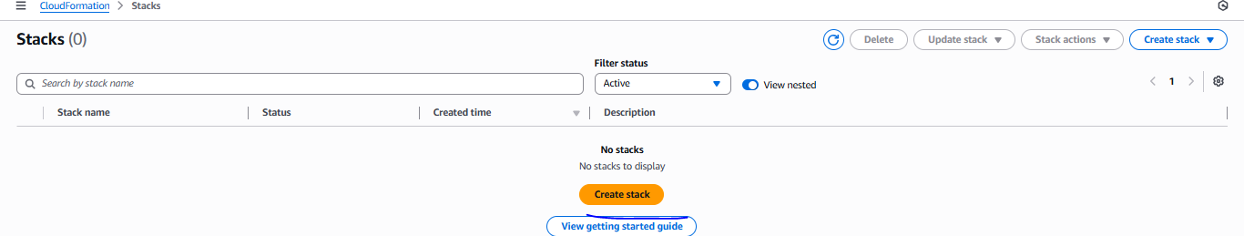
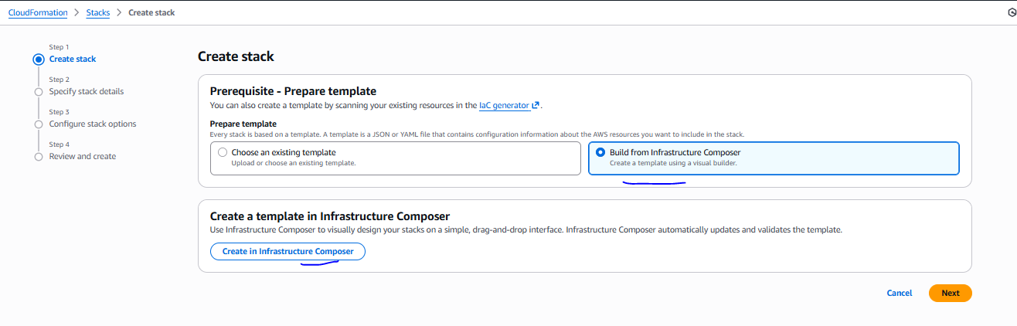
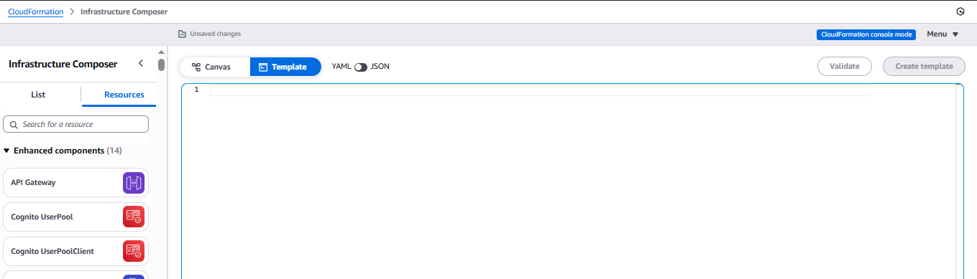
Once open a template write a template in YAML format as mention below and then validate
Resources:
EC2Instance:
Type: AWS::EC2::Instance
Properties:
InstanceType: t3.micro
ImageId: ami-0ced6a024bb18ff2e
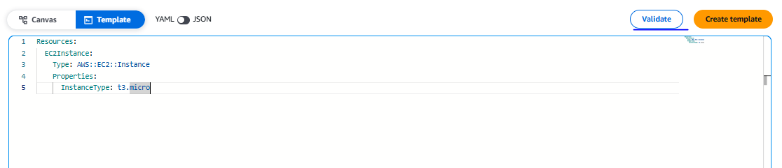
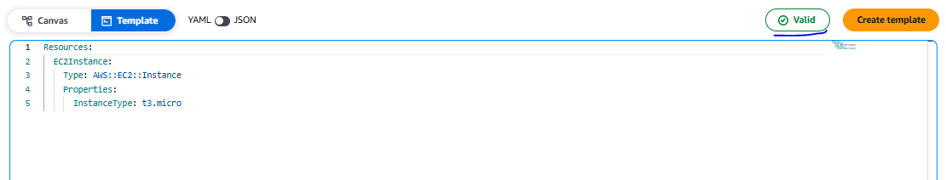
Then check the canvas
Showing the infra in diagram format in canvas section
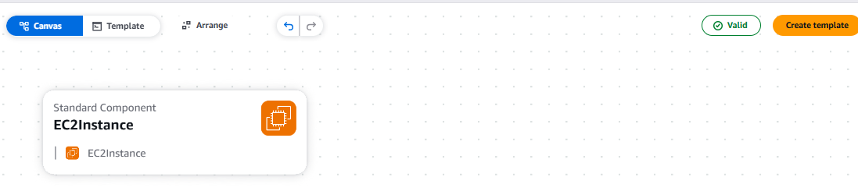
Then create a template
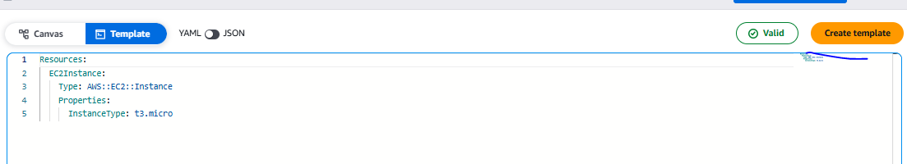
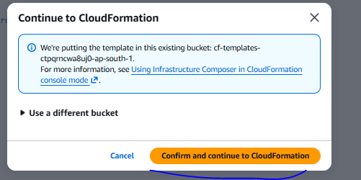

Then next
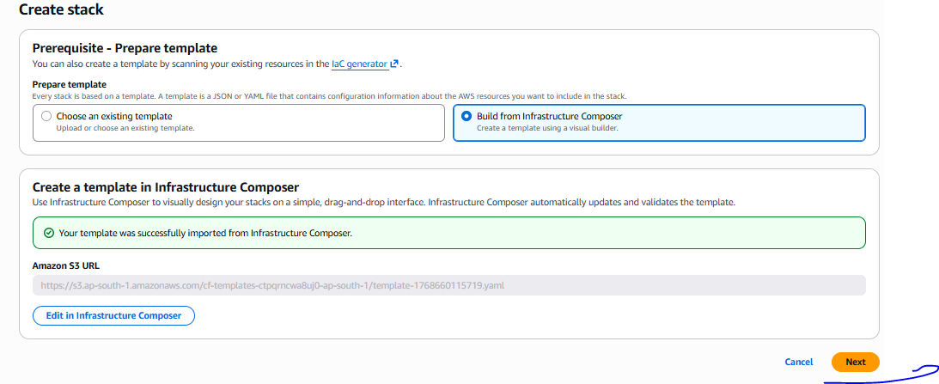
Need to specify name of stack then next and submit
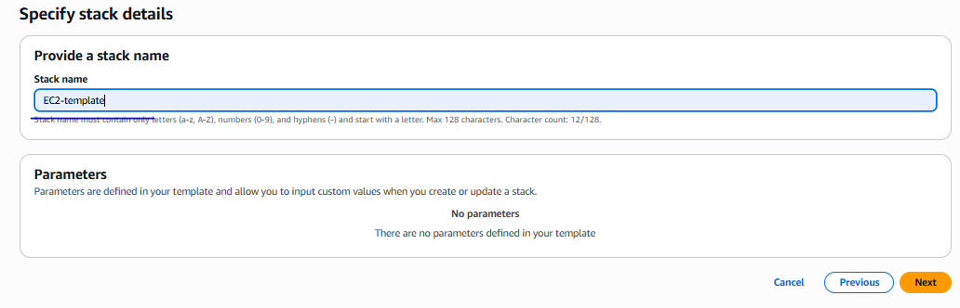
Once click on submit button will show the all events in events section
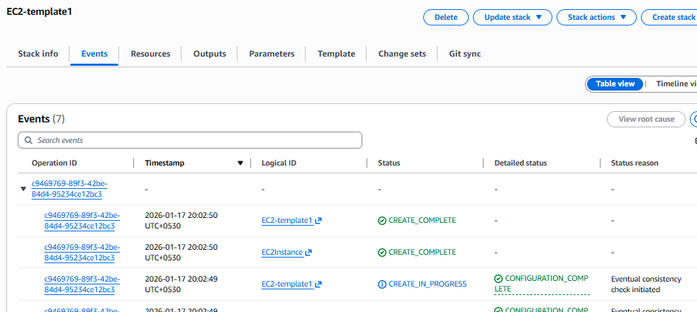

Now instance has been created using cloud formation
If we need to modify stack we can modify for eg we need to add avaibility zone then we can add AZ as mention below
Click on existing template and click on update stack
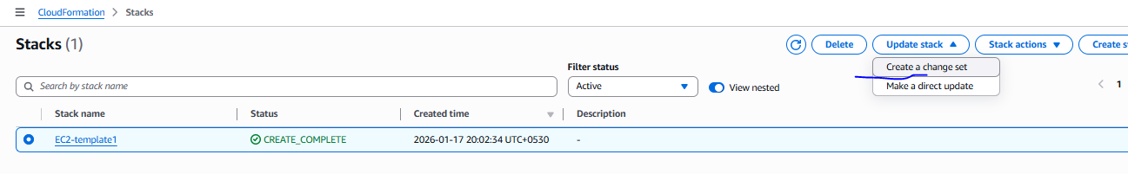
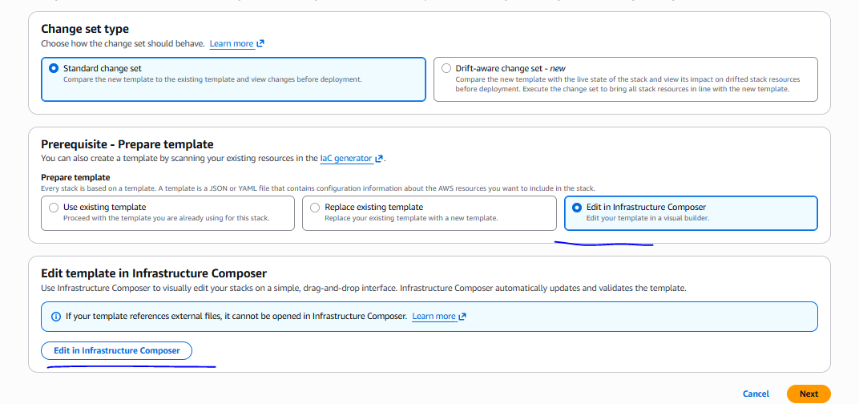
Modifie template then create change set
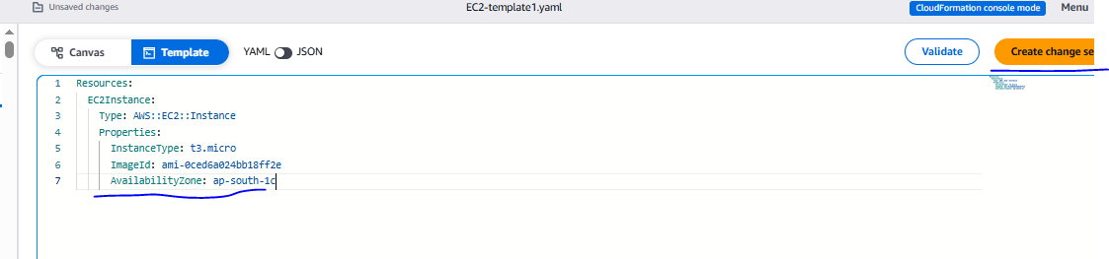
Once create change set, need to execute
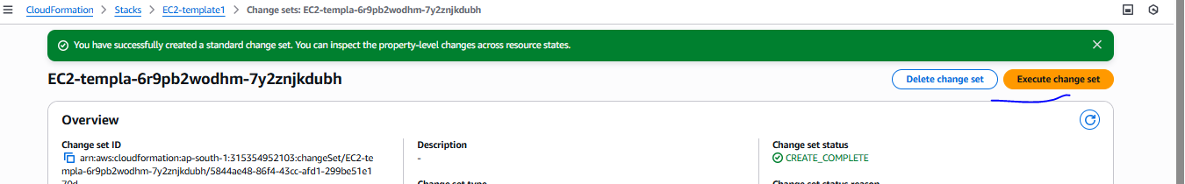
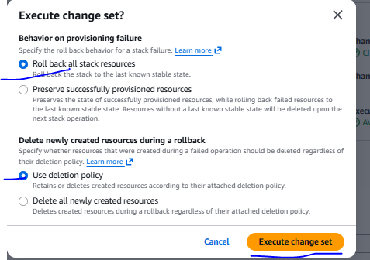
Update is progress
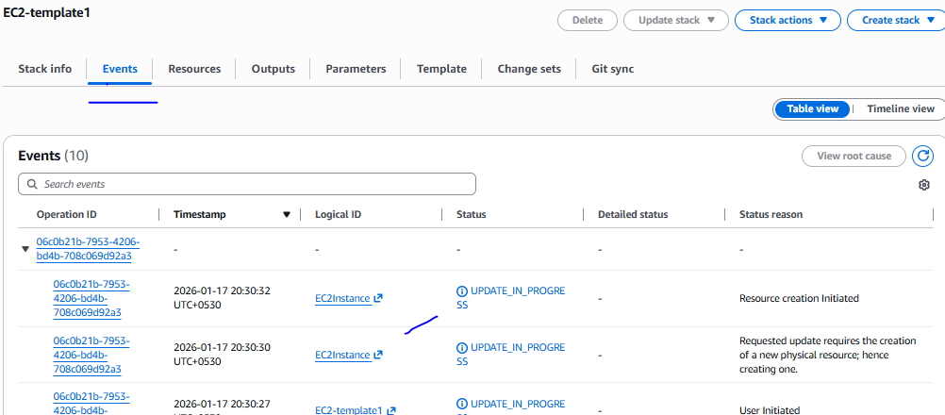
Verified
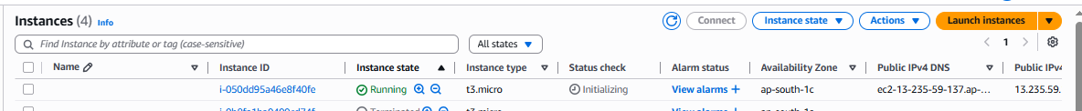

========================with parameter=========================
Parameter means a variable, we can mention variable using !Ref

Parameters:
InstanceType:
Type: String
Default: t2.micro
AvailabilityZone:
Type: String
Default: ap-south-1a

Resources:
EC2Instance:
Type: AWS::EC2::Instance
Properties:
InstanceType: !Ref InstanceType
ImageId: ami-0ced6a024bb18ff2e
AvailabilityZone: !Ref AvailabilityZone

While creating the stack if pass some parameter in template, template section will open ASE mention below
