**Enforcing Social Distancing through CCTV Surveillance**

**About the problem :**

In the current Indian public scenario, the lack of civic sense often leads to people cramping into each other at almost every unregulated queue like situation , be it for water , ration of any other general shop , even when it’s not about the queue people might just out of affection forget the distance between them . This can lead to transmission of many infectious diseases especially the current pandemic Coronavirus which though has very high recovery rate but it is uncurable as of now . So it is better to avoid the virus altogether than to “hope for the best and continue living as you were living”

**Reason for selection :**

The project aims at enforcing social distancing which people might intentionally not follow because of habit. If implemented properly the project can help to identify potential hot spots before they turn into a larger problem for everyone else. This project reflects a sense of social responsibility.

**Main Objective :**

The main objective of project is being able to detect violations of social distancing among people as observed by a fixed-orientation CCTV camera and to record those violation in a suitable and informative format which can be used for further analysis.

Some examples of violations of social distancing include:

* Two people walking closer than mandated distance (together or in-front of each other)
* A group of people walking together with a density which poses high risk of transmission
* High Risk especially at Crowded place & distancing is violate

**Scope of the Project :**

This project is a classic example of one of the uses of Digital Image Processing that is Entity Recognition .

Our initial scope is limited to successfully detecting any violations of social distancing by comparing the distances between among people in the scene if any ( every few frames) .

Although this task in itself is quite complicated than it sounds and implementing an accurate model will take several trial and errors .

To convert the model in to usable product following features might be considered after initial goal is achieved :

* Adding mask detection on faces ( detection of faces is guaranteed when the initial scope of project is implemented successfully )

# Working Methodology :

1. Checking live feed from camera fixed at some place. And then calculating distance between each and every other person.
2. Then using Python OpenCV libraries to detect object in the frame(person).
3. This is done is roughly 4 steps

* Background removal ( either subtracting empty background image from crowded frame or using inbuild OpenCV functions)
* 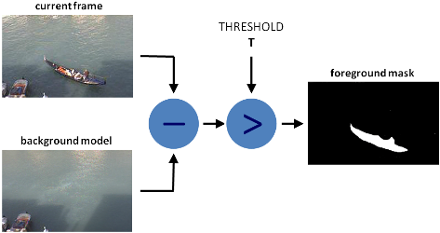

https://docs.opencv.org/master/d1/dc5/tutorial_background_subtraction.html

* Enhancement : Removing shadows and noise generated due to BG removal
* Contour tracing followed by applying convex hull on foreground ( to clearly separate out individual entities in the foreground)
* 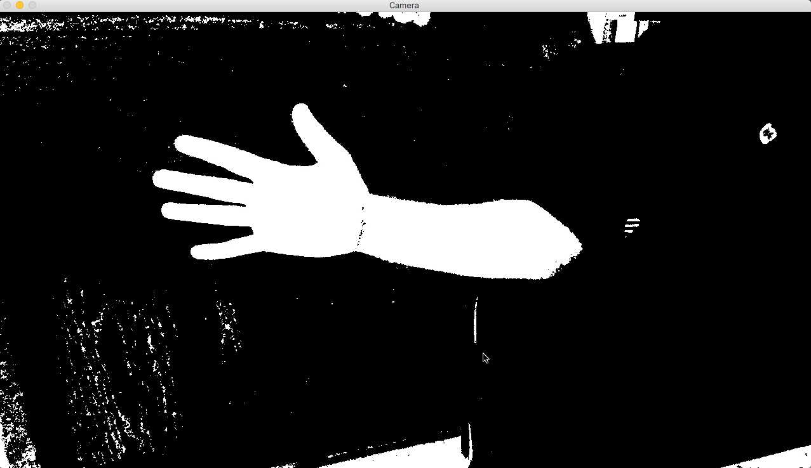
* 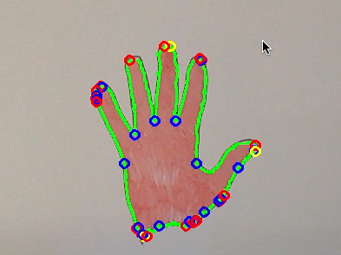
* https://handmap.github.io/convex-hull-and-contours/
* Finally applying entity tracking algorithms and finding pairwise distance between each entity .

1. If the minimum distance criteria is not followed then taking some actions based on it.
2. This will be done for 4 to 5 frames to get the better info about the current scenario of the place.
3. Some information about the orientation of the camera is also needed in order to successfully map pixel coordinates to real world distance . This problem is very easily solved if drone is used ( as drone have top view of the ground and figuring out distances is reduced to calculating height from ground and screen resolution .)

**Hardware Requirements:**

1. CCTV camera AND Working Webcam
2. RAM and CPU normal Configuration.
3. Normal Graphics Card Configuration.

**Software Requirements:**

1. Python Env (PyCharm(community version) , Anaconda )
2. Any Operating System(Linux, UNIX, Windows, MAC Os).
3. OS python Library
4. OpenCV, NumPy , Matplotlib and few other python Libraries
5. GitHub for building Project
6. Command Line Terminal for Installing python Libraries using pip .

**Testing Technologies(If any):**

1. Brute Force Matcher – It is software for feature Detection matcher between images.
2. FLANN based Matcher – It is good testing technique for finding the matches with search even with large datasets.
3. It stands for – FAST LIBRARY FOR APPROXIMATE NEAREST NEIGHBOURS and is widely used.

**Limitations of this Project:**

1. This project will work for a particular fixed place where CCTV camera will be fixed to capture images of that area.
2. There should not be a picture or poster of people at that area otherwise it will detect this as a person object and if distance between a person and picture will less then it will alarm that social distancing is not maintaining .
3. Throughout the day ambient light is changing so algorithm must be robust enough to account for intensity changes .

**Contribution of the project:**

**Saving people from getting infected with covid19:**

As we can see the cases of covid19 increases day by day very fast so it becomes necessary to maintain social distancing and because of habit people get difficult to do this. So we can solve this problem by this project which measures distance between people . and by this it will inform that social distancing are maintained or not at a particular area and by this people can be saved by infection of viruses.

**Conclusion:**

This project will give a solution to maintain social distancing at a particular area and save people by getting infected if they come closer by measuring distance between them through CCTV camera using OpenCV technology.