MOBILE SALES
Business Intelligence & Deep Insights Report

₹769M  Total Revenue | 19,150  Units Sold | 3,835  Transactions | 3.69 ★  Avg Rating

1. Executive Summary

This report analyses mobile device sales data across India spanning 2021–2024, covering 3,835 transactions, five major brands (Apple, Samsung, OnePlus, Vivo, Xiaomi), 19 cities, 15 mobile models, and four payment channels. The total revenue stands at ₹769 million across approximately 19,150 units sold. Apple leads in total revenue (₹161.6M), while UPI dominates as the preferred payment method (26%). Delhi alone accounts for 26.5% of national sales, and customers aged 46–60 contribute the highest sales volume. The majority of customers gave 5-star ratings, reflecting strong satisfaction—yet a notable share of 1–2 star ratings warrants attention.

2. Brand Performance Analysis

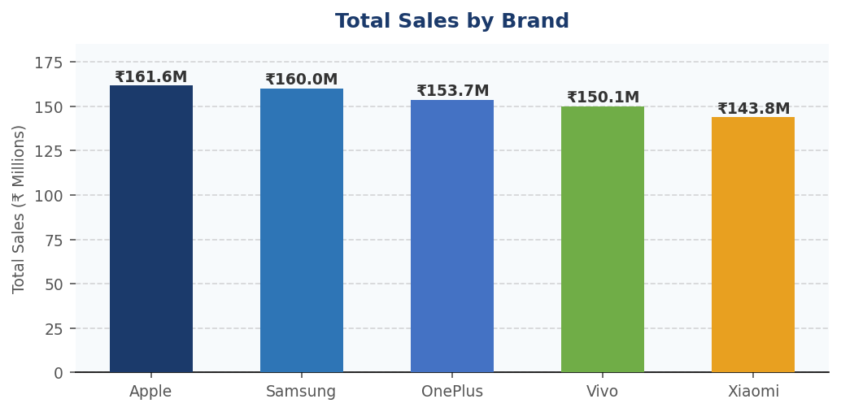

Brand | Revenue (₹M) | Units Sold | Transactions | Avg Rating | Market Share
Apple | 161.6 | 3,932 | 783 | 3.71 ★ | 21.0%
Samsung | 160.0 | 3,923 | 775 | 3.70 ★ | 20.8%
OnePlus | 153.7 | 3,830 | 768 | 3.68 ★ | 20.0%
Vivo | 150.1 | 3,801 | 766 | 3.65 ★ | 19.5%
Xiaomi | 143.8 | 3,664 | 743 | 3.72 ★ | 18.7%

KEY INSIGHT | • Apple leads revenue but by a razor-thin margin over Samsung (₹1.6M gap) — brand dominance is highly contested.  • Xiaomi rates highest (3.72★) despite lowest revenue — a strong value-for-money perception.  • All five brands maintain near-identical market share (~20%), indicating no single dominant player.  • Revenue per unit is highest for Apple & Samsung, suggesting premium pricing is working.

3. Monthly Sales Trend

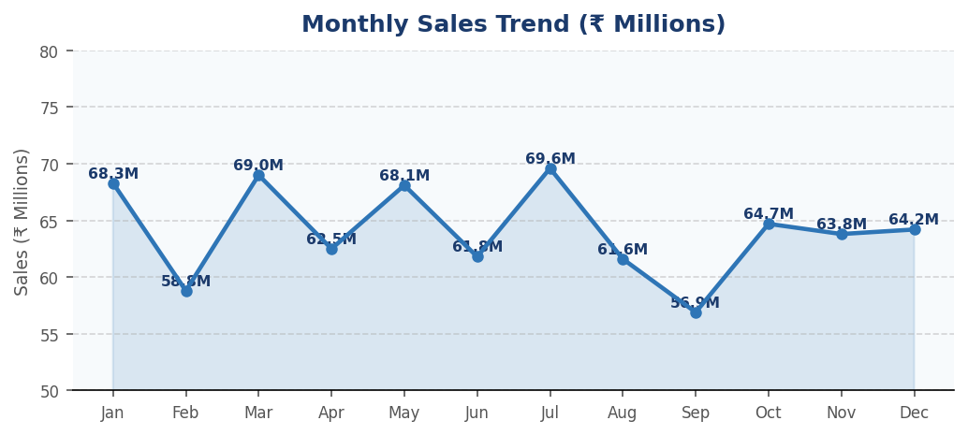

SEASONALITY | • July (₹69.6M) and March (₹69.0M) are peak months — likely tied to festive promotions and budget cycles.  • September (₹56.9M) is the weakest month — a strategic opportunity for targeted discounting.  • February and August also dip, forming a bimodal low-demand pattern worth monitoring.  • Strong Q1 and Q3 suggest sales campaigns should front-load budget in these quarters.

4. Payment Methods & Geographic Distribution
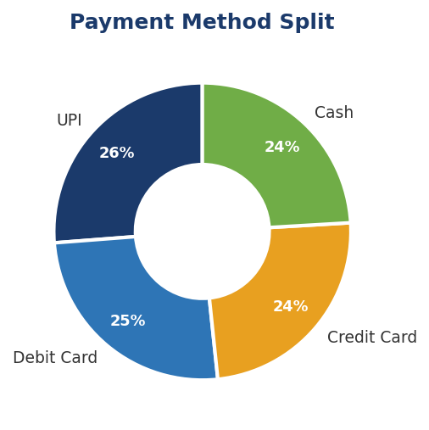 | 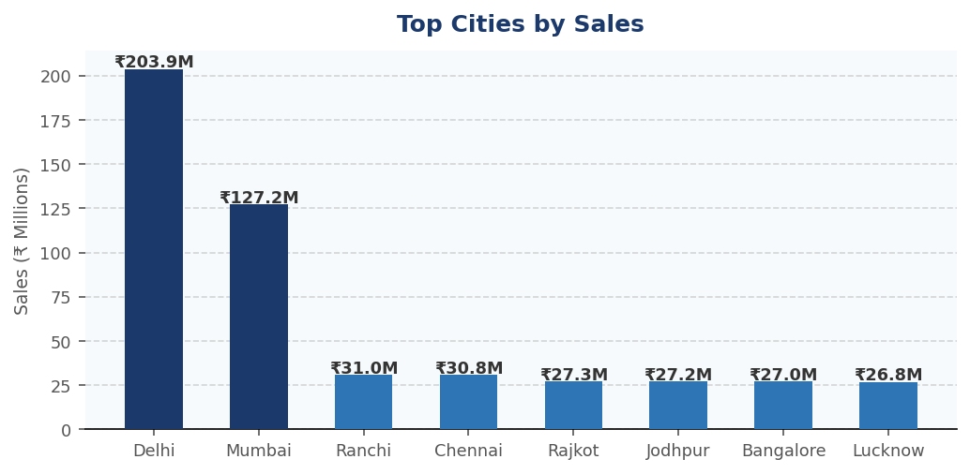

Payment Method | Transactions | Revenue (₹M) | Share
UPI | 1,011 | 201.7 | 26.2%
Debit Card | 948 | 195.7 | 25.4%
Credit Card | 947 | 186.7 | 24.3%
Cash | 929 | 185.1 | 24.1%

GEO & PAYMENT INSIGHTS | • UPI leads with ₹201.7M in revenue — digital payments are firmly mainstream in Indian mobile retail.  • Delhi generates ₹203.9M (26.5% of total), dwarfing second-place Mumbai at ₹127.2M.  • Cash remains relevant at 24.1% — non-digital customers in Tier 2 cities should not be overlooked.  • Ranchi, Chennai and Rajkot form a tight cluster at ₹27–31M — emerging markets with growth potential.

5. Customer Satisfaction & Demographics

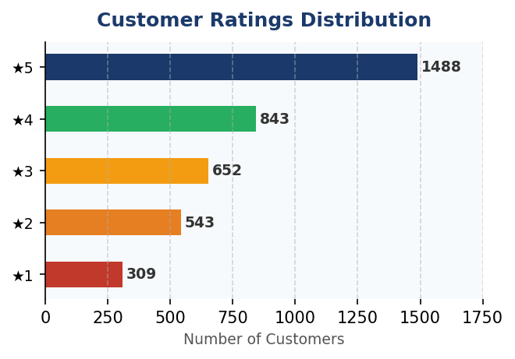

Age Group | Revenue (₹M) | Share | Implication
18–25 | 148.4 | 19.3% | Entry-level; budget-conscious
26–35 | 189.2 | 24.6% | Mid-range buyers; tech-savvy
36–45 | 182.1 | 23.7% | Balanced; value + features
46–60 | 249.5 | 32.4% | Highest spenders; premium segment

SATISFACTION ALERTS | • 5-star ratings dominate (1,488 reviews / 38.8%) — a strong net promoter base to leverage for referrals.  • 309 customers gave 1-star ratings — post-purchase follow-up and quality checks needed.  • Customers aged 46–60 drive the most revenue (₹249.5M / 32.4%) — premium models should target this group.  • 18–25 segment is underserved at only 19.3% of revenue — bundling and EMI offers could unlock growth.

6. Top-Performing Mobile Models

Rank | Mobile Model | Brand | Revenue (₹M) | Insight
1 | iPhone SE | Apple | ₹59.6M | Entry-level Apple — broad appeal
2 | OnePlus Nord | OnePlus | ₹57.9M | Value flagship — strong pull
3 | Galaxy Note 20 | Samsung | ₹56.0M | Premium productivity device
4 | Vivo Y51 | Vivo | ₹54.8M | Budget leader for Vivo
5 | Galaxy S21 | Samsung | ₹53.3M | Samsung premium performer
6 | iPhone 11 | Apple | ₹51.5M | Evergreen mid-cycle Apple
7 | Galaxy A51 | Samsung | ₹50.8M | Mid-range volume driver
8 | iPhone 12 | Apple | ₹50.5M | Flagship-lite demand
9 | Vivo V20 | Vivo | ₹49.7M | Camera-centric audience
10 | Mi 11 | Xiaomi | ₹49.6M | Flagship experience, budget price

MODEL MIX STRATEGY | • iPhone SE (₹59.6M) is the best-selling single model — affordable Apple branding drives volume.  • Samsung appears 3 times in the top 10, showing the strongest model portfolio diversity.  • Top 10 models span all 5 brands — no single brand monopolises top-selling positions.  • Mid-range models (₹25K–₹50K) dominate the top 10 list — this is the sweet-spot price band.

7. Strategic Recommendations

Priority | Recommendation | Expected Impact
High | Boost September marketing spend to counter seasonal dip | Recover ~₹10M lost revenue
High | Target 46–60 age segment with premium bundle campaigns | Increase AOV by 15–20%
High | Expand Tier 2 city presence (Ranchi, Chennai, Rajkot) | Unlock ₹30–50M growth
Medium | Launch EMI/BNPL schemes for 18–25 age group | Grow youth segment share
Medium | Address 1–2 star complaints through service quality audits | Improve NPS score
Medium | Incentivise UPI usage with cashback to drive digital adoption | Reduce cash handling cost
Low | Expand Xiaomi premium model portfolio (high satisfaction, low revenue) | Revenue uplift ₹5–8M

