**CORE JAVA PROJECT**

PROJECT TITLE**: SCHOOL MANAGEMENT SYSTEM**

AIM:

* To achieve the school management system without any interruptions.

LANGUAGES:

* JAVA and SQL

SOFTWARE REQUIREMENTS**:**

* Eclipse for java.
* Mysql for sql.

SYNOPSIS:

In this SCHOOL MANAGEMENT SYSTEM there 5 main operations are there.

That MAIN OPERATIONS are:

1. LOGIN --> Admin can perform that operation.

2. STUDENT -->Admin can perform that operation.

4. TEACHER -->Admin can perform that operation.

5.P&L OF SCHOOL -->Admin perform the operation.

The control is given to only the admin. Admin can perform operations like fetching information about the student and teacher who all are there in school how many more he can hire a teacher or give admission to student. In that Student side there is five main operations are given. The first one is Display operation it will display all student. Second one is Insert when ever you need to add the student this module will help. Third one is Delete this will remove all information like, name ,address, phone number, fees, feespaid . Forth one is Update process in this we can update fees. Final one is total feespaid by student till date.

**INITIAL SETUP:**

**(IN JAVA):**

**Mavan Project Name**: School_Management_Project.

**Package Name:** com.school.

**Classes Name :** 1. MainSchoolHandler

2. SchoolConnection

3.StudentManagement

4.TeacherManagement

**(IN DATABASE):**

Creating database in sql (query)



**Database Creation:**



**Tables Creation:**

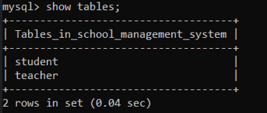

**SCHOOLMANAGEMENTSYSTEM MAIN CLASS**

**ADMIN MAIN METHOD CODE:**

/**

****************************CORE JAVA PROJECT********************

* CSR CAPGEMINI TRAINING PROJECT

* EDUBRIDGE INDIA PRIVATE LIMITED

* PROJECT TITLE: SCHOOL MANAGEMENT SYSTEM

* UNDER THE GUIDENCE OF TRAINER MRS.INDRAKA MALLI

* @DONE BY GOPALSINGH DEVADA

*

* In SCHOOL MANAGEMENT SYSTEM:

* MAIN OPERATIONS:

*

* 1. LOGIN 🡪 Admin can perform that operation.

* 3. STUDENT SECTION 🡪 Admin can perform that operation.

* 4. TEACHER SECTION 🡪 Admin can perform that operation.

* 5. CALCULATE PROFIT

AND LOSS OF SCHOOL 🡪 Admin perform the operation.

* */

* MAINSCHOOLHANDLER class is having three major operations

*This will decides which operation to perform.

1.Student Data

2.Teacher Data

3.CALCULATE PROFIT AND LOSS OF SCHOOL

case 11:

*If admin choice is student

*1. Display

*2. Add

*3. Delete

*4. Update

*5. Total fees-paid by student

*

*case 12:

*If admin choice is Teacher

*1. Display

*2. Add

*3. Delete

*4. Update

*5. Total salary-paid to teacher

*

*case 13:

*If admin choice is calculate profit and loss of school

*

*/

package com.school;

import java.sql.SQLException;

import java.util.Scanner;

public class MainSchoolHandler {

public static void main(String[] args) throws SQLException {

System.out.println("----Login in---");

Scanner sc=new Scanner(System.in);

System.out.println("Enter username");

String uname=sc.next();

System.out.println("Enter password");

String upass=sc.next();

if(uname.equals("gopal") && upass.equals("gopal@123")) {

int whichdata;

int choice;

char ch;

System.out.println("Select any");

System.out.println("11. Student Data");

System.out.println("12. Teacher Data");

System.out.println("13. Calculate profit and loss of school");

whichdata=sc.nextInt();

switch(whichdata) {

case 11:

while(true) {

System.out.println("***********Student Details*************");

System.out.println("Choose a action u want to perform");

System.out.println("1. Display student details");

System.out.println("2. Add new Student details");

System.out.println("3. Delete student details");

System.out.println("4. update student details");

System.out.println("5. Total fees paid by student");

choice=sc.nextInt();

switch(choice) {

case 1: // Display

System.out.println("Display all student details");

StudentManagement.DisplayStudent();

break;

case 2: //Insert

System.out.println("Add new student");

StudentManagement.AddStudent();

break;

case 3: //Delete

System.out.println("Delete student details");

StudentManagement.DeleteStudent();

break;

case 4://Update

System.out.println("Update student details");

StudentManagement.UpdateStudent();

break;

case 5://totalfees

System.out.println("Totalfeespaid by the students ");

StudentManagement.TotalFeesPaid();

break;

default: System.out.println("Invalid input");

}

System.out.println("Do u want to continue y/n");

ch=sc.next().charAt(0);

if(ch=='n' || ch=='N')

break;

}

System.out.println("Logout student successfully");

case 12:

System.out.println("Do u want to enter teachers details y/n");

ch=sc.next().charAt(0);

if(ch=='n' || ch=='N') {

System.out.println("Logout successfully");

break;

}

while(true) {

System.out.println("***********Teacher Details*************");

System.out.println("Choose a action u want to perform");

System.out.println("1. Display teacher details");

System.out.println("2. Add new teacher details");

System.out.println("3. Delete teacher details");

System.out.println("4. Update teacher details");

System.out.println("5. Total salary paid to teachers");

choice=sc.nextInt();

switch(choice) {

case 1: // Display

System.out.println("Display all teacher details");

TeacherManagement.DisplayTeacher();

break;

case 2://Add

System.out.println("Add new teacher details");

TeacherManagement.AddTeacher();

break;

case 3://Delete

System.out.println("Delete teacher record");

TeacherManagement.DeleteTeacher();

break;

case 4://update

System.out.println("Update teacher record");

TeacherManagement.UpdateTeacher();

break;

case 5://totalfeespaid

System.out.println("Totalsalarypaid to teacher is ");

TeacherManagement.TotalSalaryPaid();

break;

default: System.out.println("Invalid input");

}

System.out.println("Do u want to continue y/n");

ch=sc.next().charAt(0);

if(ch=='n' || ch=='N')

break;

}

System.out.println("Logout teacher successfully");

case 13:// Profit loss calculation

System.out.println("Calculate profit loss of school");

double sf=StudentManagement.TotalFeesPaid();

double ts=TeacherManagement.TotalSalaryPaid();

double Totalmoney=sf-ts;

System.out.println("Total amount = "+Totalmoney+" Rs");

if(Totalmoney<0) {

System.out.println("School is running in loss");

}else if(Totalmoney>0) {

System.out.println("School is running in profit");

}else if(Totalmoney==0) {

System.out.println("School is neither in loss nor in profit");

}else {

System.out.println("Something went wrong");

break;

}

}

}else {

System.out.println("Incorrect password");

}

}

}

**Database table creation:**

**Student table structure:**

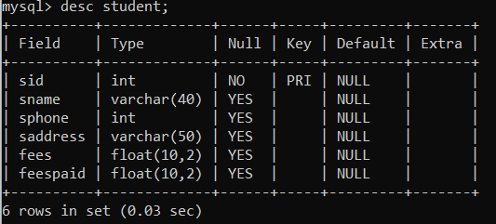

**Teacher table structure:**

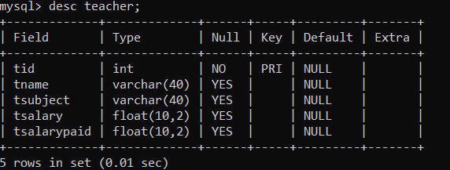

**DATABASE CONNECTION CLASS:**

**DATA BASE CODE:**

/**

* Data base connection class-> it makes a connections between the JAVA and mysql

*

* 1.Driver->That implements the java databases connectivity (JDBC) API

*

* 2.url->data base management system jdbc driver uses to connect to a database

*

* 3.username-> user name of the database

*

* 4.password->pass word for the databases

*

* 5.forname()-> method is loading the driver dynamically loads a java class at runtime

*

* 6.DriverManger->Is that class making connection to database by passing arguments as a url ,username and password.

*

*/

package com.school;

import java.sql.Connection;

import java.sql.DriverManager;

import java.sql.PreparedStatement;

import java.sql.ResultSet;

import java.util.Scanner;

public class SchoolConnection {

private static String driver="com.mysql.cj.jdbc.Driver";

private static String url="jdbc:mysql://localhost:3306/school_management_system";

private static String un="root";

private static String up="root";

private static Connection conn=null;

private static PreparedStatement pst;

private static ResultSet rs=null;

public static Connection getConnection() {

try {

Class.forName(driver);

conn=DriverManager.getConnection(url,un,up);

if(conn==null) {

System.out.println("Connection error!!!");

}

}catch(Exception e) {

e.printStackTrace();

}

return conn;

}

}

**STUDENT PROCESS CODE:**

package com.school;

import java.sql.Connection;

import java.sql.PreparedStatement;

import java.sql.ResultSet;

import java.sql.SQLException;

import java.util.Scanner;

public class StudentManagement {

private static Connection conn;

private static PreparedStatement pst;

private static ResultSet rs;

public static void DisplayStudent() throws SQLException {

conn=SchoolConnection.getConnection();

String s="Select * from student ";

pst=conn.prepareStatement(s);

rs=pst.executeQuery();

System.out.println("sid\tsname\tsphone\t\tsaddress\tfees\t\tfeespaid");

while(rs.next()) {

int id=rs.getInt("sid");

String sn=rs.getString("sname");

int sph=rs.getInt("sphone");

String sadd=rs.getString("saddress");

float sfees=rs.getFloat("fees");

float sfpaid=rs.getFloat("feespaid");

System.out.println(id+"\t"+sn+"\t"+sph+"\t"+sadd+"\t\t"+sfees+"\t\t"+sfpaid);

}

}

public static void AddStudent() throws SQLException {

conn=SchoolConnection.getConnection();

int id;

String sn;

int sph;

String sadd;

float sfees;

float feespaid;

Scanner sc=new Scanner(System.in);

System.out.println("Enter student id");

id=sc.nextInt();

String s="Select * from student where sid=?";

pst=conn.prepareStatement(s);

pst.setInt(1, id);

rs=pst.executeQuery();

if(!rs.next()) {

System.out.println("Enter student name");

sn=sc.next();

System.out.println("Enter students phone number");

sph=sc.nextInt();

System.out.println("Enter student address");

sadd=sc.next();

System.out.println("Enter student fees");

sfees=sc.nextFloat();

System.out.println("Enter student paid fees");

feespaid=sc.nextFloat();

String sel="insert into student values(?,?,?,?,?,?)";

pst=conn.prepareStatement(sel);

pst.setInt(1, id);

pst.setString(2, sn);

pst.setInt(3, sph);

pst.setString(4, sadd);

pst.setFloat(5, sfees);

pst.setFloat(6, feespaid);

int rv=pst.executeUpdate();

if(rv>0) {

System.out.println("Record is inserted");

}else {

System.out.println("Not inserted");

}

}else {

System.out.println("Student sid "+id+" already exists");

System.out.println("Enter other sid if u want to insert");

}

}

public static void DeleteStudent() throws SQLException {

conn=SchoolConnection.getConnection();

int id;

Scanner sc =new Scanner(System.in);

System.out.println("Enter student id u want to delete");

id=sc.nextInt();

String s="Select * from student where sid=?";

pst=conn.prepareStatement(s);

pst.setInt(1, id);

rs=pst.executeQuery();

if(rs.next()) {

String del="delete from student where sid=?";

pst=conn.prepareStatement(del);

pst.setInt(1, id);

int rv=pst.executeUpdate();

if(rv>0) {

System.out.println("Record has been deleted");

}else {

System.out.println("Error while deleting record");

}

}else {

System.out.println("Student sid "+id+" does not exists");

}

}

public static void UpdateStudent() throws SQLException {

conn=SchoolConnection.getConnection();

int id;

float sfpaid;

Scanner sc = new Scanner(System.in);

System.out.println("Enter student id you want to update");

id=sc.nextInt();

String s="select fees,feespaid from student where sid=?";

pst=conn.prepareStatement(s);

pst.setInt(1, id);

rs=pst.executeQuery();

float feespending;

float totalfees=0;

float feespaid=0;

if(rs.next()) {

totalfees=rs.getFloat("fees");

feespaid=rs.getFloat("feespaid");

feespending=totalfees-feespaid;

System.out.println("Pending fees is = "+feespending);

if(feespending !=0) {

System.out.println("Enter feespaid by student ");

sfpaid=sc.nextFloat();

String upd="update student set feespaid=? where sid=?";

pst=conn.prepareStatement(upd);

pst.setFloat(1, (sfpaid+feespaid));

pst.setInt(2, id);

int rv=pst.executeUpdate();

if(rv>0) {

System.out.println("Record has been updated");

}else {

System.out.println("Error!!!");

}

}

}else {

System.out.println(id+" sid does not exists");

}

}

public static double TotalFeesPaid() throws SQLException {

conn=SchoolConnection.getConnection();

double value=0.0;

pst=conn.prepareStatement("select sum(feespaid) from student ");

rs = pst.executeQuery();

rs.next();

String sum = rs.getString(1);

System.out.println("feespaid by students = "+sum+" Rs");

value = Double.parseDouble(sum);

return value;

}

}

**Java output:**

**STUDENT output:**

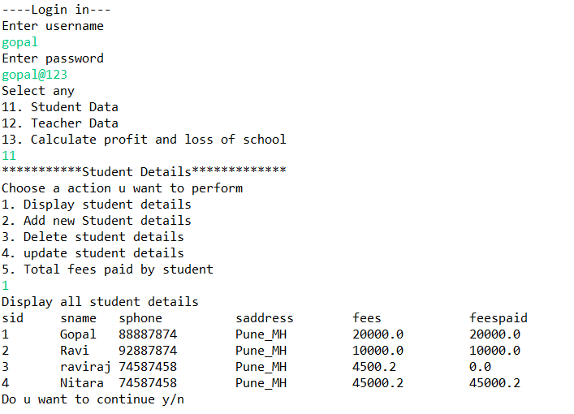

**Database output:**

**Student table:**

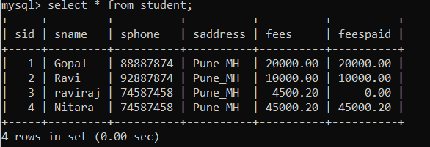

**Teacher process code:**

package com.school;

import java.sql.Connection;

import java.sql.PreparedStatement;

import java.sql.ResultSet;

import java.sql.SQLException;

import java.util.Scanner;

public class TeacherManagement {

private static Connection conn;

private static PreparedStatement pst;

private static ResultSet rs;

public static void DisplayTeacher() throws SQLException {

conn=SchoolConnection.getConnection();

String t="select * from teacher";

pst=conn.prepareStatement(t);

rs=pst.executeQuery();

System.out.println("tid\ttsalary\t\ttsalarypaid\t\ttname\t\ttsubject");

while(rs.next()) {

int id=rs.getInt("tid");

String tn=rs.getString("tname");

String ts=rs.getString("tsubject");

float tsal=rs.getFloat("tsalary");

float tsalpaid=rs.getFloat("tsalarypaid");

System.out.println(id+"\t"+tsal+"\t\t"+tsalpaid+"\t\t\t"+tn+"\t\t"+ts);

}

}

public static void AddTeacher() throws SQLException {

conn=SchoolConnection.getConnection();

int id;

String tn;

String tsub;

float tsal;

float tsalpaid;

Scanner sc=new Scanner(System.in);

System.out.println("Enter teacher id");

id=sc.nextInt();

String s="Select * from teacher where tid=?";

pst=conn.prepareStatement(s);

pst.setInt(1, id);

rs=pst.executeQuery();

if(!rs.next()) {

System.out.println("Enter teacher name");

tn=sc.next();

System.out.println("Enter teacher special subject ");

tsub=sc.next();

System.out.println("Enter teacher salary");

tsal=sc.nextFloat();

System.out.println("Enter salary paid to teacher");

tsalpaid=sc.nextFloat();

String t="insert into teacher values(?,?,?,?,?)";

pst=conn.prepareStatement(t);

pst.setInt(1, id);

pst.setString(2, tn);

pst.setString(3, tsub);

pst.setFloat(4, tsal);

pst.setFloat(5, tsalpaid);

int rv1=pst.executeUpdate();

if(rv1>0) {

System.out.println("Record is inserted");

}else {

System.out.println("Not inserted");

}

}else {

System.out.println("Teacher tid "+id+" already exists");

System.out.println("Enter some other tid to insert record");

}

}

public static void DeleteTeacher() throws SQLException {

conn=SchoolConnection.getConnection();

int id;

Scanner sc = new Scanner(System.in);

System.out.println("Enter teachers id you want to delete");

id=sc.nextInt();

String s = "select * from teacher where tid=?";

pst=conn.prepareStatement(s);

pst.setInt(1, id);

rs=pst.executeQuery();

if(rs.next()) {

String del="delete from teacher where tid=?";

pst=conn.prepareStatement(del);

pst.setInt(1, id);

int rv=pst.executeUpdate();

if(rv>0) {

System.out.println("Record has been deleted");

}else {

System.out.println("Error while deleting record");

}

}else {

System.out.println("Teacher tid"+id+"does not exists");

}

}

public static void UpdateTeacher() throws SQLException {

conn=SchoolConnection.getConnection();

int id;

float tspaid;

Scanner sc = new Scanner(System.in);

System.out.println("Enter teacher id u want update");

id=sc.nextInt();

String s="select tsalary,tsalarypaid from teacher where tid=?";

pst=conn.prepareStatement(s);

pst.setInt(1, id);

rs=pst.executeQuery();

float salarypending;

float totalsalary=0;

float salarypaid=0;

if(rs.next()) {

totalsalary=rs.getFloat("tsalary");

salarypaid=rs.getFloat("tsalarypaid");

salarypending=totalsalary-salarypaid;

System.out.println("Pending salary is = "+salarypending);

if(salarypending !=0) {

System.out.println("Enter salary paid to teacher ");

tspaid=sc.nextFloat();

String upd="update teacher set tsalarypaid=? where tid=?";

pst=conn.prepareStatement(upd);

pst.setFloat(1, (tspaid+salarypaid));

pst.setInt(2, id);

int rv=pst.executeUpdate();

if(rv>0) {

System.out.println("Record has been updated");

}else {

System.out.println("Error!!!");

}

}

}else {

System.out.println(id+" tid does not exists");

}

}

public static double TotalSalaryPaid() throws SQLException {

conn=SchoolConnection.getConnection();

double value=0.0;

pst=conn.prepareStatement("select sum(tsalarypaid) from teacher ");

rs = pst.executeQuery();

rs.next();

String sum = rs.getString(1);

System.out.println("Salarypaid to teachers = "+sum+" Rs");

value = Double.parseDouble(sum);

return value;

}

}

**java output:**



**Database output:**

