FOOD REMEDY API
Investigation Report: Variation in Daily Calorie Requirements (TICKET RE004)
STUDENT NAME: ADITHI RAJESH NAIR
STUDENT ID: 223833984

1. Introduction
Daily calorie requirements refer to the amount of energy an individual needs to sustain essential physiological processes and support daily activities. These processes include breathing, circulation, digestion, and cellular repair, collectively known as metabolism. In addition to these baseline functions, individuals require additional energy depending on their level of physical activity.
Calorie requirements vary significantly across individuals due to biological, environmental, and lifestyle factors. As a result, universal calorie recommendations are often presented as ranges rather than fixed values. Understanding these variations is critical for effective dietary planning, weight management, and the prevention of nutrition-related health conditions such as obesity and malnutrition.

2. Factors Influencing Daily Calorie Requirements
Daily energy needs are determined by a combination of internal (biological) and external (lifestyle) factors.
2.1 Age
Age plays a significant role in determining calorie requirements. During childhood and adolescence, individuals require higher caloric intake to support growth, development, and increased metabolic activity. In contrast, as individuals age, basal metabolic rate (BMR) tends to decline due to reductions in lean muscle mass and hormonal changes. Consequently, older adults generally require fewer calories.
2.2 Gender
Gender differences in calorie requirements are largely attributed to variations in body composition. On average, males possess greater lean muscle mass than females, which increases energy expenditure even at rest. Therefore, males typically require higher daily calorie intake compared to females of the same age and activity level.
2.3 Body Size and Composition
Individuals with larger body size or higher proportions of lean muscle mass have higher energy requirements. Muscle tissue is metabolically active and requires more energy to maintain compared to adipose (fat) tissue. Therefore, two individuals of the same weight may have different calorie needs depending on their body composition.
2.4 Physical Activity Level
Physical activity is one of the most influential factors affecting calorie requirements. Individuals who engage in regular physical activity, such as exercise or physically demanding work, require significantly more energy than sedentary individuals. Energy expenditure increases proportionally with the intensity, duration, and frequency of activity.

3. Recommended Daily Calorie Intake
General guidelines provide estimated calorie ranges for different population groups.
Group | Estimated Daily Intake
Adult women | 1,600 – 2,400 kcal
Adult men | 2,000 – 3,000 kcal
Sedentary individuals | Lower end of range
Active individuals | Higher end of range

These values are averages and may vary depending on individual characteristics and lifestyle.

4. Methods for Estimating Calorie Requirements
To provide more personalised estimates, several formulas are used to calculate energy needs.
4.1 Basal Metabolic Rate (BMR)
$$BMR=10W+6.25H-5A+s$$
Where:
- $W$= weight (kg)
- $H$= height (cm)
- $A$= age (years)
- $s=+5$for males and $-161$for females
BMR represents the number of calories required to maintain basic physiological functions at rest.

4.2 Total Daily Energy Expenditure (TDEE)
$$TDEE=BMR×Activity Factor$$
Activity factors typically include:
- Sedentary (1.2)
- Lightly active (1.375)
- Moderately active (1.55)
- Very active (1.725)
TDEE provides a more realistic estimate of daily calorie needs by incorporating physical activity.

4.3 Other Estimation Methods
Additional formulas used include:
- Harris–Benedict Equation
- Katch–McArdle Formula
These methods differ slightly in calculation but aim to estimate energy expenditure accurately.
5. Worked Example: Average 25-Year-Old Male
To demonstrate how calorie requirements are calculated, consider the following individual:
- Age: 25 years
- Weight: 75 kg
- Height: 175 cm
- Activity level: Moderately active
Step 1: BMR Calculation
$$BMR=(10×75)+(6.25×175)-(5×25)+5 \\ BMR=750+1093.75-125+5=1723.75≈1724 kcal/day$$
Step 2: TDEE Calculation
$$TDEE=1724×1.55=2672 kcal/day$$
Interpretation
This individual requires approximately 2670 kcal/day to maintain body weight. This value represents a balance between energy intake and energy expenditure.
- If this individual consumes ~2670 kcal/day, weight remains stable
- If intake increases to 3000 kcal/day, a surplus occurs, leading to weight gain
- If intake decreases to 2200 kcal/day, a deficit occurs, leading to weight loss
This example highlights how calorie requirements are dynamic and must be adjusted based on goals and lifestyle.
5.2 Worked Example: Average 30-Year-Old Female
To further demonstrate variation in calorie requirements, consider a different individual:
- Age: 30 years
- Weight: 65 kg
- Height: 165 cm
- Activity level: Lightly active
Step 1: BMR Calculation
Using the Mifflin-St Jeor Equation:
$$BMR=10W+6.25H-5A-161$$
Substituting values:
$$BMR=(10×65)+(6.25×165)-(5×30)-161 \\ BMR=650+1031.25-150-161=1370.25≈1370 kcal/day$$

Step 2: TDEE Calculation
Light activity factor = 1.375
$$TDEE=1370×1.375=1883.75≈1884 kcal/day$$

Interpretation
This individual requires approximately 1880 kcal/day to maintain her current weight.
Scenario Analysis:
- Weight Maintenance:
Consuming ~1880 kcal/day → stable weight
- Weight Loss:
Reducing intake to ~1400–1500 kcal/day → calorie deficit → gradual fat loss
- Weight Gain:
Increasing intake to ~2100–2200 kcal/day → calorie surplus → weight gain

Comparison with Male Example
Factor | Male (25 yrs) | Female (30 yrs)
BMR | ~1724 kcal | ~1370 kcal
TDEE | ~2670 kcal | ~1880 kcal
Key Insight:
The female requires significantly fewer calories due to:
- Lower body mass
- Lower muscle mass
- Lower metabolic rate

Conclusion from Both Examples
These two worked examples clearly demonstrate that:
- Calorie requirements vary significantly between individuals
- Gender, age, and body composition strongly influence energy needs
- Personalised calculations (BMR + TDEE) are essential for accurate dietary planning

6. Visual aid
Figure 1: Relationship between Energy Intake and Weight Changes

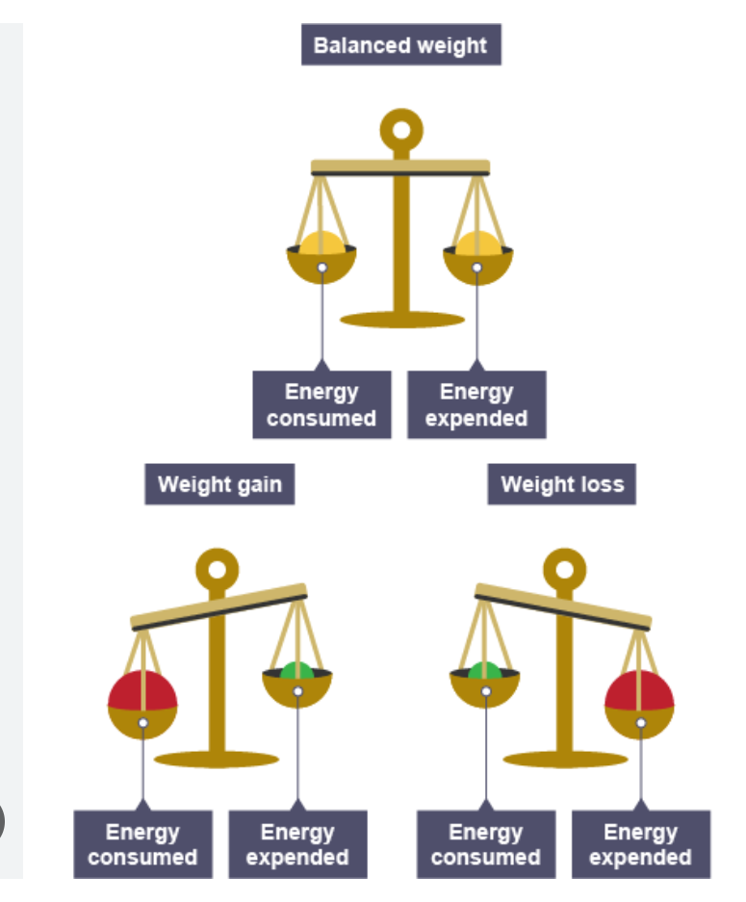
Explanation:
- Balanced Weight: Energy consumed = Energy expended → weight maintenance.
- Weight Gain: Energy consumed > Energy expended → positive energy balance → weight gain.
- Weight Loss: Energy consumed < Energy expended → negative energy balance → weight loss.
This visual effectively demonstrates how variations in energy intake and expenditure influence body weight, highlighting the importance of personalised calorie recommendations.

7. Impact on Dietary Planning
7.1 Weight Maintenance
Weight maintenance requires equilibrium between calorie intake and energy expenditure. This is achieved when individuals consume calories equal to their TDEE. Maintaining this balance is essential for long-term health and metabolic stability.

7.2 Weight Loss (Calorie Deficit)
Weight loss occurs when individuals consistently consume fewer calories than they expend.
Mechanism
A calorie deficit forces the body to utilise stored energy (primarily fat) to meet its energy demands.
Common Methods
- Calorie Restriction: Reducing daily intake by 300–500 kcal
- Intermittent Fasting (IF): Restricting eating to specific time windows (e.g., 16:8 method)
- OMAD (One Meal A Day): Consuming all daily calories in a single meal
- Low-Carbohydrate Diets: Reducing carbohydrate intake to lower overall energy consumption
- High-Protein Diets: Enhancing satiety and preserving lean muscle mass
Advantages
- Promotes gradual and sustainable fat loss
- Improves metabolic health markers
Limitations
- May lead to nutrient deficiencies if poorly planned
- Can slow metabolism over time (adaptive thermogenesis)

7.3 Weight Gain (Calorie Surplus)
Weight gain occurs when calorie intake exceeds energy expenditure.
Mechanism
Excess calories are stored in the body as fat or used for muscle growth when combined with resistance training.
Common Methods
- Calorie Surplus Diet: Increasing intake by 300–500 kcal/day
- Frequent Eating: Consuming multiple meals to increase total intake
- Energy-Dense Foods: Foods high in calories but low in volume (e.g., nuts, oils)
- Strength Training: Encourages muscle hypertrophy rather than fat accumulation
Advantages
- Supports muscle development
- Useful for underweight individuals
Limitations
- Excessive surplus can lead to unwanted fat gain

7.4 Importance of Energy Balance in Dietary Planning
Energy State | Intake vs Expenditure | Outcome
Balanced | Intake = Expenditure | Weight maintenance
Deficit | Intake < Expenditure | Weight loss
Surplus | Intake > Expenditure | Weight gain

Understanding and manipulating energy balance is fundamental to achieving dietary and health goals.

8. Conclusion
Daily calorie requirements vary widely between individuals due to differences in age, gender, body composition, and physical activity levels. While general guidelines provide a useful starting point, personalised calculations using formulas such as BMR and TDEE offer more accurate estimates.
Furthermore, dietary strategies such as calorie restriction, intermittent fasting, and OMAD demonstrate how individuals can manipulate energy intake to achieve specific outcomes, including weight loss or gain. Ultimately, understanding calorie variability is essential for effective dietary planning, long-term health, and sustainable lifestyle management.
9. References (Harvard Style)
- BizCalcs (2024) Daily Metabolism and Calorie Needs Calculator. Available at: https://www.bizcalcs.com
- EatingWell (2023) What Are Calories? Available at: https://www.eatingwell.com
- LumoCalculator (2025) Calorie Calculator: BMR and TDEE. Available at: https://lumocalculator.com
- MolecularIT (2025) Daily Calorie Needs: How Much to Eat. Available at: https://www.molecularit.com
- Vedantu (2025) Calorie Calculator. Available at: https://www.vedantu.com
- Verywell Health (2024) How Many Calories Do I Need? Available at: https://www.verywellhealth.com
- Visual aid available at: https://share.google/D3n4u4ZFQ6Dm3Pgc0

