NutriHelp — QA Regression Report
FE-T2-02

Detailed test cases

1 Auth
ID | Test case / steps | Expected result | Web | Mobile | Evidence (screenshot) | Notes
AUTH-01 | Log in with valid credentials | Authenticated, lands on home/dashboard | Works | Works | 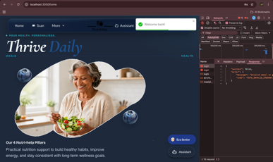  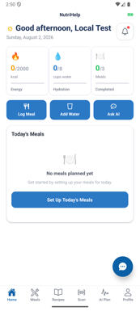
AUTH-02 | Log in with invalid credentials | Clear error, no access | Works | Works | 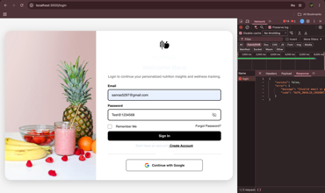  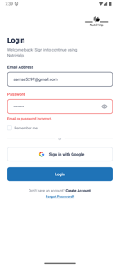 | Web : No access without an error
AUTH-03 | Create a new account / sign up | Account created, signed in | Broken | Broken | 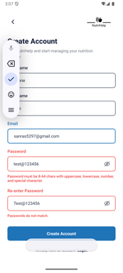  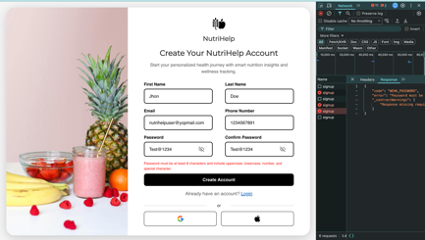 | Web & mobile : Account can’t create Handover-doc mismatch: sign-up was expected to work per the handover/feature set; live testing found account creation broken on both platforms.
AUTH-04 | Forgot / reset password | Reset flow completes | Works | Works | 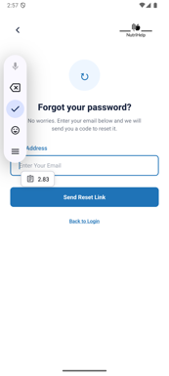  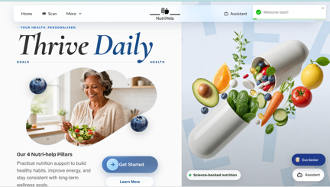 | Mobile: 3-step ForgotPassword flow
AUTH-05 | Log out | Session ends, returns to login | Works | Works | 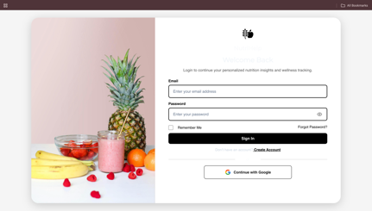  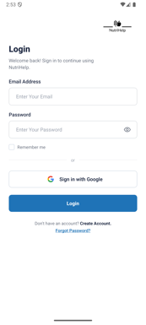

2 Meal Planning
ID | Test case / steps | Expected result | Web | Mobile | Evidence (screenshot) | Notes
MEAL-01 | Generate / create a meal plan | Plan produced from preferences | Works | Works | 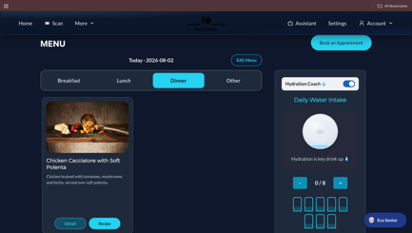  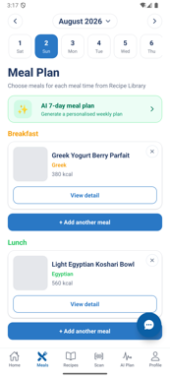 | Mobile: meal image preview is not visible
MEAL-02 | View daily / weekly plan | Plan displays correctly | Works | Works | 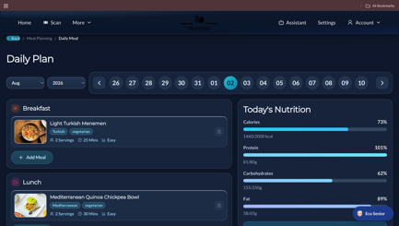 | Mobile: No specific page for weekly plan
MEAL-03 | AI personalised plan flow | Plan generates from inputs | Works | Broken | 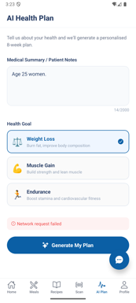  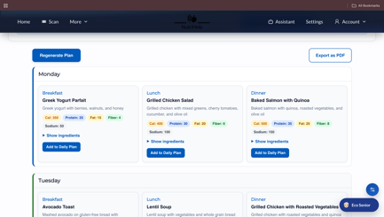 | Mobile: Not working Handover-doc mismatch: AI personalised plan was expected to work; found broken on mobile.
MEAL-04 | Save plan and reopen | Saved plan persists | Works | Broken | 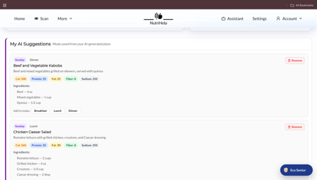 | Mobile: Not working Handover-doc mismatch: save/reopen was expected to persist; found broken on mobile.

3 Recipes
ID | Test case / steps | Expected result | Web | Mobile | Evidence (screenshot) | Notes
REC-01 | Browse recipe list | Recipes load | Works | Works | 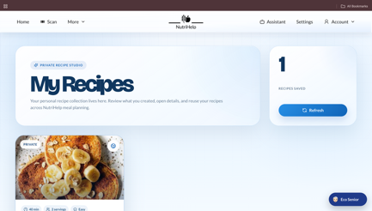  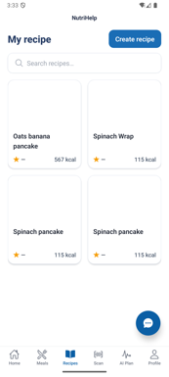 | Mobile: Image preview is not visible
REC-02 | Open recipe detail | Full recipe shown | Works | Works | 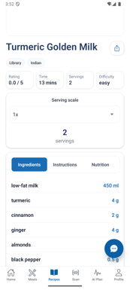  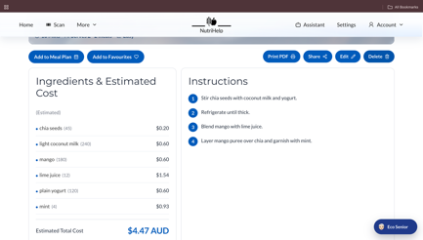 | Mobile: Image preview is not visible
REC-03 | Search / filter recipes | Results match query | Works | Works | 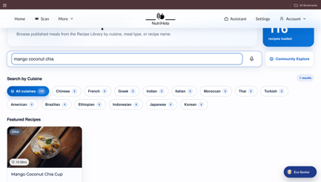  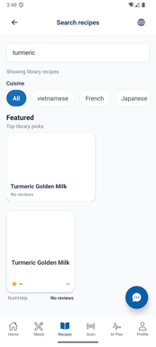
REC-04 | Create a recipe | Recipe saved | Works | Broken | 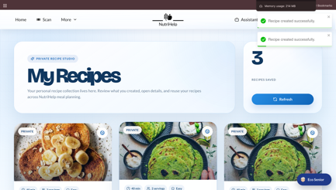   | Mobile: Not working

4 Scan
ID | Test case / steps | Expected result | Web | Mobile | Evidence (screenshot) | Notes
SCAN-01 | Scan a food / barcode | Item recognised | Broken | Broken | 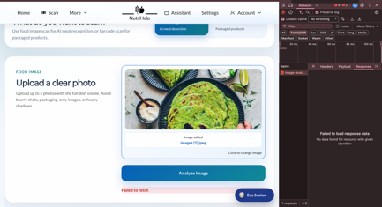  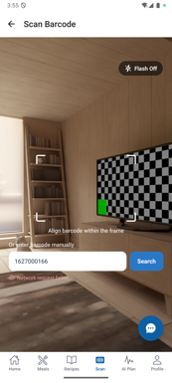 | Mobile: Scan tab (BarcodeScanner) Handover-doc mismatch: Scan was presented as an available feature; found broken on both platforms.
SCAN-02 | View scan result | Nutrition info displayed | Broken | Broken |    | Mobile: ScanProductScreen Handover-doc mismatch: scan-result nutrition display was expected to work; found broken on both platforms.

5 Community
ID | Test case / steps | Expected result | Web | Mobile | Evidence (screenshot) | Notes
COM-01 | View community feed | Feed loads | Works | Placeholder | 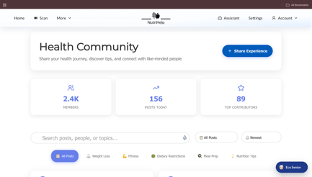 | Web page exists and renders but reachable only via the /community URL — no navigation button (screenshots attached). Mobile: CommunityStack is not mounted in any navigator, so Community is unreachable; screens are placeholders (D-01, D-16).
COM-02 | Create a post | Post appears in feed | Works | Placeholder | 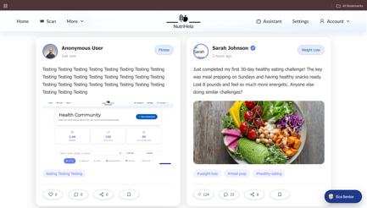 | Web reachable only via URL (no button); mobile unreachable placeholder (D-01, D-16).
COM-03 | Post detail / leaderboard | Content displays | Works | Placeholder | 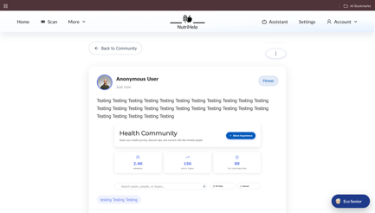 | Web reachable only via URL (no button); mobile unreachable placeholder (D-01, D-16).

6 Admin
ID | Test case / steps | Expected result | Web | Mobile | Evidence (screenshot) | Notes
ADM-01 | Access admin area | Admin-only access enforced | Works | N/A | 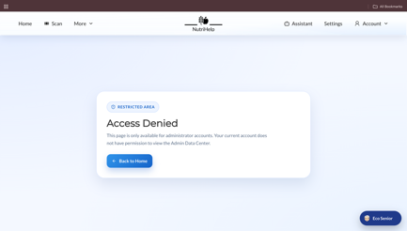 | Web Admin area exists and renders at /admin but reachable only via the URL — no navigation button (screenshots attached); full admin flows not exercised (no admin credentials). Mobile has no Admin (N/A). (D-16)
ADM-02 | Manage users / content | Changes take effect | Not Tested | N/A |  | Web Admin area exists and renders at /admin but reachable only via the URL — no navigation button (screenshots attached); full admin flows not exercised (no admin credentials). Mobile has no Admin (N/A). (D-16)

Defect log
Candidate items from the code-level review; confirm or reclassify during live testing, and add rows as testing surfaces more.
ID | Area | Severity | Description | Status
D-01 | Community (mobile) | High | All Community routes (Feed, Post detail, Create post, Leaderboard) render a shared “Coming soon” placeholder and Community is not in the tab bar - feature not implemented on mobile. Handover implied Community was present on mobile — contradicted (regression). CommunityStack is not mounted in any navigator, so Community is completely unreachable on mobile. | Open
D-02 | Community (web) | Medium | Leaderboard “Progress” shows “Progress feature coming soon…” and its fetch is commented out (FitnessJourney.jsx) - incomplete | Open
D-03 | Meal Planning (mobile) | Medium | MealStack routes EditDailyPlanScreen and MenuScreen are placeholders - edit-plan and menu flows are stubbed | Open
D-04 | Meal Planning (web) | Medium | Shopping List (UI-Only-Pages) uses hardcoded data with TODO “Replace with actual API call when backend is ready” - not backend-wired. Handover doc claimed Shopping List v2 is a “UI-only prototype” — confirmed. | Open
D-05 | Scan (web) | Medium | Scan Products lives under UI-Only-Pages/ScanProducts - appears UI-only with no real backend scan; confirm on web | Open / confirm
D-06 | Account (mobile) | Medium | Built HealthToolsScreen is misrouted: AccountStack points route “HealthToolsScreen” to the placeholder, so the real screen is unreachable | Open
D-07 | Home / Account (mobile) | Low | Several routes are placeholders: HealthNews, HealthNewsDetail, FAQ (Home); DietaryRequirements, ShoppingList, Appointments (Account) | Open
D-08 | Meal / Health (mobile) | Medium | NutritionCalculator and HealthTools render hardcoded MOCK data (MOCK_PIE_DATA / MOCK_CALORIE_DATA) instead of the user’s real data | Open
D-09 | Config (mobile) | Medium | services/healthPlanApi.js and chatbotApi.js hardcode the backend URL instead of EXPO_PUBLIC_API_BASE_URL used by baseApi — env changes won’t apply to AI plan/chatbot | Open
D-10 | Config (mobile) | Medium | .env.example sets EXPO_PUBLIC_AI_MODEL_URL=http://localhost:8000 — AI meal plan and chatbot are unreachable from a device/emulator with the default | Open
D-11 | Config (web) | Medium | Many calls default to https://localhost:8443 when REACT_APP_API_BASE_URL is unset (auth, home contact/subscribe, water, chat) — fail outside local dev | Open
D-12 | Security / hygiene (mobile) | Low | A Supabase anon JWT is committed in .env.example. Anon keys are public by design, but example files should not carry live keys | Open
D-13 | Security / hygiene (web) | Low | Firebase web apiKey is hardcoded in src/utils/firebase.js. Firebase web keys are public by design, but should come from env/config | Open
D-14 | Reliability (mobile) | Low | Empty catch blocks swallow errors in HealthConditionsContext, FloatingChatbot/ChatModal and WaterTracker — failures are silent | Open
D-15 | Admin (mobile) | Low | No Admin capability on mobile (web-only) | By design / confirm
D-16 | Navigation (web) | Medium | Web Community (/community) and Admin (/admin) pages exist and render, but have no navigation links/buttons anywhere in the UI — reachable only by manually entering the URL, so users cannot discover them. | Open

