FE-T2-03
UI Library Audit
MUI / Semantic UI → Ant Design

Migration Plan

Prepared by: Thisarani Upayangika Uggallage

Sprint: Sprint 1

Date: 26 July 2026

TABLE OF CONTENTS

1. Introduction ..................................................................................... 3

2. Objective ......................................................................................... 3

3. Audit Method .................................................................................... 4

4. Audit Findings ................................................................................... 8
4.1 Material UI Components ..................................................... 8
4.2 Semantic UI React Components.......................................... 9

5. UI Library Dependency Inventory………………………………………………….14-15

6.Ant Design Availability ........................................................................15

7. Ant Design Equivalents ......................................................................16
8. Components Requiring Design Sign-off……………….……………….………..16
9. Sprint 2 Migration Plan and Acceptance Criteria ................................ 16-20

10. Conclusion .................................................................................... 20

References .......................................................................................... 21

1. Introduction
The frontend application currently makes use of a number of UI libraries, such as Material UI (MUI) and Semantic UI. Although both of these libraries offer reusable interface components, the fact that multiple UI libraries are employed increases the complexity of development, leads to inconsistencies in the user interface, and makes future maintenance more difficult.
The audit covers all the present use of Material UI and Semantic UI components in the project and establishes a migration plan with the aim of standardising the frontend on Ant Design. The task consists solely of conducting the analysis and preparing the plan; it includes no actual code changes. (Gopher Industries, 2026).
2. Objective
This task was intended to audit the frontend part of the NutriHelp application in order to find all the Material UI and Semantic UI React components that are currently in use in the project, and it also sought to estimate the amount of effort needed to replace those components with Ant Design as well as to identify any possible problems that might arise during the migration.
A concrete and well-defined plan is needed to consolidate the NutriHelp frontend onto a single UI library with the FE-T2-03 ticket. This ticket includes the audit and planning phases only and does not involve any code migration during Sprint 1 (NutriHelp Frontend Team, 2026).

3. Audit Method
The initial synchronisation of the project with the most up-to-date version of the master branch was conducted using Git in order that the audit might be completed on the most recent source code.
To locate all the imports of Material UI and Semantic UI React within the src directory, the global search feature of Visual Studio Code was used.
The following research was carried out:
• @mui/material
• semantic-ui-react
Each of the matching files was opened and examined separately to identify the components that had been imported and to understand how they were being used.
Finally, the installed Ant Design version was verified using npm.

Evidence
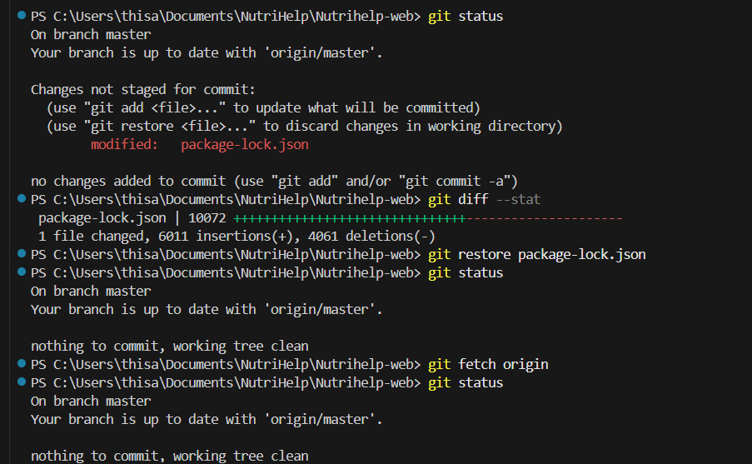
Figure 1. Git repository synchronised with the latest master branch before beginning the audit.

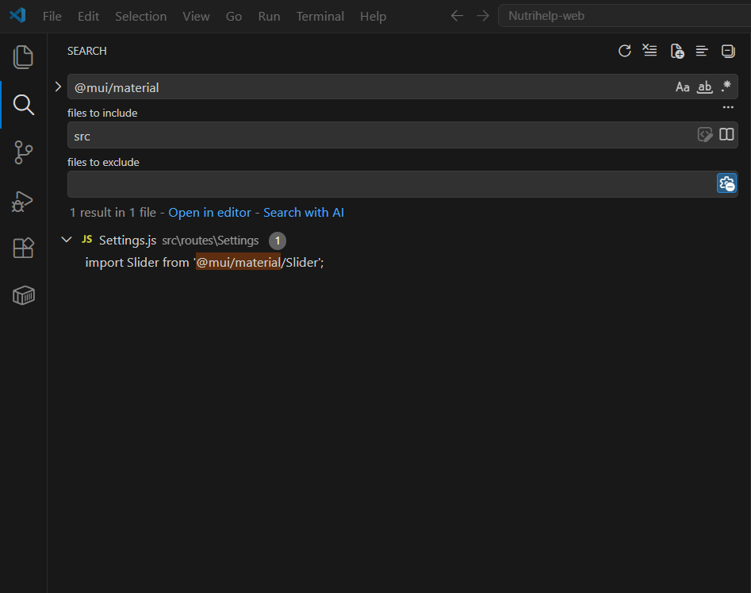
Figure 2. Global search showing the only Material UI import found in the project.
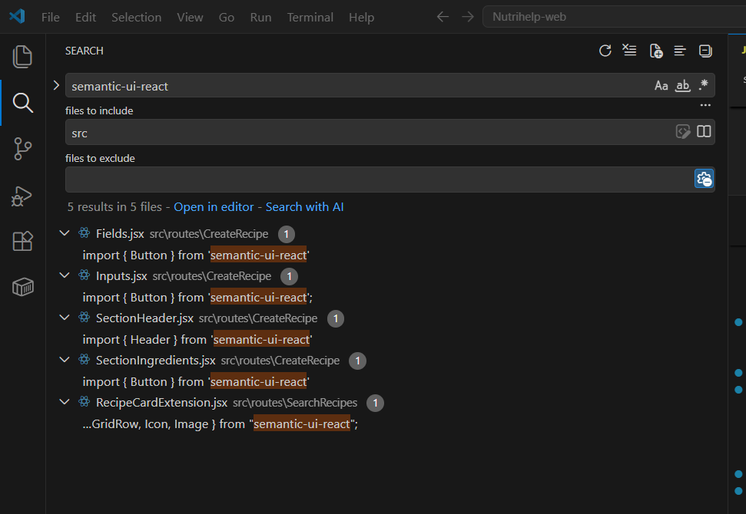Figure 3. Global search showing all Semantic UI React imports identified in the project.

4. Audit Findings
4.1 Material UI Components
Only one Material UI component was found.
File | Component | Complexity
src/routes/Settings/Settings.js | Slider | Medium

The Slider component is customised with styling and additional properties such as minimum value, maximum value, step size and value labels. Because of these customisations, replacing it with the Ant Design Slider will require some styling adjustments, although the migration complexity is considered moderate.
Evidence
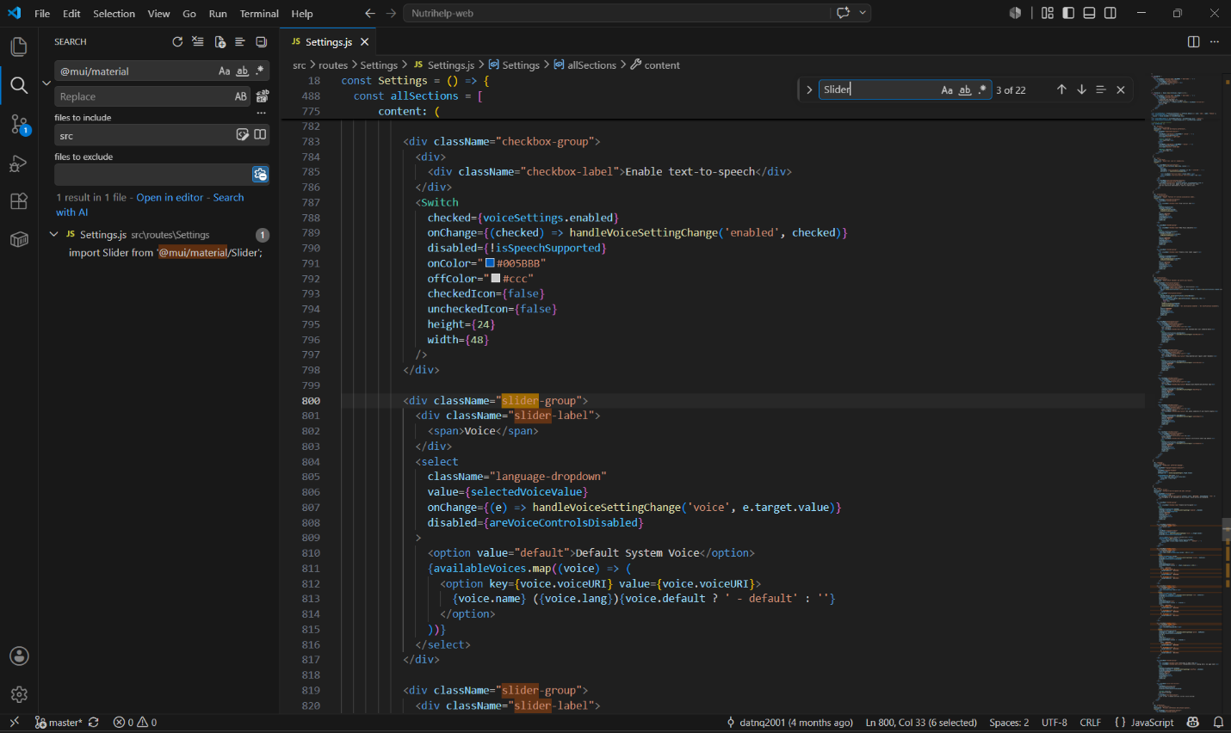
Figure 4. Material UI Slider implementation inside Settings.js.

4.2 Semantic UI React Components
Five files currently use Semantic UI React.
File | Components Used | Estimated Complexity
Fields.jsx | Button | Low
Inputs.jsx | Button | Low
SectionHeader.jsx | Header | Low
SectionIngredients.jsx | Button | Low
RecipeCardExtension.jsx | Grid, GridRow, GridColumn, Icon, Image | High

Most files only have a Button or Header component, which makes the migration easy.
The file RecipeCardExtension.jsx has layout components and icons that are very connected, to the page layout. The RecipeCardExtension.jsx file has a higher migration risk because its layout and visual components are closely connected. A review of the frontend source found no dedicated automated test file for this component. Therefore, Sprint 2 should include creating appropriate component tests for RecipeCardExtension.jsx, in addition to regression testing after the migration.

Evidence
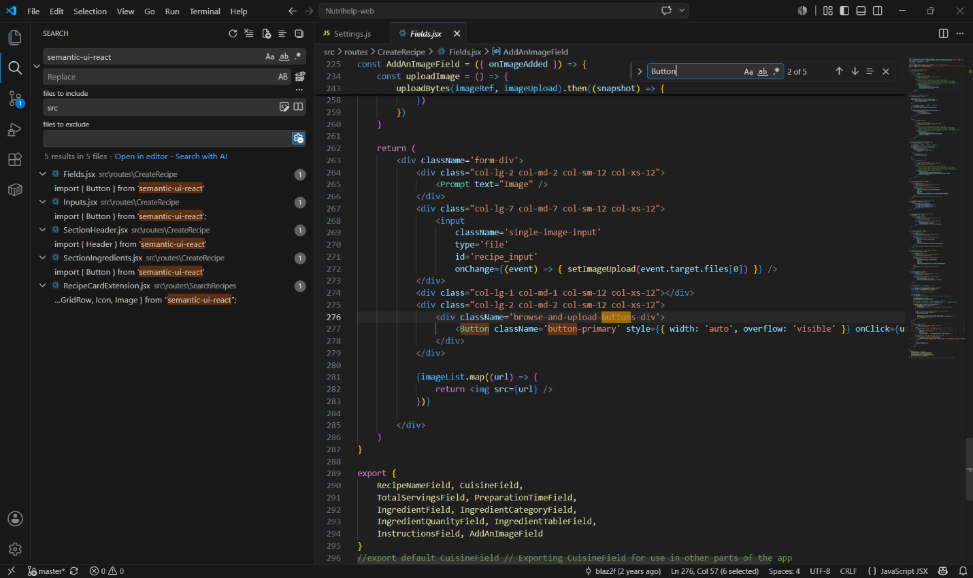
Figure 5. Button component used in Fields.jsx.
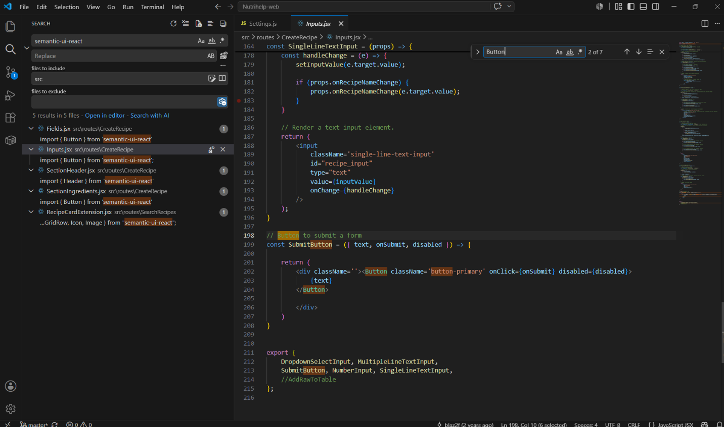
Figure 6. Button component used in Inputs.jsx.

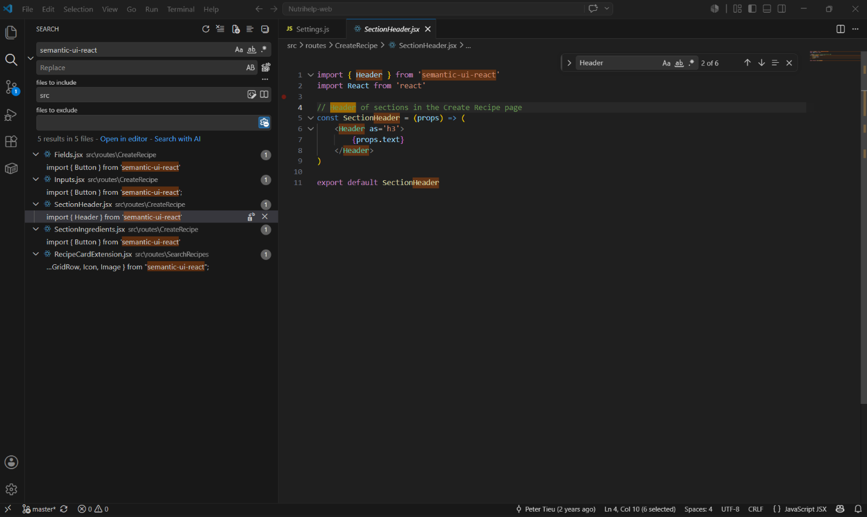Figure 7. Header component used in SectionHeader.jsx.
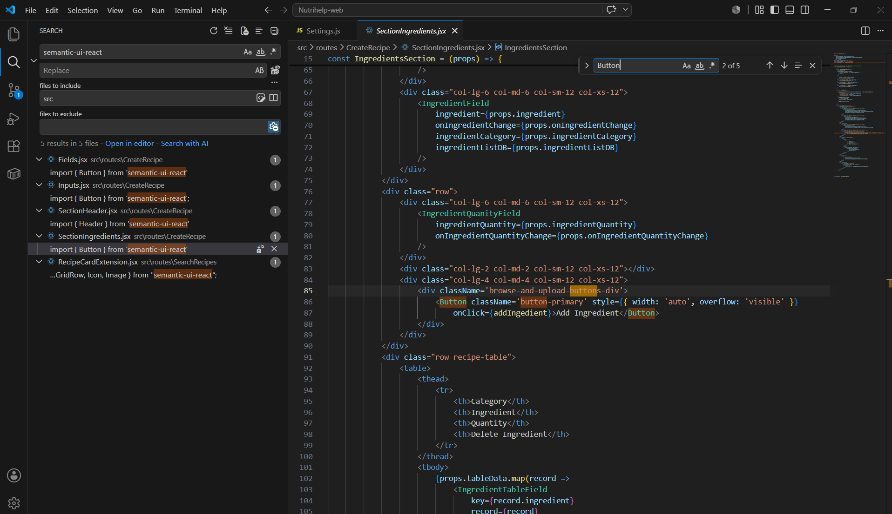
Figure 8. Button component used in SectionIngredients.jsx.

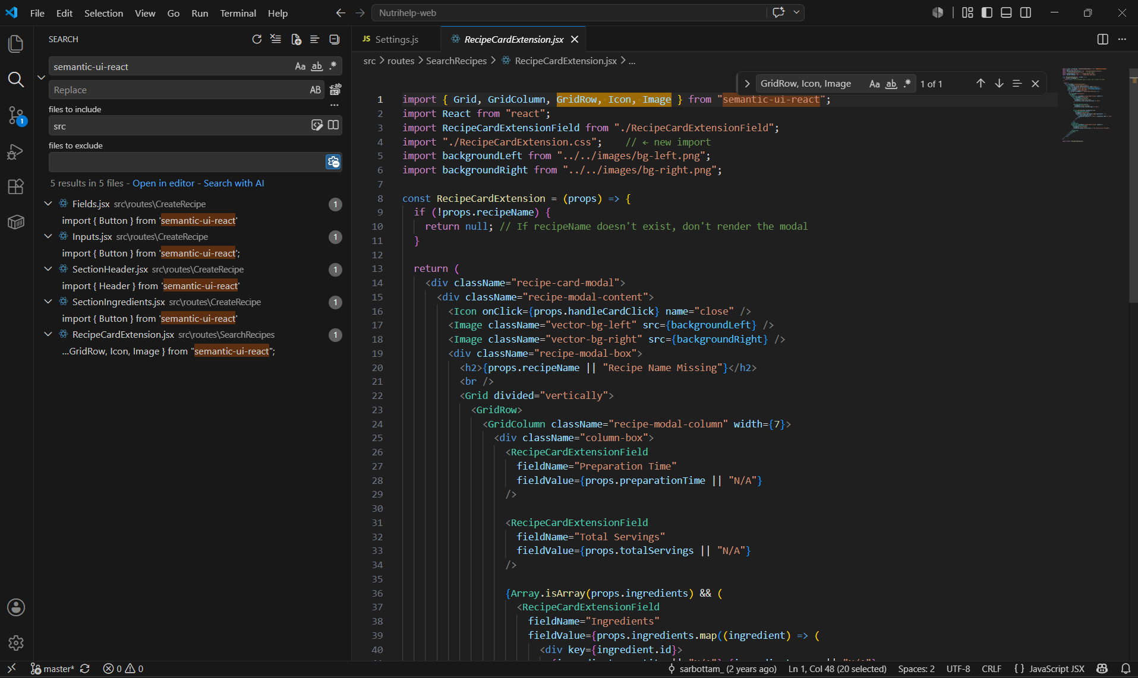Figure 9. Multiple Semantic UI React components used in RecipeCardExtension.jsx.

5. UI Library Dependency Inventory
Existing UI Library Dependencies
Package | Installed Version | Purpose | Planned Action
@mui/material | 7.3.6 | Provides the Material UI Slider component used in Settings.js. | Remove after the Slider has been migrated to Ant Design.
@emotion/react | 11.14.0 | Styling dependency required by Material UI. | Verify no remaining Material UI components depend on it before removal.
@emotion/styled | 11.14.1 | Styling dependency required by Material UI. | Remove together with Material UI after confirming it is no longer required.
semantic-ui-react | 2.1.4 | Provides the Button, Header, Grid, GridRow, GridColumn, Icon and Image components currently used by the project. | Remove after all Semantic UI components have been migrated.
semantic-ui-css | 2.5.0 | Provides Semantic UI styling and CSS resources. | Remove after migration and after confirming no remaining CSS imports exist.
antd | Declared version in package.json: ^5.22.3  Current installed version: 5.29.3 | Target UI library for the migration. | Keep as the project's standard UI library.

The UI dependencies were checked against both package.json and package-lock.json. The current local Ant Design installation was also confirmed using npm. These items create a list to help with Sprint 2 cleanup. Outdated UI dependencies should only be deleted after the migration is done after testing shows everything works and after there are no imports left in the project.
6. Ant Design Availability
The Ant Design package is already installed in the project.
Installed version:
antd 5.29.3
@ant-design/icons is not declared as a direct project dependency in package.json. It is present as a dependency of Ant Design in package-lock.json. If Sprint 2 requires direct icon imports, the team should confirm whether it needs to be added explicitly as a direct dependency.This means the migration can begin without installing the main Ant Design library, although icons may need to be added later if required.
Evidence
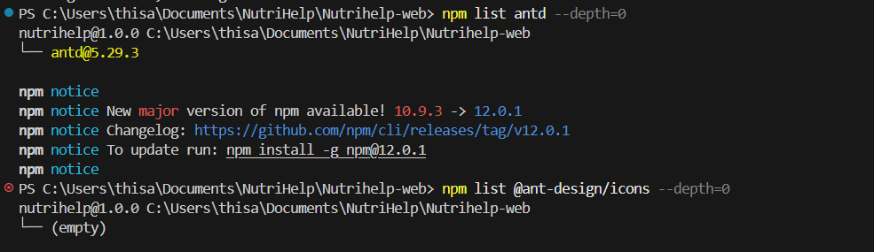
Figure 10. Terminal output confirming Ant Design installation.

7. Ant Design Equivalents
Current Library | Component | Ant Design Equivalent | Complexity
Material UI | Slider | Slider | Medium
Semantic UI | Button | Button | Low
Semantic UI | Header | Typography.Title | Low
Semantic UI | Grid | Row / Col | Medium
Semantic UI | GridRow | Row | Medium
Semantic UI | GridColumn | Col | Medium
Semantic UI | Icon | Icons package | Medium
Semantic UI | Image | Image | Low

8. Components Requiring Design Sign-off
The Settings.js Slider should be reviewed after migration to ensure its styling and behaviour remain consistent with the current interface. The RecipeCardExtension component should also be reviewed because replacing the Semantic UI Grid layout with Ant Design Row and Col components may affect spacing, alignment and responsiveness.
9. Sprint 2 Migration Plan
Based on the audit findings, Sprint 2 should begin by replacing the Button components in the CreateRecipe module because they have the lowest migration complexity. The Header component should then be migrated, followed by the Material UI Slider in Settings.js. The RecipeCardExtension component should be migrated last because it contains multiple layout and visual elements that require additional testing. After all components have been migrated, regression testing should be completed before removing unused UI library dependencies.

Proposed Sprint 2 Tickets
Sprint 2 Task | Files | Estimated Effort | Estimated effort
Ticket 1 – Migrate Button Components | Fields.jsx, Inputs.jsx, SectionIngredients.jsx | Low | 3-4 hours
Ticket 2 – Migrate Header Component | SectionHeader.jsx | Low | 2-3 hours
Ticket 3 – Migrate Material UI Slider | Settings.js | Medium | 4-6 hours
Ticket 4 – Migrate Layout Components | RecipeCardExtension.jsx | High | 6-8 hours
Ticket 5 – Final Testing and Cleanup | Entire project | Medium | 4-6 hours
Effort Estimation: The estimated effort is shown as a range of implementation hours, for Sprint 2 planning. This Effort Estimation includes component replacement, styling and layout adjustments, functional verification, accessibility checks and required testing. Actual effort may vary depending on design sign-off issues identified during regression testing and the amount of existing test coverage.
Sprint 2 Acceptance Criteria
Button components – Fields.jsx, Inputs.jsx and SectionIngredients.jsx
- Semantic UI Button imports need to be changed to Ant Design Button components.

- Button click actions and disabled states should still function properly.

- Buttons should be accessible through keyboard navigation.

- Buttons should have an visible focus state.

- Buttons should have accessible names.

- The Create Recipe layout should stay responsive, on desktop screens and tablet screens and mobile screen sizes.

Header component – SectionHeader.jsx
- The Semantic UI Header must be replaced with the appropriate Ant Design Typography component.
- The heading text and hierarchy must remain correct.
- The component must remain readable and correctly aligned across different screen sizes.
- Spacing and appearance must receive design approval.
Slider – Settings.js
- The Material UI Slider needs to be replaced with the Ant Design Slider.

- The Ant Design Slider must have the minimum maximum, step and value behaviour, as the original.

- The Ant Design Slider must continue to work with keyboard interaction.

- The Ant Design Slider must show a focus state.

- The Ant Design Slider must have a name.

- The Ant Design Slider layout must stay responsive.

- The Ant Design Slider that is migrated must get design sign-off.

RecipeCardExtension.jsx
- Semantic UI Grid, GridRow and GridColumn components must be replaced with Ant Design layout components.

- Image and Icon components must be replaced with suitable Ant Design or approved project alternatives.

- If Ant Design icons are selected for the migration add @ant-design/icons as a direct project dependency and update package.json and package-lock.json accordingly. Verify that the required icons import and render correctly after migration.

- Recipe information must remain visible and correctly aligned.

- The layout must remain responsive across mobile, tablet and desktop widths.

- Interactive elements must support keyboard navigation and visible focus.

- Images and interactive controls must have appropriate accessible names or alternative text.

- Existing recipe-card functionality must continue to work after migration.

- Create automated component tests, for RecipeCardExtension.jsx as no dedicated test file was found during the frontend source review. The tests should check that the moved component displays properly keeps recipe-card features and actions and follows the intended responsive design behavior.

- The final layout must receive design sign-off.

Final testing and cleanup
- Search the project and confirm there are no remaining @mui/material imports.
- Confirm there are no remaining semantic-ui-react imports.
- Confirm unused Semantic UI CSS imports are removed.
- Confirm keyboard navigation and focus behaviour work correctly.
- Confirm accessible names are present where required.
- Confirm text and interactive UI elements meet WCAG 2.1 AA colour-contrast requirements, including at least 4.5:1 for normal text and 3:1 for large text and relevant UI components
- Confirm affected pages remain responsive.
- Confirm Create Recipe and RecipeCardExtension functionality still works.
- Run the existing frontend test suite together with the newly created RecipeCardExtension.jsx component tests and confirm that all relevant tests pass.
- Remove unused UI dependencies only after all migration and testing is complete.
- Verify that affected migrated components have appropriate automated or regression test coverage and add further tests where required before final migration sign-off.

10. Conclusion
The audit identified one Material UI component and five files using Semantic UI React. Most components have low to medium migration complexity and can be replaced with equivalent Ant Design components with relatively limited implementation effort. RecipeCardExtension.jsx requires additional attention because it depends on multiple layout and visual components and currently has no dedicated automated test file identified within the reviewed frontend source. Since Ant Design is already installed, the project is ready to proceed to the migration phase.
The findings from this audit give a picture of the current UI library usage in the NutriHelp frontend application. The suggested migration plan and Sprint 2 task sequence create a way to move the project to Ant Design while keeping migration risks low and making sure the user interface stays consistent. This audit can be used as a guide, for migration work and help with planning during the next sprint.

References
Gopher Industries 2026, NutriHelp Project Handover Document, Trimester 1, 2026, internal project document, Gopher Industries.
NutriHelp Frontend Team 2026, NutriHelp Frontend Sprint 1 Detailed Task Breakdown, Trimester 2, 2026, internal project planning document, Gopher Industries.

