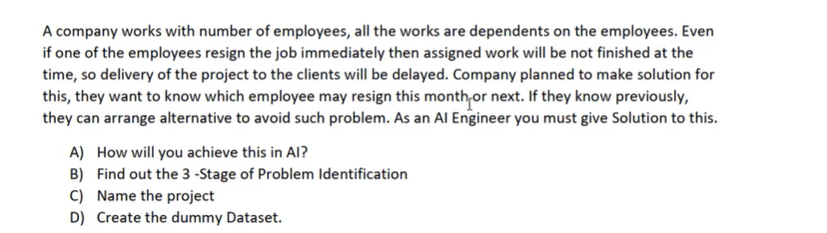

Emp ID | Experience | Resignation Date | Output lable prediction
1212 | So and so years experience | So and so date | Based on prev data we can predict whether the emp will resign or not
423 | So and so years experience | So and so date | Based on prev data we can predict whether the emp will resign or not

Note: Each company will have a set of data like emp joining date, resign date and with experience so we can predict it according to the data
Project: Attrition Prediction
I/P is already clear we know it already have a database so it is--- ML – requirement is clear to predict the output so it is Supervised
O/P we have to categorize it accordingly – Supervised learning – Classification
ML---Supervised Learning – Classification

