External VPN Windows AnyConnect client guide

Version 0.3

Document Information:
Prepared by: | Piotr Witkowski [piotr.witkowski@harman.com] | Prepare Date: | 08.04.2020
Reviewed by: |  | Review Date:

Version History:
Ver. No. | Ver. Date.  dd/mm/yyyy | Revised by | Description | Filename
0.1 | 08.04.2020 | Piotr Witkowski | Initial draft | External_VPN_Windows_client_guide
0.2 | 30.08.2020 | Piotr Witkowski | Initial draft | External_VPN_Windows_client_guide
0.3 | 04.11.2020 | PiotrWitkowski | Added DUO | External_VPN_Windows_client_guide
0.4 | 21.08.2021 | Piotr Witkowski | Minor fixes | External_VPN_Windows_client_guide

Table of Contents:

1. Purpose of document 4
1. AnyConnect External VPN service 4
2. Supported systems 4
3. How to read this document 4
4. Prerequisites 4
5. Installation 4
6. Establish VPN connection to Harman 5
7. Cisco DUO MFA application 6

Purpose of document

Purpose of this document is to provide instruction for external contractors / consultants how to install AnyConnect VPN application on Windows based systems.

AnyConnect External VPN service

Cisco AnyConnect External VPN service is method of accessing Harman resources while being connected to untrusted network. Untrusted network means any IP enabled network which is not under Harman authority for instance: customer network, home broadband network, 3G/4G/5G mobile network, free Wi-Fi network at airport or any other public places.

IP network MUST provide access to Internet on port 443 for both TCP and UDP (DTLS) protocols. Port UDP/443 is not mandatory but assure the best performance and quality.

Supported systems

AnyConnect for Windows supports only below Windows family systems

- Windows 7 SP1 x86 (32bit) and x64(64bit)
- Windows 8 x86 (32bit) and x64(64bit)
- Windows 8.1 & 10 x86 (32bit) and x64(64bit)
- Windows 10 RS1, RS2 & RS3 (32bit) and x64(64bit)

How to read this document

Enabling Harman AnyConnect VPN client on Windows is relatively simple process. Therefore, go through all below points. Don’t miss anything!

Prerequisites

Before you install and connect first time you need to follow below prerequisites points

- You should receive account (Login/Pass) credentials from your Harman contact person
- You should have provisioned Harman Multi Factor Authentication MFA app on your mobile device.
- Ask Harman contact person for help if you haven’t received any.
- You should receive e-mail from Harman contact person which contains URL links for AnyConnect binaries for specific platform. Download all related files.

Installation

- Unzip archived file anyconnect-windows-client.7z.
- After unzipping, you should receive file “anyconnect-win-XXXXXXX-core-vpn-predeploy-k9.msi” and directory /Profiles/vpn/vpn-external.xml.
- Start installation of MSI file by double click or right click + Install. Click “Next” to start and finish installation process.
- Open AnyConnect app. AnyConnect app should look like below:
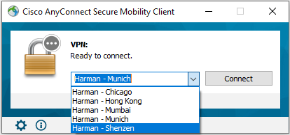

Establish VPN connection to Harman

- Decide to which gateway you wish to connect.
- Harman recommends connecting to the gateway which is the closest to destination server or application which you want to connect. For example, if you are based in Europe and want to connect to server / application which is hosted in Harman US region. It’s better to connect “Harman Chicago”.
- In some cases, it’s better to connect to the closest gateway of your physical location. For example, users in China may prefer to connect via “Harman – Shenzhen” gateway.

- Click connect to establish VPN connection
- Provide credentials
- Username: Login-name provided by Harman
- Password: Password provided by Harman
- Second Password: 6-digit code generated by your Multi Factor authentication app installed on device (mobile).
- Second Password [push] – Instead of typing 6-digit code which may not always be convenient, there is an option to type “push” string. Immediately on mobile device push message appears from DUO app. Just click “Approve” to get connected.
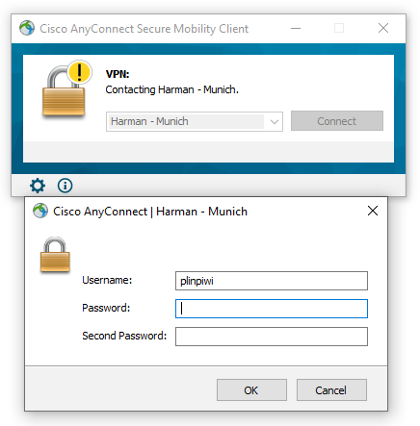

- Indication “connected” in bottom-right corner notifies about successful VPN connection



- User may disconnect anytime by clicking “disconnect” button.
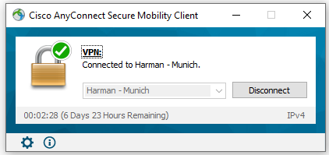

Cisco DUO MFA application

- Cisco DUO is MFA (multi-factor-authentication) app which provides second authentication method
- DUO can be provisioned via self-service portal https://mfaselfservice.harman.com/
- After DUO is activated it should look like below
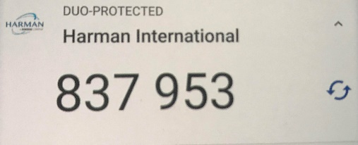
Hide button
refresh button
- Important note: The same code cannot be used twice. In order to get new code, you must:
  - Click “refresh” button
  - Click “hide” button (new code is then generated every 15sec)
  - Close / Open app (app must be completely closed on the system)
- Instead of typing 6-digit code, there is possible to type “push” string as secondary password. Push message will be sent immediately to mobile in order to “approve”. After its approved VPN connection will be established.

