Persistence of Vision (POV) Globe
A Mini Project Report submitted in partial fulfillment of the academic requirement for the award of the degree of
BACHELOR OF ENGINEERING
In
ELECTRONICS AND COMMUNICATION ENGINEERING
By

G. Dheekshith 1602-22-735-014
P. Gopi Krishna 1602-22-735-015
D. Rakesh 1602-22-735-044
Under the guidance of
Dr. K. Krishna Kishore
Associate Professor, E.C.E



Department of Electronics and Communication Engineering Vasavi College of Engineering (Autonomous)
ACCREDITED BY NAAC WITH 'A++' GRADE
IBRAHIMBAGH, HYDERABAD-500031 2022-2026

Department of Electronics and Communication Engineering Vasavi College of Engineering (Autonomous)
ACCREDITED BY NAAC WITH 'A++' GRADE
IBRAHIMBAGH, HYDERABAD-500031
CERTIFICATE
This is to certify that the Mini project work titled,
“Persistence of Vision”

G. Dheekshith 1602-22-735-014
P. Gopi Krishna 1602-22-735-015
D. Rakesh 1602-22-735-044

submitted by students of Electronics and Communication Engineering Department, Vasavi College of Engineering in partial fulfillment of the requirement for the award of the degree of Bachelor of Engineering in Electronics and Communication Engineering is a record of the bonofide work carried out by them during the academic year
2024-2025. The result embodied in this mini project report has not been submitted to any other university or institute for the award of any degree

Internal Guide Head of the Department
Dr.K.Krishna Kishore Dr. E. SREENIVASA RAO
Associate Professor Professor & HoD
E.C.E Department E.C.E Department

External Examiner

DECLARATION

This is to state that the work presented in this theme-based project report titled "Persistence of Vision (POV) Globe" is a record of work done by us in the Department of Electronics and Communication Engineering, Vasavi College of Engineering, Hyderabad. No part of the thesis is copied from books, journals, or the internet, and wherever the portion is taken, the same has been duly referred to in the text. The report is based on the project work done entirely by us and not copied from any other source. I hereby declare that the material embedded in this thesis has not been submitted by me and my team in full or in part for the award of any degree or diploma from any other institution or university previously.
Signature of the students

G. Dheekshith 1602-22-735-014
P. Gopi Krishna 1602-22-735-015
D. Rakesh 1602-22-735-044

ACKNOWLEDGEMENT

This satisfaction and euphoria that accompany the successful completion of any task would be incomplete without the mention of the people whose constant guidance and encouragement made it possible. We take pleasure in presenting before you our project, which is the result of a studied blend of both research and knowledge.
It is our privilege to express our earnest gratitude and venerable regards to our internal guide,Dr. Krishna Kishore , Associate Professor, E.C.E. Department, Vasavi College of Engineering, Ibrahim Bagh, for abounding and able guidance during the preparation and execution of the project work. We are grateful for his cooperation and his valuable suggestions.
We record with pleasure our deep sense of gratitude to Dr. E. Sreenivasa Rao, Head of the Department, E.C.E., for his simulating guidance and profuse assistance we have received, which helped throughout the project.
Our sincere thanks to the Principal and Management, Vasavi College of Engineering, Hyderabad, for providing all the facilities and carrying out the project successfully.
Also, we acknowledge with thanks the support extended by all the staff members and technical staff in shaping up our project. We are thankful to one and all who cooperated with us.during our project work.
G. Dheekshith 1602-22-735-014
P. Gopi Krishna 1602-22-735-015
D. Rakesh 1602-22-735-044

ABSTRACT

The term persistence of vision has come to be seen as inadequate to fully describe this very complex physiological reality; it remains a standard expression, and, as such, it serves as a useful metaphor.
Persistence of vision, as it is called, essentially prevents the world from becoming completely dark every time we blink. When light hits the retina, it leaves an impression on the brain that lasts for roughly 16–15 s after the light source is obscured from view. It is the result of an extended chemical process. Because of this, changes in light that happen faster than this retention period are not easily distinguished by the eye.
The LED Globe project achieves the phenomenon of persistence of vision by combining light-emitting diodes with a brushless motor and high velocity. According to the hypothesis of persistence of vision, an image can be seen by humans if it remains on the retina for about 1/16th of a second after it has been withdrawn.
To display the LEDs mounted on the ring, this project employs a manufactured ring that is fastened to the motor and a stable structure. The code that is delivered to the microcontroller, which then sends data to drive and control the LEDs, creates the globe image.
Microcontrollers, brushless motors, and lighting-emitting diodes are index terms.

INDEX

  - INTRODUCTION
    - DESCRIPTION:
    - AIM & OBJECTIVE
  - LITERATURE REVIEW
    - PAST THEORIES
    - OVERVIEW
  - SYSTEM DESIGN
    - CIRCUIT DIAGRAM
    - BLOCK DIAGRAM
    - MECHANICAL DESIGN
    - ELECTRICAL DESIGN
    - SOFTWARE DESIGN
  - SYSTEM COMPONENTS
    - ARDUINO MEGA 2560:
    - WS2812B SMART LED STRIP:
    - PROXIMITY SENSOR:
    - DC MOTOR:
    - MOTOR PULLEY
    - 608ZZ BEARINGS
    - 3D PRINTED PARTS
    - ARDUINO IDE

  - METHODOLOGY
    - HARDWARE
    - CONTROL DESIGN
    - SYNCRONISATION OF POV DISPLAY
    - RESOLUTION OF THE POV DISPLAY
    - POWER CONSIDERATIONS
      - MICRO CONTROLLER POWER SUPPLY
      - MOTOR POWER SUPPLY
    - PROGRAMMING AND TESTING
      - PROGRAM

0.6 RESULTS

0.7 CONCLUSION

0.8 REFERENCE

INTRODUCTION:

0.1.1 DESCRIPTION

All that the LED globe is a display that seems to the human eye to be a solid sphere of light. People are constantly bombarded with information these days, and most of the time, the most effective way to provide it is visually. People require a wide variety of information for their everyday needs, but when they venture outside and onto public roads, they rely on signs for directions. Simultaneously, they encounter informational banners wherever they go.
At the same time, people’s attention spans are influenced by how information is presented; hence, design is crucial to the broadcast of information. Information is displayed in one plane and one direction on conventional banners, LED signs, and TVs. Depending on the type of displayer, these might be highly costly. .

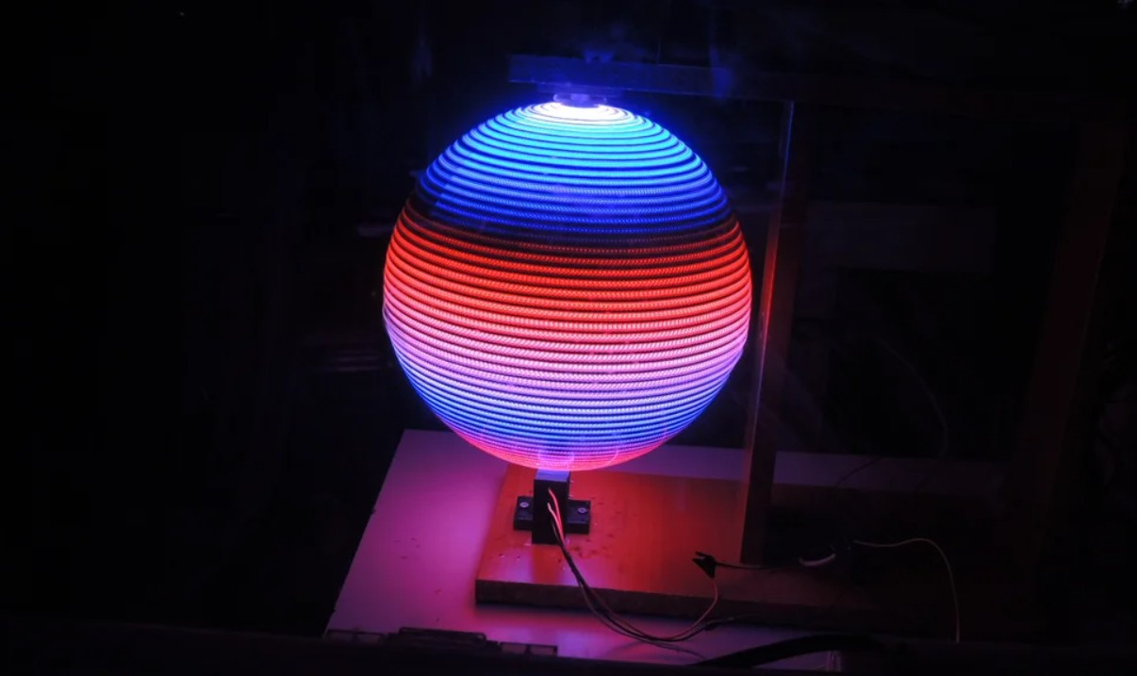

Fig-1

    - AIM & OBJECTIVE

LED Globe’s concept is to create a device that can show data in three planes with a very high resolution, depending on the design.
It is impossible for someone to overlook this glowing orb promoting businesses or products or showing directions when driving on a highway or any other dark route with poor visibility.
If we take the example of the highway exposed above again, people on the same highway or on any horizontal plane will be able to see the information displayed by the same device when they travel in both directions of the highway. This is because the application can be used to deliver information that can be seen horizontally from two opposite sides on the horizontal plane.
The LED globe must be able to light up the LEDs at a certain location and time to show a user-programmed image or text. As little power as possible should be used by all internal parts. Additionally, the system needs to be secure for the environment and the user.

LITERATURE REVIEW:

    - PAST THEORIES

These are the ideas and theories from earlier projects. This project examines how it relates to current research and theory while elucidating the approach and viewpoint used in previous initiatives. This demonstrates how the project has used the theory and concept.
By rotating a row of one-dimensional LEDs through a two-dimensional environment at a high enough frequency to produce a visible
three-dimensional display, Aditya Patel et al.’s POV display makes use of this phenomena. The Raspberry Pi, a quick and programmable credit card-sized computer, is linked to the LED matrix. When connected to a Raspberry Pi-compatible touch pad, the display is easy to operate. The device introduces a new, hassle-free category of display device since the touch pad makes sure that no programming is required at the user level.
Mr. Bedke Tushar, et al. The persistence of vision (POV) display’s design and creation are the project’s goals. Users can upload images to the display for wireless transmission. The term "persistence of vision" (POV) describes an afterimage that appears in the human eye for a short period of time (10 ms). By spinning a row of one-dimensional LEDs through a two-dimensional environment at a high enough frequency to make a two-dimensional display visible, a POV display takes use of this phenomena.

    - OVERVIEW

A POV display is a display made by quickly spinning an LED array. With the limited processing speed of human sight, the rapidly spinning LEDs seem as a solid display.
Despite several POV projects being created, they often share the trait of having LEDs positioned perpendicular to the circuit plane. Because there are only so many LEDs available, this could result in restrictions on the characters and figures that can be displayed.
Displaying a Globe:
The POV globe can display a rotating map of the Earth. The microcontroller is programmed with the map data, which it uses to control the LEDs.
As the arm spins, different sections of the map are displayed, creating the illusion of a complete globe. As a result, one can alter the display to suit their requirements.
A POV globe combines principles of electronics, mechanics, and human visual perception to create an engaging and interactive display.

SYSTEM DESIGN

The entire design of this project falls into three categories: software, mechanical, and electrical design. This project has a very clear reasoning behind it. With our design, trade-offs between the hardware and software designs can be made independently of one another.

    - CIRCUIT DIAGRAM

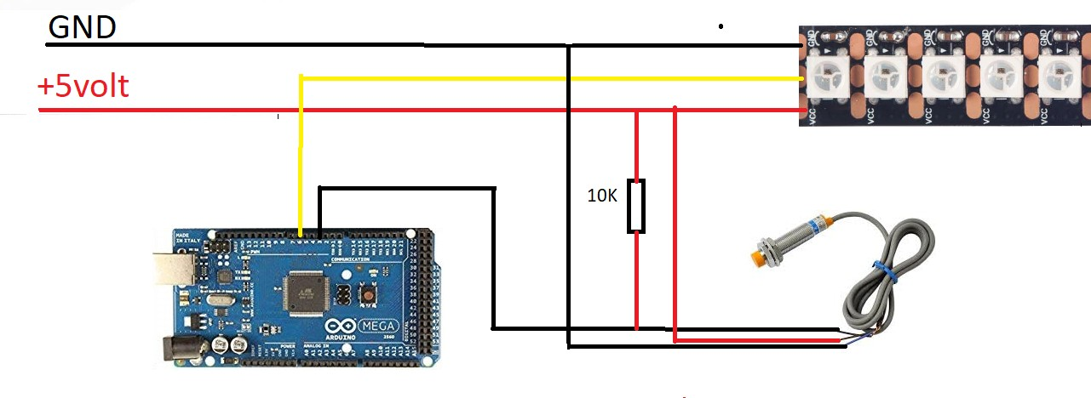
Fig-2

This circuit diagram appears to involve an Arduino Mega, a strip of WS2812B LEDs (commonly known as NeoPixels), and a sensor (possibly a temperature sensor or similar) with a pull-up resistor.
Here’s a detailed explanation of the circuit:
- Power Connections:
- +5V and GND: The red line indicates the +5V power line, and the black line indicates the GND (ground) line. These lines are distributed to the Arduino Mega, the WS2812B LED strip, and the sensor.
- WS2812B LED Strip:
- Data Line (Yellow): This line connects the data input of the LED strip to a digital output pin on the Arduino Mega. The data line carries the signal that controls the LEDs.

  - Power Lines: The LED strip is powered by the +5V and GND lines.
- Sensor:
- Power Lines: The sensor receives power from the +5V and GND lines.
- Signal Line: The signal line from the sensor is connected to an input pin on the Arduino Mega. This line is also connected to a 10K pull-up resistor, which is connected between the signal line and the +5V line. The pull-up resistor ensures that the signal line is pulled to a known state (high) when the sensor is not actively driving the line.
- Arduino Mega: - The Arduino Mega is powered by the +5V and GND lines. It controls the LED strip through the data line and reads the sensor through its signal line.
Circuit’s Purpose:
- LED Control: The Arduino Mega sends data signals to the WS2812B LED strip to control the colors and patterns displayed by the LEDs.
- Sensor Reading: The Arduino Mega reads the signal from the sensor, which could be used for various purposes such as measuring temperature, detecting motion, or other sensor-related functions.
The pull-up resistor ensures a stable signal when the sensor is not active.
This circuit is typical for projects involving LED control and sensor integration with an Arduino. The pull-up resistor is crucial for ensuring reliable sensor readings.

    - BLOCK DIAGRAM

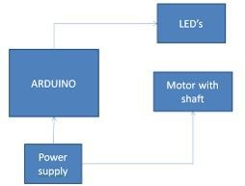
Fig-3

The block diagram provides a high-level overview of a system involving an Arduino, LEDs, a motor with a shaft, and a power supply.
- Power Supply:
- This block represents the source of electrical power for the entire system. It supplies the necessary voltage and current to operate the Arduino, LEDs, and motor.
- Arduino:
- The Arduino is the central microcontroller that controls the operation of the LEDs and the motor. - It receives power from the power supply to operate.
- LEDs:
- These are light-emitting diodes controlled by the Arduino. - The Arduino sends signals to the LEDs to turn them on, off, or control their brightness and colors (if they are RGB LEDs).

- Motor with Shaft:
- This block represents a motor, which is likely used to perform some mechanical action in the system. - The motor is controlled by the Arduino, which can send signals to start, stop, and control the speed or position of the motor shaft.

Connections:
- Power Supply to Arduino:
- The power supply provides the necessary electrical power to the Arduino, enabling it to function.
- Power Supply to Motor and LEDs:
- The power supply also provides power directly to the motor and LEDs, ensuring they receive the necessary voltage and current for their operation.
- Arduino to LEDs:
- The Arduino sends control signals to the LEDs. These signals can dictate the on/off state, brightness, and color (in the case of RGB LEDs).
- Arduino to Motor:
- The Arduino sends control signals to the motor. These signals can control the motor’s speed, direction, and positioning of the shaft.

    - MECHANICAL DESIGN

Creating a reliable rotating system that could transfer electricity to the display circuits was our main mechanical difficulty.
To achieve POV, the mechanical system must also be sufficiently dependable to endure several tests at a minimum rotation speed of 1200 rpm. We utilize a fixed-speed motor for our POV display.
We utilized a wooden board to provide a platform for our circuit board and LED array. In addition, a trapezoidal threaded rod was utilized to support and elevate the display.

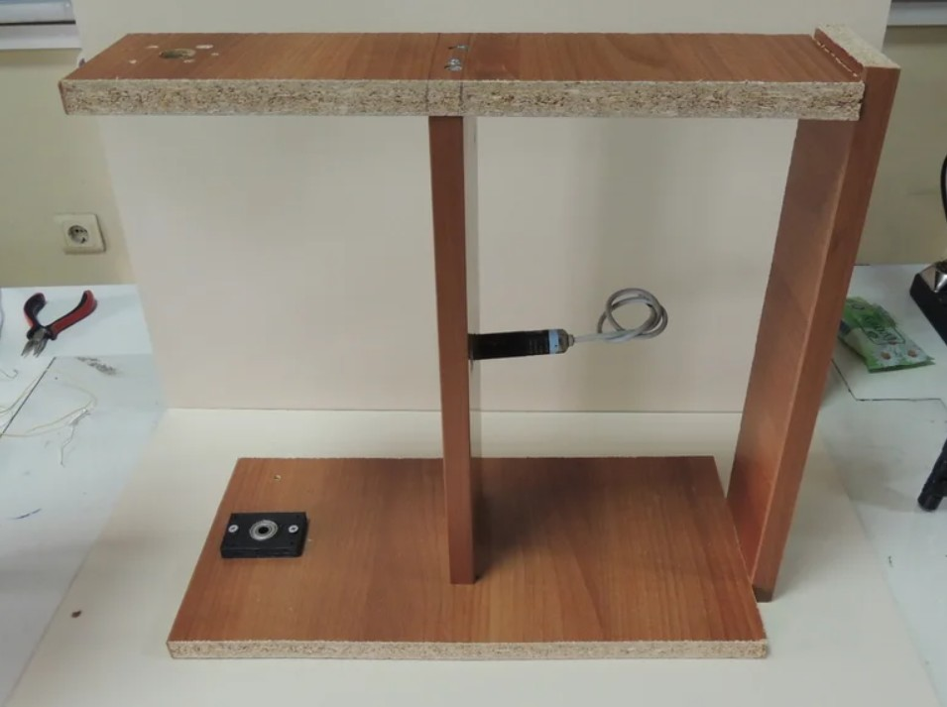

Fig-4

    - ELECTRICAL DESIGN

The primary difficulty in developing the electrical system is controlling LEDs, which are displayed using an Arduino ATmega2560.
To achieve this, LEDs are separated, allowing for the selective on and off from individual LEDs by coordinating their flashing with the DC motor’s rotation.
The Arduino-powered LED control system and timing system are the two primary electrical system components.
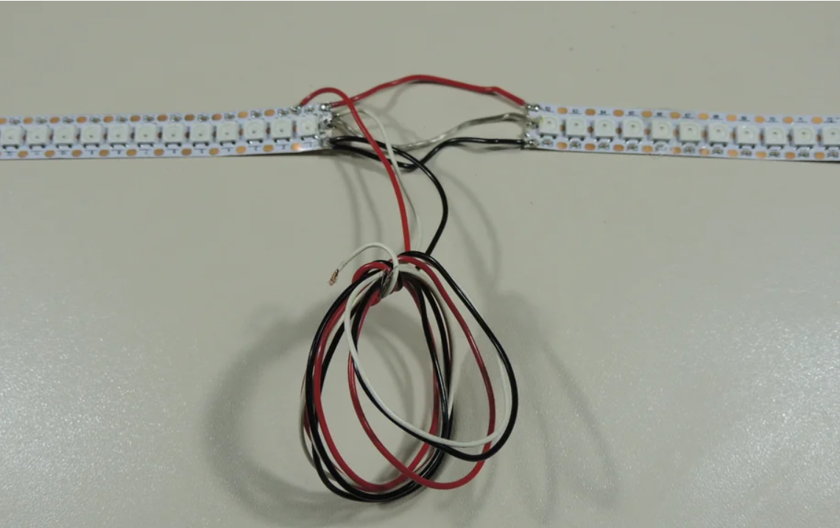
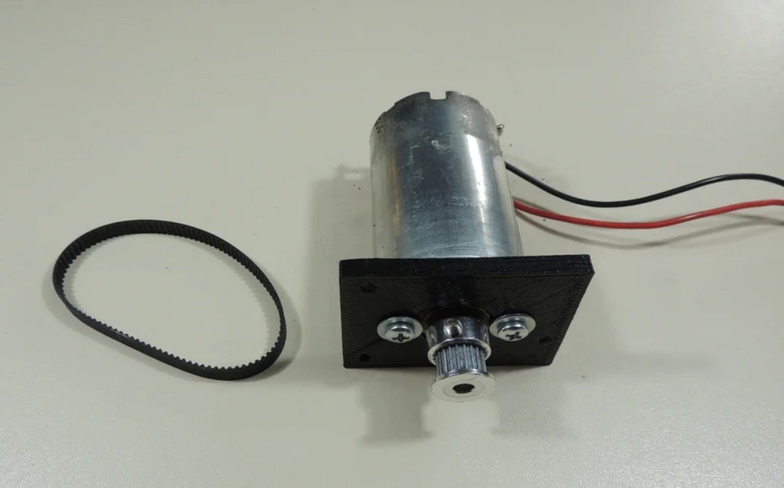
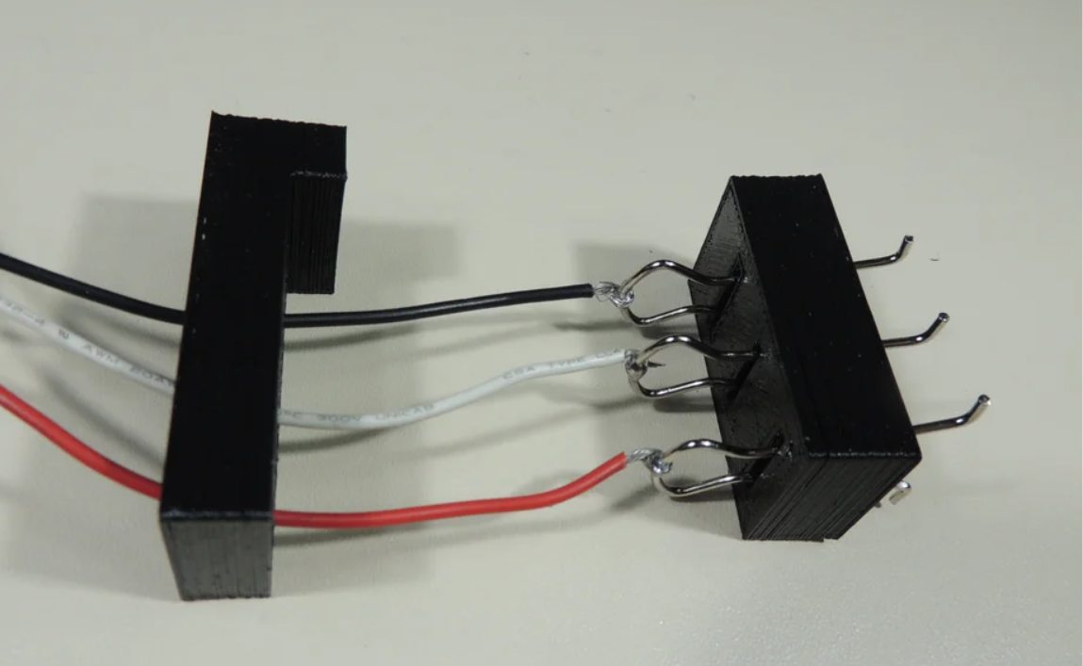

Fig-5,6&7

    - SOFTWARE DESIGN

User interaction is the final project consideration. Commercial POV displays show a static image; ours was meant to be personalized.
Completing a mechanical system in time to validate our software and electrical systems’ functionality is another difficult part of the project.

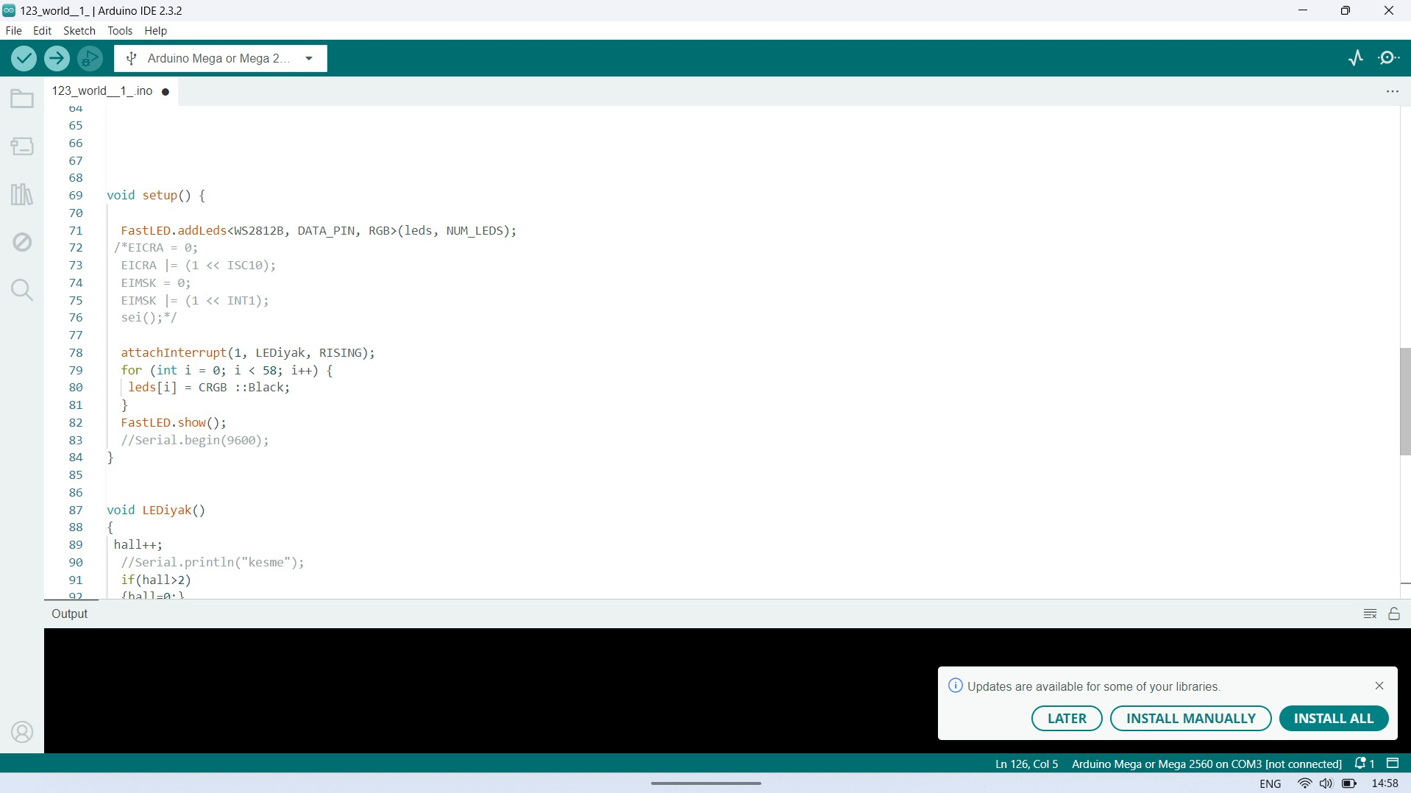

Fig-8

SYSTEM COMPONENTS

To demonstrate our result, this part offers a semi-technical introduction, a brief description of each component, and an explanation of how they work together.
This project has some materials such as electronic and 3D parts. List of;
      - Arduino Mega
      - WS2812B Smart Led Strip
      - Proximity Sensor
      - 608zz Bearings
      - DC Motor
      - 3D Parts
-Motor pulley
-Arduino IDE

    - ARDUINO MEGA 2560

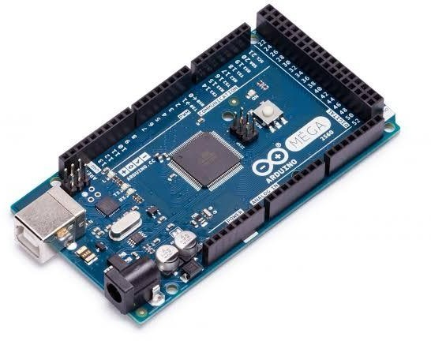

Fig-9

The Arduino Mega 2560 is a highly versatile and powerful microcontroller board designed for complex projects that require more input/output pins, memory, and processing power than standard Arduino boards. Based on the ATmega2560 microcontroller, the Mega 2560 features 54 digital I/O pins, of which 15 can be used as PWM outputs, 16 analog inputs, and 4 UARTs (hardware serial ports), providing extensive connectivity and control options. This makes it an ideal choice for advanced robotics, large-scale automation systems, and projects that require multiple sensors and actuators.
One of the standout features of the Arduino Mega 2560 is its large memory capacity, boasting 256 KB of flash memory for storing code, 8 KB of SRAM, and 4 KB of EEPROM. This expanded memory allows for more complex programs and data handling, accommodating larger libraries and more extensive programming structures. The board operates at a clock speed of 16 MHz, ensuring robust performance for various computational tasks.
The Mega 2560 is compatible with most Arduino shields designed for the Uno and other boards, providing a high degree of flexibility in expanding its functionality with additional modules for communication, motor control, displays, and more. Additionally, it

features a USB connection for programming and power, a power jack, an ICSP header, and a reset button, making it user-friendly and straightforward to integrate into projects.
The Arduino Integrated Development Environment (IDE) supports the Mega 2560, offering a seamless platform for writing, compiling, and uploading code. The IDE’s extensive library support and
community-contributed resources enhance the board’s versatility, allowing both beginners and experienced developers to create a wide array of applications. From simple interactive projects to intricate control systems, the Mega 2560 provides the necessary resources and flexibility.
In educational settings, the Arduino Mega 2560 serves as a robust tool for teaching complex electronics and programming concepts. Its extensive capabilities and straightforward programming environment make it an excellent platform for students to explore advanced topics and develop sophisticated projects. Overall, the Arduino Mega 2560 is a powerful and adaptable microcontroller board that meets the needs of a wide range of applications, making it a valuable asset in both hobbyist and professional electronics development.

    - WS2812B SMART LED STRIP

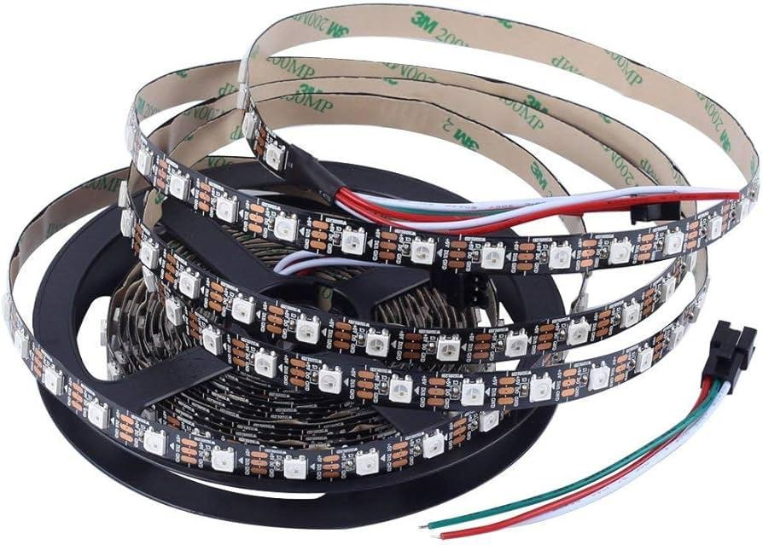

Fig-10

The WS2812B smart LED strip is a highly regarded and widely used lighting solution known for its ability to produce vibrant, customizable lighting effects. Each LED on the strip integrates a controller chip, allowing for individual control of color and brightness, which is a significant advantage over traditional LED strips. This addressable feature means that each LED can be programmed to display different colors and brightness levels, enabling intricate lighting patterns and animations. The WS2812B uses a single data line for communication, simplifying wiring and making it more user-friendly compared to
multi-line systems. This communication protocol is compatible with various microcontrollers such as Arduino, Raspberry Pi, and ESP8266, which has contributed to its popularity among hobbyists, makers, and professionals alike.
Operating at 5 volts, the WS2812B smart LED strip consumes about 60 milliamps per LED when displaying full brightness white, which balances power efficiency with impressive luminosity. This efficiency makes the strip suitable for a wide array of applications, ranging from decorative lighting in homes and art installations to functional ambient lighting for workspaces, entertainment centers, and computer setups.
The strip is typically encased in a flexible, often waterproof, silicone material, allowing it to be bent, cut, and shaped to fit various spaces

and configurations. This physical adaptability enhances its utility in diverse environments, including indoor and outdoor settings.
One of the standout features of the WS2812B smart LED strip is its ease of programming. Numerous libraries and coding examples are available across different programming platforms, lowering the entry barrier for users with varying levels of experience. This ease of use enables users to create smooth animations, color transitions, and responses to music or other inputs, providing a high degree of customization. Additionally, the strips can be daisy-chained, meaning multiple strips can be connected end-to-end and controlled as a single continuous strip, facilitating extensive and complex lighting installations without the need for complicated wiring setups.
The combination of addressability, ease of use, vibrant color output, and adaptability has made the WS2812B smart LED strip a preferred choice for a wide range of creative lighting projects. From DIY enthusiasts creating personalized home décor to professionals designing elaborate stage lighting or commercial displays, these LED strips offer a powerful and flexible solution for bringing any space to life with light. Whether used for practical purposes or artistic expression, the WS2812B smart LED strip stands out as a versatile tool for innovative lighting design.

    - PROXIMITY SENSOR

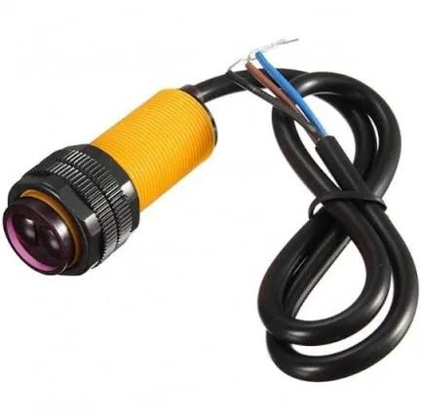

Fig-11

A proximity sensor is a device designed to detect the presence or absence of nearby objects without any physical contact. It works on the principle of electromagnetic fields, infrared radiation, or ultrasound waves. These sensors play a crucial role in various industries and everyday applications, enhancing efficiency, safety, and convenience.
One of the most common types of proximity sensors is the capacitive sensor, which detects the presence of an object by measuring changes in capacitance. When an object enters the sensor’s electromagnetic field, it alters the capacitance, triggering the sensor to send a signal indicating the object’s presence. Capacitive sensors are widely used in touchscreens, smartphones, and industrial automation systems for proximity detection and object recognition.
Another widely used type is the inductive proximity sensor, which operates based on the principle of electromagnetic induction. These sensors generate an electromagnetic field and detect changes in the field caused by the presence of metallic objects. They are commonly employed in manufacturing plants for detecting the presence of metal components in conveyor systems, machinery, and assembly lines.
Ultrasonic proximity sensors emit high-frequency sound waves and measure the time it takes for the waves to bounce back after hitting an

object. By calculating the time delay, these sensors determine the distance between the sensor and the object. Ultrasonic sensors are utilized in automotive parking assistance systems, robotics, and industrial automation for object detection and distance measurement.
Infrared (IR) proximity sensors emit infrared light and measure the reflection or interruption of the light to detect nearby objects. They are frequently used in smartphones for proximity sensing during calls to deactivate the touchscreen when the device is held close to the ear. Infrared sensors also find applications in motion detection systems, security alarms, and robotics.
Overall, proximity sensors have revolutionized numerous industries by providing reliable, non-contact detection capabilities. Their versatility, accuracy, and ability to operate in various environmental conditions make them indispensable in modern technology and automation. As technology continues to advance, proximity sensors are likely to become even more sophisticated, contributing to further advancements in automation, robotics, and smart devices.

    - DC MOTOR

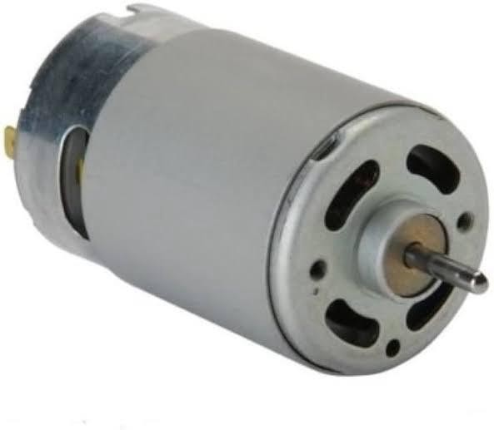
Fig-12
Direct current (DC) motors are electro-mechanical devices that convert electrical energy into mechanical motion through the interaction of magnetic fields. They consist of two main components: the stator (stationary part) and the rotor (rotating part). The stator contains a series of coils wound around an iron core, which create a magnetic field when an electric current is passed through them. The rotor, typically made of a coil of wire wrapped around a core or a permanent magnet, interacts with this magnetic field, resulting in rotational motion.
One of the key advantages of DC motors is their simplicity and ease of control. By varying the voltage applied to the motor, the speed and torque can be adjusted precisely to suit the requirements of a particular application. This feature makes DC motors widely used in a variety of devices, from household appliances to industrial machinery.
DC motors come in different types, including brushed and brushless motors. Brushed DC motors have carbon brushes that conduct electricity to the rotor, creating the magnetic field necessary for rotation. While these motors are simple and economical, the brushes can wear out over time, requiring maintenance. In contrast, brushless DC motors eliminate the need for brushes by using electronic commutation to control the direction of current flow in the motor windings. This design offers improved efficiency, reliability, and

lifespan, making brushless DC motors ideal for applications where maintenance is a concern.
DC motors find extensive use in robotics, automation, electric vehicles, and aerospace applications due to their controllability, efficiency, and reliability. In robotics, DC motors power the movement of robotic arms, wheels, and joints with precision and responsiveness. In electric vehicles, DC motors drive propulsion systems, providing the torque and speed required for acceleration and deceleration. Furthermore, DC motors are commonly employed in actuators and servo systems for precise positioning and control in industrial automation.
In summary, DC motors are versatile and widely used
electro-mechanical devices that offer efficient and controllable motion for various applications. With advancements in technology, such as the development of brushless designs and improvements in control systems, DC motors continue to play a vital role in powering modern machinery and devices.

    - MOTOR PULLEY

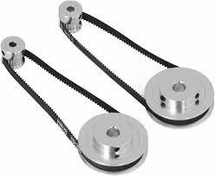

Fig-13

A motor pulley is a vital component in mechanical systems, serving as an essential link in the transmission of power from an electric motor to other rotating elements. It functions by transferring rotational motion and torque via a belt or chain drive system, enabling the operation of various machinery and devices. The motor pulley is typically mounted on the motor shaft and is designed to fit specific size and power requirements, ensuring efficient power transmission. Its size, material, and design directly influence the speed and torque of the driven components, making it a critical factor in the overall performance and efficiency of the system.
Motor pulleys come in various sizes and materials, including steel, aluminum, and cast iron, each offering different levels of durability and performance characteristics. The choice of material and design depends on the application, load requirements, and operating conditions. For example, steel pulleys are favored for their strength and durability in heavy-duty applications, while aluminum pulleys are chosen for their lightweight properties and corrosion resistance in less demanding environments.
The ability to adjust the diameter of the motor pulley allows engineers to fine-tune the speed ratio between the motor and the driven equipment. By selecting the appropriate pulley size, it is possible to

increase or decrease the speed and torque output, optimizing the machinery for specific tasks. This flexibility is particularly useful in applications such as conveyor systems, HVAC units, and automotive engines, where precise control of speed and torque is necessary for efficient operation.
In addition to their functional role, motor pulleys also contribute to the longevity and reliability of mechanical systems. By ensuring smooth and consistent power transmission, they help reduce wear and tear on belts and other components, minimizing maintenance requirements and downtime. Advances in pulley design and materials have further enhanced their performance, making them integral to modern engineering and industrial applications.
In summary, the motor pulley is an indispensable element in mechanical systems, facilitating the effective transfer of power and enabling precise control of speed and torque. Its adaptability, durability, and impact on system performance make it a cornerstone of mechanical design, essential for the efficient operation of a wide range of machinery and equipment.

    - 608ZZ BEARINGS
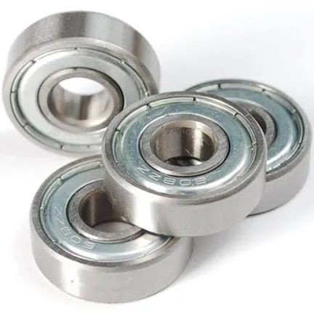

Fig-14
608ZZ bearings are miniature ball bearings renowned for their versatility, durability, and widespread application across various industries. Measuring 22 millimeters in outer diameter, 8 millimeters in inner diameter, and 7 millimeters in width, these bearings are compact yet robust. The "ZZ" designation indicates that they are shielded on both sides, which provides protection against dust, debris, and contaminants while retaining lubrication within the bearing raceways. This shielding makes them particularly suitable for environments with moderate contamination, ensuring consistent and efficient operation over prolonged periods.
The construction of 608ZZ bearings includes an inner and outer ring, with steel balls held in place by a cage, allowing for smooth rotation with minimal friction. This design is essential for applications requiring precise motion control and efficient energy transfer.
High-quality materials and meticulous manufacturing processes contribute to the durability and reliability of these bearings, enabling them to withstand high speeds and loads.
One of the most common uses of 608ZZ bearings is in recreational equipment, such as skateboards and inline skates. In these contexts,

they support the rotating wheels, ensuring smooth and controlled movement. Their compact size fits perfectly within the limited space of skateboard wheels, and their ability to handle high speeds and loads makes them ideal for intense activities. The shielded design helps protect the bearings from dirt, moisture, and debris, which is crucial for maintaining performance and longevity.
Beyond recreational uses, 608ZZ bearings are integral to various industrial applications. In electric motors, they support rotating shafts, reducing friction and facilitating efficient power transmission. These bearings are also found in hand tools, such as drills and grinders, where they enhance smooth and precise operation.
Additionally, 608ZZ bearings are used in conveyor systems to support rotating rollers or pulleys, aiding in the movement of materials along conveyor belts while withstanding industrial environments’ challenges.
In summary, 608ZZ bearings are vital components in numerous mechanical systems due to their compact size, durability, and ability to perform under high speeds and loads. Their versatile applications, from recreational equipment to industrial machinery, highlight their importance in ensuring smooth, efficient, and reliable operations across various fields.

    - 3D PRINTED PARTS

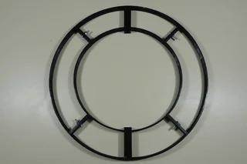
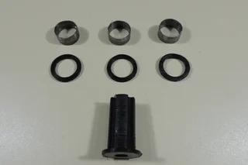

Fig-15&16
3D printed parts have revolutionized manufacturing, prototyping, and design across various industries due to their flexibility, customization capabilities, and rapid production time. Utilizing additive manufacturing techniques, 3D printing constructs objects layer by layer directly from digital models, allowing for the creation of complex geometries and intricate details that would be difficult or impossible to achieve with traditional manufacturing methods. This process enables significant cost savings and efficiency improvements, particularly for low-volume production runs and bespoke items, as it eliminates the need for expensive molds and tooling.
The range of materials available for 3D printing is vast, including various plastics, metals, ceramics, and even advanced composites, each offering different properties such as strength, flexibility, heat resistance, and biocompatibility. This material diversity makes 3D printing suitable for a wide array of applications, from aerospace and automotive components to medical implants and consumer products.

For instance, in the medical field, 3D printing is used to create patient-specific prosthetics and implants, tailored to the precise
anatomical requirements of individual patients, enhancing comfort and functionality.
One of the key advantages of 3D printing is its ability to facilitate rapid prototyping. Designers and engineers can quickly produce and test prototypes, iterating their designs based on real-world feedback and performance, significantly shortening the development cycle. This rapid iteration capability not only accelerates innovation but also reduces the risk and cost associated with product development.
Furthermore, 3D printing supports on-demand production, allowing manufacturers to produce parts as needed, reducing inventory costs and waste.
Despite its numerous benefits, 3D printing also faces certain limitations. The surface finish and mechanical properties of 3D printed parts can vary depending on the printing technology and materials used. Additionally, the build size is typically constrained by the dimensions of the 3D printer, and the process can be slower compared to some traditional manufacturing techniques for large-scale production. However, continuous advancements in 3D printing technologies, materials, and post-processing methods are steadily overcoming these challenges, expanding the capabilities and applications of 3D printed parts.
In conclusion, 3D printed parts represent a transformative approach to manufacturing and design, offering unparalleled flexibility, customization, and efficiency. Their ability to produce complex,
high-precision components quickly and cost-effectively is driving innovation across numerous fields, making 3D printing an essential tool in modern engineering and product development.

    - ARDUINO IDE



Fig-17
The Arduino Integrated Development Environment (IDE) stands as a cornerstone in the world of hobbyist electronics and prototyping, providing a user-friendly platform for programming Arduino microcontroller boards.
Designed with simplicity and accessibility in mind, the Arduino IDE offers a seamless interface for writing, compiling, and uploading code to Arduino-compatible devices. One of its key strengths lies in its
open-source nature, fostering a vibrant community of makers, students, and enthusiasts who share knowledge, code, and projects worldwide.
At its core, the Arduino IDE features a text editor that supports the Arduino programming language, a variant of C/C++, simplified for ease of use, especially for beginners. The IDE also includes a suite of built-in functions and libraries tailored to the Arduino ecosystem, enabling users to interact with sensors, actuators, displays, and other peripherals effortlessly. Additionally, the IDE offers comprehensive documentation and tutorials, empowering users of all skill levels to embark on electronics projects with confidence.
The Arduino IDE streamlines the development process with its integrated compiler and uploader tools, allowing users to compile their code and upload it directly to the Arduino board with a single click.
This seamless integration simplifies the iteration cycle, enabling rapid prototyping and experimentation. Furthermore, the IDE provides

robust debugging features, including real-time serial monitoring, which aids in troubleshooting and fine-tuning projects.
Beyond its core functionality, the Arduino IDE supports an extensive ecosystem of third-party libraries and extensions, expanding its capabilities and compatibility with a myriad of hardware peripherals and communication protocols. This extensibility enables users to leverage a vast array of sensors, actuators, displays, and communication modules, empowering them to realize diverse projects, from simple blinking LEDs to complex IoT devices.
In conclusion, the Arduino IDE serves as a gateway to the world of electronics and programming, democratizing access to technology and fostering creativity and innovation. Its intuitive interface, extensive documentation, and vibrant community make it an indispensable tool for students, educators, hobbyists, and professionals alike, driving the proliferation of DIY electronics projects and enabling new possibilities in the Internet of Things (IoT) era.

METHODOLOGY

    - HARDWARE

A mechanical frame is designed to give POV display stability while it is operating. It is made up of two parts: a rotating part that supports the microcontroller, the associated electronic circuitry, and LEDs, and a fixed part that holds the motor and other components.
The rotary part load is intended to be supported by the motor shaft without impairing its operation. Moreover, the motor shaft and rotary portion share the same mass centroid to prevent shaft fatigue and to lessen vibrations and stresses.

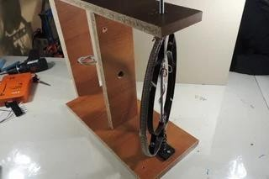

Fig-18

    - CONTROL DESIGN

When the machine first powers up, it begins transmitting images to the microcontroller, which then causes LEDs to display images, messages, or numbers. Nevertheless, to determine the angular location, the microcontroller must wait to receive a signal from the proximity sensor.

Additionally, the microcontroller ceases delivering triggers to LEDs to save energy and attempts to raise the motor speed if it is not fast enough to display pictures. In this study, photos are transformed into matrices that the microcontroller can handle with ease using image processing.

    - SYNCRONISATION OF POV DISPLAY

To identify the reference point (first column of the image) from which images are displayed when the motor is functioning and turning the rotary portion, synchronization is necessary in the POV display.
More significantly, to have a smooth display and prevent flickering, the motor speed (measured in Hz) and microcontroller frequency need to match. In this instance, at least 25 frames per second are needed.
This suggests that a motor running at 1500 rpm or higher is required. However, a motor speed range of 1800 to 3000 rpm is needed because the ideal frequency for POV displays is roughly 30 to 50 Hz.

    - RESOLUTION OF THE POV DISPLAY

The number of distinct pixels in each dimension that may be displayed is known as the display resolution. Typically, it is stated as the width times the height in pixels. The number of LEDs determines the POV display height resolution, and the thickness and rotational portion radius of the LEDs determine the width resolution.
The resolution of the POV display affects its synchronization.
High-quality photos can only be obtained if they are compatible. To maintain resolution and aspect ratio, the microcontroller lowers the speed rate at which images are sent while the motor speed increases, and vice versa. To solve these issues, the microcontroller clock frequency is adjusted appropriately.

    - POWER CONSIDERATIONS

      - MICRO CONTROLLER POWER SUPPLY

5 V is the operating voltage for Arduino. The power source for the initial try is a 9 V battery. Despite its small weight, it is not feasible to use due to its limited lifespan.
As an alternative, a wireless DC power supply (rotary transformer) is used. Although its efficiency is poor (about 60), it has a good transmission and receiving range that provides a wide range of flexibility. This efficiency declines significantly with increasing separation distance, suggesting that separation distance needs to be carefully chosen.

      - MOTOR POWER SUPPLY

This prototype uses an AC brushless motor. It requires 1.5 A and 220
V. Power delivery to the rotating portion without causing damage to the wire connections by wrapping around the body itself is implemented based on the commutation approach used in DC machines. Due to commutator rotation, the source in this method alternates in direction. To transform DC electricity into AC power. The difficult thing is that the rotating section’s electronic components are all DC powered.

    - PROGRAMMING AND TESTING

Programming microcontroller begins with converting images to matrices that the microcontroller deals easily with them.
The image is reconstructed as a 24x77 2D matrix.
The following stage involves transforming this matrix into triggering signals that activate and deactivate LEDs to display the desired image.
LEDs are identified as being ON by a value of 1 (True Value) and OFF by a value of 0 (False Value). The matrix (picture) is seen as a collection of column vectors.
The microprocessor delivers triggers to the LEDs in parallel, handling each column independently.
After that, it waits one to two milliseconds to prevent interference from column vectors before moving on to the next column vector and continuing until the entire image is presented.
After the image is successfully sent, we can see it rotating around the POV display.

      - PROGRAM

include "FastLED.h" define NUMLEDS 58
define DATAPIN 6
unsigned char i; unsigned char m; unsigned int wait = 1; unsigned int wait2 =10; byte hall = 0;
CRGB leds[NUMLEDS];
bool kalp[40][75] = {
{0, 0, 0, 0, 0, 0, 0, 0, 0, 0, 0, 0, 0, 0, 0, 0, 0, 0, 1, 1, 1, 1, 1, 1, 1, 1, 1, 1,
1, 1, 1, 1, 0, 0, 0, 0, 1, 1, 0, 0, 0, 1, 1, 1, 0, 0, 0, 0, 1, 1, 1, 0, 0, 0, 0, 0,
0, 0, 0, 0, 0, 0, 0, 0, 0, 0, 0, 0, 0, 0, 0, 0, 0, 0, 0 },
{0, 0, 0, 0, 0, 0, 0, 0, 0, 0, 0, 0, 0, 1, 1, 1, 1, 1, 1, 1, 0, 0, 1, 1, 1, 1, 1, 1,
1, 1, 1, 0, 0, 0, 0, 0, 0, 0, 0, 0, 0, 0, 0, 0, 1, 1, 0, 0, 0, 1, 1, 1, 1, 1, 0, 0,
0, 1, 1, 1, 0, 0, 0, 0, 0, 0, 0, 0, 0, 0, 0, 0, 0, 0, 0},
{0, 0, 0, 1, 1, 1, 0, 0, 0, 0, 0, 1, 1, 1, 1, 1, 1, 1, 1, 1, 1, 0, 0, 1, 1, 1, 1, 1,
1, 1, 0, 0, 0, 0, 0, 0, 0, 0, 1, 1, 0, 0, 0, 1, 0, 0, 1, 1, 1, 1, 1, 1, 1, 1, 1, 1,
1, 1, 1, 1, 1, 1, 1, 0, 0, 0, 0, 0, 0, 0, 0, 0, 0, 0, 0},
{0, 1, 1, 1, 1, 1, 1, 1, 1, 1, 1, 1, 1, 1, 1, 1, 1, 1, 1, 1, 1, 1, 0, 1, 1, 1, 1, 1,
1, 0, 0, 0, 0, 0, 0, 0, 1, 1, 1, 1, 1, 1, 1, 1, 1, 1, 1, 1, 1, 1, 1, 1, 1, 1, 1, 1,
1, 1, 1, 1, 1, 1, 1, 1, 1, 1, 1, 1, 1, 0, 0, 0, 0, 0, 0},
{1, 1, 1, 1, 1, 1, 1, 1, 1, 1, 1, 1, 1, 1, 1, 1, 0, 1, 1, 1, 1, 0, 0, 1, 1, 1, 0, 0,
0, 1, 1, 0, 0, 0, 0, 1, 1, 1, 1, 1, 1, 1, 1, 1, 1, 1, 1, 1, 1, 1, 1, 1, 1, 1, 1, 1,
1, 1, 1, 1, 1, 1, 1, 1, 1, 1, 1, 1, 1, 1, 1, 0, 0, 0, 0},
{1, 1, 1, 1, 1, 1, 1, 1, 1, 1, 1, 1, 1, 1, 0, 0, 0, 1, 1, 1, 0, 0, 0, 0, 1, 0, 0, 0,
0, 0, 0, 0, 0, 0, 1, 1, 1, 0, 1, 1, 1, 1, 1, 1, 1, 1, 1, 1, 1, 1, 1, 1, 1, 1, 1, 1,
1, 1, 1, 1, 1, 1, 1, 1, 1, 1, 0, 1, 1, 0, 0, 0, 0, 0, 0},

{0, 0, 0, 0, 1, 1, 1, 1, 1, 1, 1, 1, 1, 1, 1, 0, 0, 1, 1, 1, 1, 0, 0, 0, 0, 0, 0, 0,
0, 0, 0, 1, 1, 0, 0, 1, 1, 0, 1, 1, 1, 1, 1, 1, 1, 1, 1, 1, 1, 1, 1, 1, 1, 1, 1, 1,
1, 1, 1, 1, 1, 1, 1, 0, 0, 0, 0, 1, 1, 0, 0, 0, 0, 0, 0},
{0, 0, 0, 0, 1, 1, 1, 1, 1, 1, 1, 1, 1, 1, 1, 1, 1, 1, 1, 1, 1, 0, 0, 0, 0, 0, 0, 0,
0, 0, 0, 1, 1, 1, 1, 1, 1, 1, 1, 1, 1, 1, 1, 1, 1, 1, 1, 1, 1, 1, 1, 1, 1, 1, 1, 1,
0, 0, 1, 1, 1, 1, 1, 1, 1, 0, 0, 1, 1, 0, 0, 0, 0, 0, 0},
{0, 0, 0, 0, 1, 1, 1, 1, 1, 1, 1, 1, 1, 1, 1, 1, 1, 1, 1, 1, 1, 0, 0, 0, 0, 0, 0, 0,
0, 0, 0, 0, 1, 1, 1, 1, 1, 1, 1, 1, 1, 1, 1, 1, 1, 1, 1, 1, 1, 1, 1, 1, 1, 1, 1, 1,
1, 1, 1, 1, 1, 1, 1, 1, 1, 1, 0, 0, 0, 0, 0, 0, 0, 0, 0},
{0, 0, 0, 0, 1, 1, 1, 1, 1, 1, 1, 1, 1, 0, 1, 1, 1, 1, 1, 0, 1, 0, 0, 0, 0, 0, 0, 0,
0, 0, 0, 0, 0, 1, 1, 1, 1, 1, 1, 1, 0, 1, 1, 1, 0, 1, 1, 1, 1, 1, 1, 1, 1, 1, 1, 1,
1, 1, 1, 1, 1, 1, 1, 1, 1, 0, 1, 0, 0, 0, 0, 0, 0, 0, 0},
{0, 0, 0, 1, 1, 1, 1, 1, 1, 1, 1, 1, 1, 1, 1, 1, 0, 0, 0, 0, 0, 0, 0, 0, 0, 0, 0, 0,
0, 0, 0, 1, 1, 1, 0, 1, 1, 1, 1, 1, 1, 0, 0, 1, 1, 0, 1, 1, 1, 1, 1, 1, 1, 1, 1, 1,
1, 1, 1, 1, 1, 1, 1, 1, 1, 0, 1, 0, 0, 0, 0, 0, 0, 0, 0},
{0, 0, 0, 1, 1, 1, 1, 1, 1, 1, 1, 1, 1, 1, 1, 0, 0, 0, 0, 0, 0, 0, 0, 0, 0, 0, 0, 0,
0, 0, 0, 1, 1, 0, 0, 0, 1, 1, 1, 1, 1, 1, 1, 1, 1, 0, 1, 1, 1, 1, 1, 1, 1, 1, 1, 1,
1, 1, 1, 1, 1, 1, 1, 1, 1, 0, 1, 1, 0, 0, 0, 0, 0, 0, 0},
{0, 0, 0, 1, 1, 1, 1, 1, 1, 1, 1, 1, 1, 1, 1, 0, 0, 0, 0, 0, 0, 0, 0, 0, 0, 0, 0, 0,
0, 0, 0, 1, 1, 1, 1, 1, 0, 0, 0, 0, 0, 1, 1, 1, 1, 1, 1, 1, 1, 1, 1, 1, 1, 1, 1, 1,
1, 1, 1, 1, 1, 1, 1, 0, 1, 0, 1, 1, 0, 0, 0, 0, 0, 0, 0},
{0, 0, 0, 0, 1, 1, 1, 1, 1, 1, 1, 1, 1, 0, 0, 0, 0, 0, 0, 0, 0, 0, 0, 0, 0, 0, 0, 0,
0, 0, 0, 1, 1, 1, 1, 1, 1, 0, 1, 1, 0, 1, 1, 1, 1, 1, 1, 1, 1, 1, 1, 1, 1, 1, 1, 1,
1, 1, 1, 1, 1, 1, 1, 0, 0, 1, 0, 0, 0, 0, 0, 0, 0, 0, 0},
{0, 0, 0, 0, 1, 1, 1, 1, 1, 0, 0, 0, 1, 0, 0, 0, 0, 0, 0, 0, 0, 0, 0, 0, 0, 0, 0, 0,
0, 0, 1, 1, 1, 1, 1, 1, 1, 1, 1, 1, 1, 1, 1, 1, 1, 1, 1, 1, 1, 1, 1, 1, 1, 1, 1, 1,
1, 1, 1, 1, 1, 1, 1, 1, 0, 0, 0, 0, 0, 0, 0, 0, 0, 0, 0},
{0, 0, 0, 0, 1, 1, 1, 1, 1, 0, 0, 0, 0, 0, 0, 0, 0, 0, 0, 0, 0, 0, 0, 0, 0, 0, 0, 0,
0, 1, 1, 1, 1, 1, 1, 1, 1, 1, 1, 1, 1, 1, 0, 1, 1, 1, 1, 1, 1, 1, 1, 1, 1, 1, 1, 1,
1, 1, 1, 1, 1, 1, 1, 0, 0, 0, 0, 0, 0, 0, 0, 0, 0, 0, 0},

{0, 0, 0, 0, 0, 1, 1, 1, 0, 0, 1, 0, 1, 1, 0, 0, 0, 0, 0, 0, 0, 0, 0, 0, 0, 0, 0, 0,
1, 1, 1, 1, 1, 1, 1, 1, 1, 1, 1, 1, 1, 1, 0, 1, 1, 1, 1, 1, 0, 0, 0, 1, 1, 1, 1, 1,
1, 1, 1, 1, 1, 1, 0, 1, 0, 0, 0, 0, 0, 0, 0, 0, 0, 0, 0},
{0, 0, 0, 0, 0, 0, 1, 1, 1, 1, 1, 1, 0, 1, 1, 1, 1, 0, 0, 0, 0, 0, 0, 0, 0, 0, 0, 0,
1, 1, 1, 1, 1, 1, 1, 1, 1, 1, 1, 1, 1, 1, 1, 0, 1, 1, 1, 0, 0, 0, 0, 0, 1, 1, 1, 0,
0, 1, 1, 1, 0, 1, 0, 0, 1, 0, 0, 0, 0, 0, 0, 0, 0, 0, 0},
{0, 0, 0, 0, 0, 0, 0, 0, 1, 1, 1, 1, 0, 0, 0, 0, 0, 0, 0, 0, 0, 0, 0, 0, 0, 0, 0, 0,
1, 1, 1, 1, 1, 1, 1, 1, 1, 1, 1, 1, 1, 1, 1, 0, 1, 1, 0, 0, 0, 0, 0, 0, 1, 1, 0, 0,
0, 1, 1, 1, 1, 0, 0, 0, 1, 0, 0, 0, 0, 0, 0, 0, 0, 0, 0},
{0, 0, 0, 0, 0, 0, 0, 0, 0, 0, 1, 1, 0, 0, 1, 1, 1, 1, 0, 0, 0, 0, 0, 0, 0, 0, 0, 0,
0, 1, 1, 1, 1, 1, 1, 1, 1, 1, 1, 1, 1, 1, 1, 1, 0, 0, 0, 0, 0, 0, 0, 0, 1, 1, 0, 0,
0, 0, 1, 1, 1, 0, 0, 0, 0, 1, 0, 0, 0, 0, 0, 0, 0, 0, 0},
{0, 0, 0, 0, 0, 0, 0, 0, 0, 0, 1, 1, 1, 1, 1, 1, 1, 1, 0, 0, 0, 0, 0, 0, 0, 0, 0, 0,
0, 1, 1, 1, 1, 1, 1, 1, 1, 1, 1, 1, 1, 1, 1, 1, 1, 1, 0, 0, 0, 0, 0, 0, 0, 1, 0, 0,
0, 0, 1, 0, 0, 0, 0, 1, 0, 1, 0, 0, 0, 0, 0, 0, 0, 0, 0},
{0, 0, 0, 0, 0, 0, 0, 0, 0, 0, 0, 0, 0, 1, 1, 1, 1, 1, 1, 1, 0, 0, 0, 0, 0, 0, 0, 0,
0, 0, 1, 1, 1, 1, 1, 1, 1, 1, 1, 1, 1, 1, 1, 1, 1, 1, 0, 0, 0, 0, 0, 0, 0, 0, 1, 0,
0, 0, 1, 1, 0, 0, 0, 1, 0, 1, 0, 0, 0, 0, 0, 0, 0, 0, 0},
{0, 0, 0, 0, 0, 0, 0, 0, 0, 0, 0, 0, 1, 1, 1, 1, 1, 1, 1, 1, 0, 0, 0, 0, 0, 0, 0, 0,
0, 0, 0, 0, 0, 0, 0, 1, 1, 1, 1, 1, 1, 1, 1, 1, 1, 0, 0, 0, 0, 0, 0, 0, 0, 0, 0, 0,
0, 0, 1, 1, 0, 1, 1, 1, 0, 1, 0, 0, 0, 0, 0, 0, 0, 0, 0},
{0, 0, 0, 0, 0, 0, 0, 0, 0, 0, 0, 0, 1, 1, 1, 1, 1, 1, 1, 1, 1, 1, 0, 0, 0, 0, 0, 0,
0, 0, 0, 0, 0, 0, 0, 1, 1, 1, 1, 1, 1, 1, 1, 1, 0, 0, 0, 0, 0, 0, 0, 0, 0, 0, 0, 0,
0, 0, 0, 1, 0, 1, 1, 1, 1, 0, 1, 1, 1, 1, 0, 0, 0, 0, 0},
{0, 0, 0, 0, 0, 0, 0, 0, 0, 0, 0, 0, 1, 1, 1, 1, 1, 1, 1, 1, 1, 1, 1, 1, 0, 0, 0, 0,
0, 0, 0, 0, 0, 0, 0, 0, 1, 1, 1, 1, 1, 1, 1, 0, 0, 0, 0, 0, 0, 0, 0, 0, 0, 0, 0, 0,
0, 0, 0, 0, 1, 0, 0, 0, 1, 0, 1, 0, 1, 1, 1, 0, 0, 0, 0},
{0, 0, 0, 0, 0, 0, 0, 0, 0, 0, 0, 0, 1, 1, 1, 1, 1, 1, 1, 1, 1, 1, 1, 1, 0, 0, 0, 0,
0, 0, 0, 0, 0, 0, 0, 0, 1, 1, 1, 1, 1, 1, 1, 0, 0, 0, 0, 0, 0, 0, 0, 0, 0, 0, 0, 0,
0, 0, 0, 0, 0, 1, 1, 0, 1, 1, 1, 0, 0, 1, 1, 0, 0, 0, 0},

{0, 0, 0, 0, 0, 0, 0, 0, 0, 0, 0, 0, 0, 1, 1, 1, 1, 1, 1, 1, 1, 1, 1, 1, 0, 0, 0, 0,
0, 0, 0, 0, 0, 0, 0, 0, 1, 1, 1, 1, 1, 1, 1, 1, 0, 0, 0, 0, 0, 0, 0, 0, 0, 0, 0, 0,
0, 0, 0, 0, 0, 0, 0, 0, 0, 0, 1, 1, 0, 0, 0, 0, 0, 0, 0},
{0, 0, 0, 0, 0, 0, 0, 0, 0, 0, 0, 0, 0, 0, 1, 1, 1, 1, 1, 1, 1, 1, 1, 0, 0, 0, 0, 0,
0, 0, 0, 0, 0, 0, 0, 0, 1, 1, 1, 1, 1, 1, 1, 0, 1, 1, 0, 0, 0, 0, 0, 0, 0, 0, 0, 0,
0, 0, 0, 0, 0, 0, 0, 0, 0, 1, 1, 1, 1, 1, 1, 0, 0, 0, 0},
{0, 0, 0, 0, 0, 0, 0, 0, 0, 0, 0, 0, 0, 0, 0, 1, 1, 1, 1, 1, 1, 1, 1, 0, 0, 0, 0, 0,
0, 0, 0, 0, 0, 0, 0, 0, 1, 1, 1, 1, 1, 1, 0, 0, 1, 1, 0, 0, 0, 0, 0, 0, 0, 0, 0, 0,
0, 0, 0, 0, 0, 0, 0, 0, 1, 1, 1, 1, 1, 1, 1, 0, 0, 0, 0},
{0, 0, 0, 0, 0, 0, 0, 0, 0, 0, 0, 0, 0, 0, 0, 1, 1, 1, 1, 1, 1, 1, 1, 0, 0, 0, 0, 0,
0, 0, 0, 0, 0, 0, 0, 0, 1, 1, 1, 1, 1, 1, 0, 0, 1, 1, 0, 0, 0, 0, 0, 0, 0, 0, 0, 0,
0, 0, 0, 0, 0, 0, 1, 1, 1, 1, 1, 1, 1, 1, 1, 1, 0, 0, 0},
{0, 0, 0, 0, 0, 0, 0, 0, 0, 0, 0, 0, 0, 0, 0, 1, 1, 1, 1, 1, 1, 1, 0, 0, 0, 0, 0, 0,
0, 0, 0, 0, 0, 0, 0, 0, 0, 1, 1, 1, 1, 1, 0, 0, 1, 0, 0, 0, 0, 0, 0, 0, 0, 0, 0, 0,
0, 0, 0, 0, 0, 0, 1, 1, 1, 1, 1, 1, 1, 1, 1, 1, 0, 0, 0},
{0, 0, 0, 0, 0, 0, 0, 0, 0, 0, 0, 0, 0, 0, 0, 1, 1, 1, 1, 1, 1, 0, 0, 0, 0, 0, 0, 0,
0, 0, 0, 0, 0, 0, 0, 0, 0, 1, 1, 1, 1, 0, 0, 0, 0, 0, 0, 0, 0, 0, 0, 0, 0, 0, 0, 0,
0, 0, 0, 0, 0, 0, 1, 1, 1, 1, 1, 1, 1, 1, 1, 1, 0, 0, 0},
{0, 0, 0, 0, 0, 0, 0, 0, 0, 0, 0, 0, 0, 0, 0, 1, 1, 1, 1, 1, 1, 0, 0, 0, 0, 0, 0, 0,
0, 0, 0, 0, 0, 0, 0, 0, 0, 1, 1, 1, 0, 0, 0, 0, 0, 0, 0, 0, 0, 0, 0, 0, 0, 0, 0, 0,
0, 0, 0, 0, 0, 0, 1, 1, 1, 1, 1, 1, 1, 1, 1, 0, 0, 0, 0},
{0, 0, 0, 0, 0, 0, 0, 0, 0, 0, 0, 0, 0, 0, 0, 1, 1, 1, 1, 1, 0, 0, 0, 0, 0, 0, 0, 0,
0, 0, 0, 0, 0, 0, 0, 0, 0, 0, 0, 0, 0, 0, 0, 0, 0, 0, 0, 0, 0, 0, 0, 0, 0, 0, 0, 0,
0, 0, 0, 0, 0, 0, 0, 0, 0, 0, 0, 1, 1, 1, 0, 0, 0, 0, 0},
{0, 0, 0, 0, 0, 0, 0, 0, 0, 0, 0, 0, 0, 0, 0, 1, 1, 1, 1, 1, 0, 0, 0, 0, 0, 0, 0, 0,
0, 0, 0, 0, 0, 0, 0, 0, 0, 0, 0, 0, 0, 0, 0, 0, 0, 0, 0, 0, 0, 0, 0, 0, 0, 0, 0, 0,
0, 0, 0, 0, 0, 0, 0, 0, 0, 0, 0, 1, 1, 0, 0, 0, 0, 0, 0},
{0, 0, 0, 0, 0, 0, 0, 0, 0, 0, 0, 0, 0, 0, 0, 1, 1, 1, 1, 0, 0, 0, 0, 0, 0, 0, 0, 0,
0, 0, 0, 0, 0, 0, 0, 0, 0, 0, 0, 0, 0, 0, 0, 0, 0, 0, 0, 0, 0, 0, 0, 0, 0, 0, 0, 0,
0, 0, 0, 0, 0, 0, 0, 0, 0, 0, 0, 1, 1, 0, 0, 0, 0, 0, 0},

{0, 0, 0, 0, 0, 0, 0, 0, 0, 0, 0, 0, 0, 0, 0, 0, 1, 1, 0, 0, 0, 0, 0, 0, 0, 0, 0, 0,
0, 0, 0, 0, 0, 0, 0, 0, 0, 0, 0, 0, 0, 0, 0, 0, 0, 0, 0, 0, 0, 0, 0, 0, 0, 0, 0, 0,
0, 0, 0, 0, 0, 0, 0, 0, 0, 0, 0, 0, 0, 0, 0, 0, 1, 0, 0},
{0, 0, 0, 0, 0, 0, 0, 0, 0, 0, 0, 0, 0, 0, 0, 0, 1, 1, 0, 0, 0, 0, 0, 0, 0, 0, 0, 0,
0, 0, 0, 0, 0, 0, 0, 0, 0, 0, 0, 0, 0, 0, 0, 0, 0, 0, 0, 0, 0, 0, 0, 0, 0, 0, 0, 0,
0, 0, 0, 0, 0, 0, 0, 0, 0, 0, 0, 0, 0, 0, 0, 0, 0, 0, 0},
{0, 0, 0, 0, 0, 0, 0, 0, 0, 0, 0, 0, 0, 0, 0, 0, 1, 1, 0, 0, 0, 1, 1, 0, 0, 0, 0, 0,
0, 0, 0, 0, 0, 0, 0, 0, 0, 0, 0, 0, 0, 0, 0, 0, 0, 0, 0, 0, 0, 0, 0, 0, 0, 0, 0, 0,
0, 0, 0, 0, 0, 0, 0, 0, 0, 0, 0, 0, 0, 0, 0, 0, 0, 0, 0},
{0, 0, 0, 0, 0, 0, 0, 0, 0, 0, 0, 0, 0, 0, 0, 0, 0, 1, 1, 0, 1, 0, 0, 0, 0, 0, 0, 0,
0, 0, 0, 0, 0, 0, 0, 0, 0, 0, 0, 0, 0, 0, 0, 0, 0, 0, 0, 0, 0, 0, 0, 0, 0, 0, 0, 0,
0, 0, 0, 0, 0, 0, 0, 0, 0, 0, 0, 0, 0, 0, 0, 0, 0, 0, 0} } ;
void setup()
{
FastLED.addLeds<WS2812B, DATA_{P} IN, RGB > (leds, NUM_{L}EDS);
/*EICRA = 0;
EICRA |= (1 « ISC10); EIMSK = 0;
EIMSK |= (1 « INT1);
sei();*/
attachInterrupt(1, LEDiyak, RISING); for (int i = 0; i < 58; i++)
{
leds[i] = CRGB ::Black;
}
FastLED.show();
//Serial.begin(9600);
}
void LEDiyak()
{
hall++;
//Serial.println("kesme"); if(hall>2)

hall=0;
}
void loop()
{
if (hall >0)
{
// delay(10);
for (m = 0; m < 75; m++)
{
for (i = 0; i < 40; i++)
{
if (kalp[i][m] == 1)
leds[i + 7] = CRGB::Green; else
leds[i + 7] = CRGB::Blue;
}
FastLED.show(); delayMicroseconds(wait);
}
for (int i = 0; i < 58; i++)
{
leds[i] = CRGB ::Blue;
}
FastLED.show(); delayMicroseconds(wait2); for (int i = 0; i < 58; i++)
{
leds[i] = CRGB ::White;
}
FastLED.show(); delayMicroseconds(wait2);
//hall=0;
}
}

RESULTS:

In this work, we proved that integrating multiple disciplines (mechanical and electrical systems, microcontroller programming, communication, electronics, control. . . ) realizes flourishing mechatronics systems.
In this study, we summarize the design and building of a spherical POV display system that exhibits messages in space (3D).
We managed to synchronize the frequency of control signals from Arduino with the motor speed. The display was non-flickering, and the quality was good enough to let viewers differentiate distinct characters.

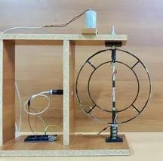

Fig-19

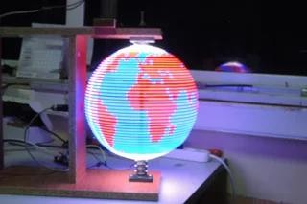

Fig-20

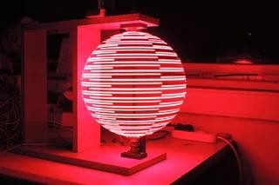

Fig-21

CONCLUSION:

More than we could have imagined, this project has taught us both how to build imaginative, eye-catching displays utilizing Arduino hardware and software. To keep within a fair budget, we also learnt how to use effective supplies and save money.
Above all, though, time management did come into play when we encountered numerous difficulties, and I think we handled the management with reasonableness.
In many respects, the project enhanced our mechanical and electrical abilities. Since we have never created anything pertaining to point of view before, the persistence of vision has shown us how technology functions.
The Persistence of Vision (POV) globe represents a captivating fusion of technology and creativity, utilizing the human eye’s ability to retain images for a brief moment to create stunning visual displays.
This innovative technology has already found diverse applications across various fields, including education, advertising, entertainment, corporate settings, and public information systems.
As technology continues to advance, the future scope of POV globes promises even greater versatility and impact.

REFERENCES:

- https://courses.engr.illinois.edu/ece445

- https://www.ece.ucf.edu/seniordesign/su2013fa20

- https://iarjset.com/wpcontent/uploads/2023/07/IARJSET

- https://courses.engr.illinois.edu/ece445

- https://www.ee.iitb.ac.in/course

- https://justdoelectronics.com

