Carlton Daniel
Senior Machine Learning Engineer

PROFILE SUMMARY

Machine Learning Engineer with 6 years of experience spanning Generative AI, NLP, and automotive sensor analytics. Skilled in developing agentic AI workflows using Model Context Protocol (MCP), MCP AGNO, LangGraph, LangChain, and LangSmith for document intelligence, retrieval augmentation, and multilingual email classification systems. At Bosch SensorTech, I led benchmarking for wafer and stripmap classification/localization, developed Digital Twin–based predictive maintenance and sensor-fusion systems, and authored two patents on elastomer RUL estimation and deep-learning-driven virtual sensors. Experienced in similarity search, time-series modeling, and advanced ML, I connect industrial AI with modern GenAI ecosystems to deliver scalable, explainable, and production-ready solutions.

EDUCATION

2022

2017
M.Tech

Vellore Institute of Technology

B.Tech/B.E.

Dayananda Sagar Academy of Technology and Management, Bangalore

WORK EXPERIENCE

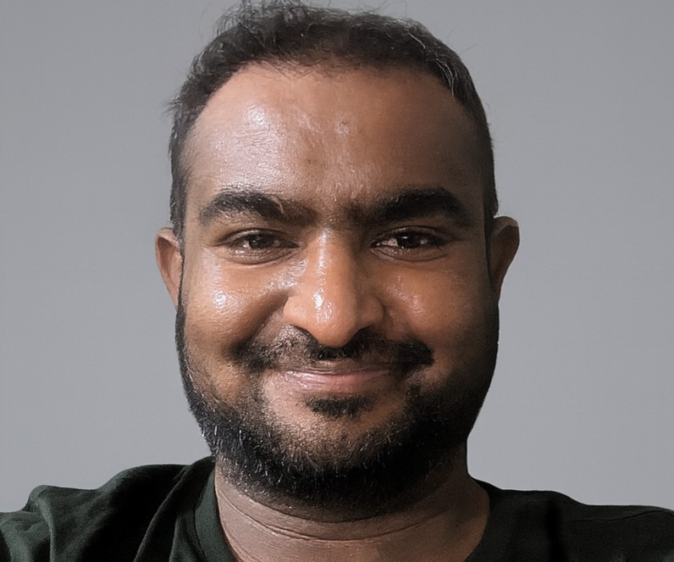
Mar 2022 -

PERSONAL INFORMATION

Email
carltondaniel95@gmail.com

Mobile
(+91) 9535821032

Total work experience
6 Years 0 Month

Social Link
https://www.linkedin.com/in/carlton- daniel-077054149/

KEY SKILLS

Predictive Maintenance Industry 4.0
digital twin machine learning deep learning
natural language processing artificial intelligence
data analytics data visualization sql scripting
statistical modeling Langchain
Model Context Protocol (MCP) Agentic Ai

OTHER PERSONAL DETAILS
Present
Senior Machine Learning Engineer

Bosch

Bengaluru, India)

GenAI, NLP & Document Intelligence

Built Generative AI pipelines using LangChain, LangGraph, LangSmith, Model Context Protocol (MCP), and MCP AGNO for automated document processing, retrieval, and knowledge extraction.

Developed custom Named Entity Recognition (NER) models in spaCy, trained on domain-specific automotive and warranty datasets to extract structured entities from multilingual documents.

Delivered an email classification and spam detection system for a German automotive manufacturer using TF-IDF features with supervised ML and AWS Textract OCR, reducing manual triage time from 5–6 minutes to ~30 seconds and improving accuracy
> 85%.

Implemented agentic AI workflows for document routing, metadata validation, and knowledge-base integration.

Managed end-to-end MLOps pipelines on DataBricks with MLflow for experiment tracking, model versioning, and deployment to production, ensuring reproducibility and

governance of GenAI and NLP models.

Predictive Maintenance, Digital Twin & Edge AI Designed and deployed Digital Twin–based predictive
maintenance models for conveyor belts, gearbox bearings, and capacitors using vibration, ultrasonic, and RFID sensor fusion.

Engineered Edge AI inference modules for on-device condition monitoring, reducing latency and cloud dependency.

Authored two patents on elastomer Remaining Useful Life (RUL) estimation and deep-learning-based virtual sensors within Bosch’s Industry 4.0 framework.

Led wafer and stripmap classification/localization benchmarking, applying geometric heuristics and ML models to enhance MEMS wafer defect localization and yield.

Impact Highlights

Unified GenAI and Industrial AI pipelines connecting document automation with sensor analytics.

Advanced Bosch’s Industry 4.0 objectives through production- grade Digital Twin, Predictive Maintenance, Edge AI, and MLOps (DataBricks + MLflow) implementations.

Sep 2021 - Mar 2022
City
Bengaluru
Country
INDIA
LANGUAGES
english
EXTRA CURRICULAR
Sports Nationals
https://drive.google.com/file/d/1RquoUtkde0r3fRfOh7 sNKcHRFTHXbEUd/view

Hackathon
https://www.linkedin.com/in/carlton-daniel- 077054149/overlay/1635532014320/single- media□viewer/? profileId=ACoAACPHwFsBqLuzenwvZQAx8PXw1I9dAV1 BWiI

Patent
https://www.linkedin.com/in/carlton-daniel- 077054149/overlay/1635532015222/single-media- viewer/?

Github
https://github.com/carltondaniel/project

Feb 2020 - Aug 2020

Jun 2019 - Jan 2020
Senior Software Engineer

Quest Global

Helped the team build a POC for a chatbot using RASA for Japanese text with custom actions to query a Knowledge Base.

Helped implement a POC for Bill of Material comparison, identifying component-level differences across BOM versions.

Contributed to design and prototyping of NLP-based enterprise automation tools, collaborating with internal stakeholders to move from PoC to functional solutions.

Machine Learning Engineer

Dimaag-AI

Worked on a project for a multibillion-dollar Japanese corporation, helping implement Information Retrieval systems using ElasticSearch.

Contributed to transitioning the solution from Proof of Concept (PoC) to a full-scale project.

Collaborated on a Time Series classification problem for a U.S.- based semiconductor client, assisting with:

Data Visualization development

Writing Data Aggregation and Sliding Window scripts for feature generation.

Python

Bunglow 8 technology

Built dashboards using Plotly Dash to visualize annotation

performance and neural network events.

Classified suspicious neural events manually and automated data workflows using Airflow.

Developed R-script validation tools for pre-upload checks and integrated data from MongoDB, Google Sheets, and SQL.

Automated reporting and streamlined annotation pipelines to support ML model validation.

Nov 2017 - Jan 2019
Associate Software Engineer

Accenture

Managed customer and vendor master data, withholding tax, and GL account issues.

Deployed changes from QA to production environments and supported UAT activities.

Handled year-end finance operations, including extending number ranges.

Worked on-site at client location, ensuring smooth system operations and SAP-related task

INTERNSHIP

- Days

- Days
Hal

Future tech

COURSES & CERTIFICATIONS

Rasa Developer Certification Applied Ai course
Spacy and Rasa for NLP

MCP Masterclass: Complete Guide to MCP in Python [2025] https://ude.my/UC- 27b6f21f-cccf-411f-81cd-35d6414edb86

CUSTOM SECTION

Hackathon
Ranked in Top 250 (Rank #250 out of thousands of participants).Achieved a private leaderboard score of 1146.05 in a supervised regression problem using deep learning .

https://www.analyticsvidhya.com/datahack/leaderboard/practice-problem-big-mart-sales-iii/

