This is a sample visual testing o f postman refer uploaded postman link or json file

⚙️ Collection: Rice Trade Platform

📁 Folder: Auth
Request Name | Method | URL | File (Route → Controller)
Auth – Register | POST | /auth/register | src/routes/auth.js → src/controllers/authController.js
Auth – Login | POST | /auth/login | src/routes/auth.js → src/controllers/authController.js
Auth – Me | GET | /auth/me | src/routes/auth.js → src/controllers/authController.js

1. Auth – Register
- Headers
  - Content-Type: application/json
Body (raw JSON)
{
"name": "Gopi",
"phone": "6302511822",
"password": "gopi123",
"role": "seller"
}

Expected
{
"token": "<jwt>",
"userId": "<uuid>",
"role": "seller"
}
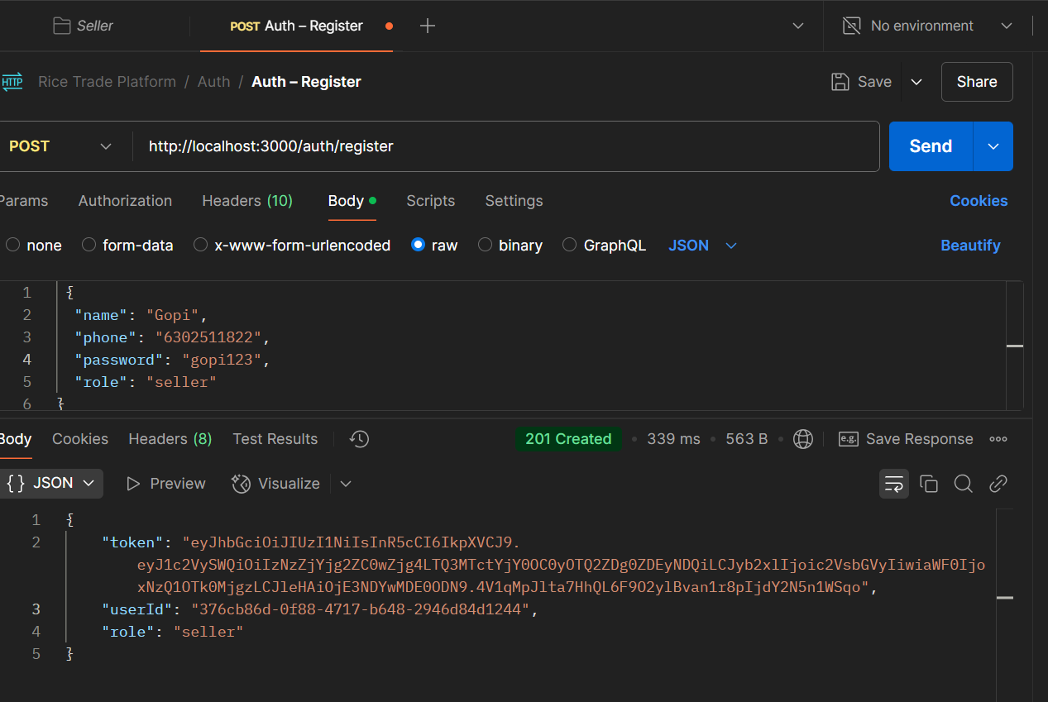

2. Auth – Login
- Headers
  - Content-Type: application/json
Body
{
"phone": "6302511822",
"password": "gopi123"
}

Expected
{
"token": "<jwt>",
"userId": "<uuid>",
"name": "Alice",
"role": "seller"
}
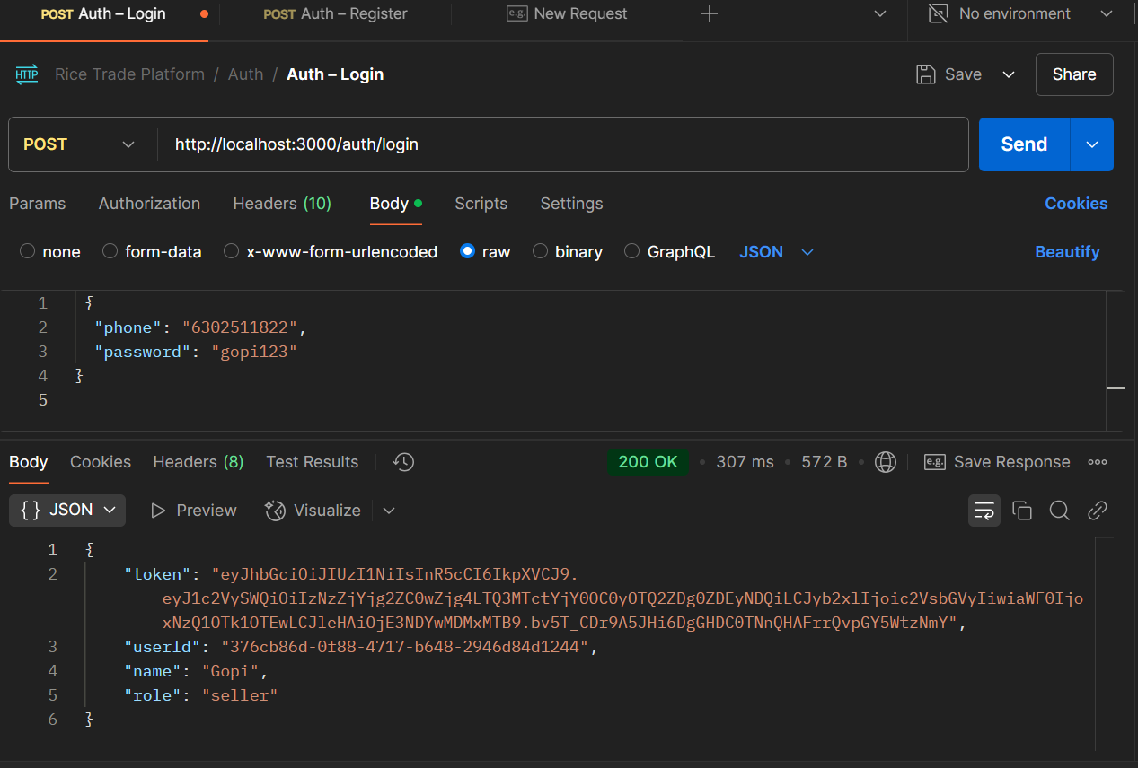

3. Auth – Me
- Headers
  - Authorization: Bearer <jwt>
- No body
Expected
{
"userId": "<uuid>",
"role": "seller"
}
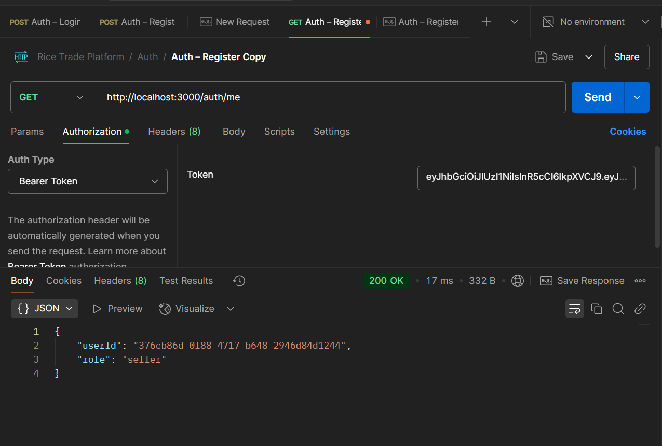

📁 Folder: Seller
Request Name | Method | URL | File (Route → Controller)
Seller – Get My Profile | GET | /sellers/profile | src/routes/Sellers.js → src/controllers/sellersController.js
Seller – Create Profile | POST | /sellers/profile | src/routes/Sellers.js → src/controllers/sellersController.js
Seller – List Products | GET | /sellers/{sellerId}/products | src/routes/Sellers.js → src/controllers/sellersController.js
Seller – Add Product | POST | /sellers/{sellerId}/products | src/routes/Sellers.js → src/controllers/sellersController.js
Seller – Update Product | PATCH | /sellers/{sellerId}/products/{productId} | src/routes/Sellers.js → src/controllers/sellersController.js

Create Your Seller Profile
- New Request → Name it “Seller – Create Profile”
- Method: POST
URL:
{{baseUrl}}/sellers/profile

- Authorization tab
  - Type: Bearer Token
  - Token: paste the JWT you got from login
- Headers
Key | Value
Content-Type | application/json
Body (raw → JSON)
{
"millName": "Mandepudi",
"city": "Khammam",
"lat": 12.9796,
"lng": 77.5966
}

Send → you should get:
{ "sellerId": "84804662-ebee-452c-9d91-8d58d9de9cec" }

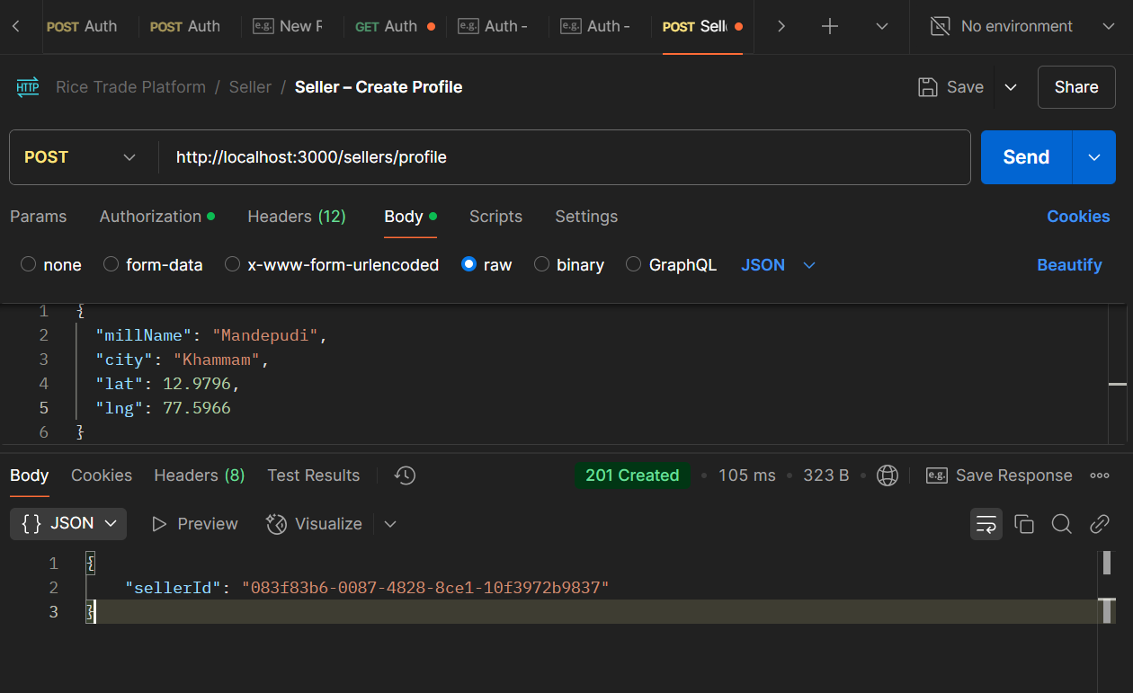

4. Seller – Get My Profile
- Headers
  - Authorization: Bearer <jwt>
Expected
{
"sellerId": "<uuid>",
"millName": "Siddipet Rice Mill #1",
"city": "Siddipet",
"lat": 18.0984,
"lng": 78.8490
}
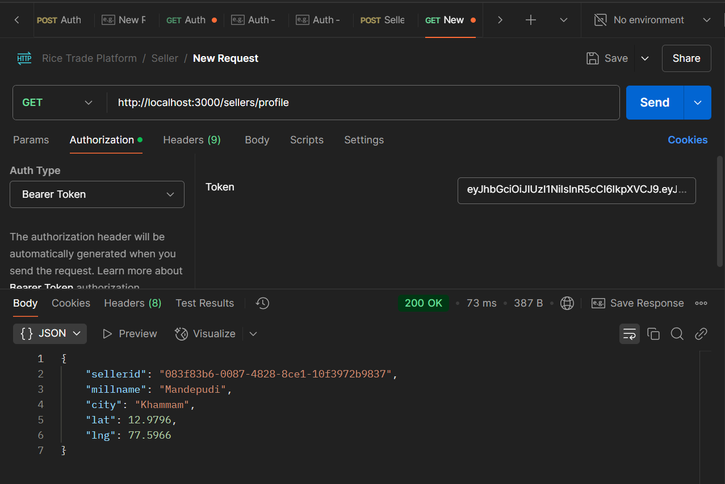

Seller – Add Product
- Headers
  - Authorization: Bearer <jwt>
  - Content-Type: application/json
Body
{
"type": "Biryani rice",
"quantity": 25.0,
"price": 90.00
}

Expected
{ "productId": "<uuid>" }

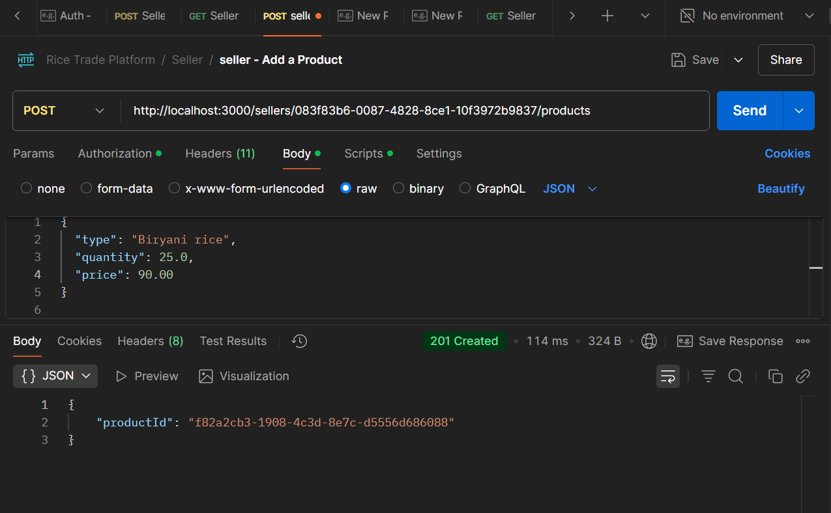6. Seller – List Products
- Headers
  - Authorization: Bearer <jwt>
Expected
[
{
"id": "<productUuid>",
"type": "Biryani rice",
"quantity": 25.0,
"price": 90.00,
"available": false,
"updated_at": "2025-04-30T…Z"
}
]
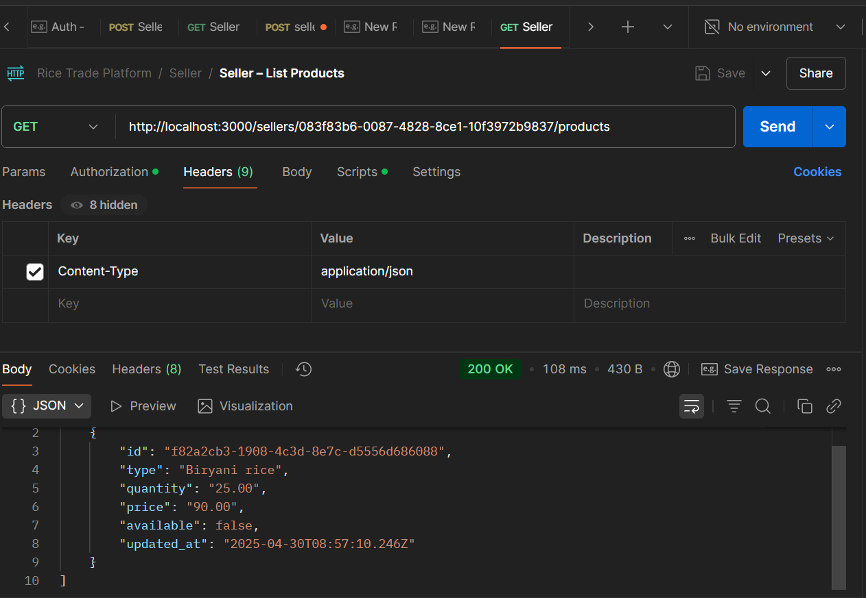

. Seller – Update Product
- Headers
  - Authorization: Bearer <jwt>
  - Content-Type: application/json
Body (any subset)
{ "available": true }

Expected
{ "success": true }
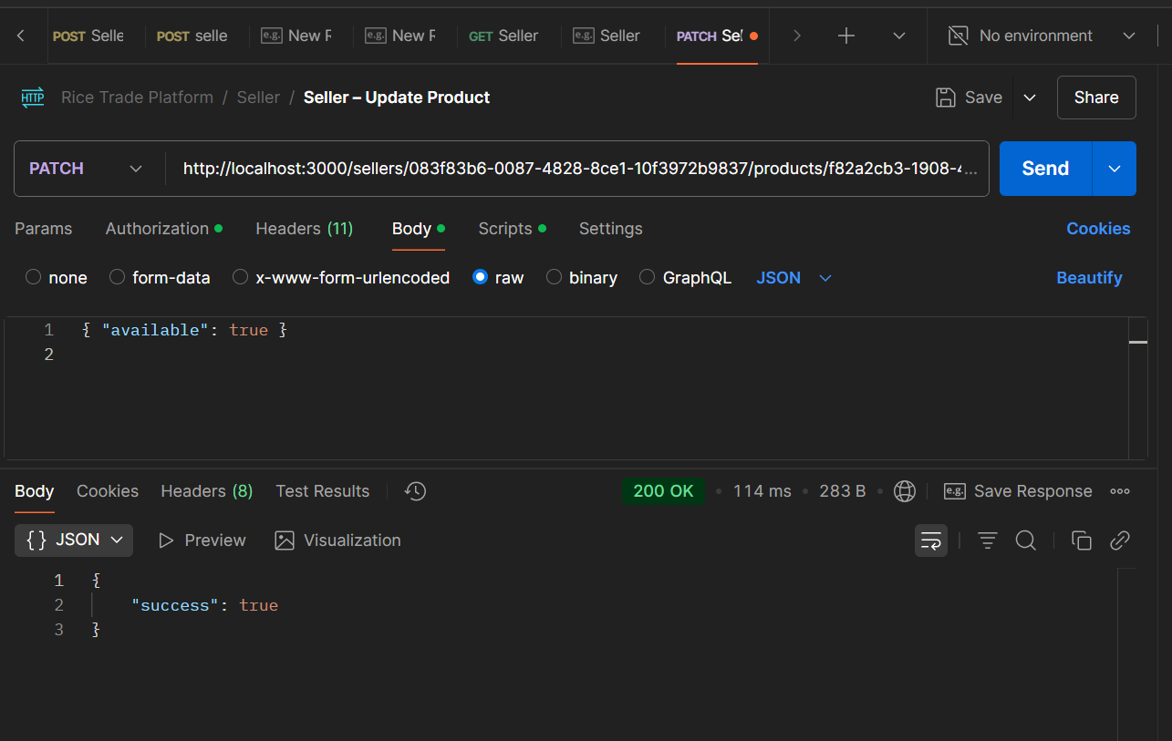

1. Create a Buyer Account

POST /auth/register
URL:
{{baseUrl}}/auth/register

Headers:
Content-Type: application/json

Body (raw → JSON):
{
"name": "Bob",
"phone": "9123456780",
"password": "buyerpass",
"role": "buyer"
}

Expected Response:
{
"token": "<jwt_token>",
"userId": "<uuid>",
"role": "buyer"
}
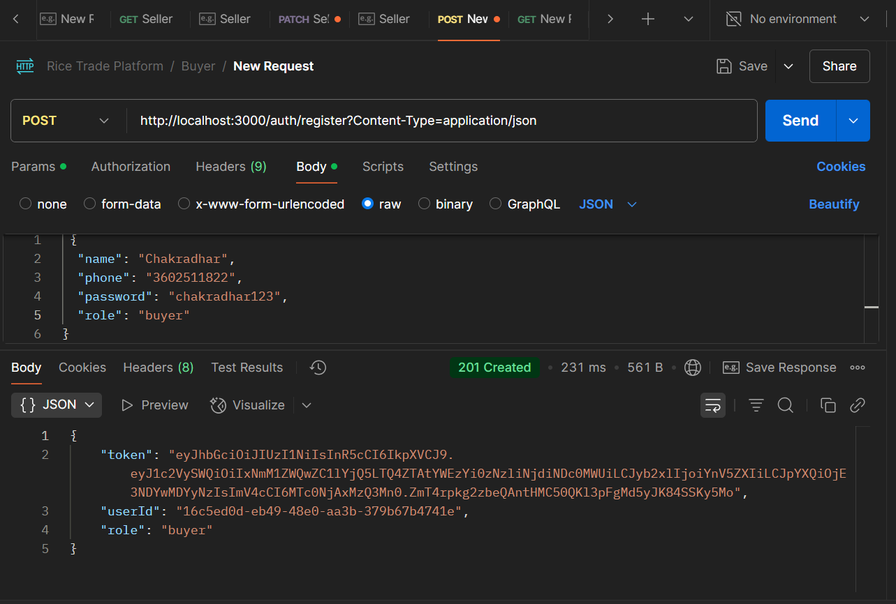
2. Login Buyer (Optional)

POST /auth/login
URL:
{{baseUrl}}/auth/login

Headers:
Content-Type: application/json

Body:
{
"phone": "3602511822",
"password": "chakradhar123"
}

Expected Response:
{
"token": "<jwt_token>",
"userId": "<uuid>",
"name": "Chakradhar",
"role": "buyer"
}
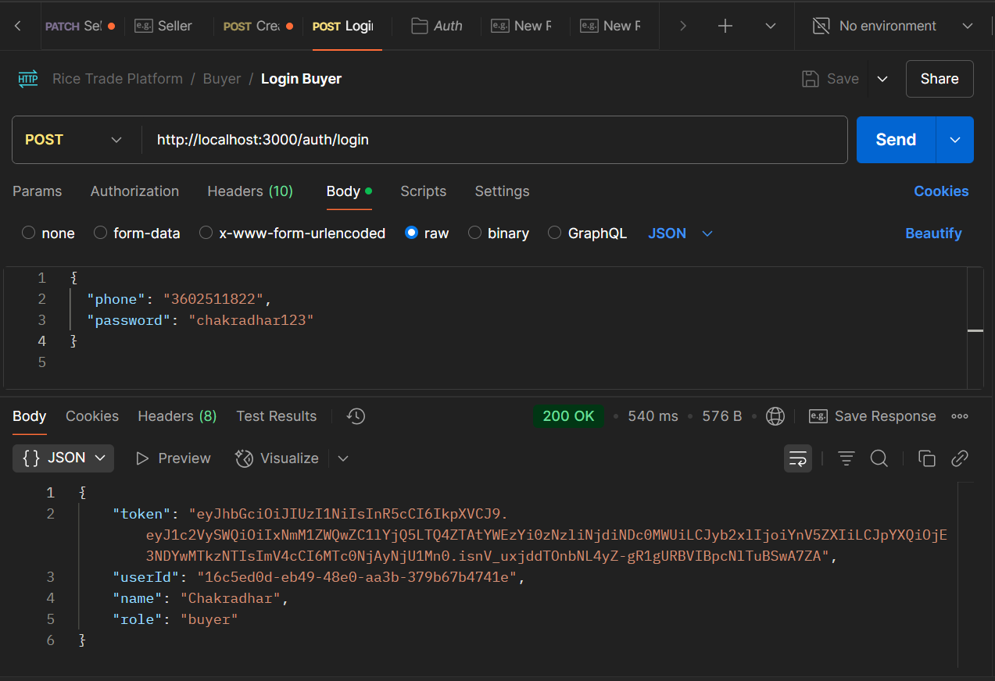

3. Search Products (Buyer Searches for Basmati Rice)

GET /products/search?type=Basmati&qty=5&lat=18.1&lng=78.8
URL:
{{baseUrl}}/products/search?type=Basmati&qty=5&lat=18.1&lng=78.8

Headers:
Authorization: Bearer <buyer_token>

Expected Response:
[
{
"productId": "<product_uuid>",
"type": "Basmati",
"quantity": 10,
"priceWithCommission": 52.50,
"transportCost": null,
"sellerAnonName": "Siddipet Rice Mill #1"
}
]
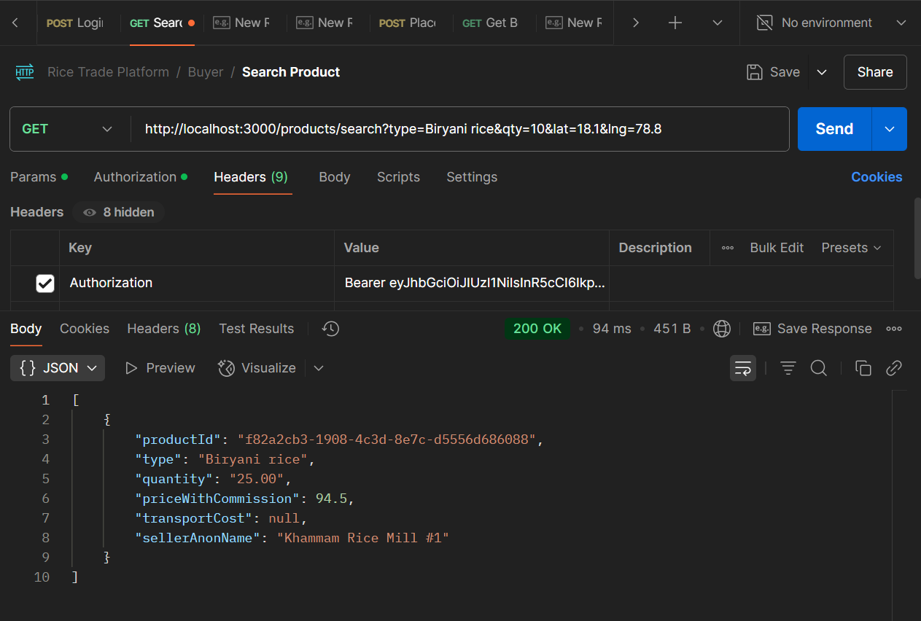

4. Place Bid

POST /bids
URL:
{{baseUrl}}/bids

Headers:
Authorization: Bearer <buyer_token>
Content-Type: application/json

Body:
{
"productId": "<from_search>",
"bidPrice": 55
}

Expected Response:
{
"bidId": "<bid_uuid>",
"status": "accepted",
"orderId": "<order_uuid>"
}
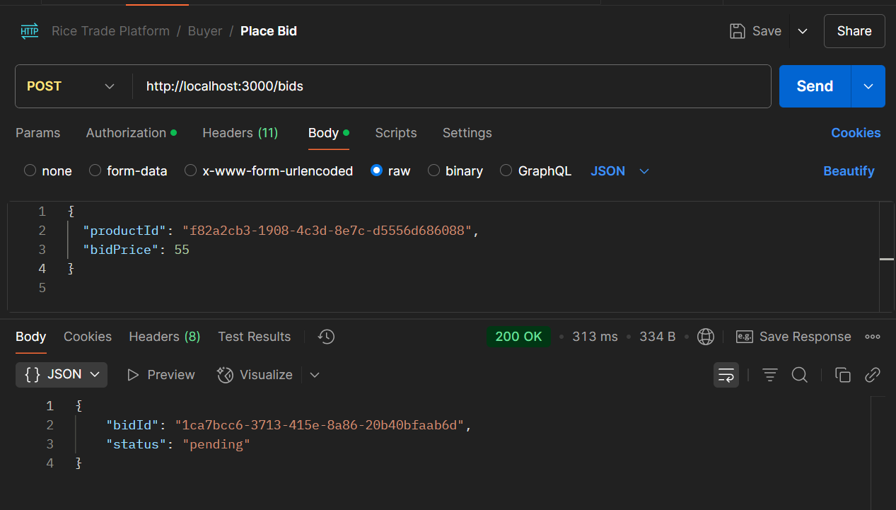
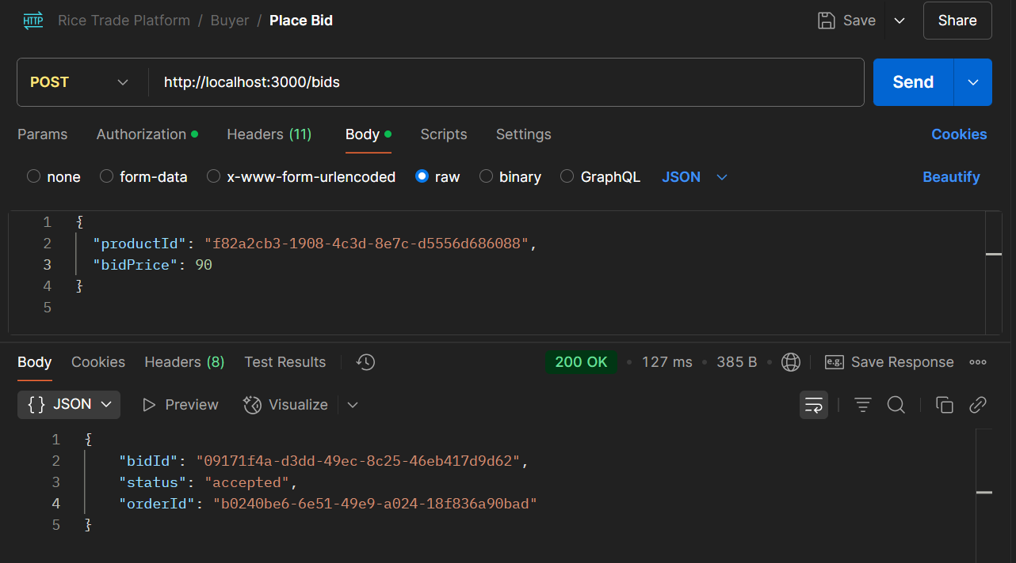

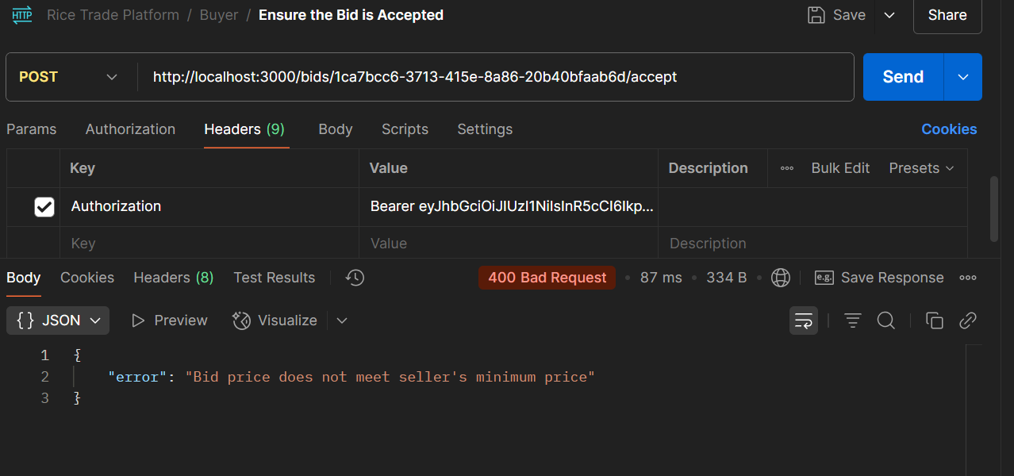5. Get Buyer Orders

GET /buyers/{buyerId}/orders
URL:
{{baseUrl}}/buyers/{buyerUserId}/orders

Headers:
Authorization: Bearer <buyer_token>

Expected Response:
[
{
"orderId": "<order_uuid>",
"sellerAnonName": "Siddipet Rice Mill #1",
"productType": "Basmati",
"finalPrice": 55,
"paymentStatus": "paid",
"createdAt": "2025-04-30T...Z"
}
]
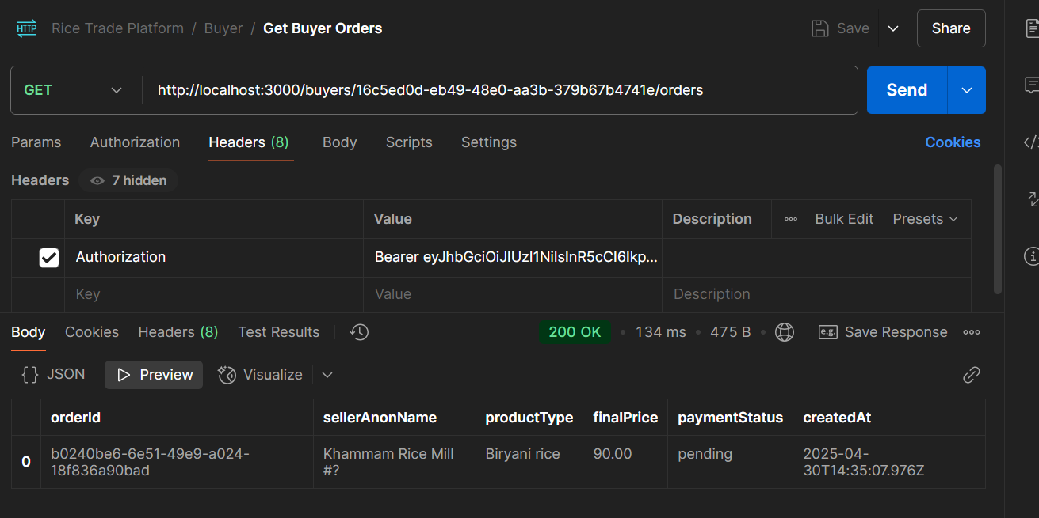

6. Mock Payment (Buyer Pays for Order)

POST /orders/{orderId}/pay
URL:
{{baseUrl}}/orders/{orderId}/pay

Headers:
Authorization: Bearer <buyer_token>

- No Body
Expected Response:
{ "paymentStatus": "paid", "orderId": "<order_uuid>" }
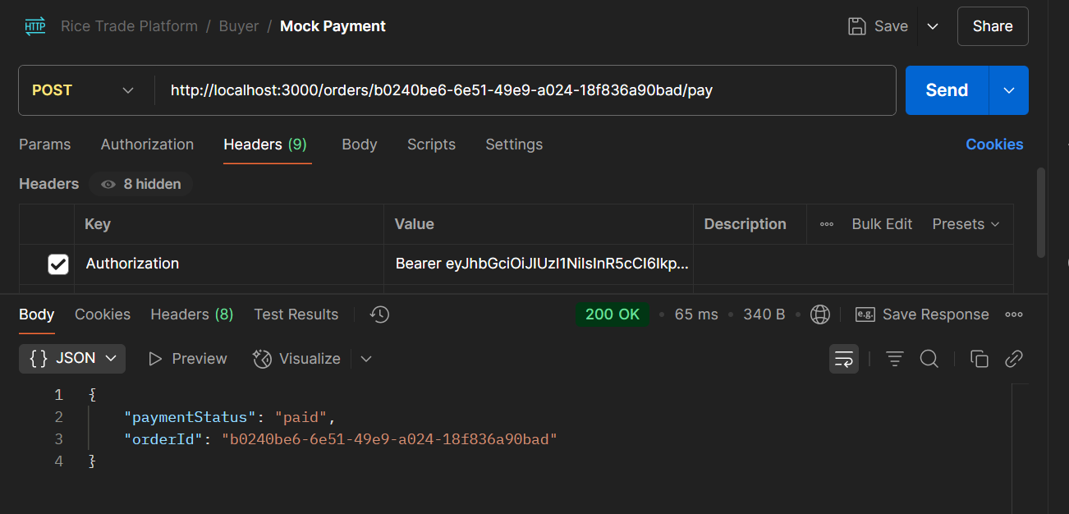

Summary
- Step 1: Create Buyer (register)
- Step 2: Log in to Buyer (optional, can skip if you have the token)
- Step 3: Search for Products (like Basmati)
- Step 4: Place a Bid
- Step 5: Get Orders (view orders made by the buyer)
- Step 6: Mock Payment (mark order as paid)

📁 Folder: Logistics13. Logistics – Get Nearby Partners

Request Name | Method | URL | File (Route → Controller)
Logistics – Get Nearby Partners | GET | /logistics/nearby?lat=&lng= | src/routes/logistics.js → src/controllers/logisticsController.js
Logistics – Assign Partner | POST | /logistics/{partnerId}/assign | src/routes/logistics.js → src/controllers/logisticsController.js
Logistics – Partner Accepts Assignment | POST | /logistics/assignments/{assignmentId}/accept | src/routes/logistics.js → src/controllers/logisticsController.js
Logistics – Update Assignment (GPS/OTP/Lorry) | PATCH | /logistics/assignments/{assignmentId} | src/routes/logistics.js → src/controllers/logisticsController.js
Logistics – Confirm Delivery | POST | /logistics/{orderId}/confirm | src/routes/logistics.js → src/controllers/logisticsController.js
- Headers
  - Authorization: Bearer <jwt>
URL Params
?lat=18.1&lng=78.8

Expected
[
{ "partnerId":"<uuid>", "name":"FastTransport", "distance":0.00123 }
]
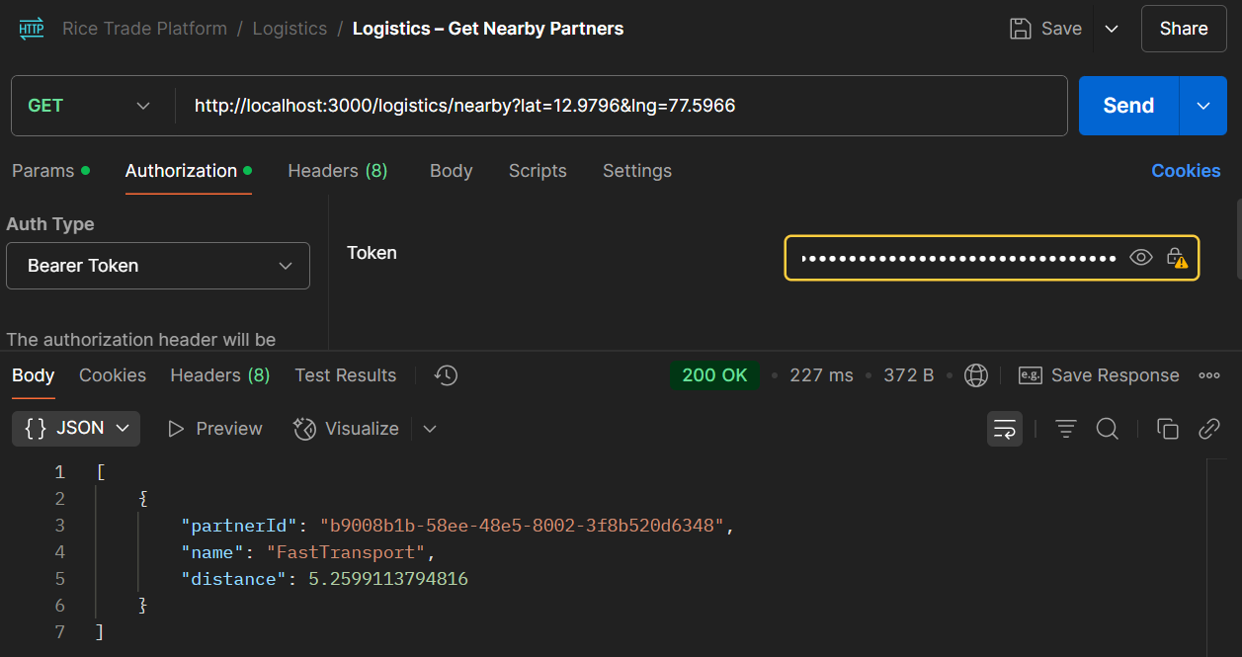

14. Logistics – Assign Partner
- Headers
  - Authorization: Bearer <jwt>
  - Content-Type: application/json
Body
{ "orderId": "<orderId>" }

Expected
{ "assignmentId":"<uuid>", "status":"notified" }

15. Logistics – Partner Accepts Assignment
- Headers
  - Authorization: Bearer <jwt>
- No body
Expected
{ "status":"accepted" }

16. Logistics – Update Assignment
- Headers
  - Authorization: Bearer <jwt>
  - Content-Type: application/json
Body
{
"lorryNumber":"KA01AB1234",
"lat":18.1,
"lng":78.8,
"otp":"5678"
}

Expected
{ "status":"in_transit" }

17. Logistics – Confirm Delivery
- Headers
  - Authorization: Bearer <jwt>
  - Content-Type: application/json
Body
{ "otpConfirmation":"5678" }

Expected
{ "delivered": true }

