Customer Support Ticket Classification System
AI Fresher Technical Assignment – Solution Report
Supriya Gope
September 2026

A. Problem Understanding
A company receives support requests through email, chat and other channels. Each request has a description written in free text, and someone has to read it and decide which type of problem it is (for example a login problem, an application error or a report request) so it can be routed to the right team. Doing this by hand is slow and inconsistent.
The goal of this project is to build a basic machine-learning system that learns from past tickets and predicts the category of a new ticket from its description alone. This is a multi-class text classification problem with five categories.

B. Dataset

Final dataset
The final dataset is synthetic and was created for this assignment. It was produced by the script src/generate_dataset.py, which combines hand-written phrases for each category with random openers, closers and extra details, and removes duplicate texts. About 20% of the tickets in each category are deliberately ambiguous: they mix vocabulary from other categories (for example "login takes forever and my password is rejected") to make the task more realistic. Each ticket is labelled by the customer's main intent.
Property | Value
File | dataset/claude_tickets.csv
Records | 200 tickets
Categories (5) | Login Issue, Application Error, Report, Account Update, Performance (40 each)
Fields | ticket_id, ticket_description, category, priority, status
Priority values | Critical, High, Medium, Low (weighted by category, not real)
Status values | Open, In Progress, Closed (random, not real)

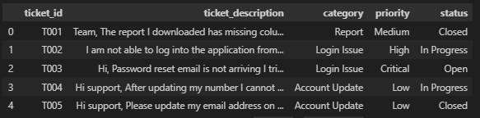
Figure 0: Preview of claude_tickets.csv

Public dataset evaluated first
I first tried a public dataset: Customer Support Ticket Dataset by suraj520 on Kaggle (https://www.kaggle.com/datasets/suraj520/customer-support-ticket-dataset, 8,469 tickets). I sampled 200 balanced tickets and mapped its ticket type to my category field. The first model scored only 25% accuracy, so I investigated instead of just accepting it. I ran the whole dataset through three models and also added the ticket subject as input:
Model (all 8,469 tickets, 80/20 split) | Description only | Subject + description
Logistic Regression | 20.2% | 20.2%
Naive Bayes | 21.0% | 20.2%
Linear SVM | 19.7% | 19.4%
Random guessing (5 classes) | 20% | 20%

Every model performed at the level of random guessing, and the same ticket subjects appeared under every ticket type. The dataset is synthetic and its labels are unrelated to its text, so no model could learn from it. I therefore did not use it and created my own dataset. No modifications of the Kaggle data were used in the final project.

C. Data Preprocessing

Missing values and duplicates
The dataset was checked with df.isnull().sum() and df.duplicated(). There were no missing values and no duplicate records (200 non-null values in each of the 5 columns), so no rows had to be removed or filled. Had there been missing descriptions I would have dropped those rows, since the description is the model's only input.

Text cleaning
A function clean_text() is applied to every description, producing a new column clean_description. The original text is kept for comparison. The cleaned data is saved as dataset/claude_tickets_cleaned.csv.
Step | What it does | Why it is needed
Lowercase | "Login" and "login" become the same word | Stops the model treating them as different words
Remove {...} placeholders | Deletes template tags such as {product_purchased} | Left over from the public dataset; harmless here, kept for safety
Remove punctuation | Keeps only letters, digits and spaces | Punctuation adds little for a word-frequency model
Collapse whitespace | Multiple spaces or newlines become one space | Keeps tokens clean

Stop words (such as "the", "is") are not removed manually; the TF-IDF vectorizer removes them with its built-in English list.

Exploratory Data Analysis
Total tickets: 200. Tickets per category: 40 each (perfectly balanced). Priority: High 65, Medium 60, Low 51, Critical 24. Status: Closed 68, In Progress 66, Open 66.
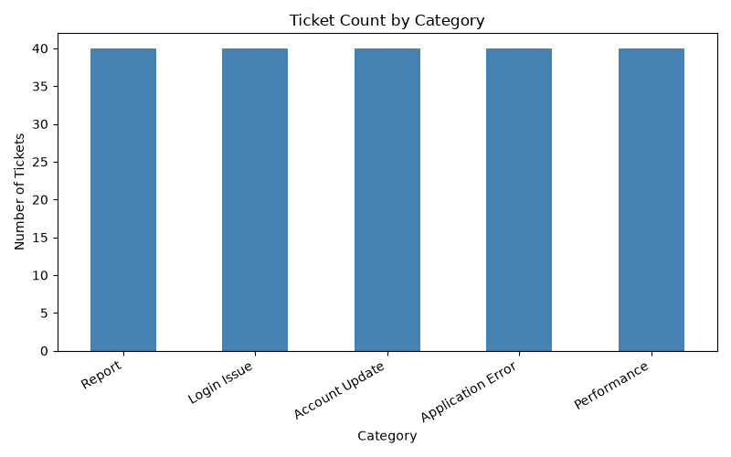
Figure 1: Ticket count by category
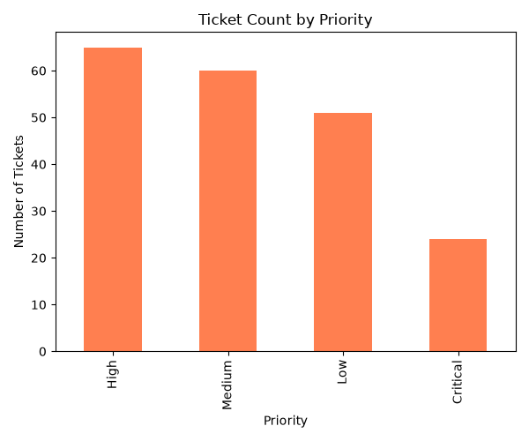
Figure 2: Ticket count by priority
Observations. The categories are perfectly balanced, so accuracy is a fair metric and no class dominates. High and Medium are the most common priorities and Critical is the rarest, which is a plausible shape for a support queue. Status is spread almost evenly with no meaningful link to category. Because I generated this dataset, priority and status follow my own rules and random assignment, so they show how the data was built, not real customer behaviour. Only the category and description are used for the model.

D. Model Selection
Algorithm: Logistic Regression on TF-IDF features.

How text becomes features
TF-IDF (Term Frequency – Inverse Document Frequency) turns each cleaned description into a vector of numbers, one per word in the vocabulary. A word scores high when it appears often in a ticket but rarely across all tickets, so category-specific words such as "password", "report" or "slow" stand out while common words carry little weight. The vectorizer uses the built-in English stop-word list.

Why Logistic Regression
- It works well on high-dimensional, sparse text features such as TF-IDF vectors.
- It is fast to train and needs no heavy tuning, which suits a small dataset.
- It gives class probabilities, which are used as a confidence score in the prediction program.
- It is easy to explain: each word gets a weight per category, and no black box is involved.

How the model predicts
For a new ticket, the model computes a score for each of the five categories from the TF-IDF word weights, converts the scores into probabilities that add up to 100%, and returns the category with the highest probability along with that probability as the confidence.

E. Training and Testing
- Split: 80% training (160 tickets) and 20% testing (40 tickets), with stratify=y and random_state=42, so each category has 32 training and 8 test tickets.
- Order of steps: the text is cleaned first (a row-by-row operation), then split. The TF-IDF vectorizer is fitted on the training data only and then only applied to the test data. This avoids data leakage, where the test tickets would influence the vocabulary and word weights.
- Training: LogisticRegression(max_iter=1000) is fitted on the training vectors and labels.
- Testing: the trained model predicts the categories of the 40 unseen test tickets, which are compared with the true labels.

F. Results
Accuracy: 92.5%. The model correctly classified 37 of the 40 test tickets.
Category | Precision | Recall | F1-score | Support
Account Update | 0.89 | 1.00 | 0.94 | 8
Application Error | 0.86 | 0.75 | 0.80 | 8
Login Issue | 1.00 | 0.88 | 0.93 | 8
Performance | 1.00 | 1.00 | 1.00 | 8
Report | 0.89 | 1.00 | 0.94 | 8
Macro average | 0.93 | 0.93 | 0.92 | 40

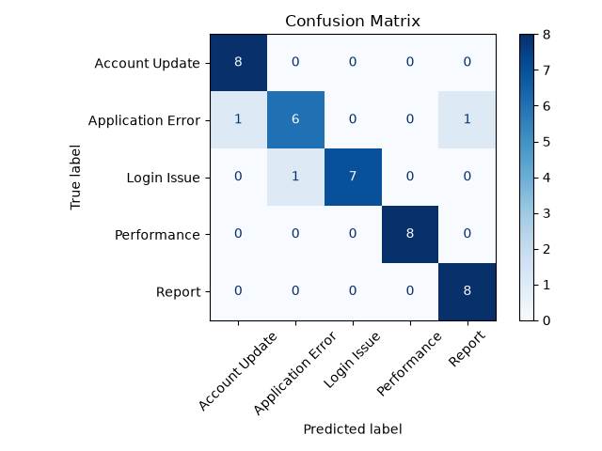
Figure 3: Confusion matrix on the test set

Explanation in simple language
Precision answers: when the model says a ticket is, say, a Report, how often is it right? Recall answers: of all the real Report tickets, how many did the model find? F1 combines the two. All categories score 0.80 or higher. Performance was perfect, and Account Update and Report tickets were all found. Application Error is the weakest (recall 0.75): two of its eight tickets were predicted as other categories.

The three mistakes
- "the app throws an error at the login screen every time" – true: Login Issue, predicted: Application Error (contains both "login" and "error").
- "something went wrong when i tried to update my account details" – true: Application Error, predicted: Account Update.
- "error while opening the report page it shows a blank screen" – true: Application Error, predicted: Report.
All three are ambiguous tickets that mix vocabulary from more than one category, and in some of them the correct label is debatable. The model works from word frequencies and does not understand intent.
Is the performance satisfactory? Yes, as a baseline. The results are strong and the errors are explainable. However, the test set has only 40 tickets, so each mistake changes accuracy by 2.5 percentage points. Repeating the split with other random seeds gave roughly 92–97%, so the true accuracy on this data is best described as about 90–95%. The dataset is also synthetic and easier than real tickets, so real-world accuracy would likely be lower.

G. Prediction on New Tickets
The program src/predict.py loads the saved vectorizer and model, applies the same clean_text() to the input, converts it with vectorizer.transform (never re-fitting) and prints the predicted category with its confidence. The test tickets were written in my own words and were not part of the training data.

# | Test input | Expected | Predicted | Confidence | Correct?
1 | I can't get into my account, it says wrong password | Login Issue | Login Issue | 39.9% | Yes
2 | Getting a failure message every time I hit the save button | Application Error | Application Error | 39.3% | Yes
3 | Could you send me last week's inventory summary? | Report | Report | 39.3% | Yes
4 | My company name has changed, please update it in the profile | Account Update | Account Update | 43.9% | Yes
5 | The portal is crawling and pages take ages to open | Performance | Performance | 30.6% | Yes
6 | The app is slow and shows an error | Ambiguous (Performance / Application Error) | Application Error | 37.3% | Plausible
7 | I want to change my email but the page shows an error | Account Update | Account Update | 51.5% | Yes
8 | What are your office hours? | None (off-topic) | Performance | 20.8% | No valid category

Tests 1–5 are clear single-topic tickets and were all classified correctly, with confidence between 31% and 44%. These figures look modest in isolation, but with five possible categories the model only needs to score meaningfully above the 20% random-guess baseline to be confidently right, and it clearly separates the correct class from the rest in each case. Tests 6–8 were added on purpose to check the limits. The ambiguous tickets got similar or lower confidence (37% and 52%), which correctly signals uncertainty. For the off-topic ticket, confidence was 20.8%, right at the random-guess baseline: the model has no real signal but still has to pick one of its known categories.
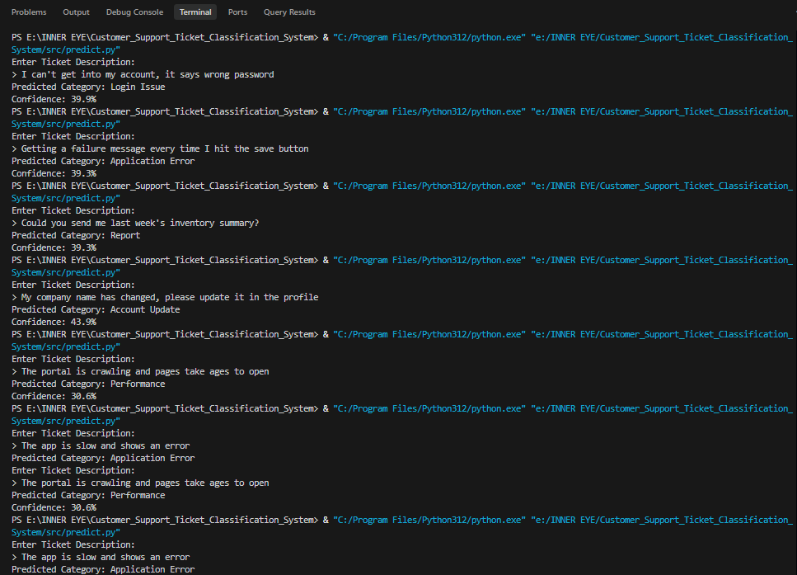
Figure 4: predict.py running in the terminal on several test tickets

H. Limitations
- Synthetic, template-based data: the tickets come from a limited pool of phrases, so the model has seen very similar wording in training and testing. Real customers write far more varied, messy and ambiguous text, so real accuracy would be lower.
- Small dataset and test set: 200 tickets in total and 40 for testing, so the accuracy figure has a wide margin of error.
- Limited categories: only five categories, and the model cannot answer "none of these". Off-topic input still receives one of the five labels.
- Keyword-based model: TF-IDF ignores word order and meaning. Tickets mixing topics ("error" with "login" or "report") are confused, and synonyms not seen in training are not understood.
- Ambiguous labels: some tickets fit more than one category, so the single label is partly a judgement call.
- Priority and status are not real signals: they were assigned by rules and randomly, so they cannot be used for analysis or prediction.
- Public dataset unusable: the Kaggle dataset I first tried had labels unrelated to the text, so a real-world benchmark could not be used.

I. Future Improvements
- Real data: train on real, human-labelled tickets from the company, with a larger and more varied dataset and more categories.
- Confidence threshold: send low-confidence predictions (for example below 40%) to a human agent instead of guessing, and add an "Other" category.
- Better text handling: n-grams, lemmatization, spelling correction and handling of multi-topic tickets.
- Better models: compare Linear SVM, Random Forest and cross-validation; later use sentence embeddings or a transformer model, or an LLM-based classifier.
- Human feedback and retraining: let agents correct predictions and retrain regularly.
- Production setup: a REST API and web interface, database integration, monitoring, and automatic suggested replies per category.
- Multi-label output: allow a ticket to belong to more than one category.

Use of AI Tools
I used Claude (Anthropic) as a guide throughout this assignment. It was used to: discuss the approach and plan the tasks; suggest the code for each step, which I ran, reviewed and adapted; write the synthetic dataset generator (src/generate_dataset.py); help investigate why the Kaggle dataset performed at random-guess level; and help interpret the results and draft this report and the README. I reviewed the code and results and can explain them. The prediction and evaluation results in this report come from my own runs. No API keys, passwords or credentials are included in the project.

Additional libraries
Only the preferred libraries were used: pandas, NumPy, Matplotlib, scikit-learn and joblib.

