“PROJECT NAME : AMAZON Clone”

***Overview of the project :***

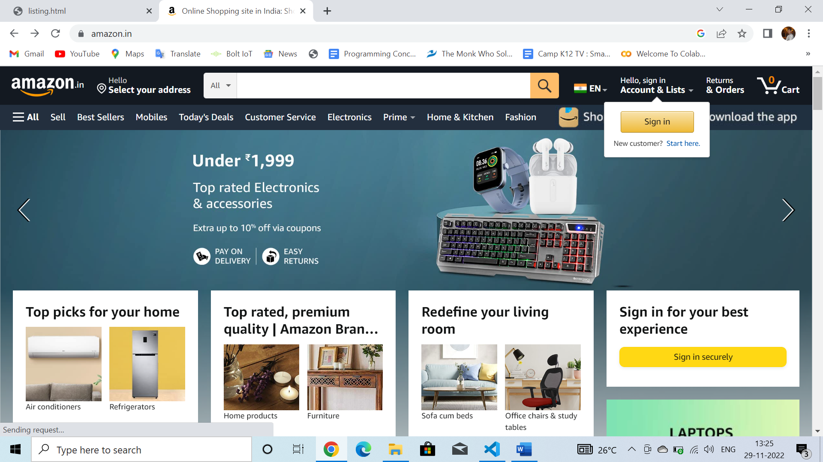

*Amazon.com is a vast Internet-based enterprise that sells books, music, movies, housewares, electronics, toys, and many other goods, either directly or as the middleman between other retailers and Amazon's millions of customers.*

***NUMBER OF WEB PAGES :***

*HOME PAGE*

*SIGN UP/SIGN IN PAGE*

*PRODUCT PAGE*

*PRODUCT DESCRIPTION PAGE*

*PAYMENT PAGE*

*ORDER CONFIRMATION PAGE*

***Page Contents:***

***Home Page:***

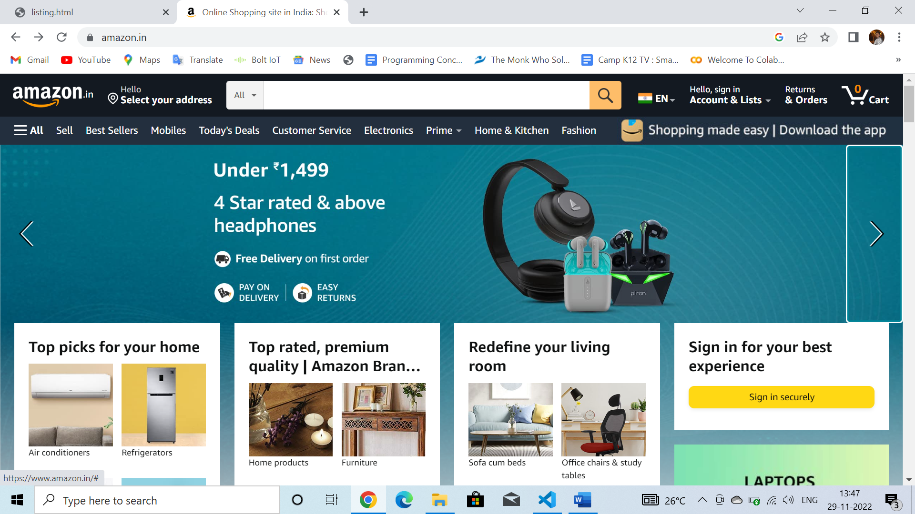

*Some trending products*

*Sliding images*

*Product images*

*Different product categories*

**Sign up/Sign in page:**

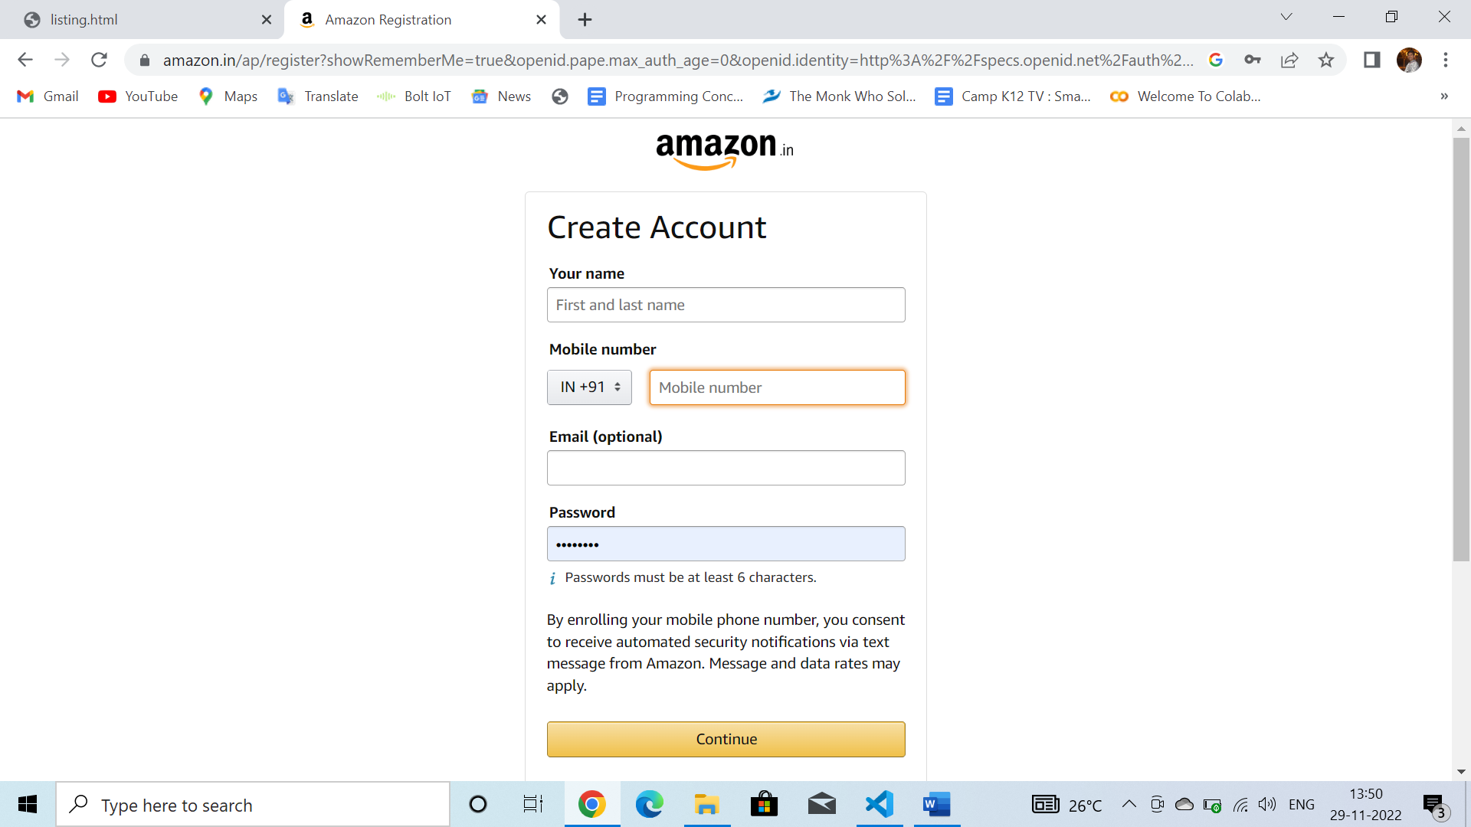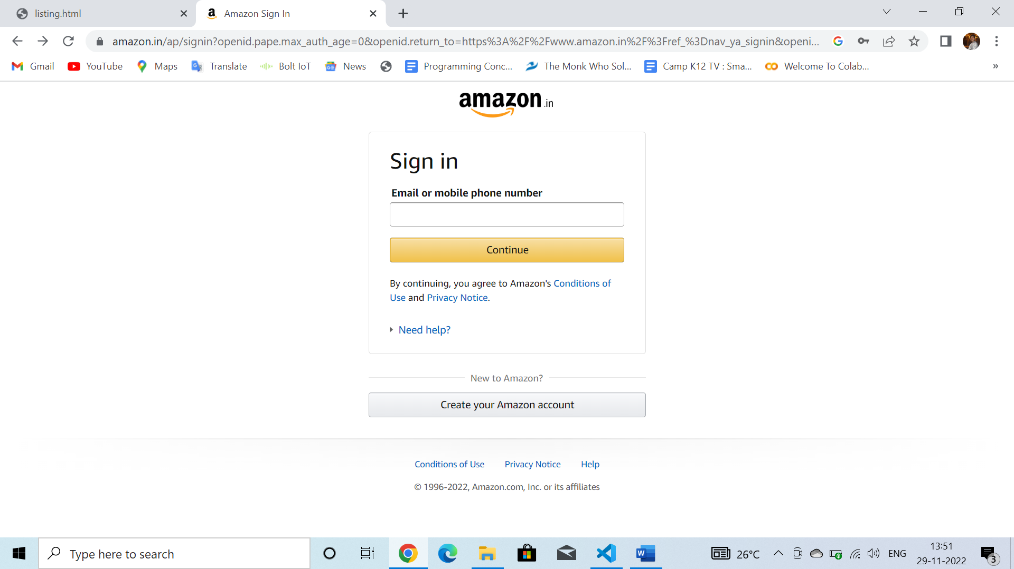

Form for new account creation

Sign in and User validation

**Product page:**

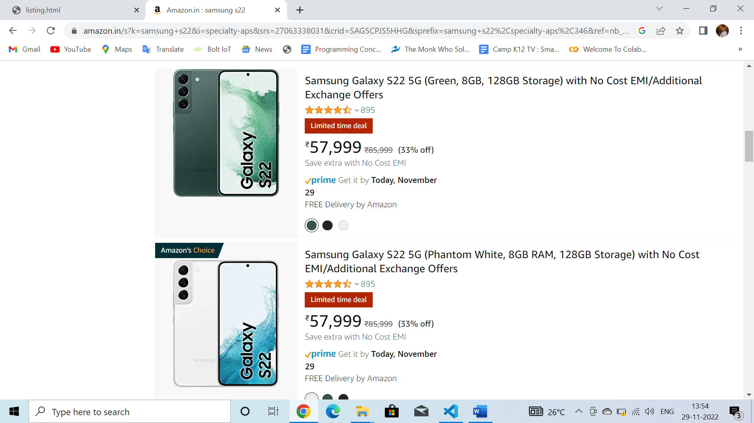

Different Products and Services

Images of the products and services

***Product Description page :***

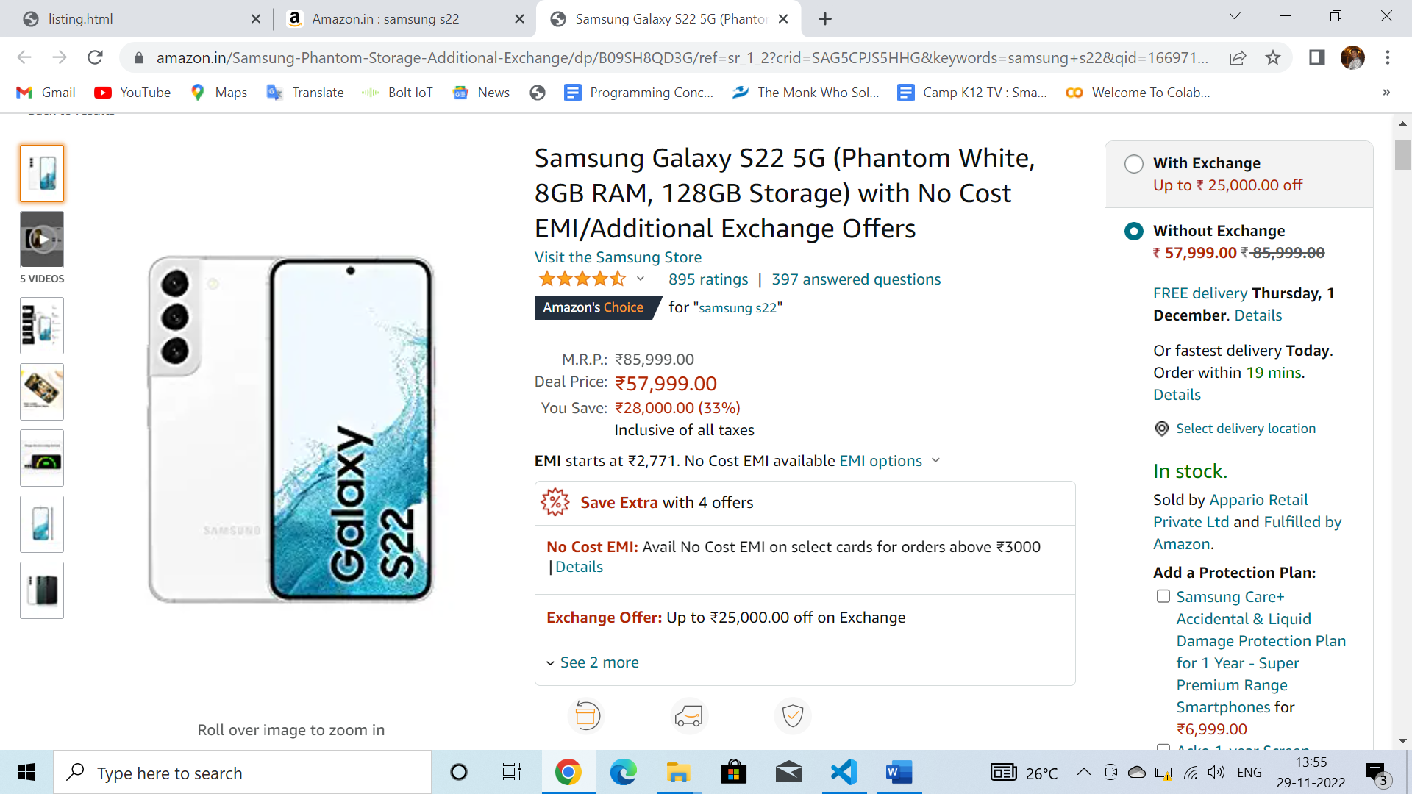

Complete Details of the Product and Service

***Payment Page :***

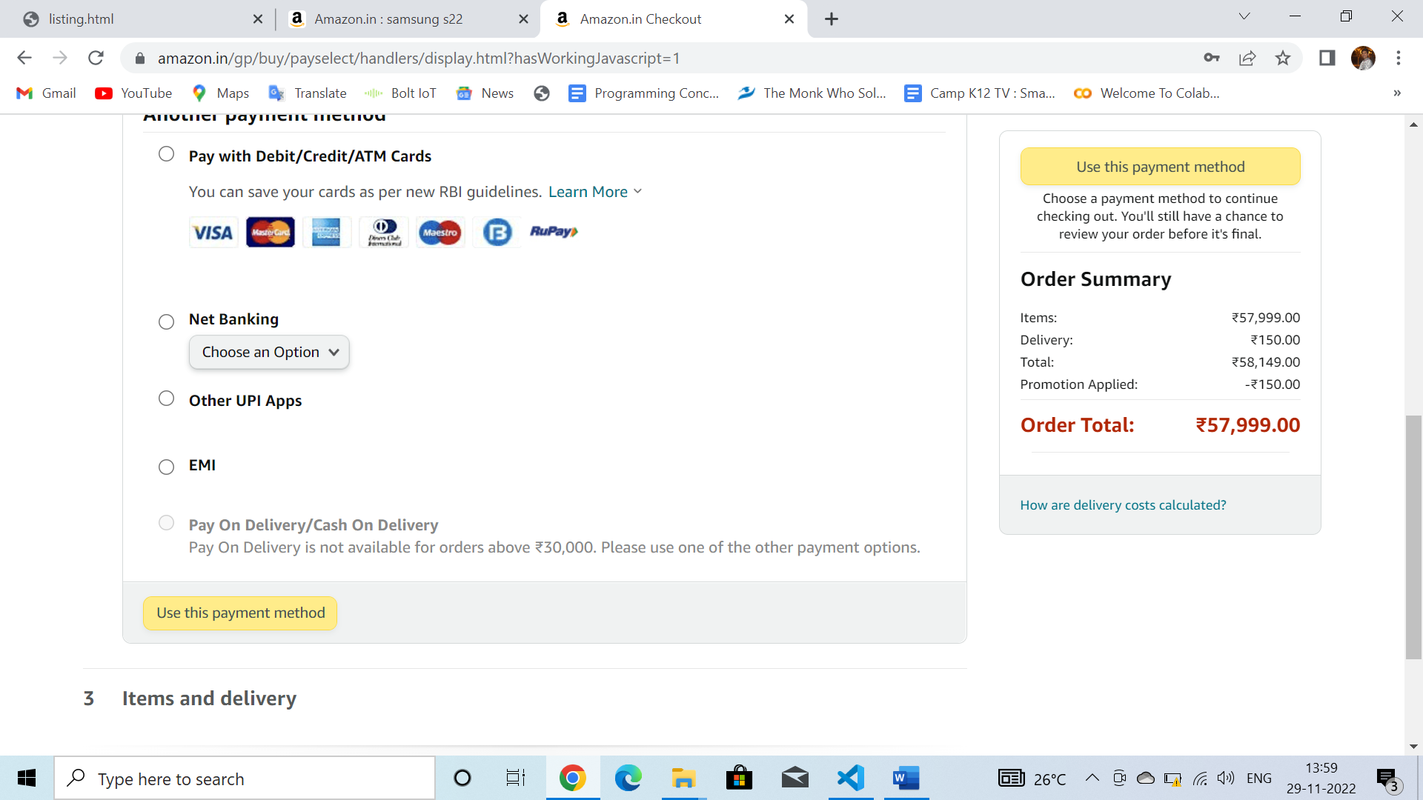

* Different payment modes
* Upi
* Credit/Debit Card
* Amazon Pay Wallet

***Order Confirmation Page :***

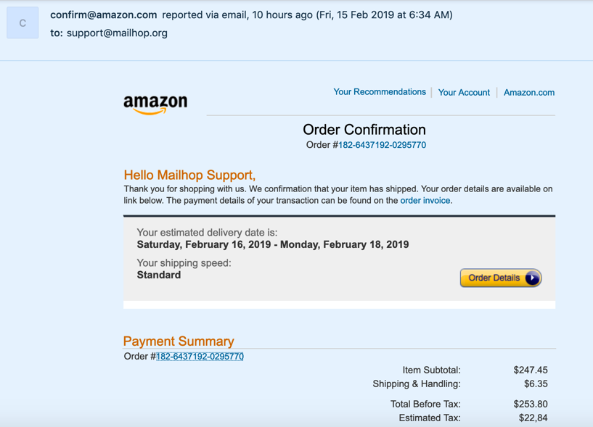

Details of the Order after successful transaction

Product Delivery Details