PHASE 4:

**TN Marginal Workers Assessment**

**Data Preparation**:

First, ensure that you have collected and cleaned your data. Make sure the data includes information on age, industrial category, and sex of the workers.

To download our dataset file in “**https://tn.data.gov.in/resource/marginal-workers-classified-age-industrial-category-and-sex-scheduled-caste-2011-tamil** “

**Data Aggregation and Manipulation**:

Use Python and libraries like Pandas to aggregate and manipulate the data. You can use Pandas to group and count records based on age, industrial category, and sex to calculate the distribution of marginal workers. Here's a code example:

**Data Visualization**:

Use data visualization libraries like Matplotlib and Seaborn to create visualizations. Here's how you can create visualizations for the distribution of marginal workers:

1. **Cognos Integration**: Now that you have your data analysis and visualizations ready, you can import them into Cognos for reporting and presentation. You can export the visualizations as images and include them in your Cognos reports or dashboards.
2. **Report Generation**: In Cognos, you can create reports, dashboards, or interactive visualizations that convey your findings. Use Cognos tools to design and customize your reports to present the demographic analysis of marginal workers in Tamil Nadu effectively.

**Code for install pandas :**

pip install pandas matplotlib seaborn

**Code for implementing pandas seaborn and matplotlib :**

import pandas as pd

import matplotlib.pyplot as plt

import seaborn as sns

**Load data set for visualization :**

df=pd.read_csv('C:/Users/HP/Downloads/DDW_B06SC_3300_State_TAMIL_NADU-2011.csv')

**data aggregation based on place, Age group :**

place = df['Total/ Rural/ Urban'].value_counts()

print(place)

#based on agewise

age= df['Age group’].value_counts()

print(age)

Screenshot for create a dashboard:

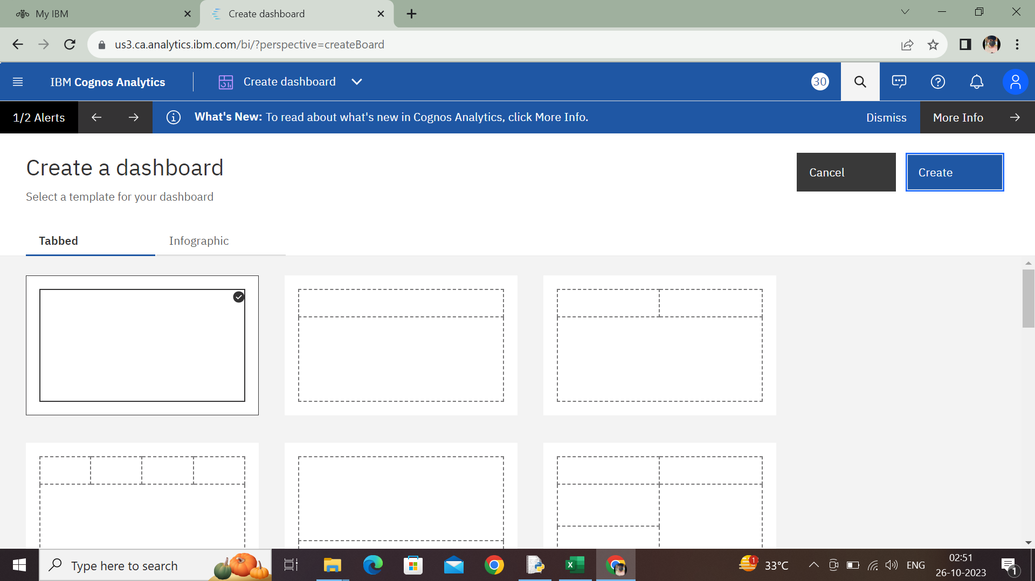

Load our dataset file:

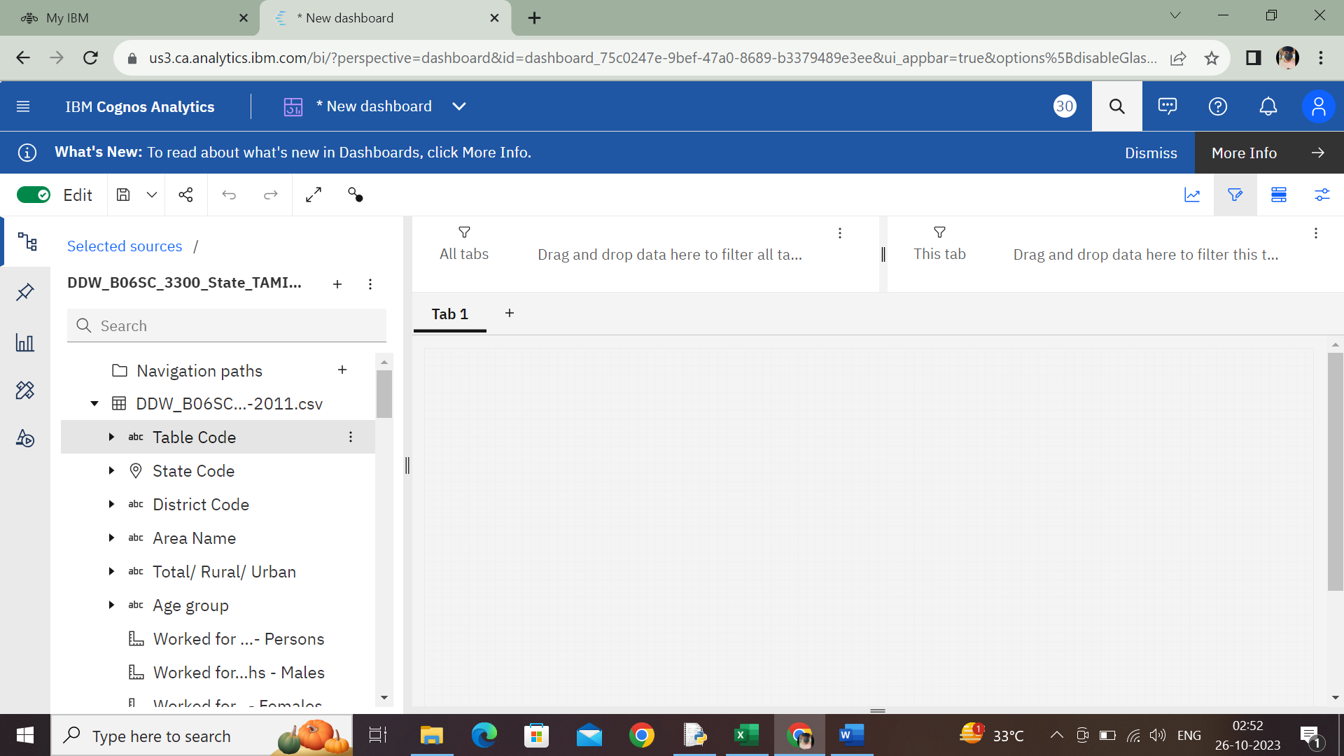

Select a visualizations to data visual :

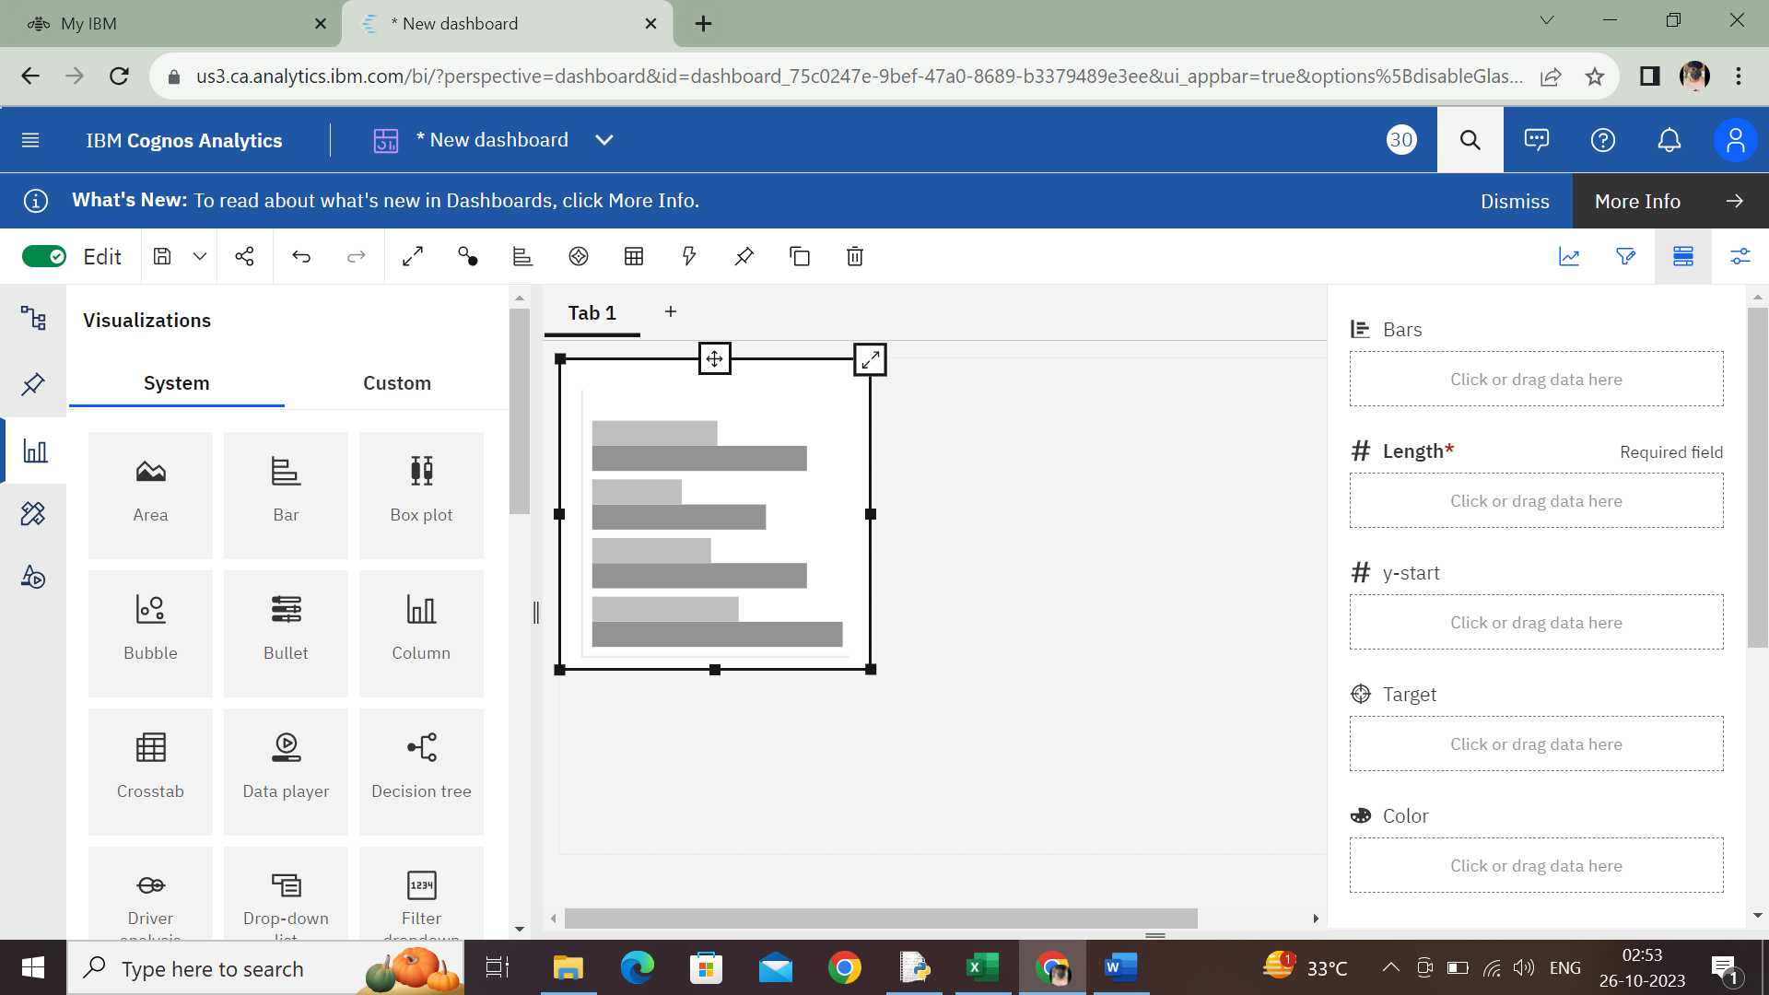

Screenshot of age and person data (bar chart):

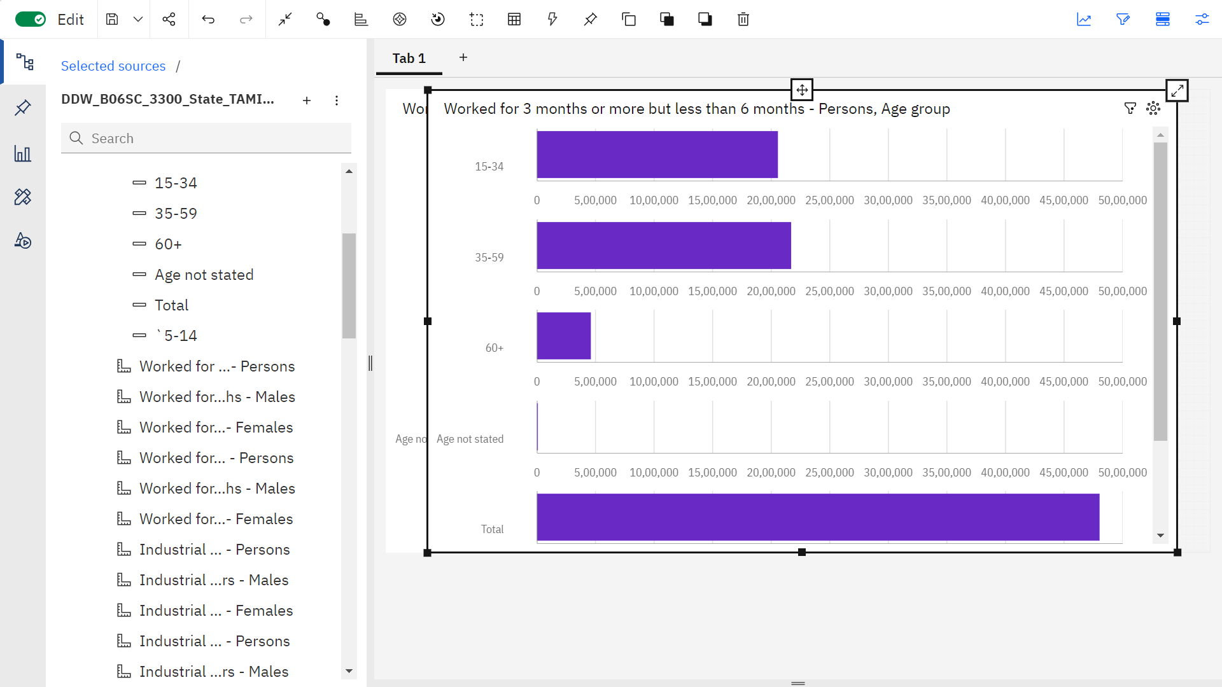

Screenshot of Industrial category C and persons area and less then 3 months work (Scatterplot ):

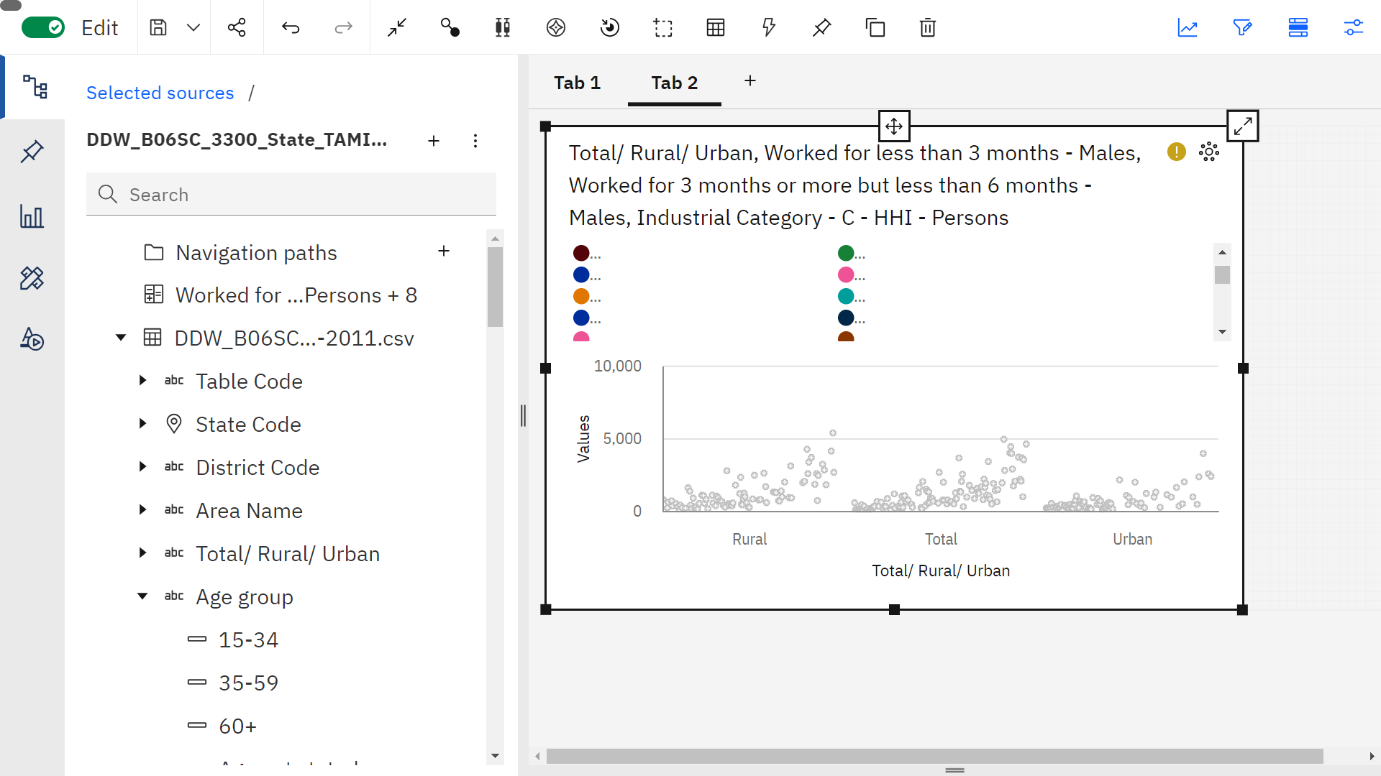

Screenshot of Industrial category A and persons by age (pie chart):

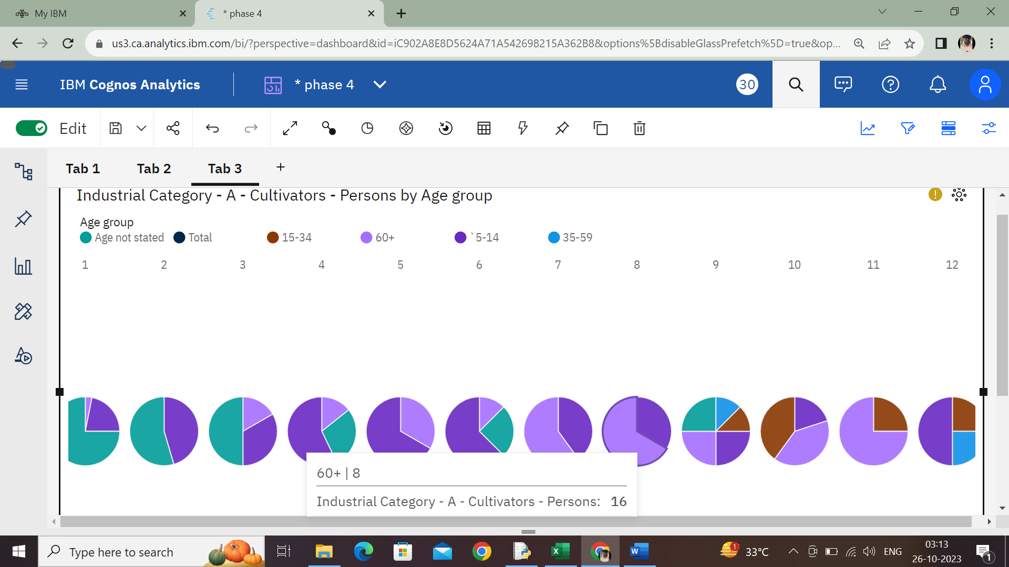

Screenshot of Industrial category A and persons by age (Histogram chart):

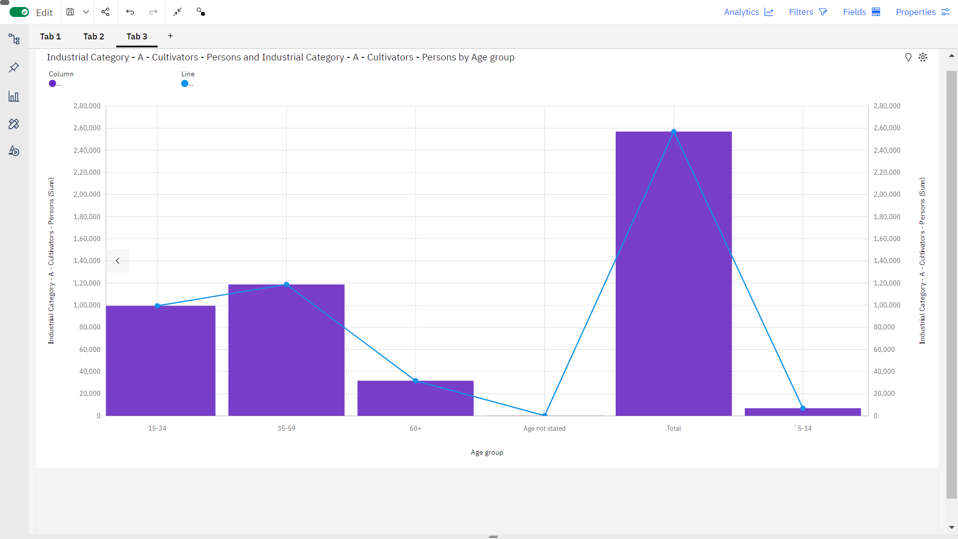

Screenshot of Aggregation:

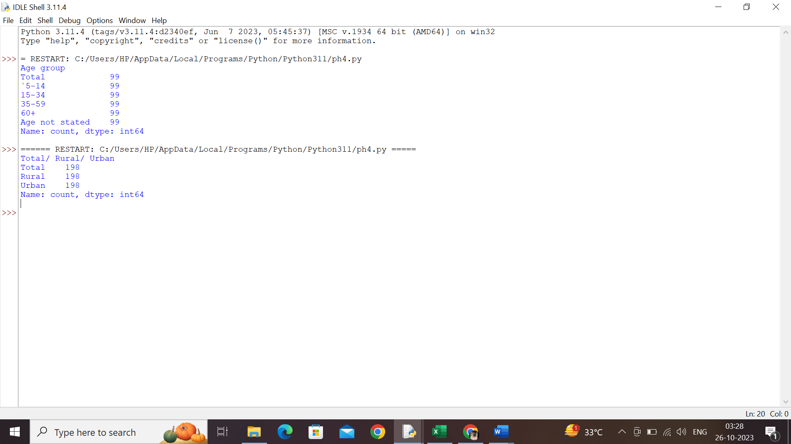

Screenshot of category g – age group:

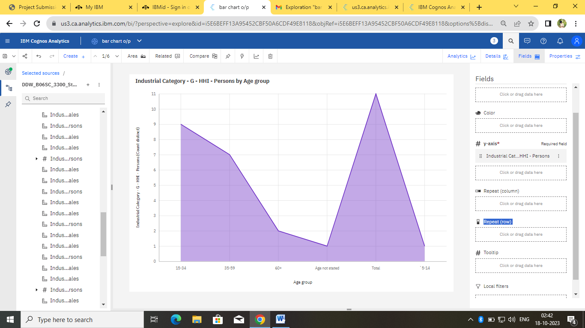

Screenshot of category B – Area :

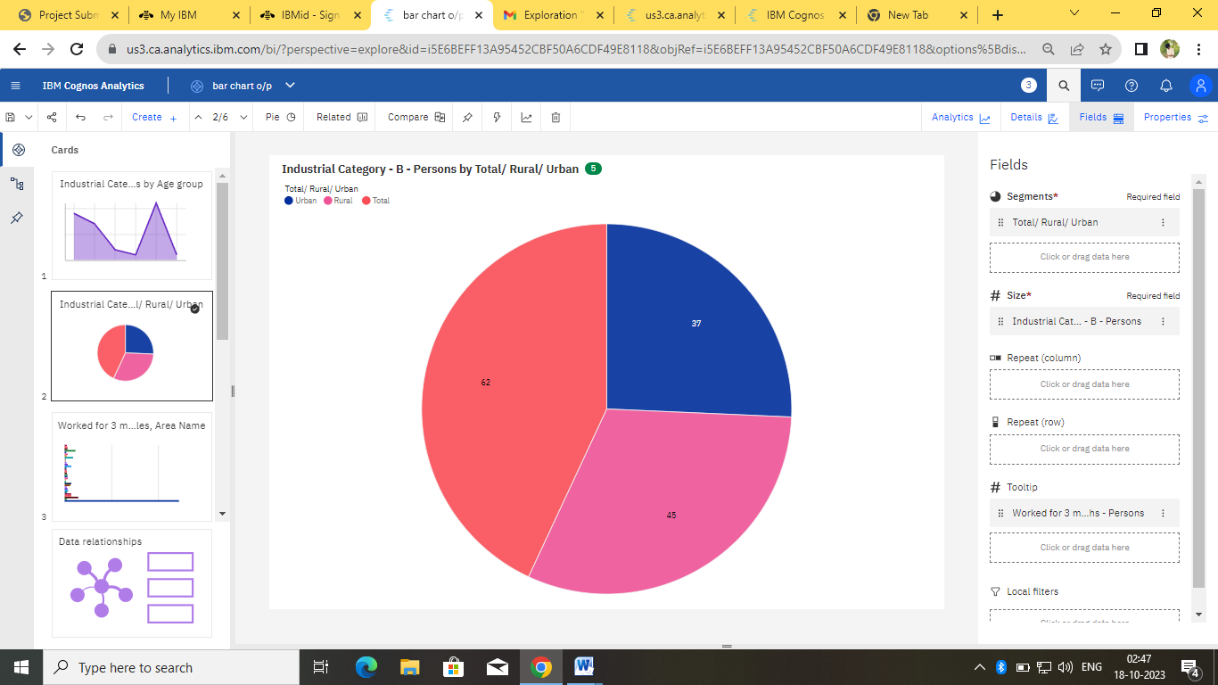

Screenshot of Worked for 3 month -females with an area wise:

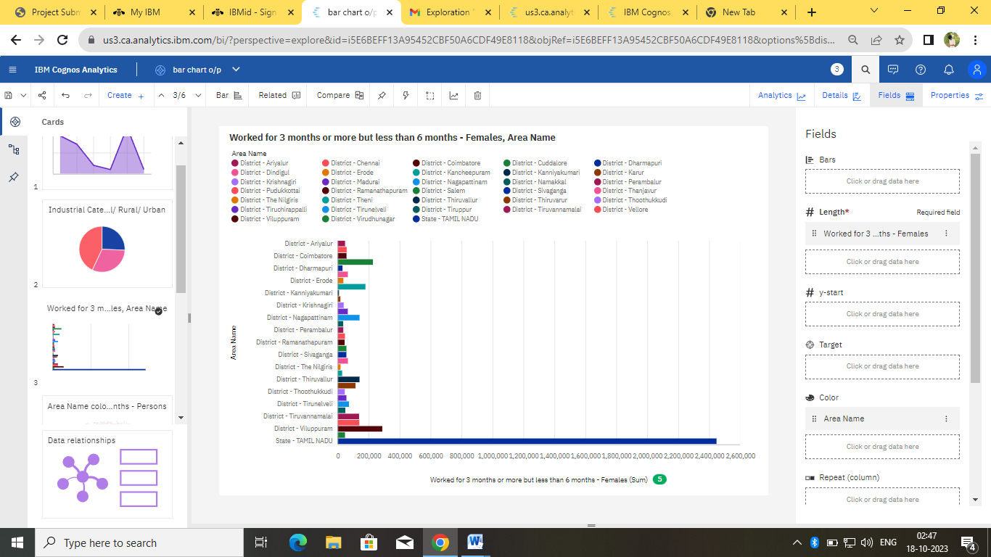

Screenshot of Area name compare with age group :

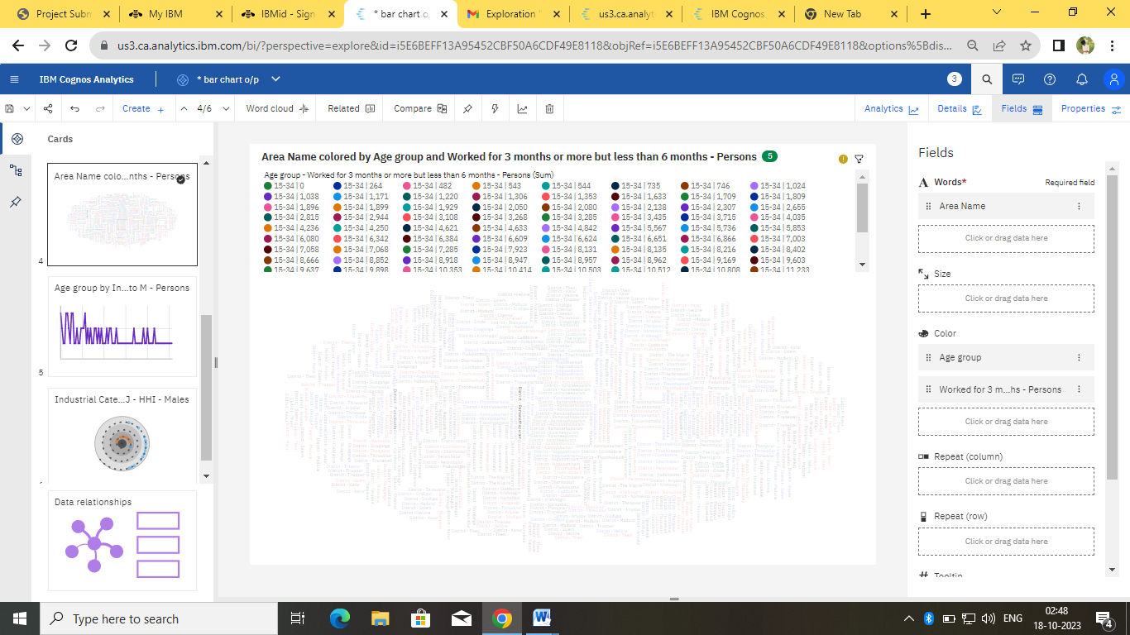

Screenshot of category K to M –Persons:

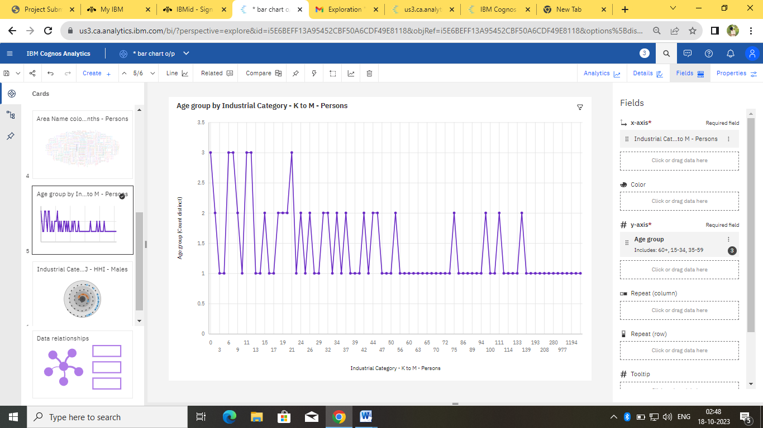

Screenshot of category J - Males:

