BDA400 - Data Science Tools and Techniques
Assignment 2: Technical Analysis using R (Preliminary Stage)
Student Name: Gopi Sharan Gajmer Sunar
Student ID: 664427618
Instructor: Jinalben Patel
Submission Date: 30/09/2026
GitHub Repositoryhttps://github.com/GopiGajmer/TechnicalAnalysis

1. Setting up GitHub Account and Repository

1..1 Create the TechnicalAnalysis repository
Click New repository, name it TechnicalAnalysis, add a README, and create it.
[ INSER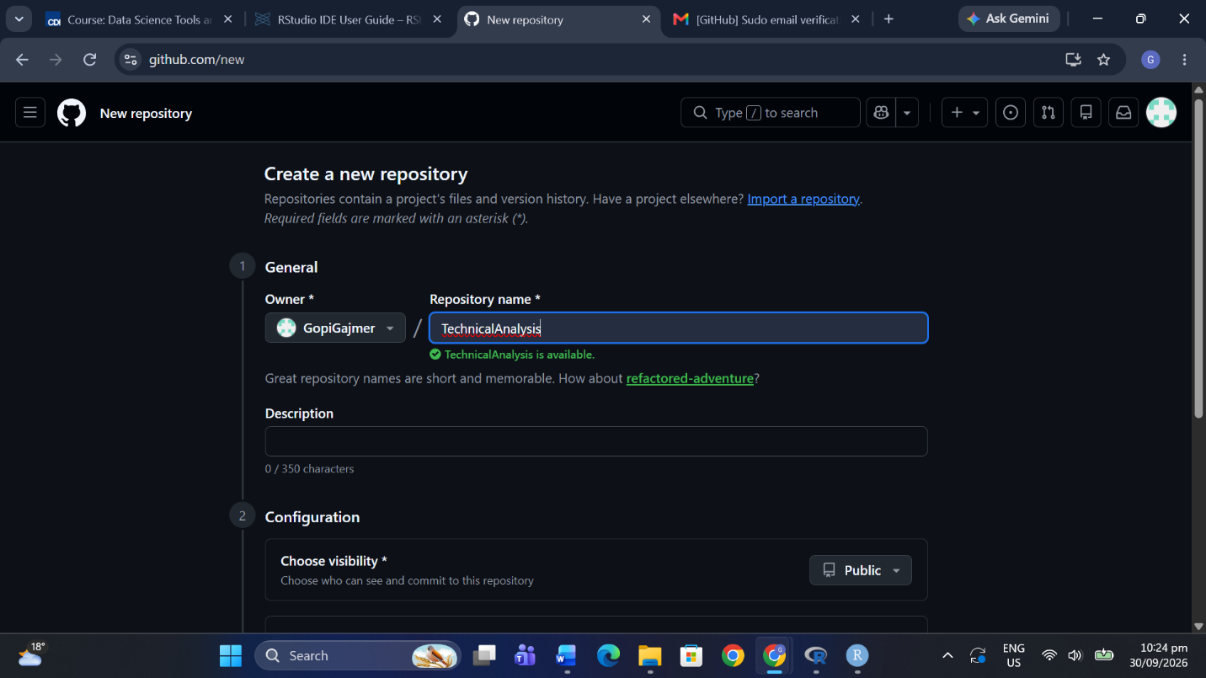T SCREENSHOT: New repository form ]

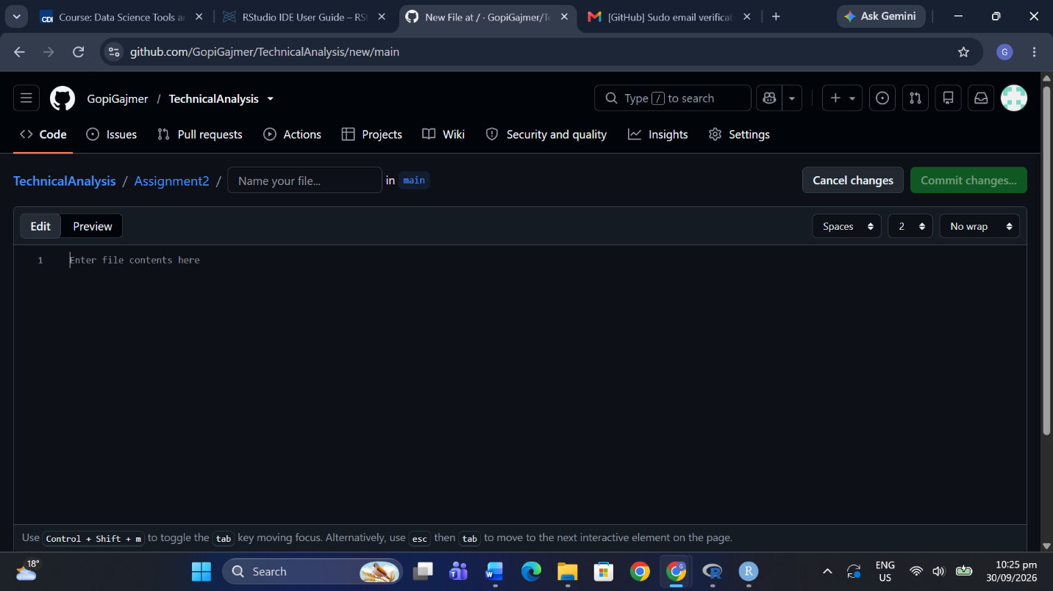[ INSERT SCREENSHOT: Repository page ]

1.2 Create folder Assignment2
Use Add file > Create new file, type Assignment2/README.md, and commit. Upload your files here later.
[ INSERT SCREENSHOT: Assignment2 folder in rep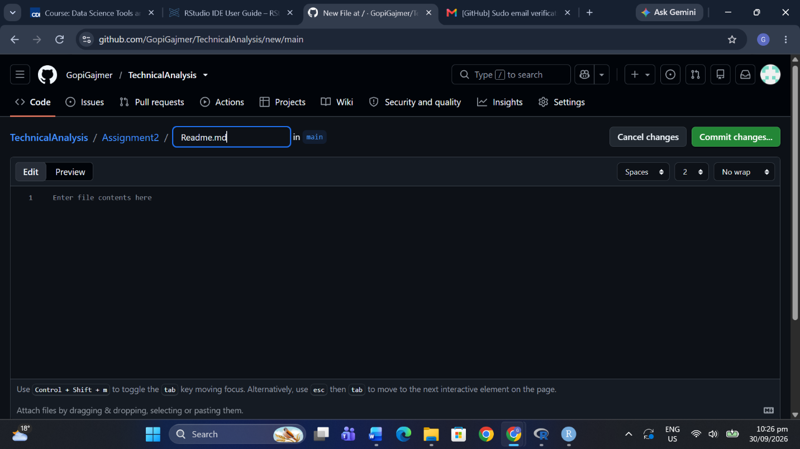o ]

2. Installing and Configuring R and RStudio

2.1 Download and install R
Download R from https://cran.rstudio.com/ for your operating system and run the installer.
[ INSERT S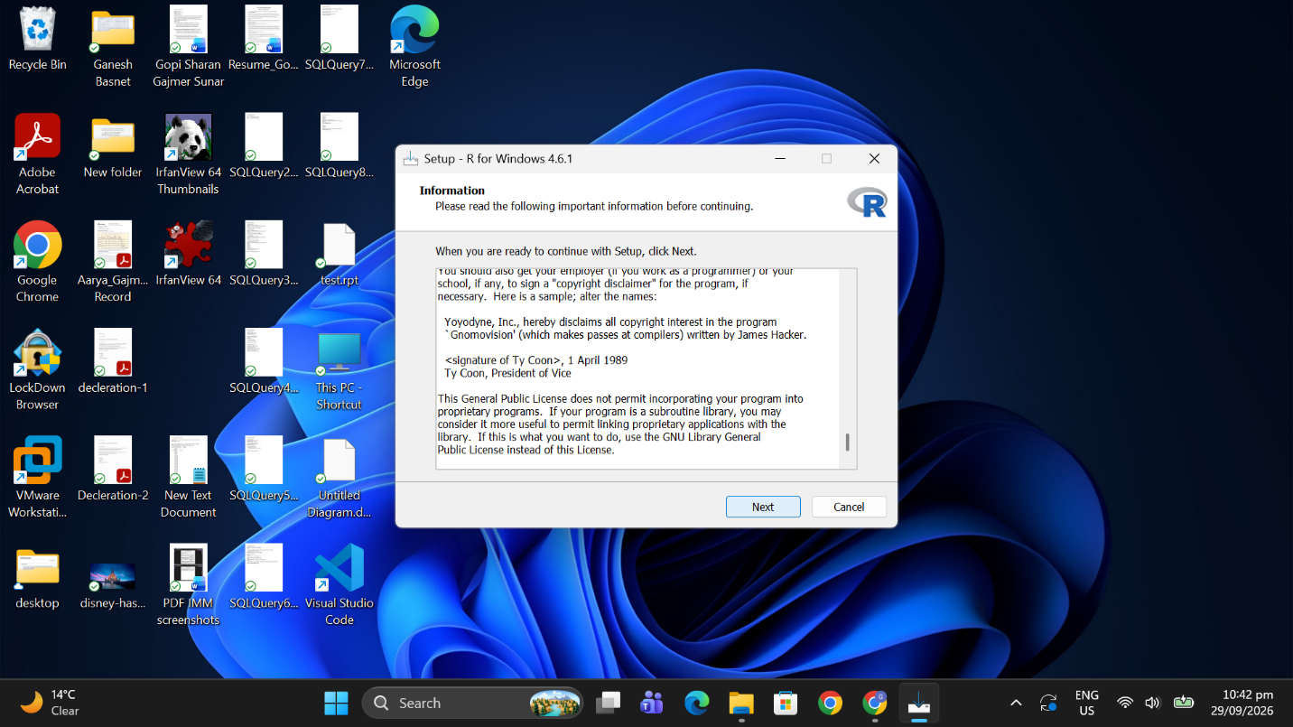CREENSHOT: CRAN download page ]

2.2 Download and install RStudio
Download RStudio Desktop from posit.co and install it.
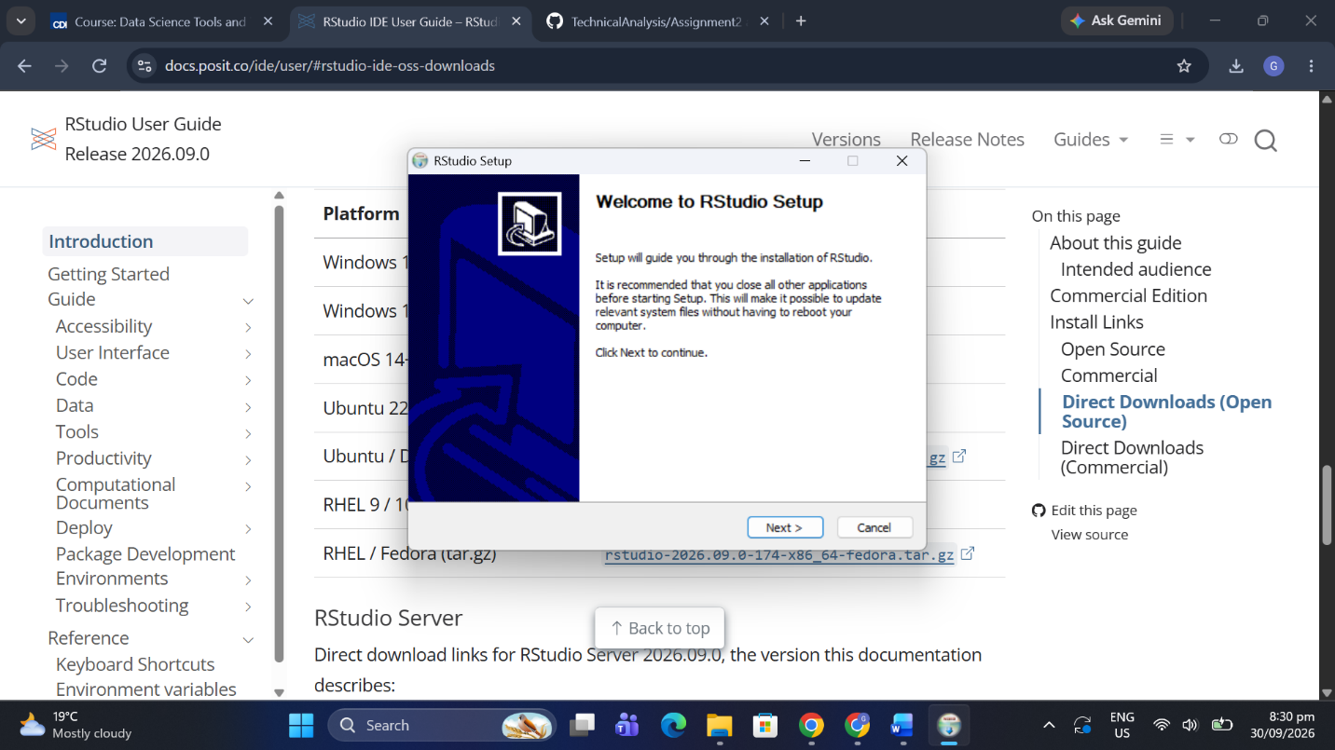[ INSERT SCREENSHOT: RStudio download page ]

3. Installing R Packages
Packages: quantmod, TTR, xts, zoo, ggplot2, knitr, rmarkdown.

3.1 Install packages
In the RStudio console run: install.packages(c("quantmod","TTR","xts","zoo","ggplot2","knitr","rmarkdown")).
[ IN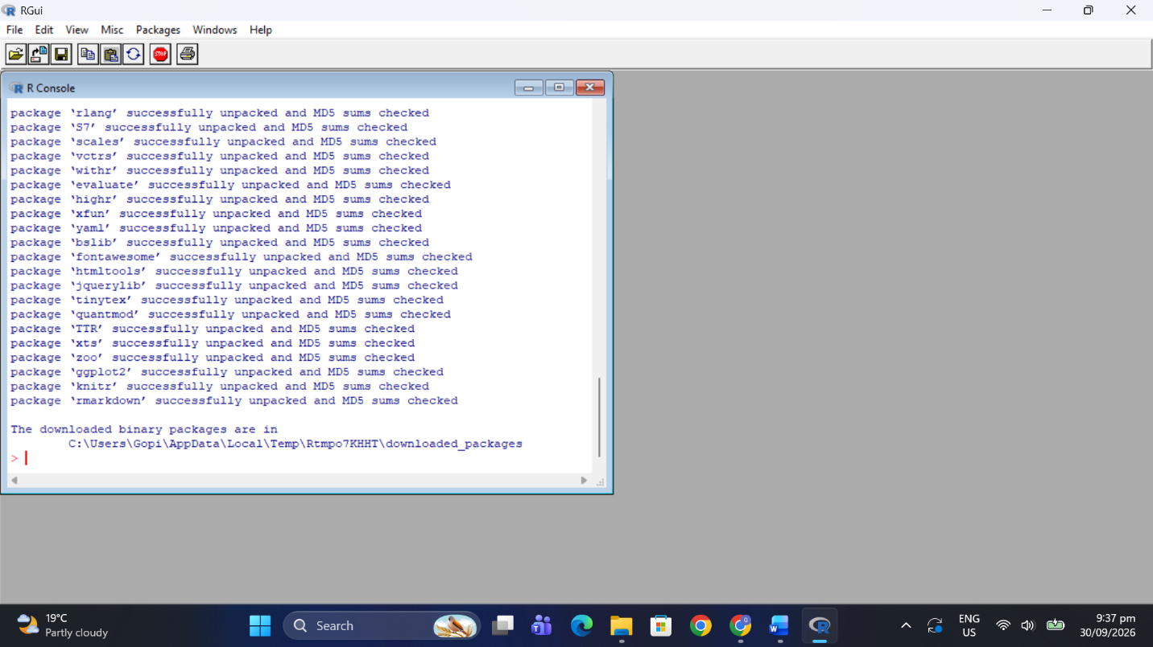SERT SCREENSHOT: install.packages() running ]

3.2 Verify packages load
Run library(quantmod); library(TTR); library(ggplot2) without errors.

4. Project Configuration and Initialization
portfolio.txt contains one ticker per line:
- AAPL
- MSFT
- GOOGL
- AMZN
- TSLA

[ INSERT SCREENSHOT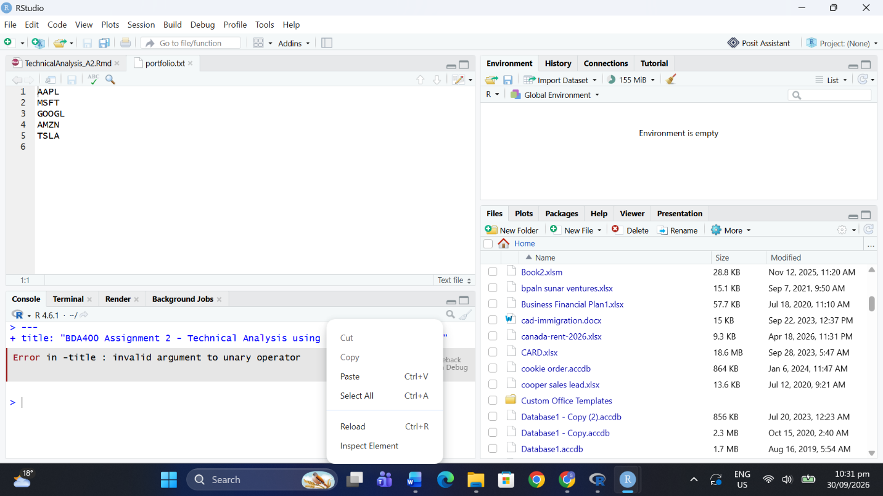: portfolio.txt opened in RStudio/Notepad ]

5. Function to Import and Load Stock Data
load_stock_data() reads portfolio.txt (via read_portfolio()), downloads each symbol from Yahoo Finance using quantmod::getSymbols(), converts the xts object to a data frame (Date, Open, High, Low, Close, Volume, Adjusted) and returns a named list with one data frame per symbol. Failed downloads are skipped with a warning.
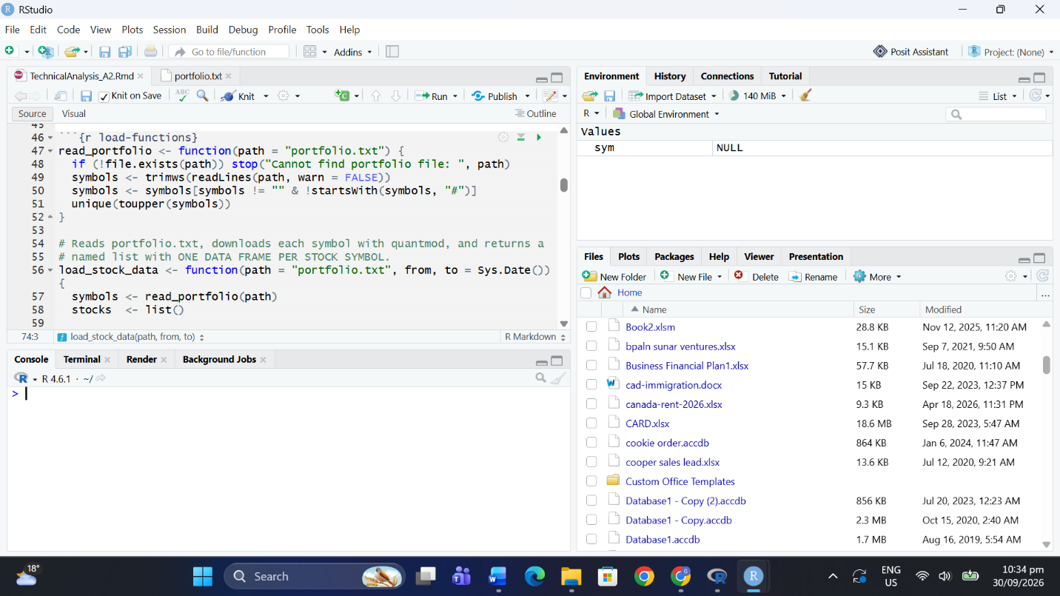[ INSERT SCREENSHOT: load_stock_data() code in RStudio ]

6. Function to Compute Basic Statistics
calculate_statistics() takes one stock data frame and computes: mean, median, mode (get_mode(), on rounded closing prices), standard deviation, min, max, and simple moving averages (SMA 20 and SMA 50 via TTR::SMA). Results are stored as a list containing a summary data frame and the data frame with SMA columns.
[ INSERT SCREENSHOT: calculate_statisti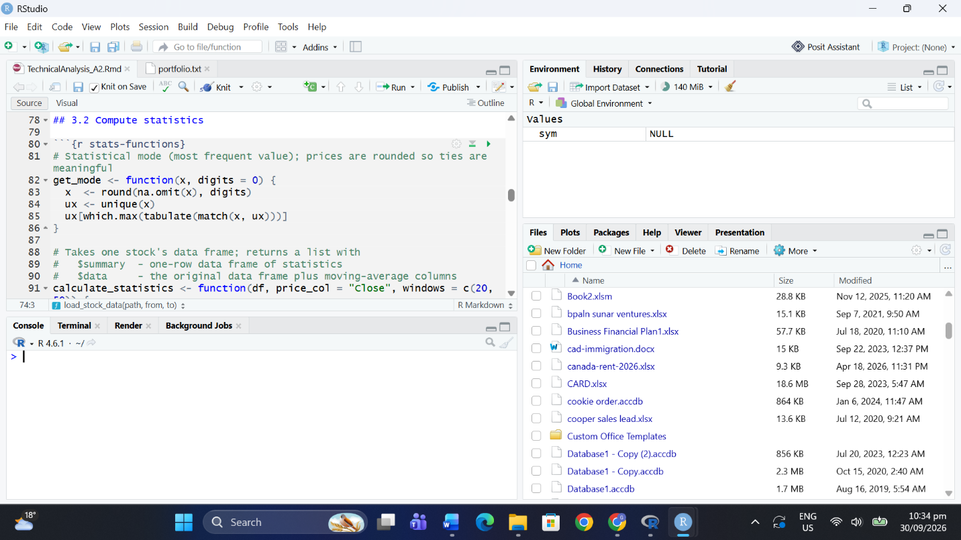cs() code ]

7. Utilities to Display Output
Display functions: display_stock_table() (recent OHLC table), plot_price_ma() (price + moving averages), plot_distribution() (histogram with mean/median/mode), plot_volume() (volume bars), plot_candlestick() (quantmod candlestick chart).
[ INSERT SCREENSHOT: Data table for each stock ]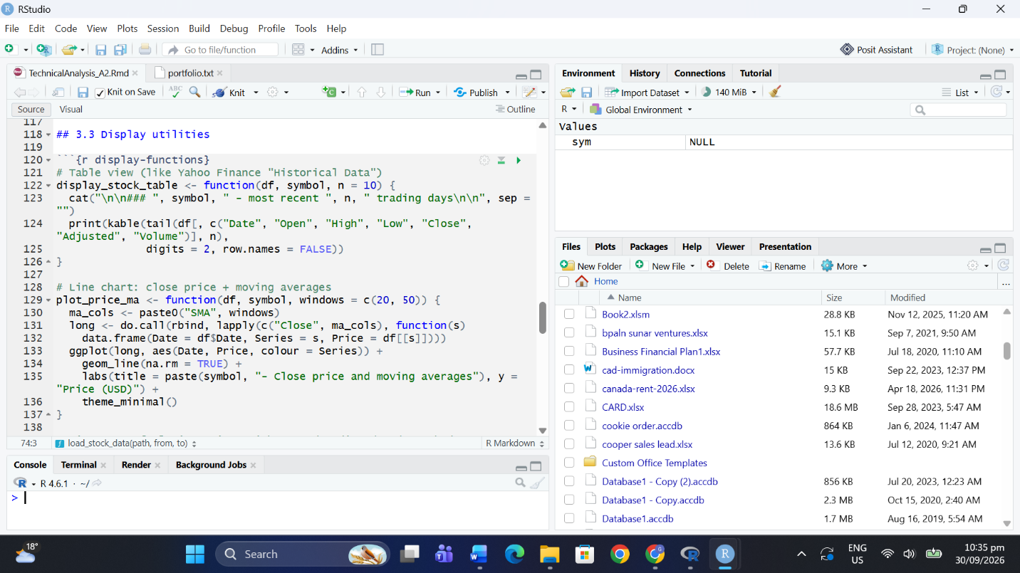

[ INSERT SCREENSHOT: Pri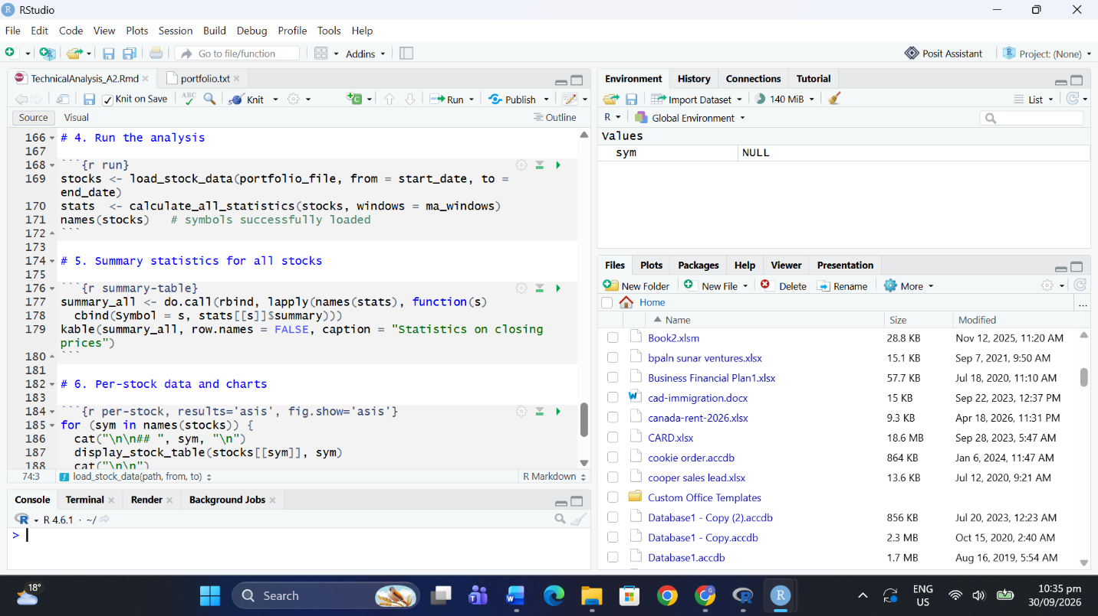ce and moving average chart ]

[ INSERT SCREENSHOT: Distributi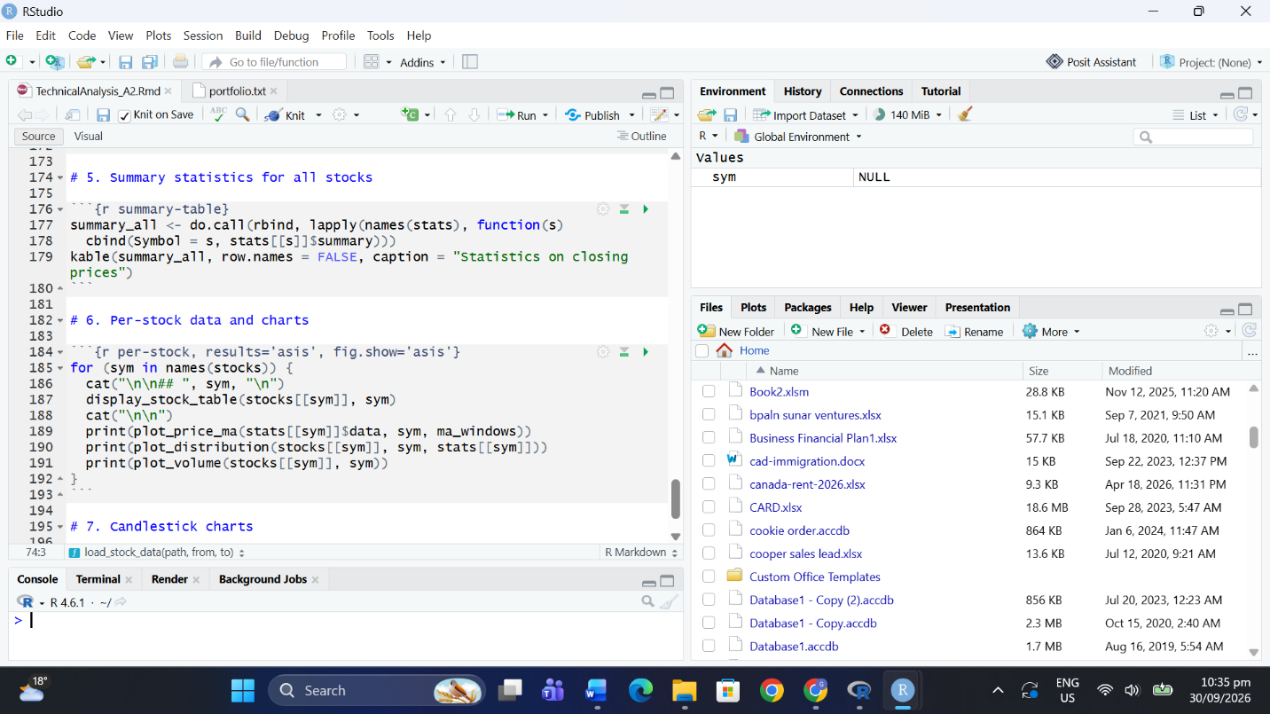on chart ]

[ INSERT SCREENSHOT: Volume chart ]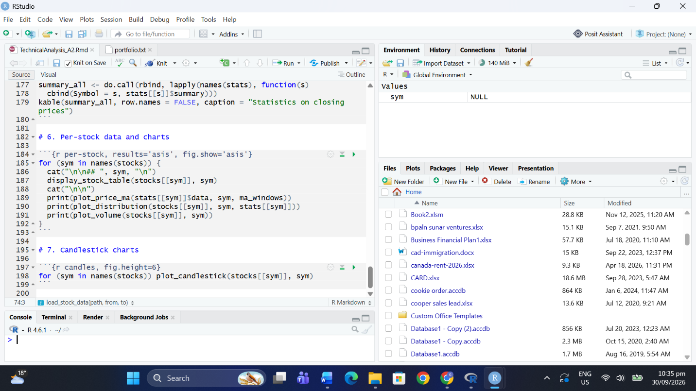

8. Uploading Files to GitHub
Upload portfolio.txt, TechnicalAnalysis_A2.Rmd, this report (Word), and optionally the knitted HTML to the Assignment2 folder.
[ INSERT S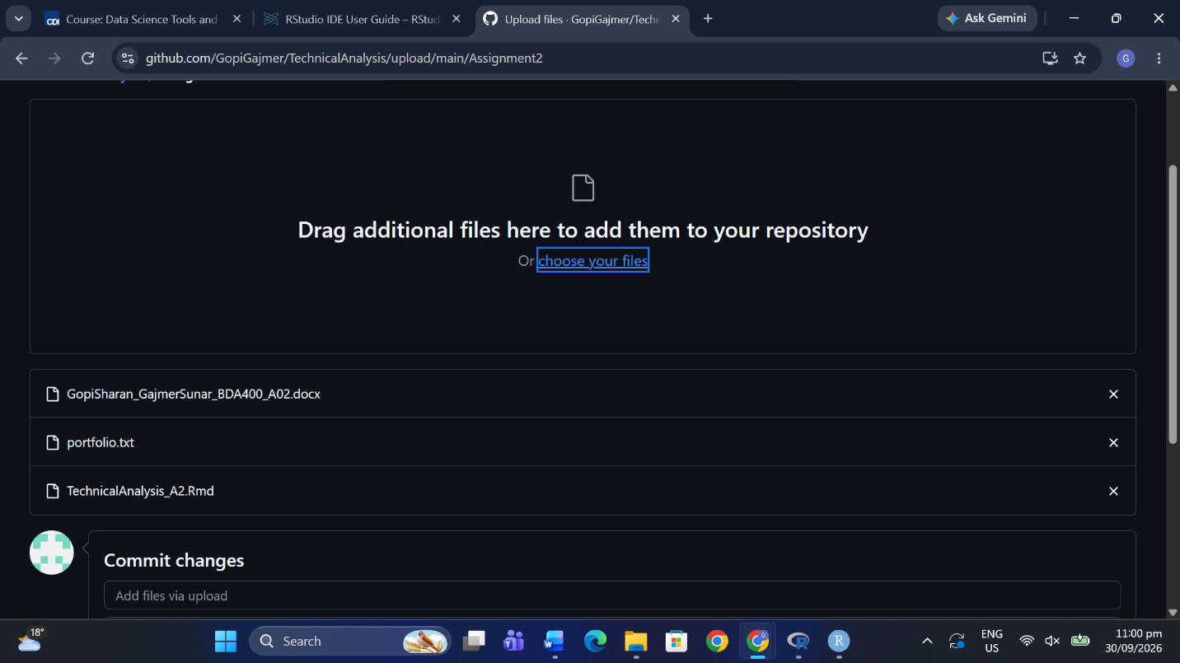CREENSHOT: Assignment2 folder with all files in GitHub ]

9. Conclusion

In this assignment, I set up a GitHub account and the TechnicalAnalysis repository, installed R and RStudio, and installed the quantmod, TTR, ggplot2 and knitr packages needed for technical analysis. I created a portfolio.txt file listing five stock symbols (AAPL, MSFT, GOOGL, AMZN and TSLA) and wrote R functions to import each stock's data from Yahoo Finance into its own data frame, then calculate the mean, median, mode, standard deviation and 20- and 50-day moving averages. The results were displayed as data tables and charts, including price and moving-average lines, distributions, volume and candlestick charts, which made it easy to compare how each stock behaved. During setup, R showed a warning that the system library was not writable, but it automatically used a personal library and the packages installed successfully. Completing this stage gave me a working foundation of data import, statistics and visualization that I can build on in the next two assignments.

Repository Link
https://github.com/YOUR-USERNAME/TechnicalAnalysis

