**Ideation Phase Empathize & Discover**

|  |  |
| --- | --- |
| Date | 06 May 2023 |
| Team ID | NM2023TMIDO7087 |
| Project Name | The Meme Museum |
| Maximum Marks | 4 Marks |

✴

**Develop shared understanding and empathy**

Summarize the data you have gathered related to the people that are impacted by your work. It will help you generate ideas, prioritize features, or discuss decisions.

**Empathy map canvas**

## **GOAL**

**What do they need to DO?**

What do they need to do differently? What job(s) do they want or need to get done? What decision(s) do they need to make?

# Use this framework to empathize with

a customer, user, or any person who is affected by a team’s work.

# Document and discuss your observations and note your assumptions to gain more empathy for the people you serve.

## **What do they HEAR?**

What are they hearing others say? What are they hearing from friends? What are they hearing from colleagues? What are they hearing second-hand?

## **What do they THINK and FEEL?**

**PAINS**

What are their fears, frustrations, and anxieties?

## **GAINS**

What are their wants, needs, hopes, and dreams?

need to develop app from which we can get reply within 24hrs

How will we know they were successful?

actions must be taken quickly

there may be no immediate response to complaints

Originally created by Dave Gray at

can register complaint in app

sometimes there may be server error

proper compaint with required information

complaints files may get missed

spending lots of money due to corruption

save time and money

## **What do they SEE?**

What do they see in the marketplace? What do they see in their immediate environment? What do they see others saying and doing?

What are they watching and reading?

minimum fees for registration

## **What do they SAY?**

What have we heard them say? What can we magine them saying?

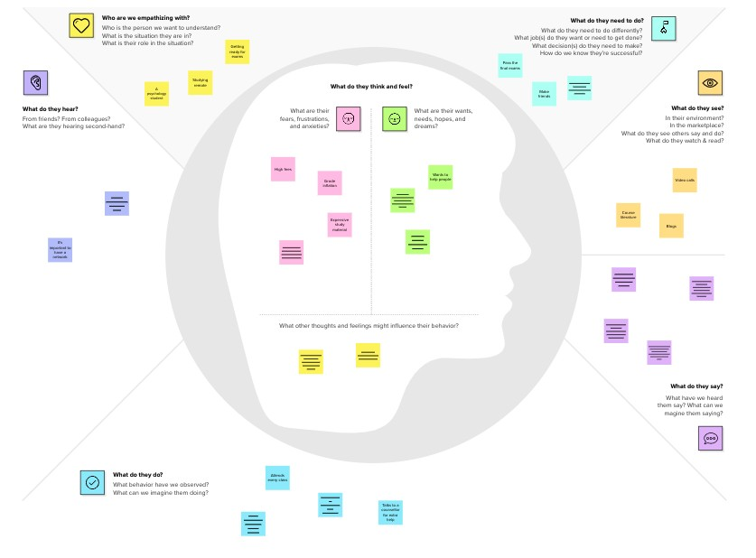

**Template**

register with proper details

provide required documents

## **[Share template feedback](https://muralco.typeform.com/to/CiqaHVat?typeform-source=app.mural.co)**

**Need some inspiration?**

See a finished version of this template to kickstart your work.

**[Open example](https://app.mural.co/template/018339d6-ff71-42d8-9e5c-abddde77d5ab/982236e0-c7e5-4fb6-83e9-ef1b972b25bd)**