PREDICTIVE ABS THROUGH PREDICTIVE WHEEL LOCK AND PRESSURE MODULATION
S2-25_SSZG628T: Dissertation
By

GOPINATH MADHESWARAN
2024MT12082

Dissertation work carried out at
AUMOVIO INDIA PVT LTD (Former CONTINENTAL AUTOMOTIVE), Bangalore

Submitted in partial fulfilment of M.Tech degree programme

Under the Supervision of Vaidyanathan AG
AUMOVIO INDIA PVT LTD, Bangalore

BIRLA INSTITUTE OF TECHNOLOGY & SCIENCE PILANI (RAJASTHAN)
(March 2026)

ABSTRACT
Anti-lock Braking Systems (ABS) play an essential role in improving vehicle stability and braking safety. Conventional ABS methods operate based on reactive control, where brake pressure modulation is initiated after the onset of excessive wheel slip. Although widely adopted, such reactive approaches may lead to oscillatory braking behaviour and delayed response during rapid braking conditions.
The present work focuses on the development of a predictive anti-lock braking strategy using multi-feature signal analysis techniques. The proposed approach utilizes wheel speed data sampled at 1000 Hz to compute slip ratio and statistical indicators that provide early signs of impending wheel lock.
Three primary signal features are evaluated in this work:
- Approximate Entropy
- Statistical Kurtosis
- Dominant Frequency Estimation
These features are combined to generate a weighted lockup probability, which enables early prediction of unstable wheel behaviour before traditional ABS activation.
The algorithm has been implemented using Python-based signal processing tools and evaluated using a real-world braking dataset consisting of 15,000 samples across four wheels. Simulation and validation results demonstrate earlier lockup detection and improved braking efficiency when compared with conventional ABS logic.
The findings indicate that predictive feature-based methods can improve braking smoothness, reduce stopping distance, and enhance slip regulation under dynamic driving conditions.

________________________ ______________________
Signature of the Student Signature of the Supervisor
Name: Gopinath Madheswaran Name:
Date: 26-03-2026 Date:
Place: Bangalore Place:
1. MODULES IN PREDICTIVE ABS SYSTEM
The predictive ABS architecture consists of several interconnected functional modules that enable signal acquisition, feature computation, prediction logic, and braking control evaluation.
The major modules in the system are:
a) Wheel Speed Data Acquisition
b) Signal Conditioning and Buffer Management
c) Slip Ratio Computation
d) Feature Extraction Module
e) Lockup Probability Estimation
f) Predictive Warning Generation
g) Performance Evaluation Module
Each module is described below.
a) Wheel Speed Data Acquisition
Wheel speed measurements are obtained from a dataset representing braking behaviour under various surface conditions. The dataset consists of rotational speed values for four wheels: Front Left (FL), Front Right (FR), Rear Left (RL), and Rear Right (RR).
The signals are sampled at a rate of 1000 Hz, allowing fine temporal resolution during braking events. The dataset also includes brake pressure information and reference vehicle speed values used for slip estimation.
b) Signal Conditioning and Buffer Management
Incoming wheel speed data is processed through a fixed-size signal buffer that stores recent samples required for feature computation. A sliding window of 20 samples is used to analyse signal behaviour over short time intervals.
Basic signal normalization and filtering steps are applied to reduce noise and improve stability of the computed features.
This buffering mechanism ensures consistent feature evaluation during continuous braking operation.
c) Slip Ratio Computation
Slip ratio is calculated using vehicle speed and wheel speed signals. This parameter represents the difference between vehicle motion and wheel rotational speed.
Slip ratio values are continuously monitored to determine whether the wheel operates within the optimal friction region.
Typical optimal slip values lie between 10% and 20%, which corresponds to maximum tire-road friction conditions.
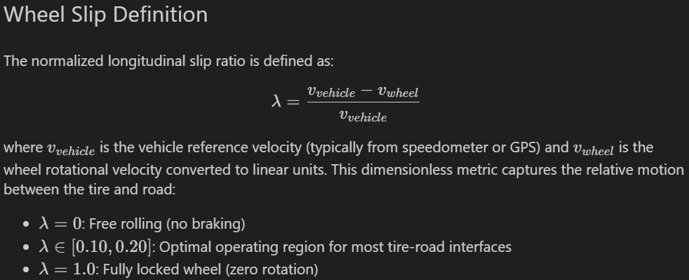
d) Feature Extraction Module
The feature extraction stage computes multiple statistical indicators that characterize the behaviour of wheel speed signals.
The following features are evaluated:
Approximate Entropy
Approximate entropy measures the irregularity present in wheel speed signals. As a wheel approaches lock conditions, the signal behaviour changes and entropy values exhibit noticeable variations.
This feature is computed using sliding window samples and tolerance-based pattern comparison methods.
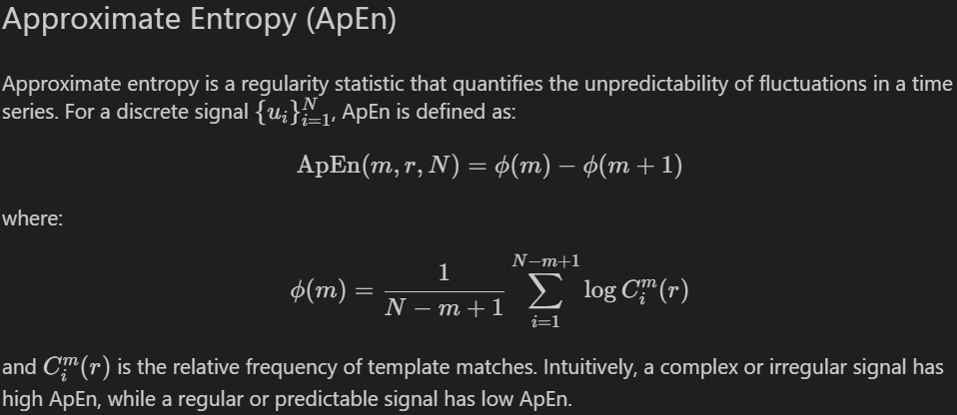
Statistical Kurtosis
Kurtosis is used to quantify the presence of sharp variations in signal distribution.
During stable braking conditions, wheel speed variations typically follow near-Gaussian behaviour. However, near lock conditions introduce impulsive variations, leading to increased kurtosis values.
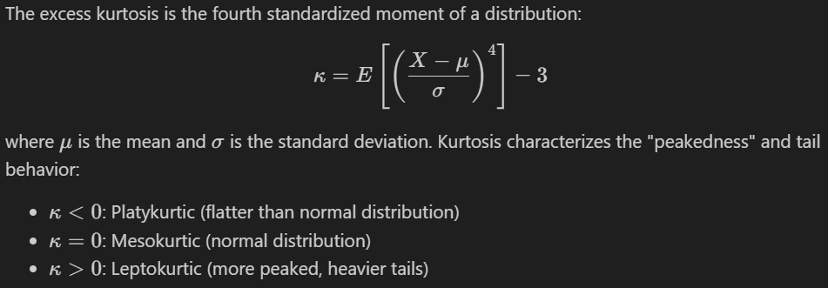
Dominant Frequency Estimation
Dominant frequency is estimated using zero-crossing techniques to identify oscillatory behaviour in the signal.
Changes in frequency characteristics provide additional indication of abnormal wheel behaviour.
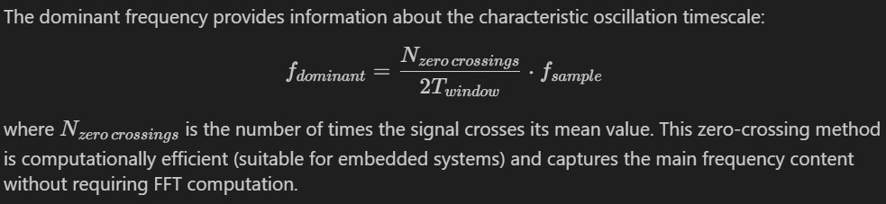
e) Lockup Probability Estimation
A weighted lockup probability is calculated using multiple signal features.
The weighting factors used in this implementation are:
- Entropy contribution: 35%
- Kurtosis contribution: 25%
- Frequency contribution: 40%
These weights are applied to combine feature outputs into a single probability value representing the likelihood of wheel lock.
f) Predictive Warning Generation
Based on computed lockup probability values, predictive warnings are generated before the occurrence of excessive slip.
These warnings are compared against traditional ABS activation signals to evaluate early detection capability.
The predictive method generated 170 predictive events, compared with conventional reactive triggers in the dataset.
g) Performance Evaluation Module
The final module evaluates predictive ABS performance against traditional ABS behaviour.
Performance parameters evaluated include:
- Detection latency
- Slip regulation accuracy
- Stopping distance
- Computational overhead
These results are used to assess the effectiveness of predictive feature-based control.
2. FUNCTIONAL BLOCK DIAGRAM / DESCRIPTION
The predictive ABS system operates in a closed-loop configuration that continuously monitors wheel dynamics and generates early warnings when abnormal behaviour is detected.
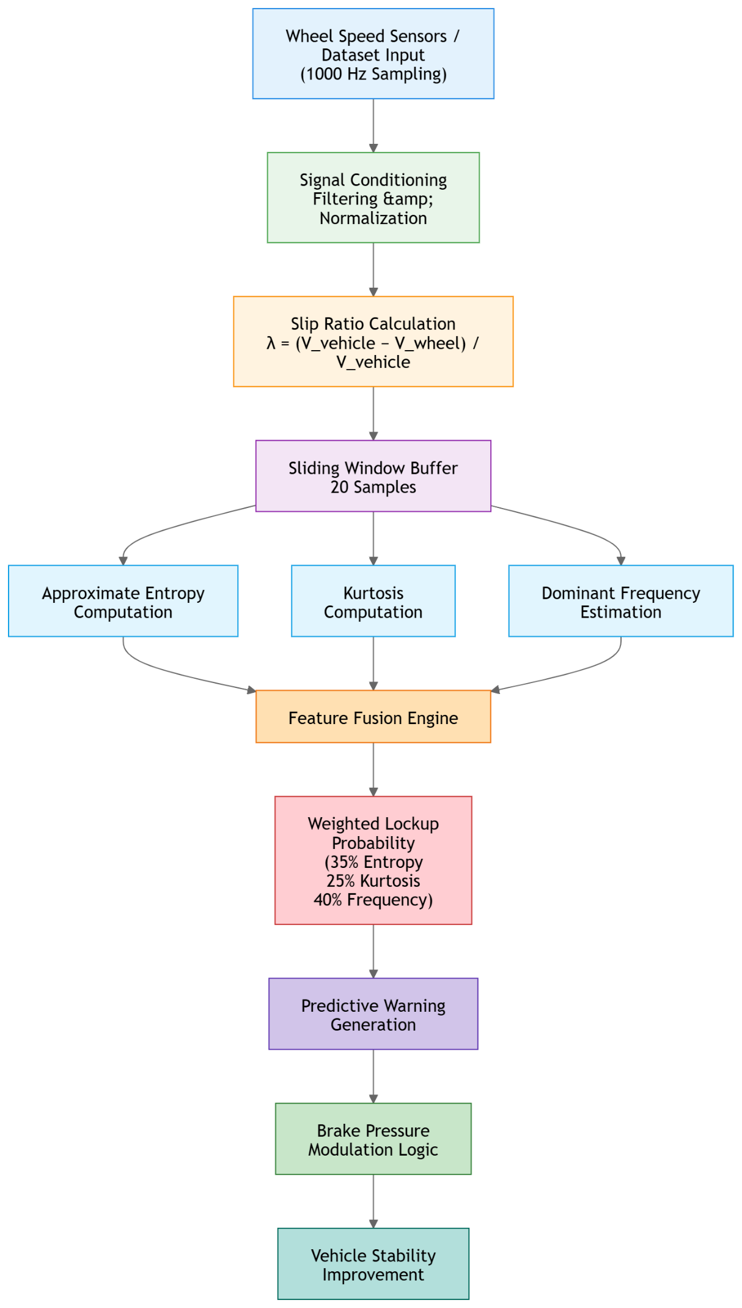
The generated outputs are compared with conventional ABS activation signals to determine detection latency differences and evaluate improvement in braking response timing.

3. MAJOR TECHNICAL SPECIFICATIONS
Sl No | Parameter | Specification
1 | Application | Predictive Anti-lock Braking System
2 | Data Source | Real braking dataset
3 | Sampling Rate | 1000 Hz
4 | Number of Wheels | Four
5 | Buffer Size | 20 Samples
6 | Feature Extraction | Entropy, Kurtosis, Frequency
7 | Lockup Prediction | Weighted multi-feature method
8 | Processing Platform | Python-based signal processing
9 | Dataset Size | 15,000 Samples
10 | Slip Range | 10% – 20% optimal region
11 | Prediction Method | Probability-based detection
12 | Output | Predictive warning signal

4. DESIGN CONSIDERATIONS
- Several design considerations were incorporated during system development.
- The system must operate under real-time constraints with limited computational resources. Feature computation methods were therefore selected based on computational efficiency.
- Signal window size was carefully chosen to balance detection accuracy and processing latency.
- Slip ratio limits were maintained within the optimal friction range to prevent excessive tire slip.
- Multiple features were combined to reduce dependency on a single indicator and improve prediction reliability.
- Threshold values were designed to support operation across multiple road surface conditions such as dry, wet, and low-friction surfaces.

5. FUTURE PLAN
Phase | Activity | Status
Literature Review | Study of predictive braking techniques | Completed
Algorithm Development | Implementation of entropy-based detection | In Progress
Dataset Processing | Multi-feature computation | In Progress
Performance Evaluation | Comparative validation | Pending
Real-Time Implementation | Embedded deployment testing | Pending
Final Dissertation | Documentation and submission | Pending

