Django Forms

Django provides a ***Form*** class which is used to create HTML forms. It describes a form and how it works and appears.

It is similar to the **ModelForm** class that creates a form by using the Model, but it does not require the Model.

Each field of the form class map to the HTML form **<input>** element and each one is a class itself, it manages form data and performs validation while submitting the form.

Lets see an example, in which we are creating some fields too.

from django import forms

class StudentForm(forms.Form):

firstname = forms.CharField(label="Enter first name",max_length=50)

lastname = forms.CharField(label="Enter last name", max_length = 100)

A StudentForm is created that contains two fields of CharField type. Charfield is a class and used to create an HTML text input component in the form.

The label is used to set HTML label of the component and max_length sets length of an input value.

When rendered, it produces the following HTML to the browser.

<label for="id_firstname">Enter first name:</label>

<input type="text" name="firstname" required maxlength="50" id="id_firstname" />

<label for="id_lastname">Enter last name:</label> <input type="text" name="lastname" required maxlength="100" id="id_lastname" />

#### **Note: Django Form does not include <form> tags, or a submit button. We'll have to provide those ourselves in the template.**

Commonly used fields and their details are given in the below table.

|  |  |  |  |
| --- | --- | --- | --- |
| **Name** | **Class** | **HTML Input** | **Empty value** |
| BooleanField | class BooleanField(**kwargs) | CheckboxInput | False |
| CharField | class CharField(**kwargs) | TextInput | Whatever you've given as empty_value. |
| ChoiceField | class ChoiceField(**kwargs) | Select | '' (an empty string) |
| DateField | class DateField(**kwargs) | DateInput | None |
| DateTimeField | class DateTimeField(**kwargs) | DateTimeInput | None |
| DecimalField | class DecimalField(**kwargs) | NumberInput | None |
| EmailField | class EmailField(**kwargs) | EmailInput | '' (an empty string) |
| FileField | class FileField(**kwargs) | ClearableFileInput | None |
| ImageField | class ImageField(**kwargs) | ClearableFileInput | None |

Let's see a complete example to create an HTML form with the help of Django Form class.

## **Building a Form in Django**

Suppose we want to create a form to get Student information, use the following code.

from django **import** forms

**class** StudentForm(forms.Form):

    firstname = forms.CharField(label="Enter first name",max_length=50)

    lastname  = forms.CharField(label="Enter last name", max_length = 100)

Put this code into the **forms.py** file.

## **Instantiating Form in Django**

Now, we need to instantiate the form in **views.py** file. See, the below code.

**// views.py**

from django.shortcuts **import** render

from myapp.form **import** StudentForm

def index(request):

    student = StudentForm()

**return** render(request,"index.html",{'form':student})

Passing the context of form into index template that looks like this:

**// index.html**

<!DOCTYPE html>

<html lang="en">

<head>

    <meta charset="UTF-8">

    <title>Index</title>

</head>

<body>

<form method="POST" **class**="post-form">

        {% csrf_token %}

        {{ form.as_p }}

        <button type="submit" **class**="save btn btn-default">Save</button>

</form>

</body>

</html>

Provide the URL in urls.py

from django.contrib **import** admin

from django.urls **import** path

from myapp **import** views

urlpatterns = [

    path('admin/', admin.site.urls),

    path('index/', views.index),

]

Run Server and access the form at browser by **localhost:8000/index,** and it will produce the following output.

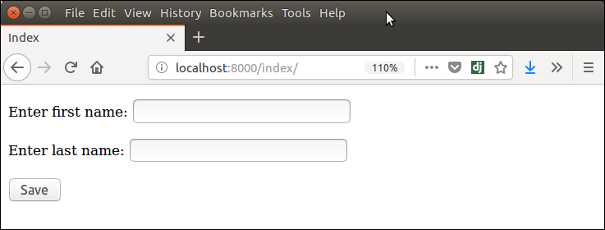

There are other output options though for the <label>/<input> pairs:

* {{ form.as_table }} will render them as table cells wrapped in <tr> tags
* {{ form.as_p }} will render them wrapped in <p> tags
* {{ form.as_ul }} will render them wrapped in <li> tags

#### **Note: that we'll have to provide the surrounding <table> or <ul> elements yourself.**

# Django Form Validation

Django provides built-in methods to validate form data automatically. Django forms submit only if it contains CSRF tokens. It uses uses a clean and easy approach to validate data.

The **is_valid()** method is used to perform validation for each field of the form, it is defined in Django Form class. It returns True if data is valid and place all data into a cleaned_data attribute.

Let's see an example that takes user input and validate input as well.

### **Django Validation Example**

This example contains the following files and code.

**// models.py**

from django.db **import** models

**class** Employee(models.Model):

    eid = models.CharField(max_length=20)

    ename = models.CharField(max_length=100)

    econtact = models.CharField(max_length=15)

**class** Meta:

        db_table = "employee"

Now, create a form which contains the below code.

**// forms.py**

from django **import** forms

from myapp.models **import** Employee

**class** EmployeeForm(forms.ModelForm):

**class** Meta:

        model = Employee

        fields = "__all__"

## **Instantiate the form**

Instantiate the form, check whether request is post or not. It validate the data by using **is_valid()** method.

**//views.py**

def emp(request):

**if** request.method == "POST":

        form = EmployeeForm(request.POST)

**if** form.is_valid():

**try**:

**return** redirect('/')

            except:

                pass

**else**:

        form = EmployeeForm()

**return** render(request,'index.html',{'form':form})

Index template that shows form and errors.

**// index.html**

<!DOCTYPE html>

<html lang="en">

<head>

    <meta charset="UTF-8">

    <title>Index</title>

</head>

<body>

<form method="POST" **class**="post-form" enctype="multipart/form-data">

        {% csrf_token %}

        {{ form.as_p }}

        <button type="submit" **class**="save btn btn-default">Save</button>

</form>

</body>

</html>

Start server and access the form.

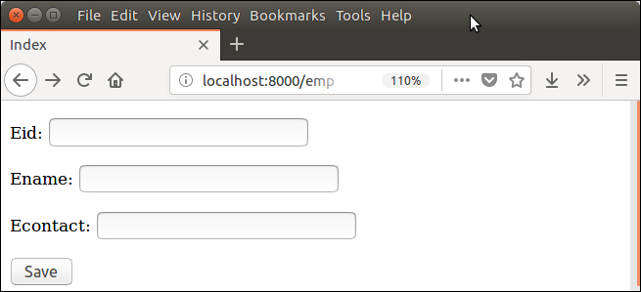

It validates each field and throws errors if any validation fails.

