**Content Projection**

Content projection allows you to insert a shadow DOM in your component.

i.e if you want to insert HTML elements or other components in a component, then you do that using the concept of content projection.

In Angular, you achieve content projection using **<ng-content ></ng-content >**.

You can make reusable components and scalable applications by properly using content projection.

References:

<https://blog.angular-university.io/angular-ng-content/>

ex.

I have **SkeletonComponent**, it has HTML template contains Header, Body and Footer.

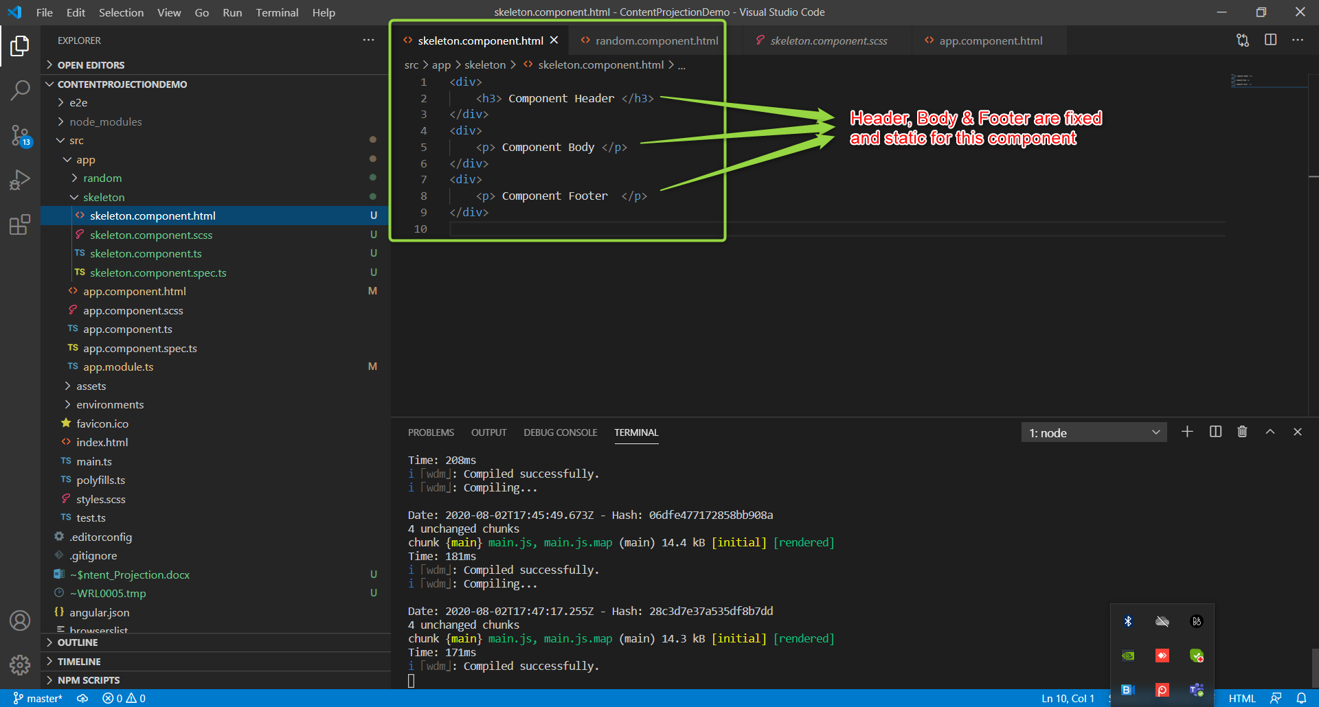

Which results output as like follows:

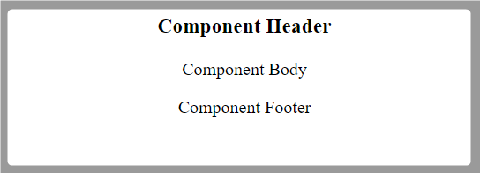

I wanted to build this component in a more maintainable and scalable and futuristic.

So, I wanted to use Multi slot Content Projection here.

We can use **“select”** in **ng-content** in number of ways, but I wanted to show you 3 ways of selecting like **ID**, **CSS class** and **Attribute**.

**CODE: skeleton.component.html**

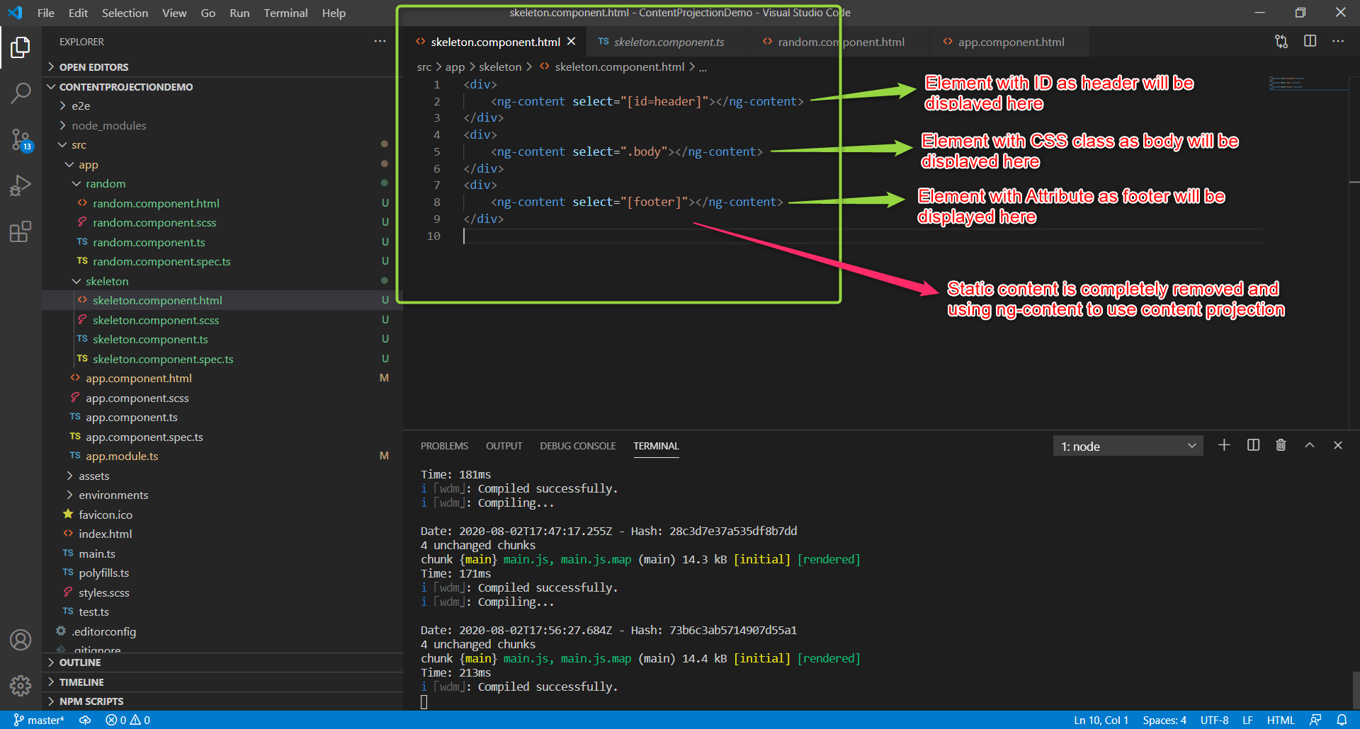

Random Component which is using skeleton component and passing content to it as follows.

**random.component.html**

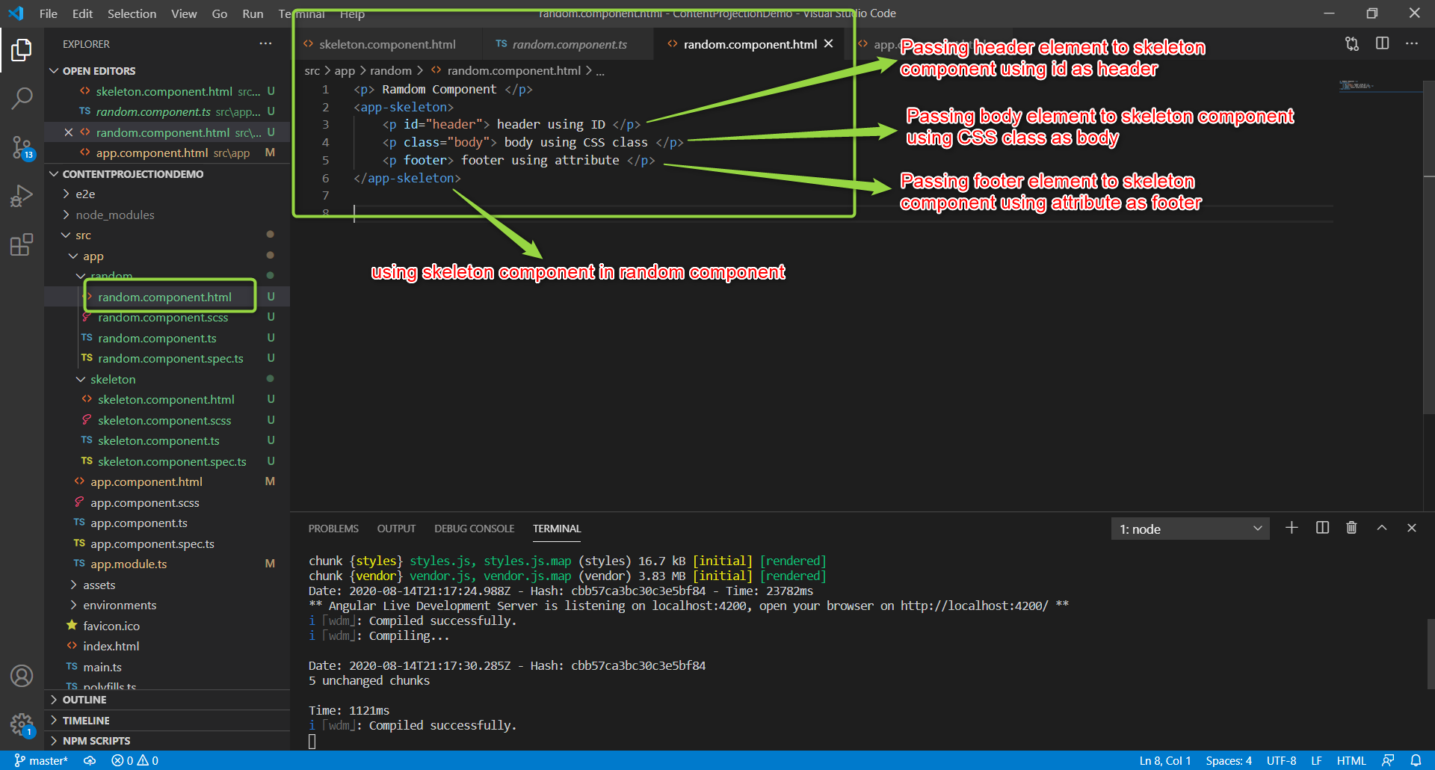

Here is result:

