**Functions Vs Pipes in HTML template**

In HTML templates function calls are invoked every time a change occurs(no caching).

Functions are executed on every change even the source data does not changed**.**

**Pipe :** Pipes are useful to transform data from one format to another format.

Ex. Date pipes, Upper , Lower

Pipes are two types

1. Pure pipe
2. Impure pipe

**Pure pipe:**

Executed only when a pure change to input value is detected.

Pure change is either a change to a primitive input value(string, Number, Boolean) or a changed object reference.

A Pure pipe is not executed if the input to the pipe is an object and only the property values of the object is changed not the reference.

**Impure Pipe:**

Impure pipes are executed on every change even the source data does not changed**.**

**NOTE:**

**It’s better to avoid functions using in angular HTML templates to achieve better performance and best practices.**

**Instead of functions replace with pure pipes in all possible scenarios.**

**Ex.**

**In below example we can find two components**

1. **RandomComponent**
2. **ProductListComponent**

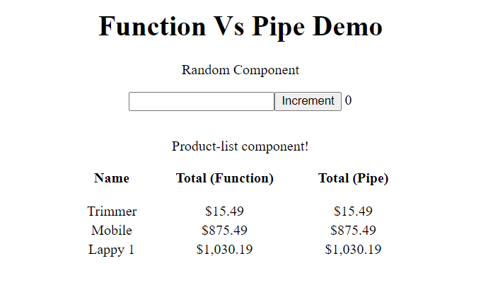

**In ProductListComponent we have two columns**

**Total(Function) which uses function in HTML temple to get total.**

**Total(Pipe) which uses Pipe in HTML temple to get total.**

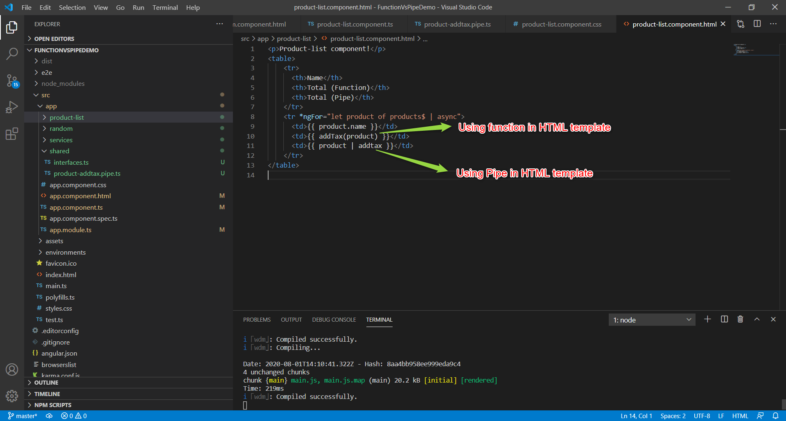

**Console Logging added in addTax() function.**

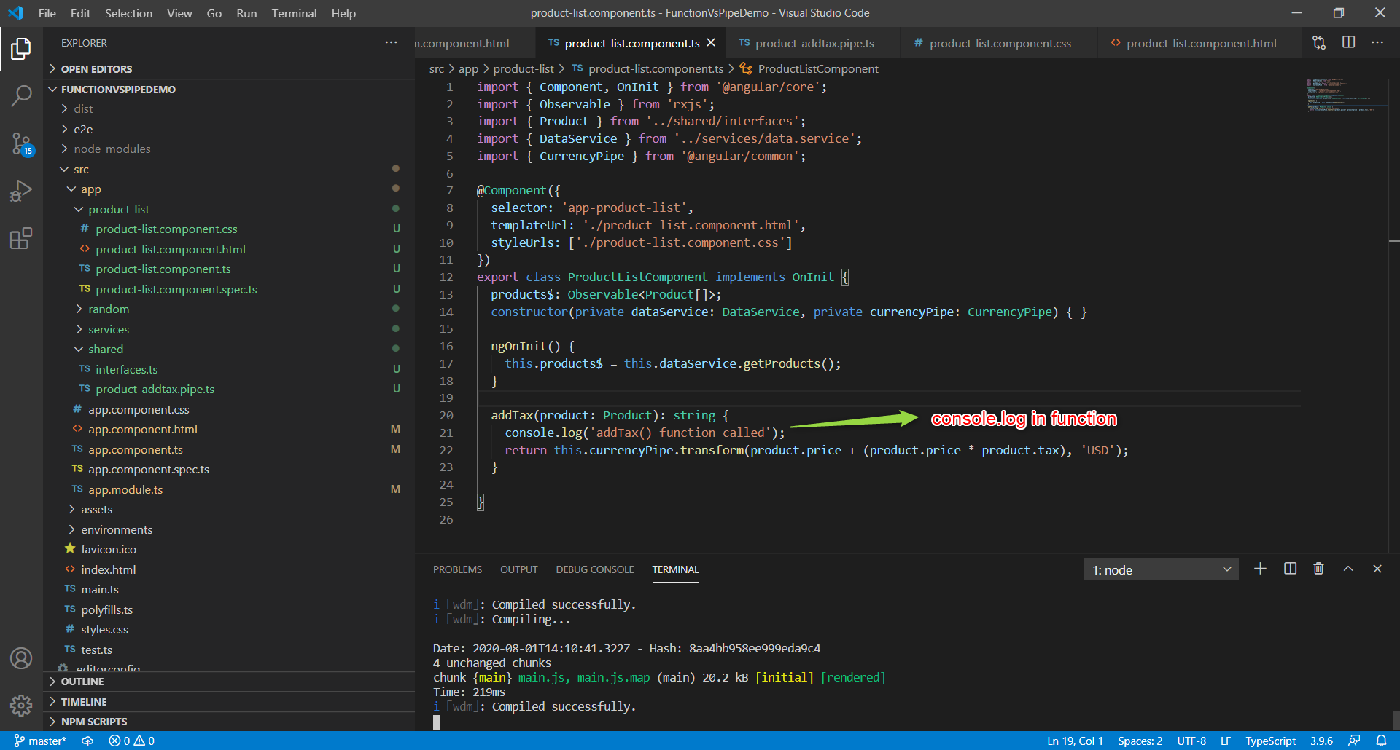

**Console Logging added in addTax pipe.**

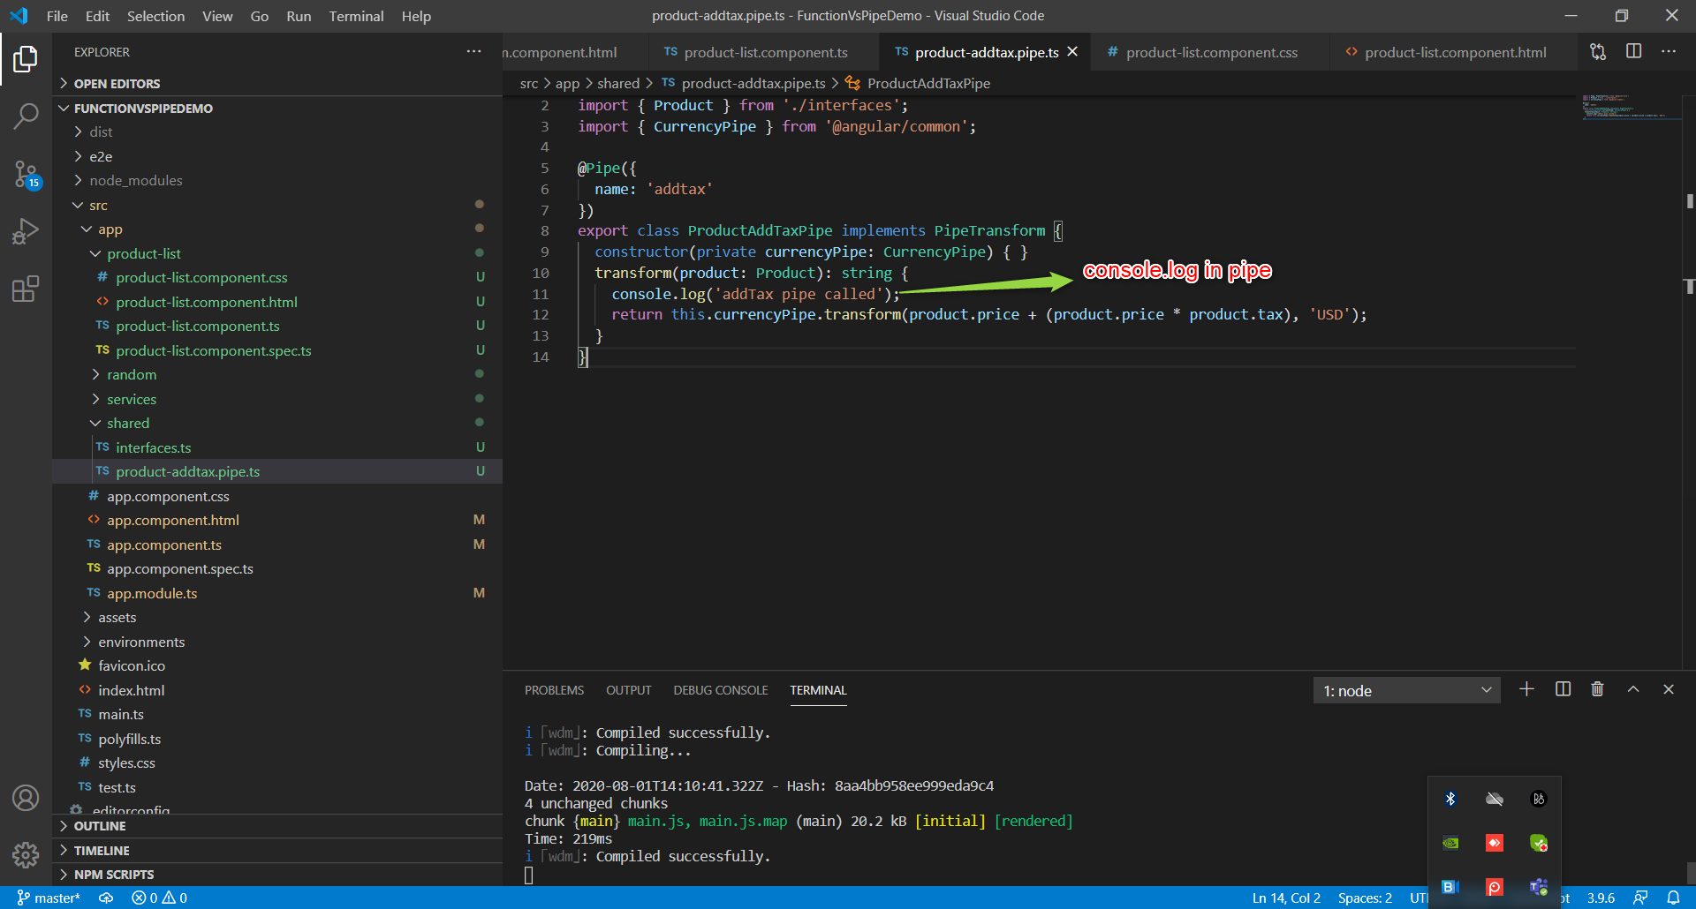

**On Initial Page load**

**AddTax Pipe is called only 3times because only 3 products .**

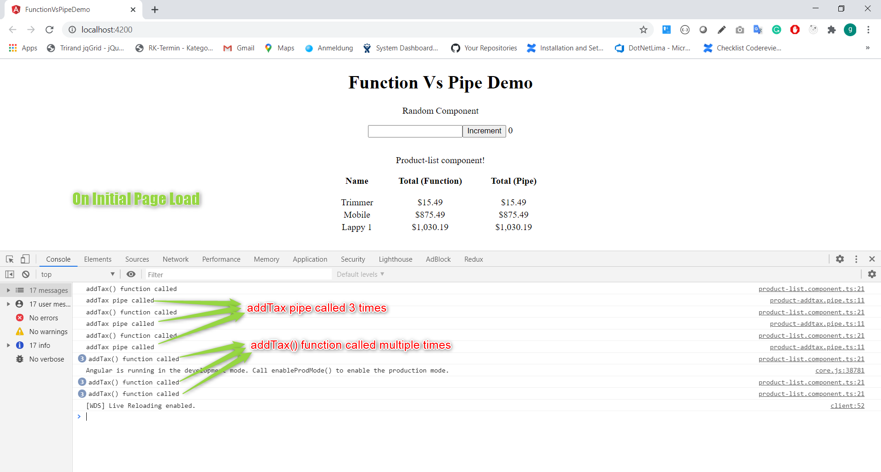

**Functions are executed on every change detection even the source data does not changed.**

**Entering some text in Textbox in RandomComponent**

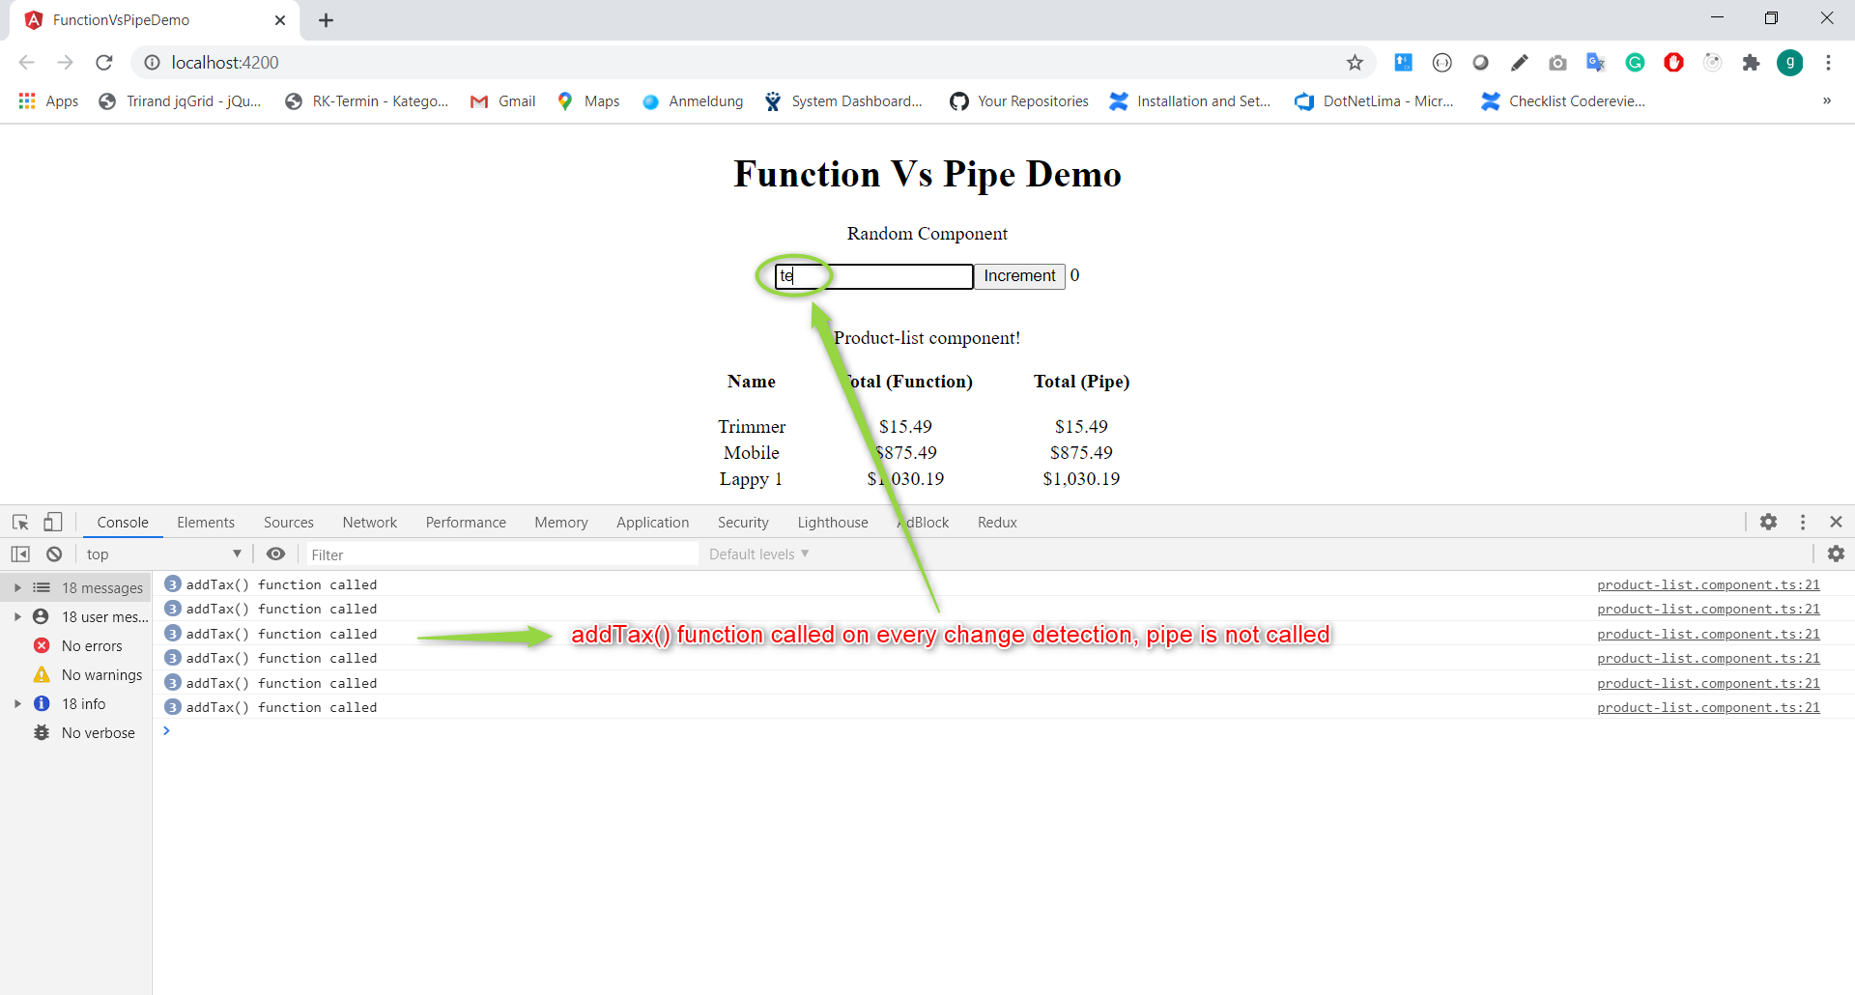

**Clicked on Increment button, which increments local counter variable in RandomComponent**

