**HTTP-INTERCEPTORS**

**\*\*\*\*\*\*\*\*\*\*\*\*\*\*\*\*\*\*\*\*\*\*\*\*\*\*\*\*\*\*\*\*\*\*\*\*\*\*\*\*\*\***

**What are HTTP Interceptors ?**

Interceptors are just angular services that implements the HTTP Interceptor interface.

1. Interceptors are allows us to manipulate the HTTP Requests before they sent to the server.

i.e manipulation is possible while HTTP requests leaving the client on their way to the server.

2. Interceptors are allows us to manipulate the HTTP Response before they returned to your application.

**Flow diagram:**

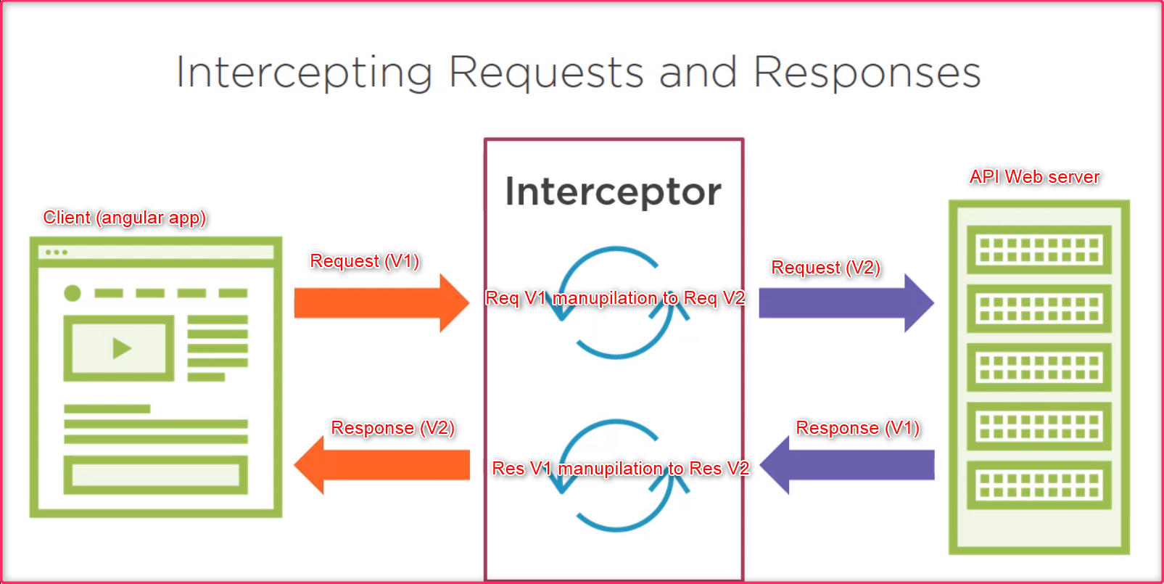

**Uses of Interceptors:**

Interceptors are provides lot of freedom and control to customize the HTTP requests and responses in a centralized one place. So that DEV doesn’t need to do customize over and over again in each request and response.

1. Adding Headers to all Request
2. Logging (Centralized HTTP Request & Response Logging)
3. Reporting progress events
4. Client Side Caching

**Define an Interceptor:**

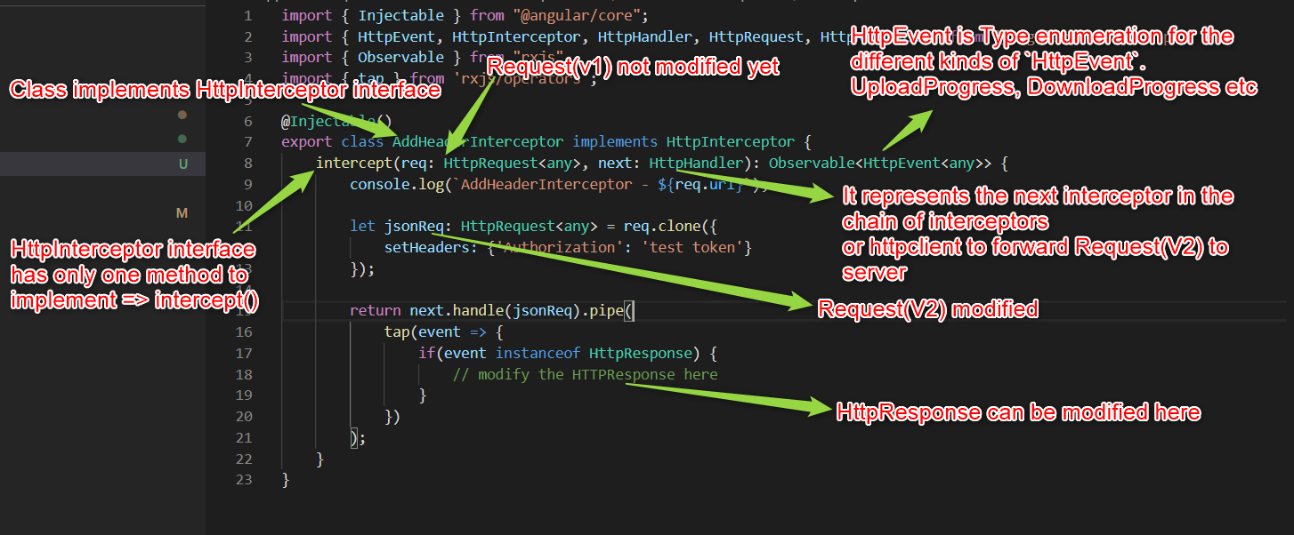

**Providing an Interceptor:**

Providing interceptors are just like services little different than other services.

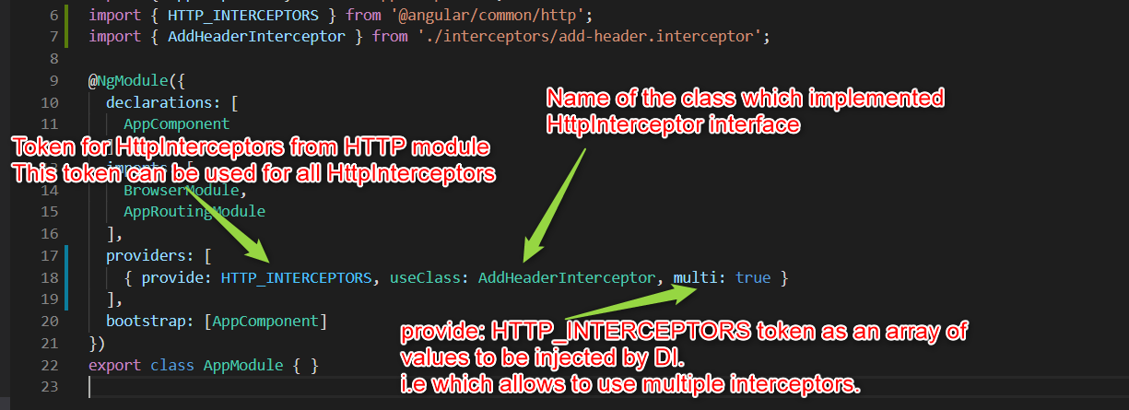

**Working with HTTPRequest DEMO**

**DEMO code available here:** <https://github.com/GopiKrishnaGummadidala/HttpInterceptorDemo>

ProductsComponent.ts contains the following code i.e httpclient making an API call without header.

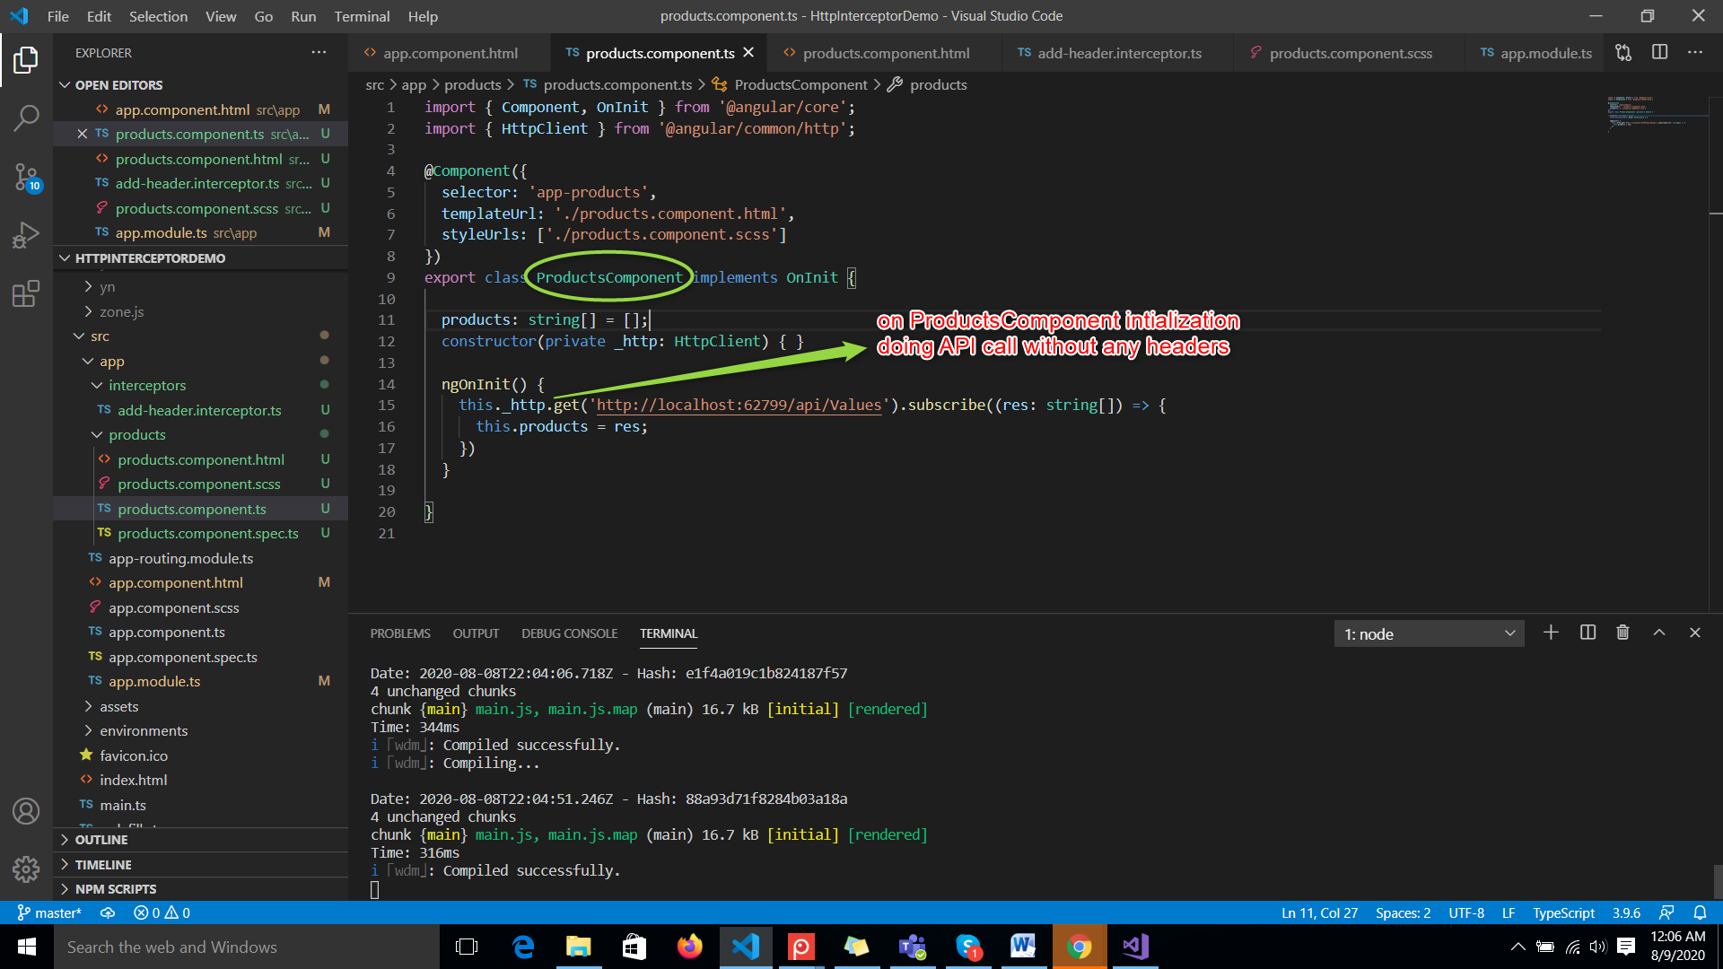

ProductsComponent.html contains the following HTML template.

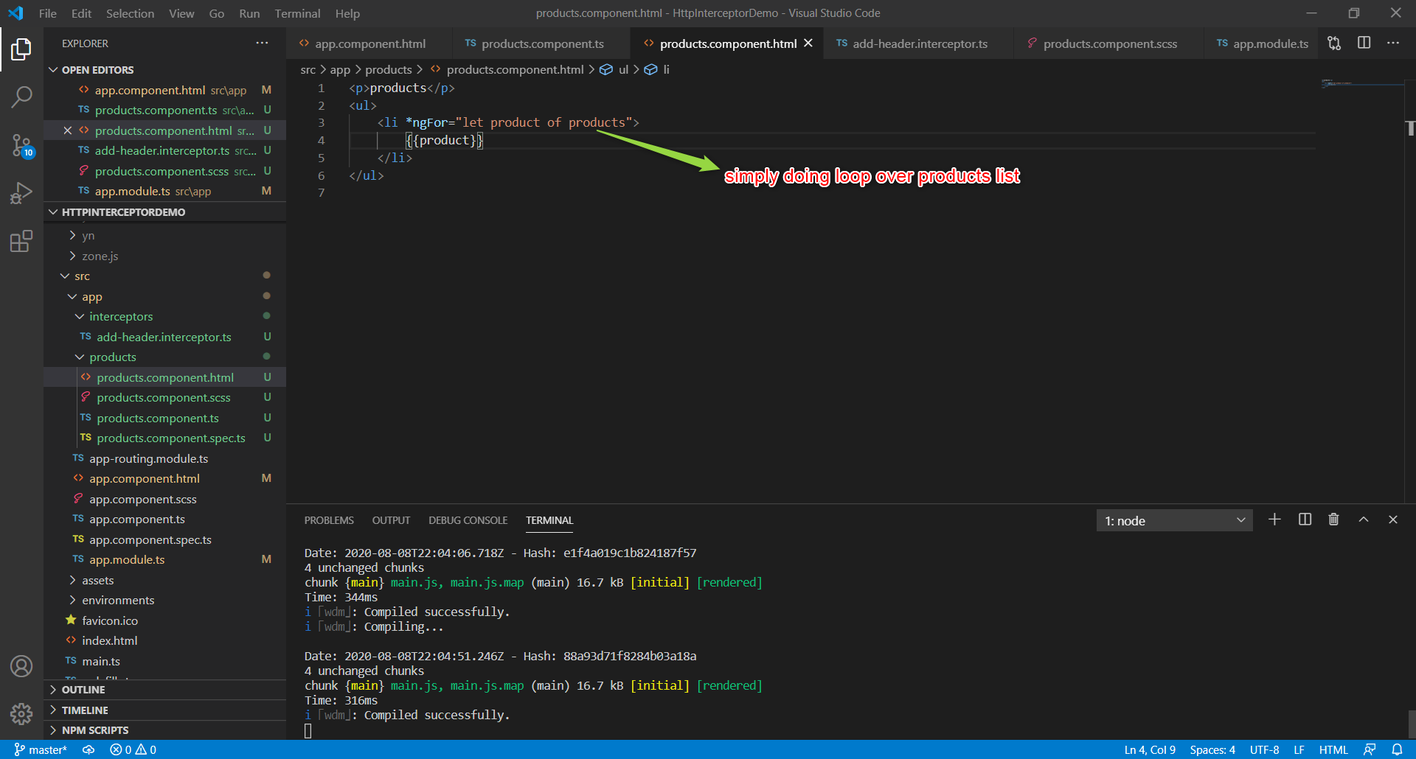

add-header.interceptor.ts contains the following code i.e sets Authorization header to request

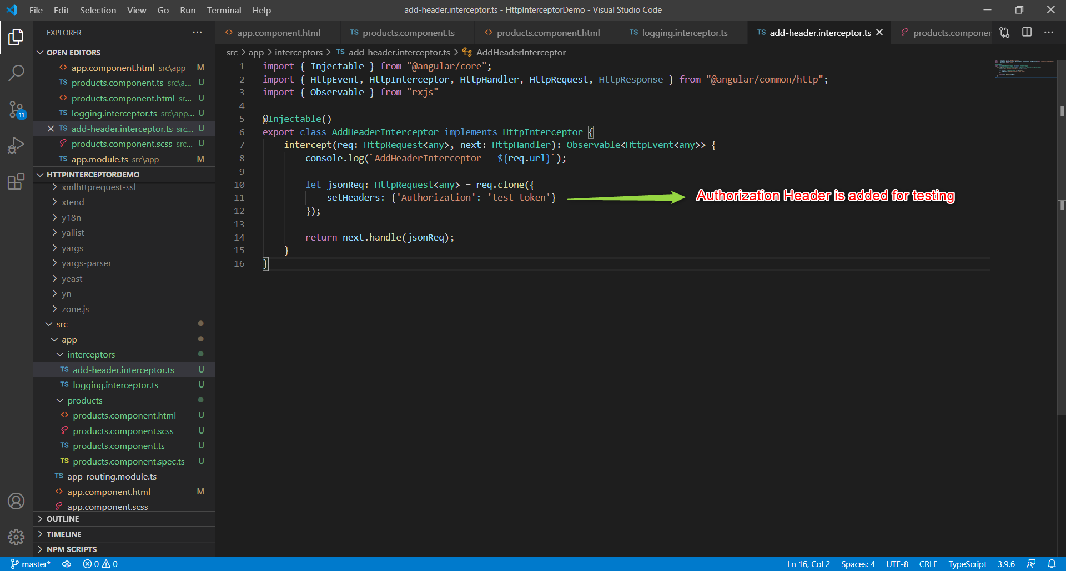

Providing AddHeaderInterceptor to AppModule.

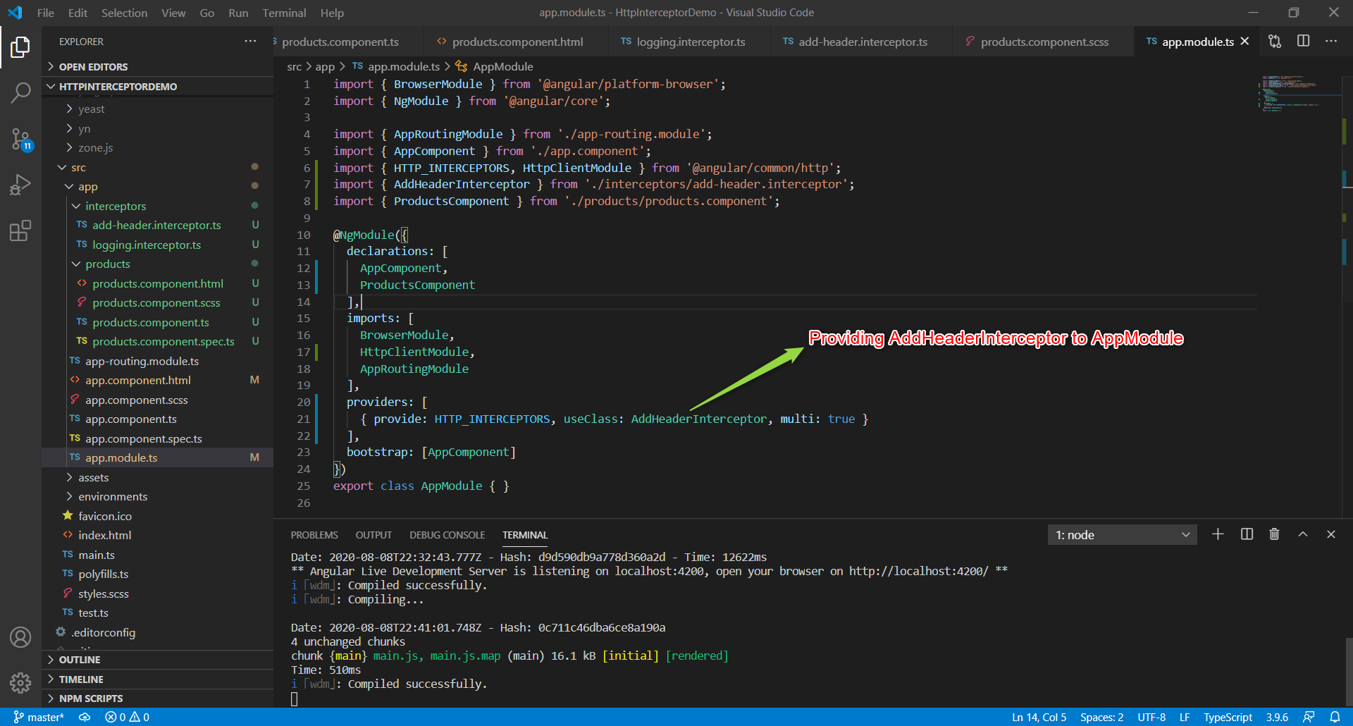

API Response hard coded  
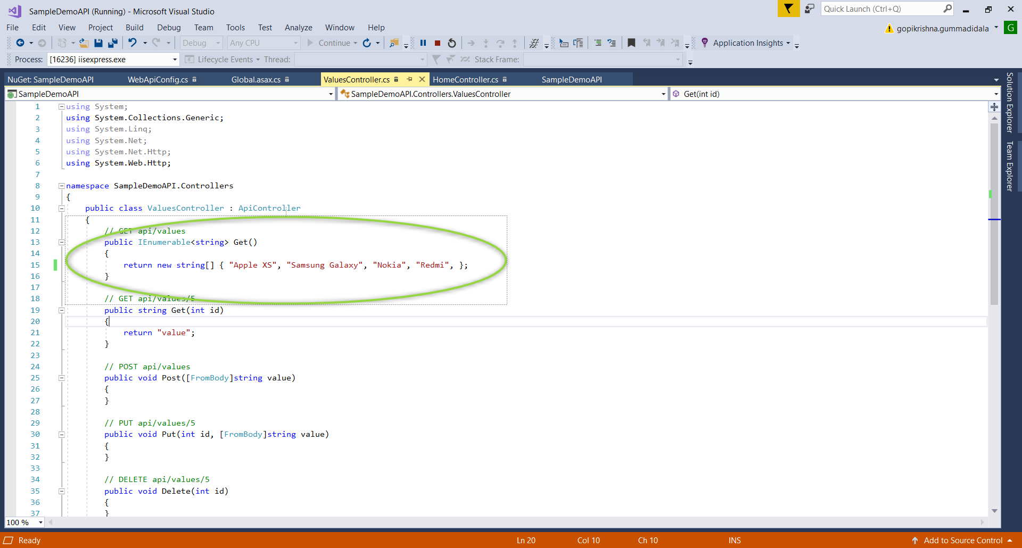

**Here is Result :**

Authorization header is available on the request which is added by AddHeaderInterceptor

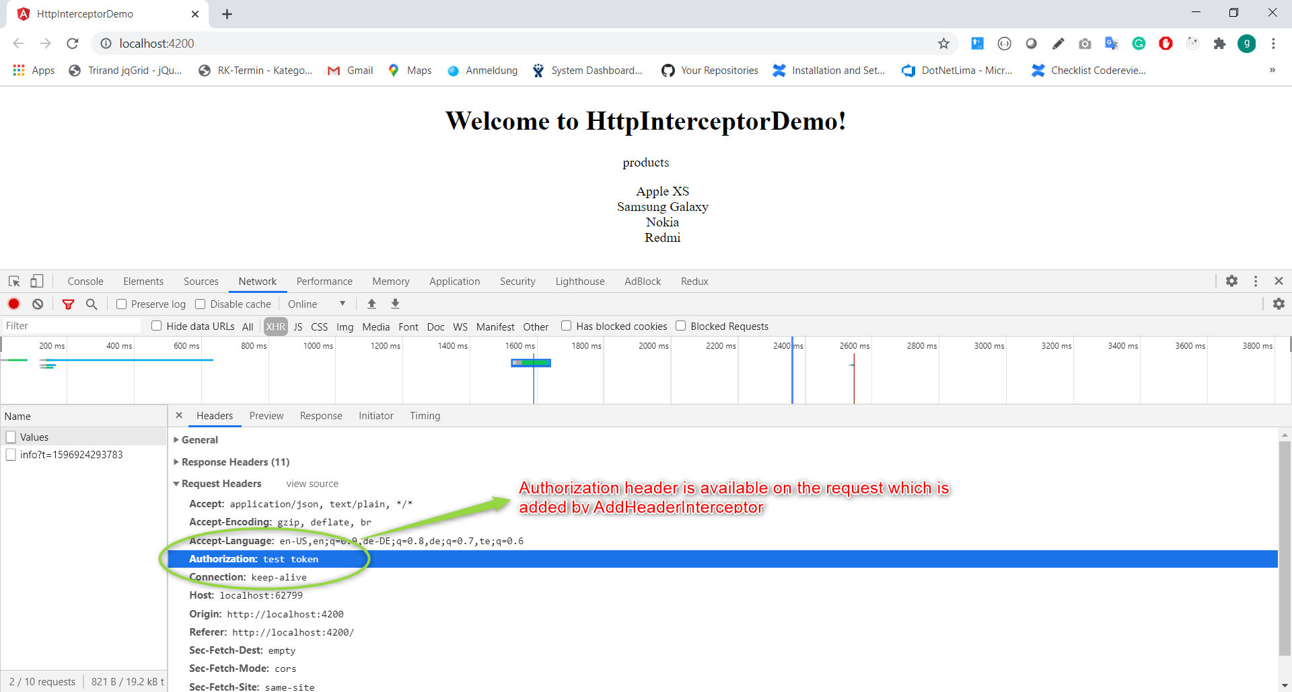

**Working with HTTPResponse and multiple interceptors DEMO**

Added LoggingInterceptor to log HTTPResponse to console

logging.interceptor.ts contains the following code

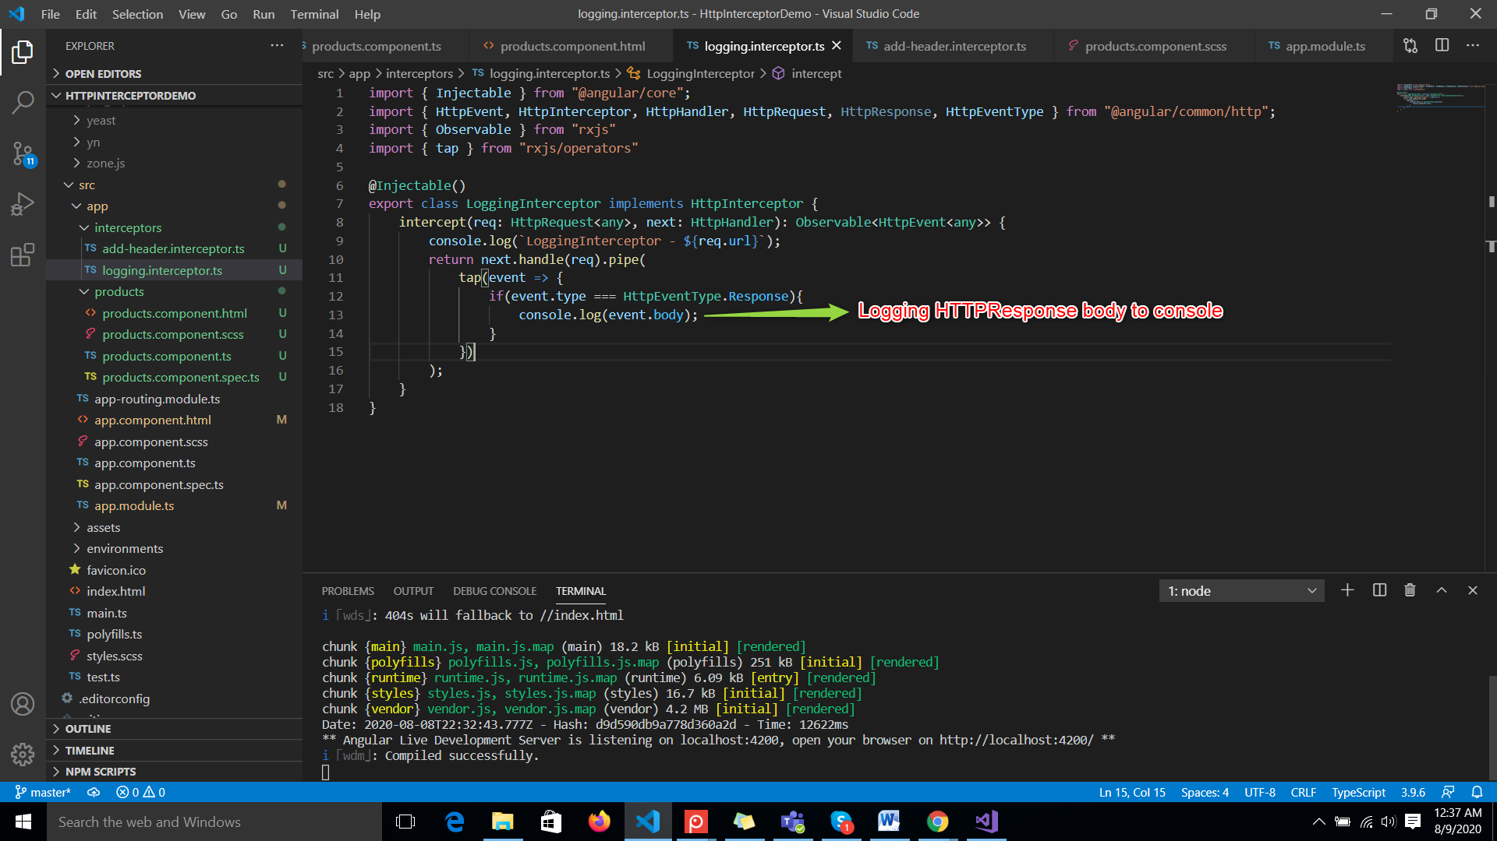

Providing LoggingInterceptor to appModule as the other I did.

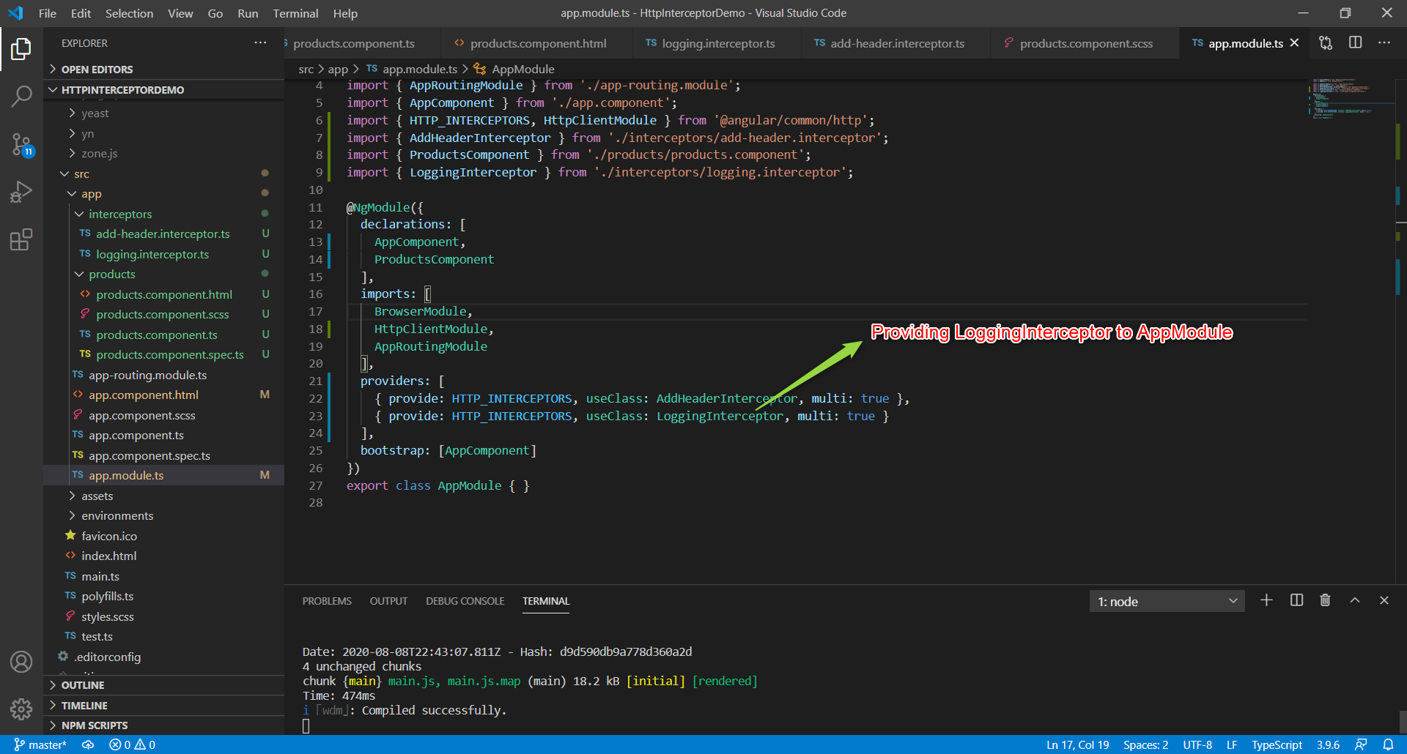

**NOTE:**

Based on the order of providing interceptors follows the same for execution

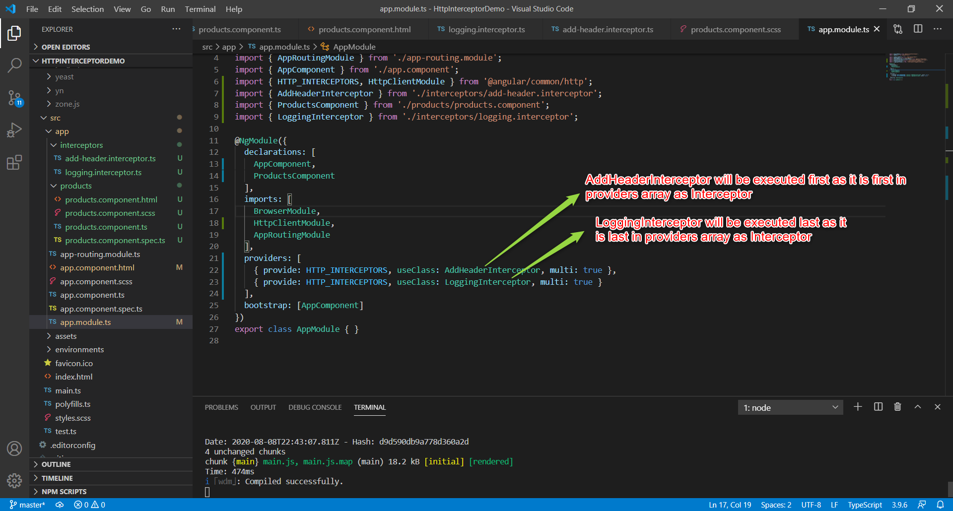

**Here is Result :**

