**Angular Routing**

****************************************************************

Here we are working on a sample application especially on routing concepts in angular.

Here is the sample application **components** configured in this demo.

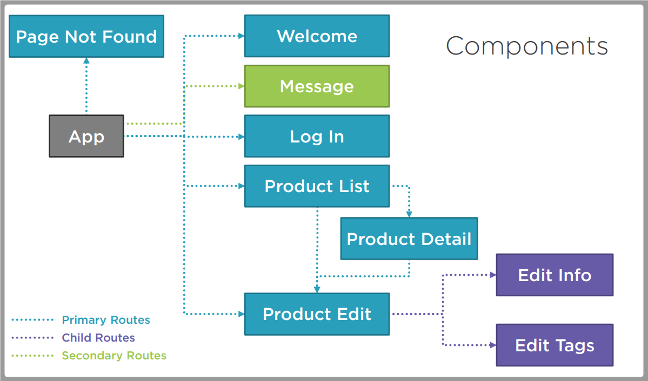

Here is the sample application modules configured in this demo.

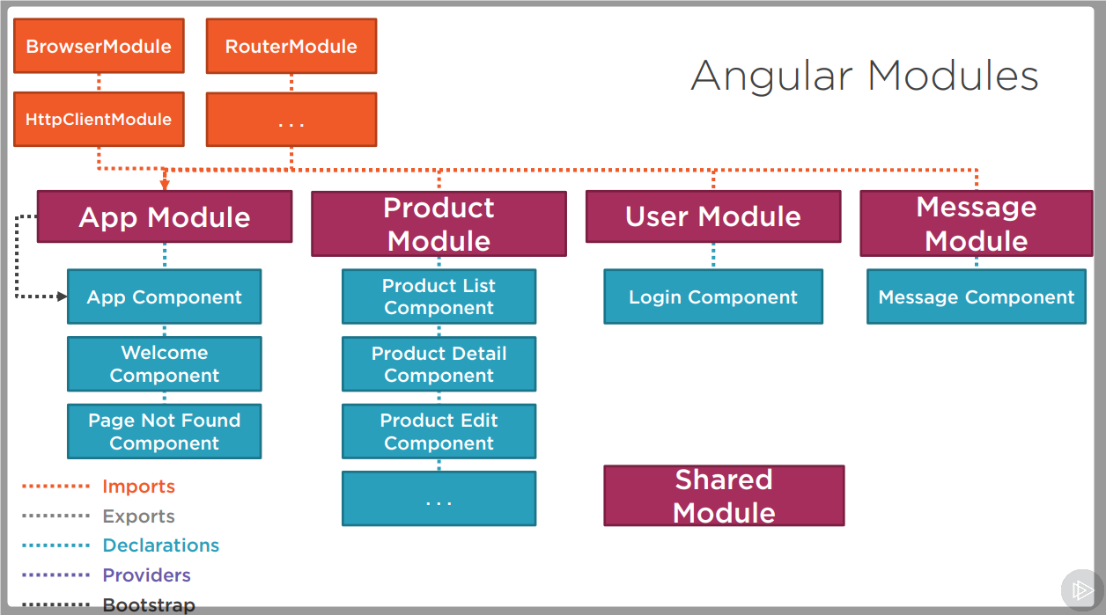

Routing works as follows?

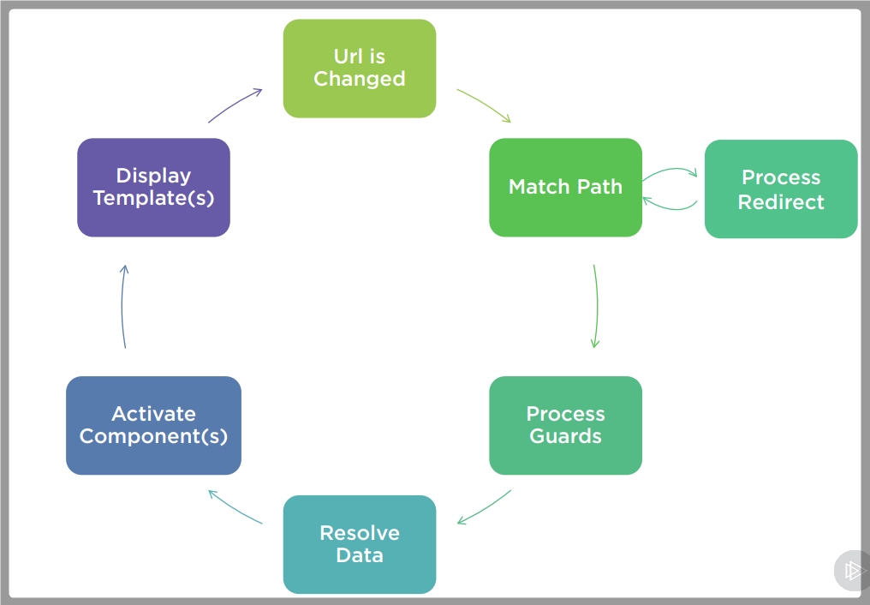

Course Outline =>

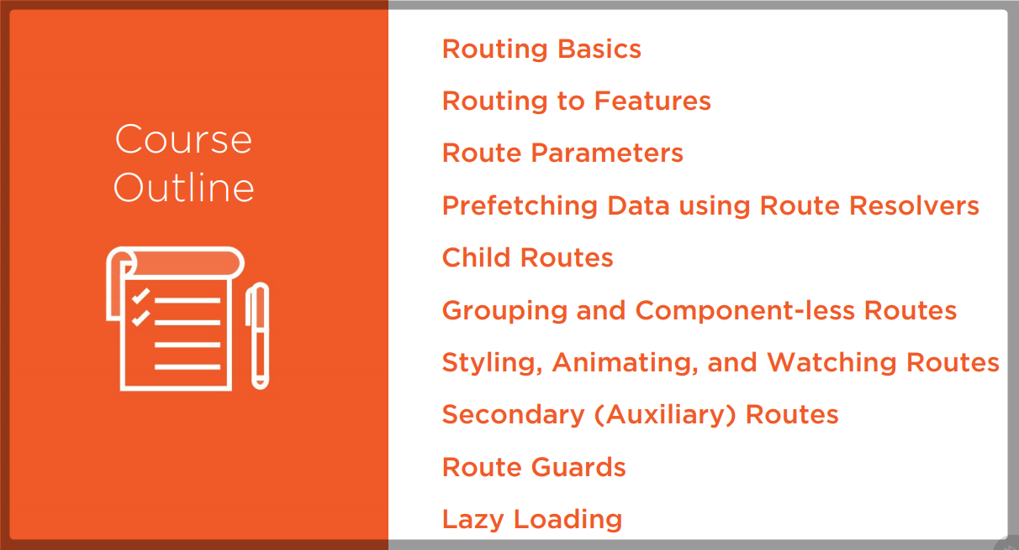

Our final application routing

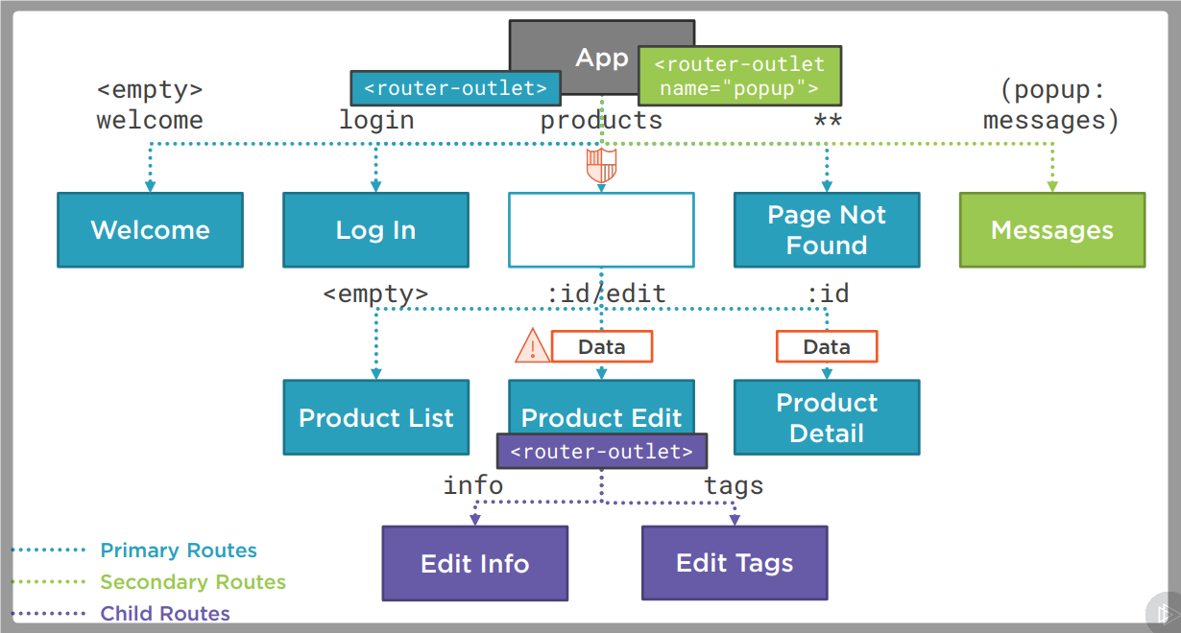

Import Angular Router

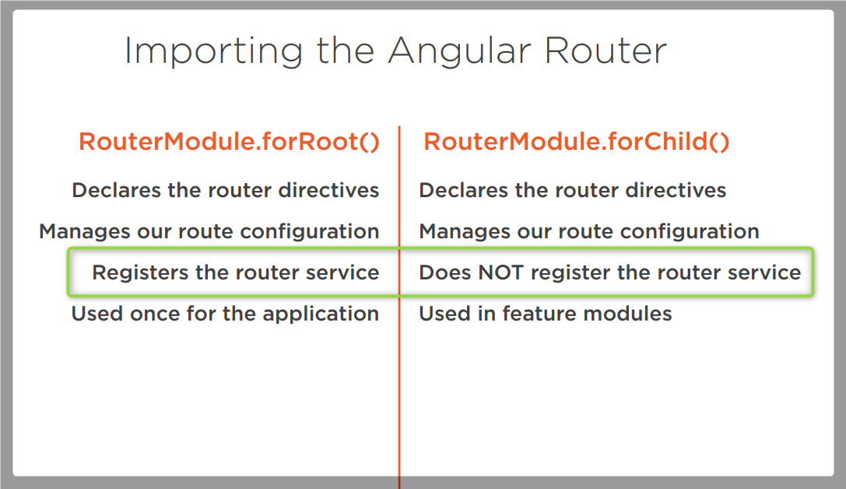

**HTML 5 vs Hashbased Routing**

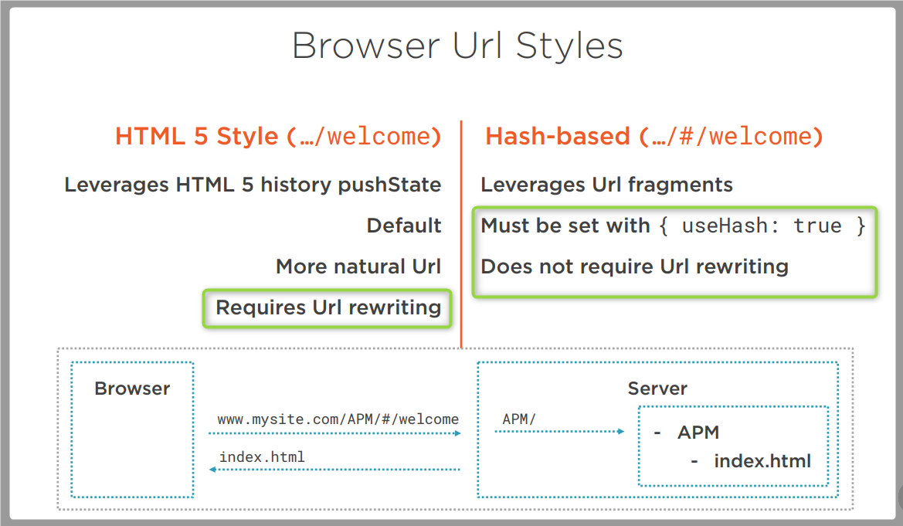

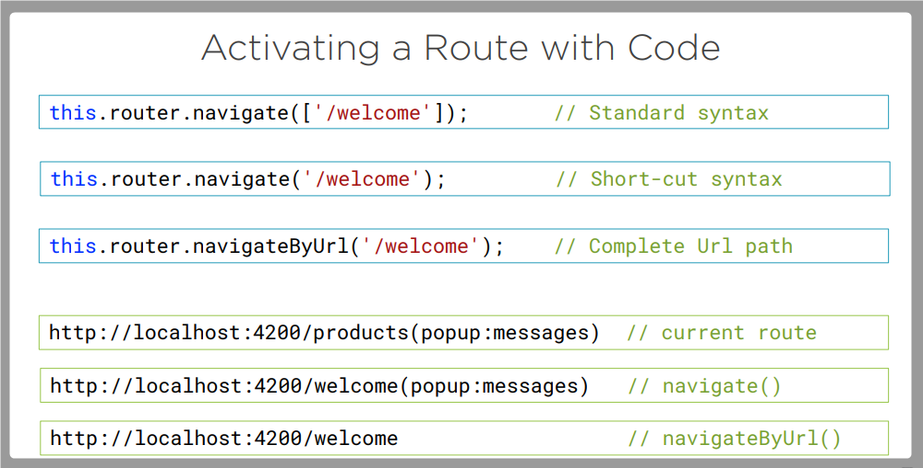

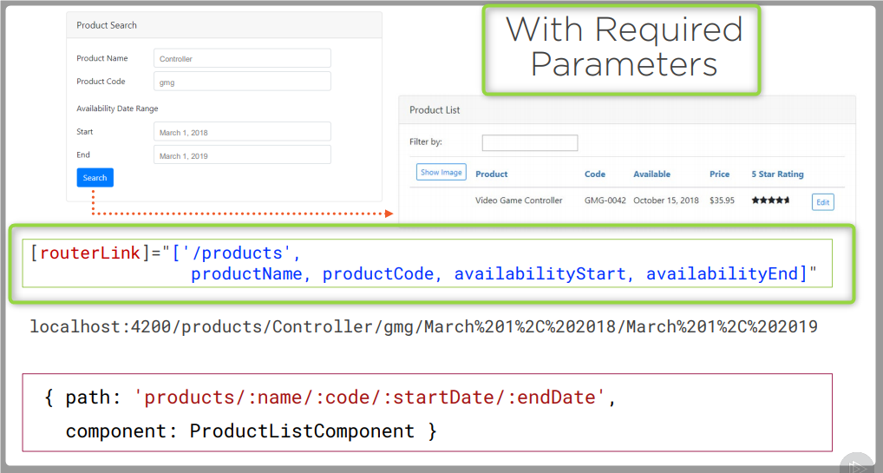

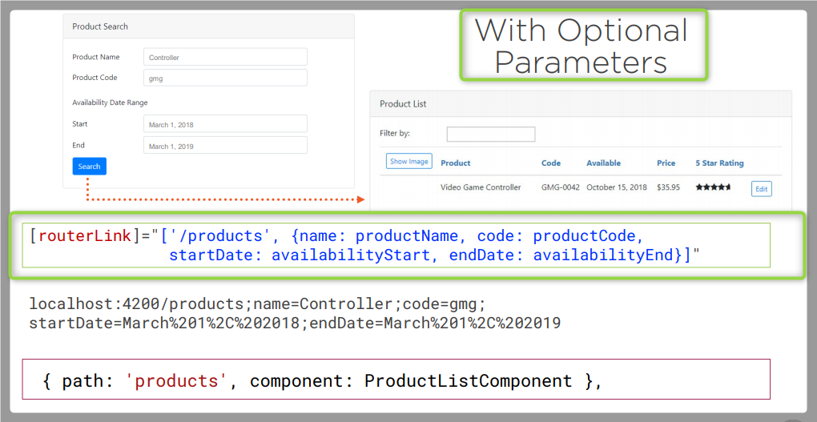

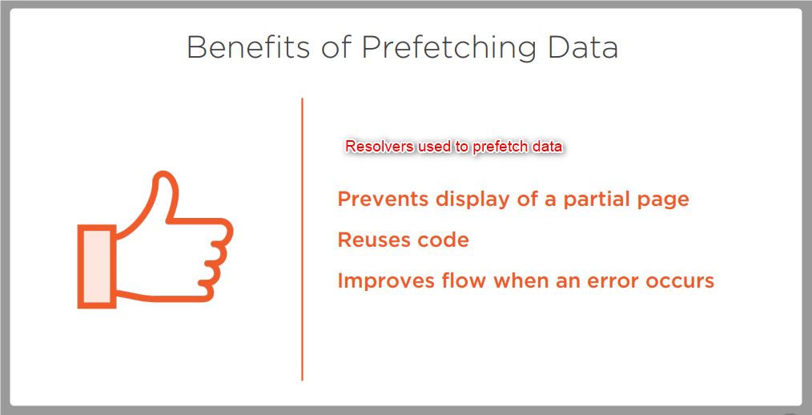

Resolver Error Handling:

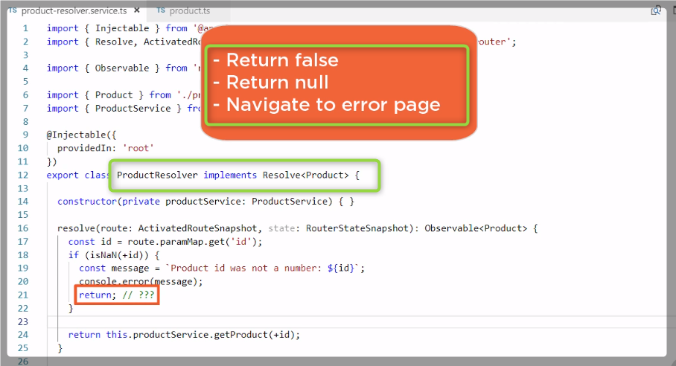

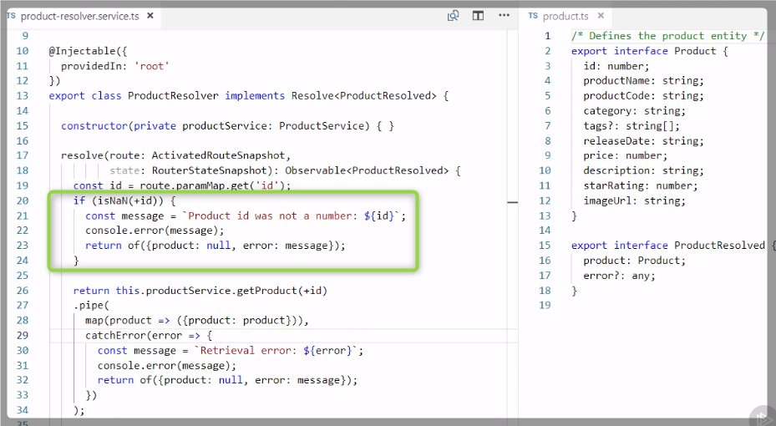

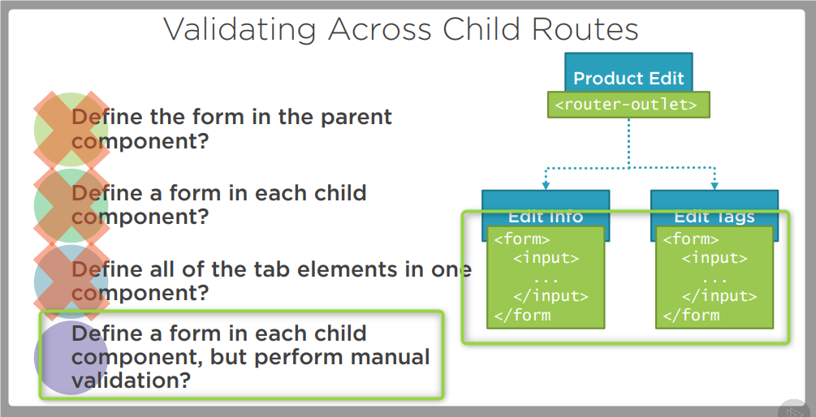

**Routes Grouping**

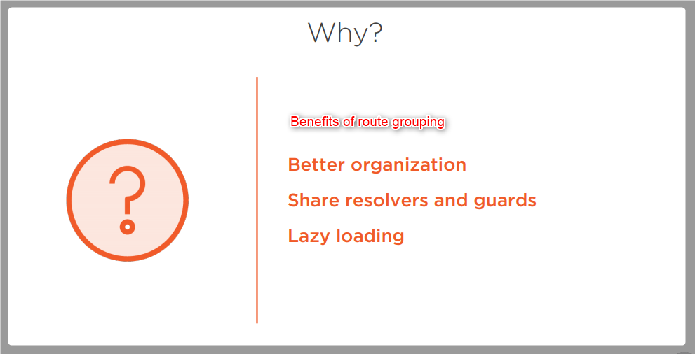

**Component-less routing**

