**Angular App In MVC application**

**\*\*\*\*\*\*\*\*\*\*\*\*\*\*\*\*\*\*\*\*\*\*\*\*\*\*\*\*\*\*\*\*\*\*\*\*\*\*\*\*\***

**Angular** is one of the most in-demand web front-end frameworks developed by Google; it gets integrated with any server-side technology. In this article, let’s learn how to use Angular (Version 11) with ASP.NET MVC 5 using Angular-CLI.

**Software Pre-Requisites**

1. Visual Studio 2017/2019
2. NodeJs & Angular Cli
3. Visual Studio Code (Optional)

Minimum knowledge on MVC routing and Angular routing.

**Step 1**: Create angular application.

Command: **ng new angular-mvc-demo**

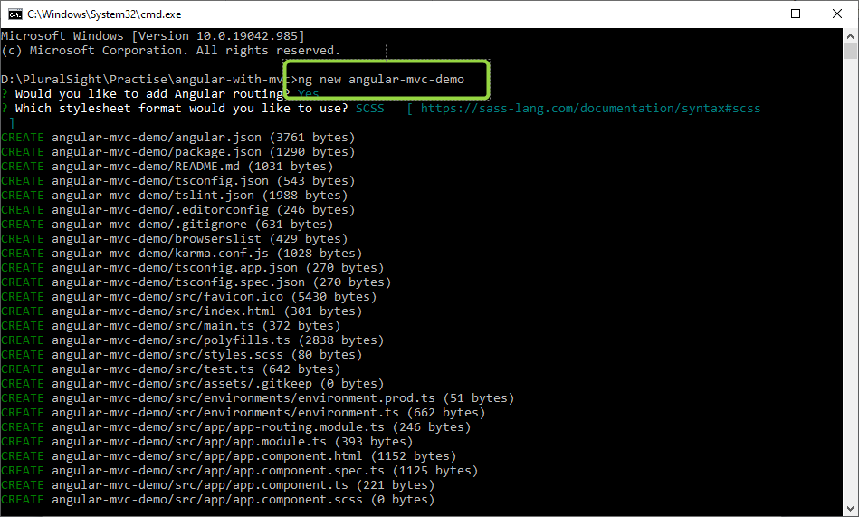

Adding Routing in Angular Application.