**APACHE-SOLR**

**\*\*\*\*\*\*\*\*\*\*\*\*\*\*\*\*\*\*\*\*\*\*\*\*\*\*\*\*\*\*\*\*\*\*\*\***

**APACHE-SOLR is one of the best for enterprise searching.**

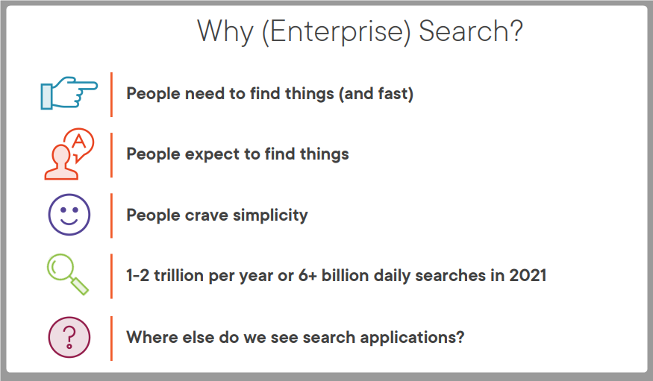

**Why Solr?**

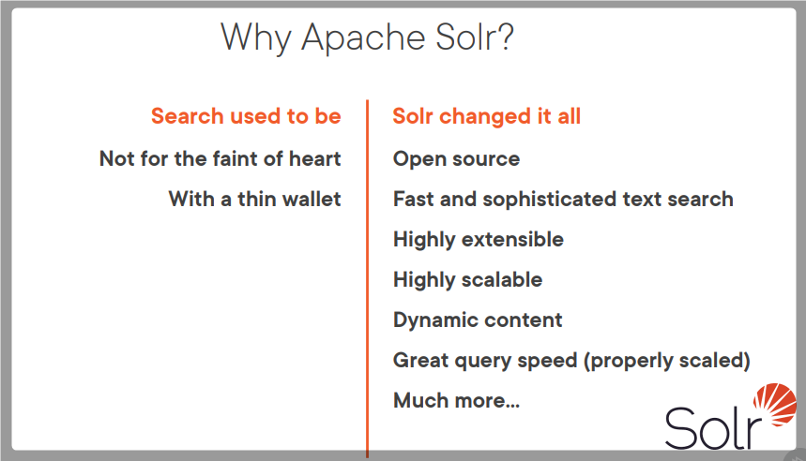

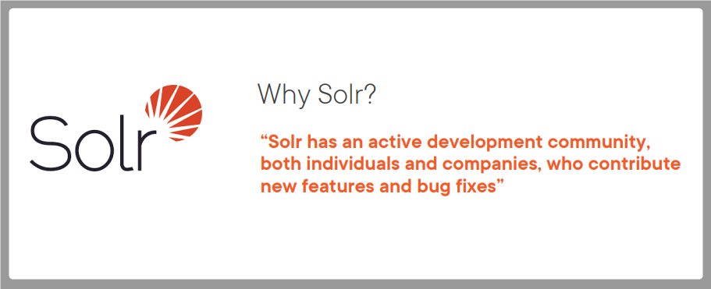

**Functions of a Search Engine**

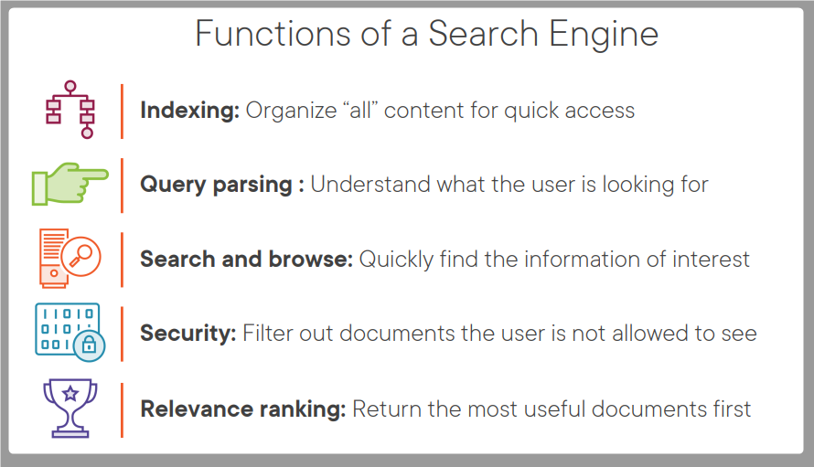

**Purpose of a Search engine**

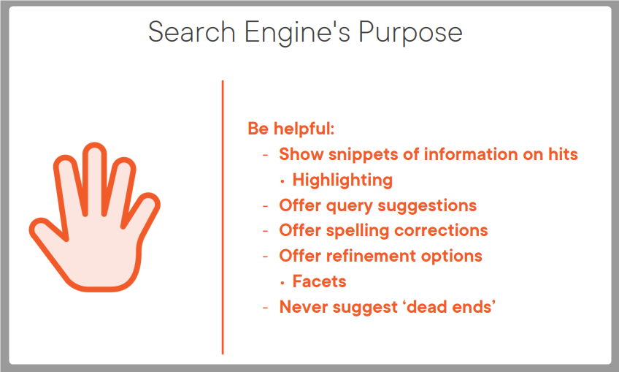

**Solr Features**

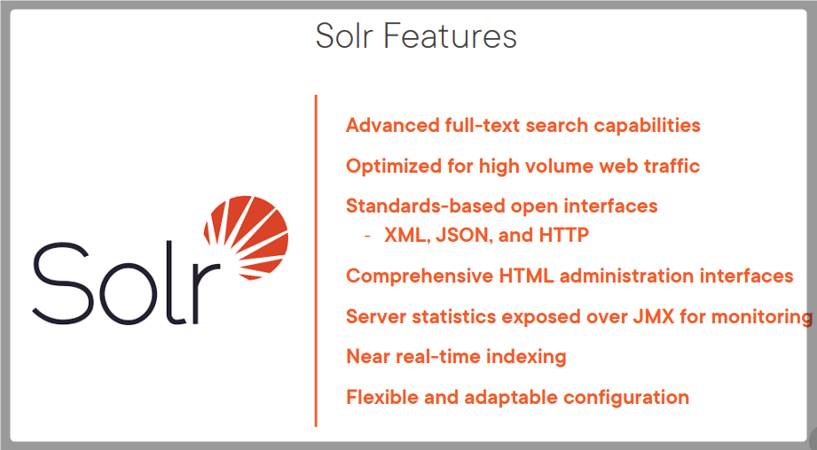

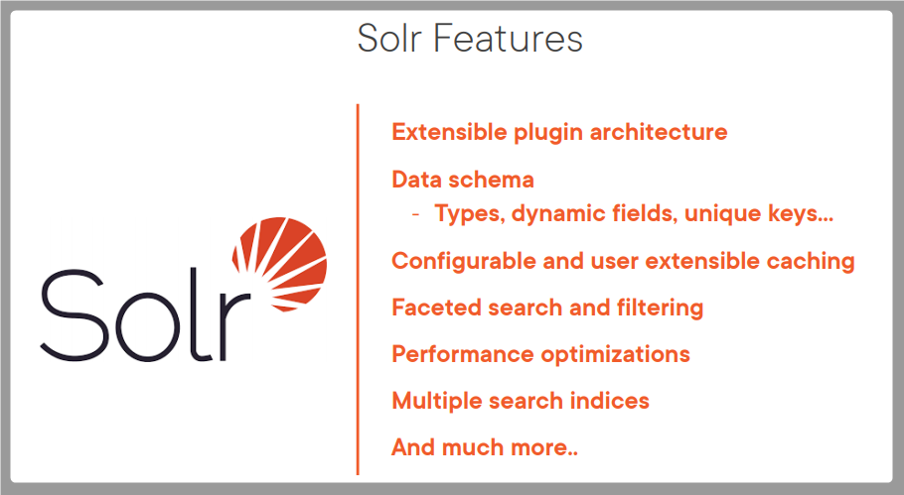

**Scalability via Solr Cloud**

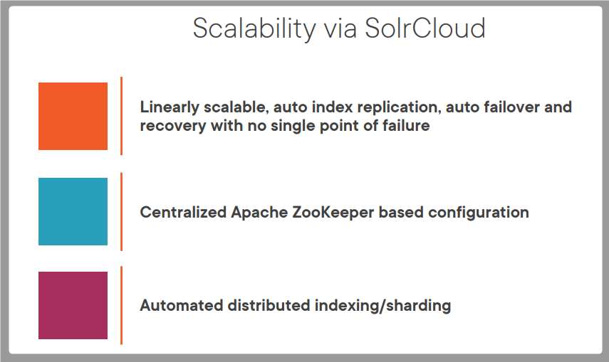

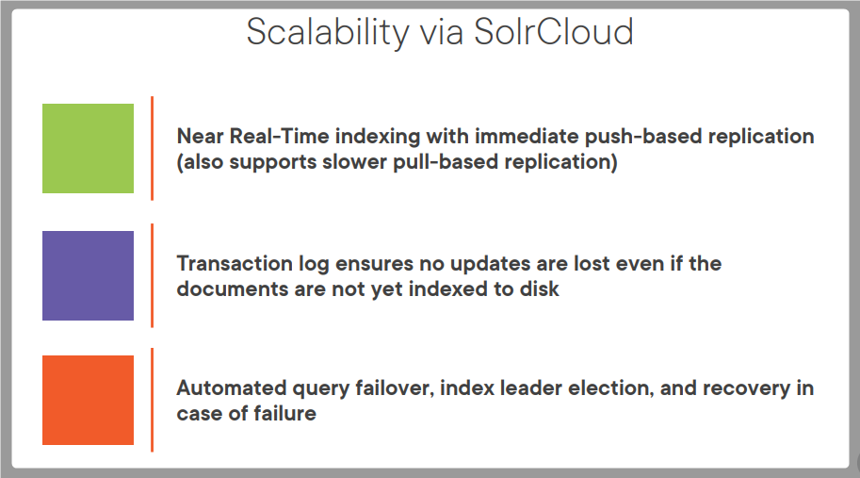

**SOLR Architecture**

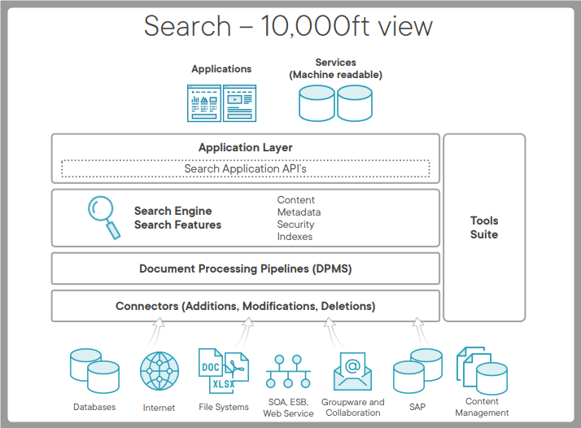

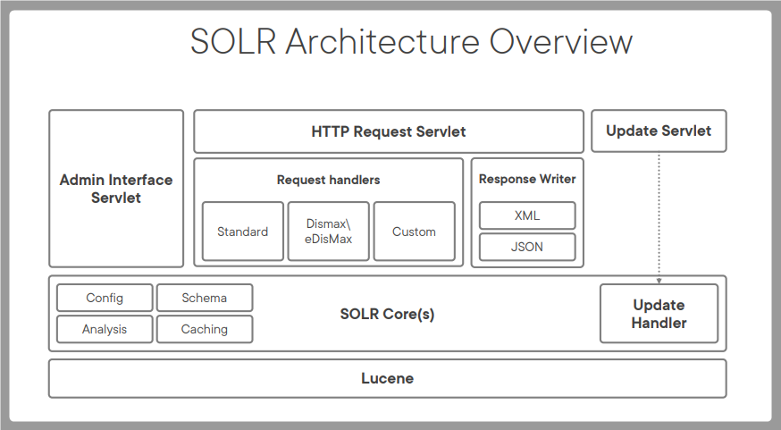

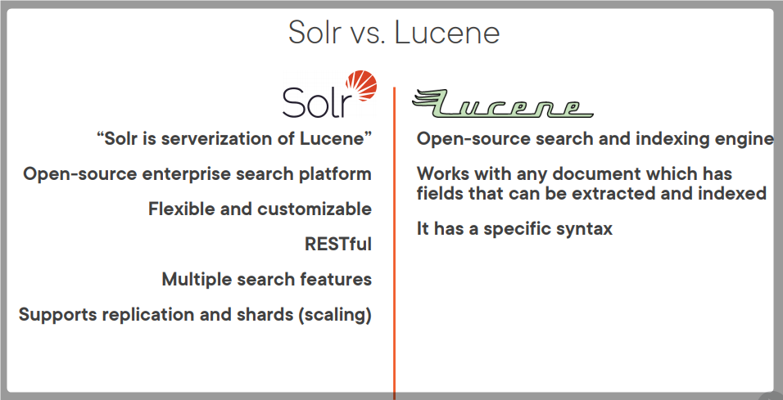

**Configuration**

**Download Solr from here** [**https://solr.apache.org/**](https://solr.apache.org/)

**Use this Reference** [**https://solr.apache.org/guide/**](https://solr.apache.org/guide/)

**Step 1: Installed Java Runtime from** [**https://www.oracle.com/java/technologies/javase-downloads.html**](https://www.oracle.com/java/technologies/javase-downloads.html)

**Step 2: Set JAVA_HOME environment variable.**

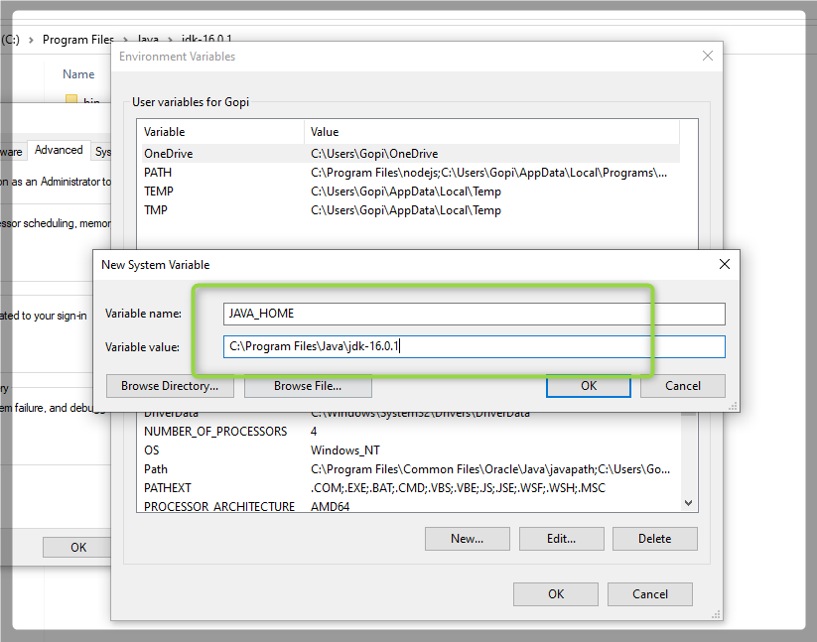

**Step 3: Unzip the Solr file after download and copy the complete folder to C:/ drive**

**Step 4: goto cmd prompt and change directory to solr directory as specified in screenshot.**

**Command : bin\solr.cmd start**

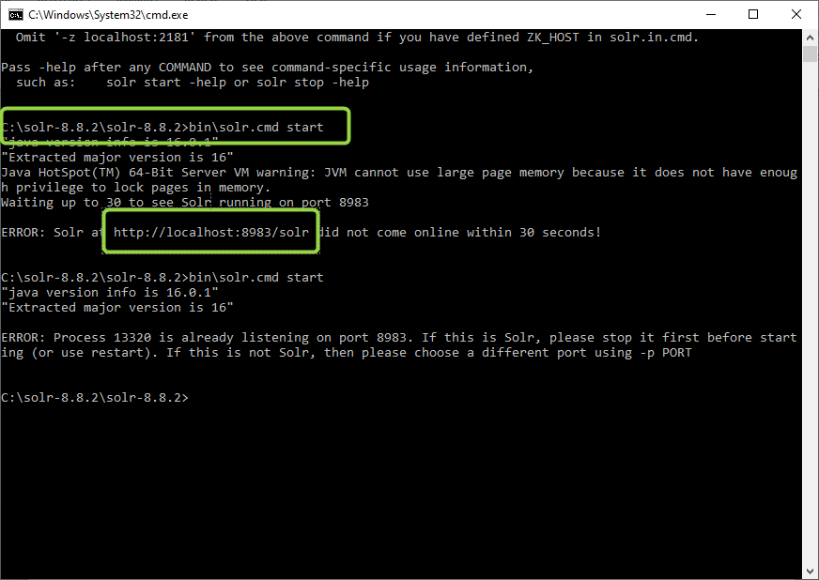

**As specified in the screenshot open browser and type this url**

[**http://localhost:8983/solr**](http://localhost:8983/solr)

**You can see a Solr Admin panel**

