**Cypress**

**\*\*\*\*\*\*\*\*\*\*\*\*\*\*\*\*\*\*\*\*\*\*\*\*\*\*\*\*\*\*\*\*\*\*\*\*\*\*\*\*\*\*\*\*\*\*\*\*\*\*\*\*\*\*\*\*\*\*\*\*\*\*\*\*\*\*\*\*\*\*\*\*\***

**Cypress features**

1. **Default it supports JavaScript, out of the box it supports Typescript.**
2. **It has in built Assert methods to validate.**
3. **Automatic waiting default it has 6sec.**
4. **Takes automatic screen shot and videos.**
5. **Cross browser testing**
6. **Tests can run in CI CD environments.**

**Reference:** [**https://docs.cypress.io/guides/overview/why-cypress#Features**](https://docs.cypress.io/guides/overview/why-cypress#Features)

**Cypress Setup:**

1. Go to the specified folder where you need to maintain your test cases.
2. Execute the command: **npm init -y =>** creates **package.json** file
3. Execute the command: **npm install cypress =>** it installs all the required stuff to run cypress test cases.
4. If you want to create test cases in Typescript, install typescript as follows.

Execute the command: **npm install -D typescript**

1. Create a **tsconfig.json** file with the following configuration.

<https://docs.cypress.io/guides/tooling/typescript-support#Configure-tsconfig-json>

**Cucumber Setup:**

1. **npm install --save-dev cypress-cucumber-preprocessor**
2. **npm install --save-dev @cypress/browserify-preprocessor (optional)**
3. **npm install --save-dev tsify (optional)**
4. Cypress Configuration => Add it to your plugins:

**cypress/plugins/index.js**

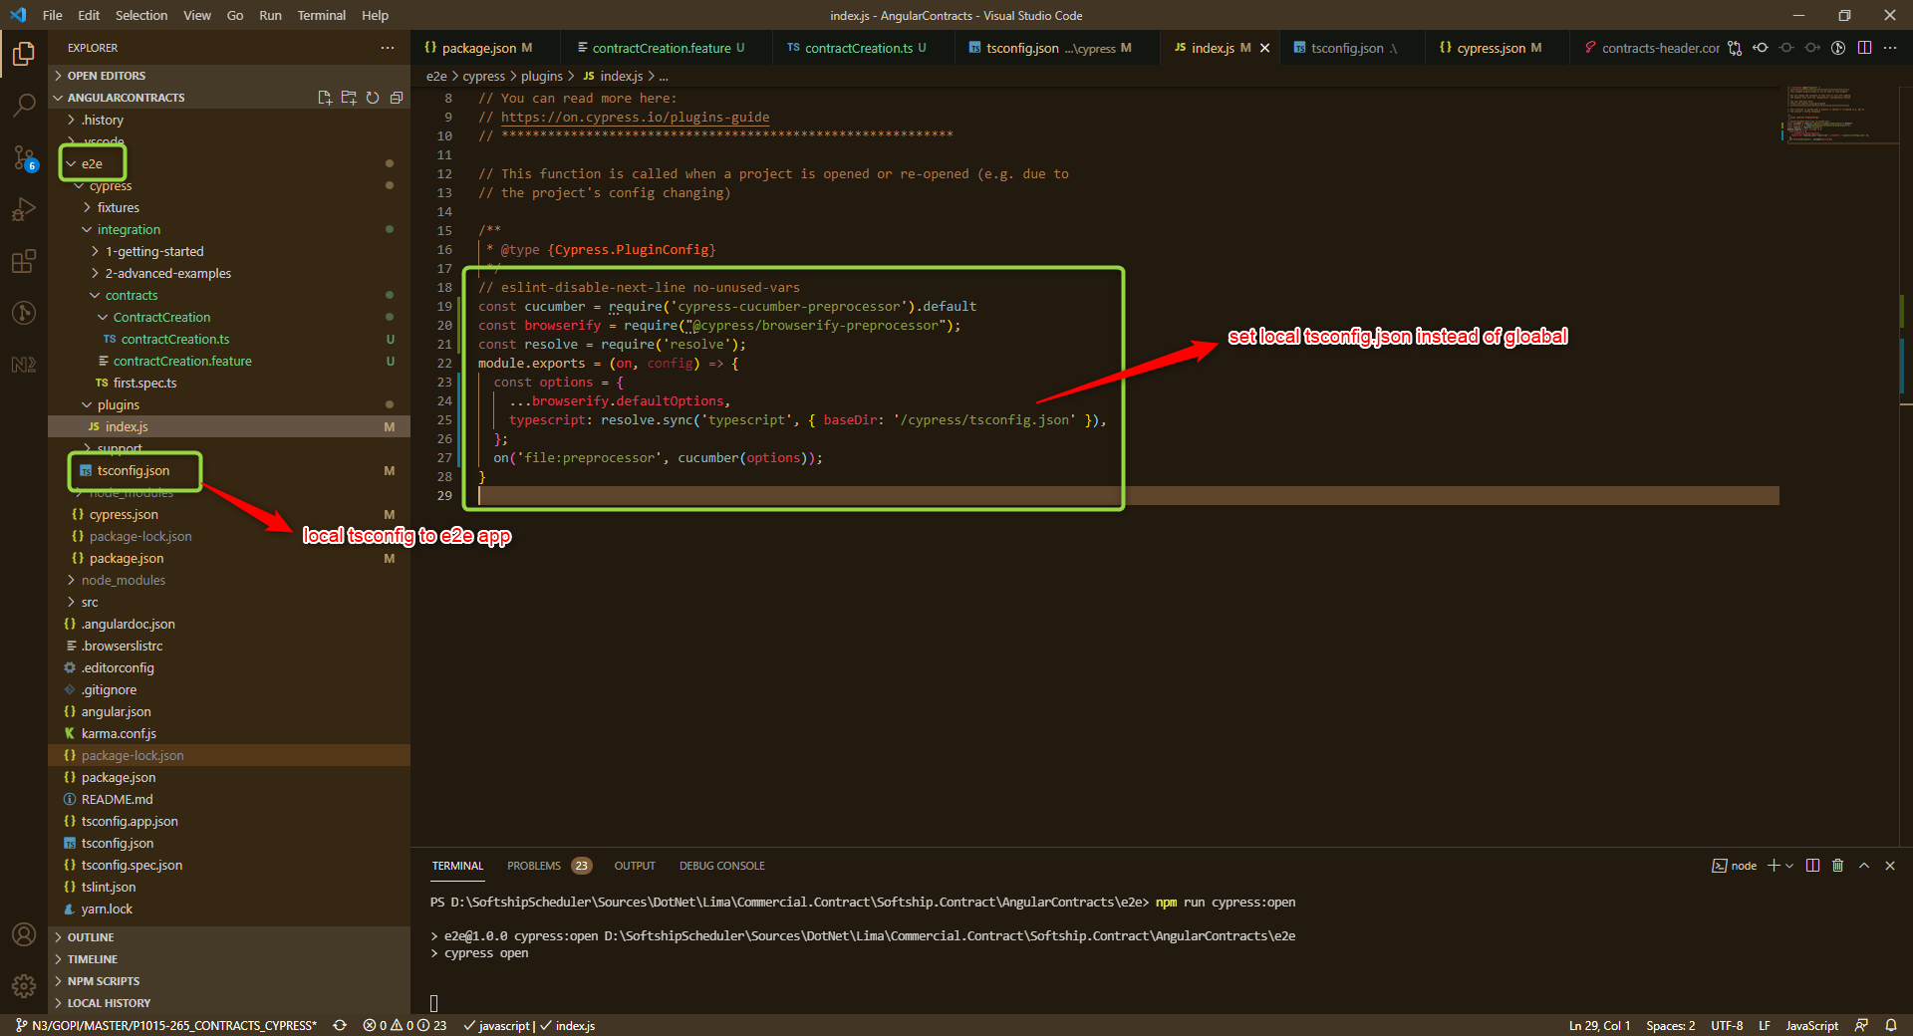

1. Add support for feature files to your Cypress configuration

**cypress.json**

**{**

**"testFiles": "**/*. feature"**

**}**

1. Configuration => **package. json**

**"cypress-cucumber-preprocessor": {**

**"nonGlobalStepDefinitions": true**

**}**

1. Now create feature files as follows.

Ex. **contractCreation.featute**

Create a folder **contractCreation,** inside create a stepdefination file as **contractCreation.ts**

1. Add tool in VS Code => **Cucumber (Gherkin) Full Support**

<https://github.com/TheBrainFamily/cypress-cucumber-preprocessor>