**What is NGXS?**

[**NGXS**](https://ngxs.gitbook.io/ngxs/) is a state management pattern + library for [**Angular**](https://angular.io/).

There are 4 major concepts to **NGXS**:

* **Store**: Global state container, action dispatcher and selector
* **Actions**: Class describing the action to take
* **State**: Class definition of the state
* **Selects**: State slice selectors

## Angular NGXS CRUD Tutorial

In this tutorial, we will use Angular 8 with NGXS to create a simple CRUD application consuming dummy REST APIs.

**Step 1**: Install Angular CLI

For creating a new angular project we will be using Angular CLI, use the following command to install it

npm install -g @angular/cli  
# or  
yarn add global @angular/cli

Create a new Angular project,  
ng new ngxs-sample-app

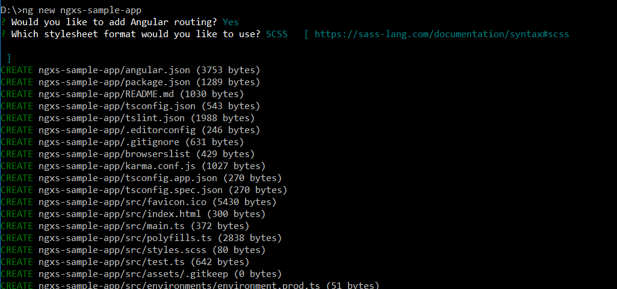

**Step 2:**Install NGXS Store and plugins

To install NGXS Store, simply fire this command  
cd ngxs-crud-app

npm install @ngxs/store --save  
# or if you are using yarn  
yarn add @ngxs/store

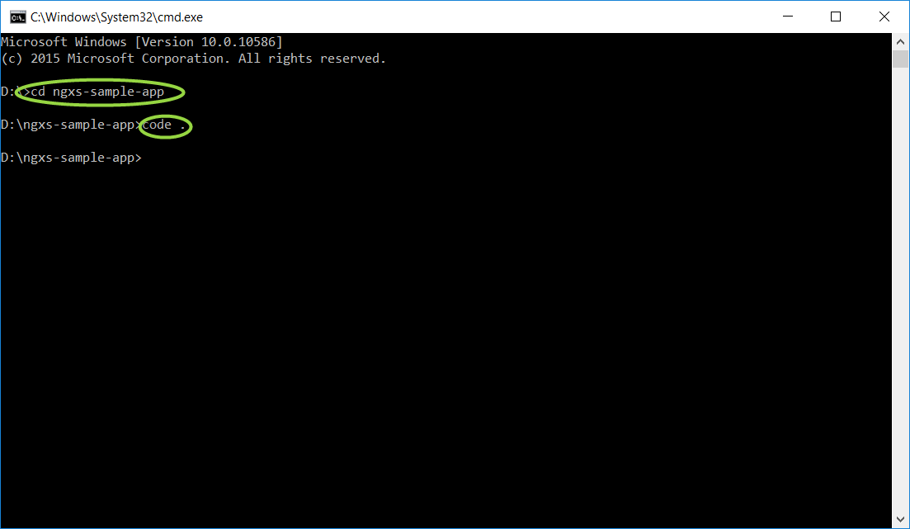

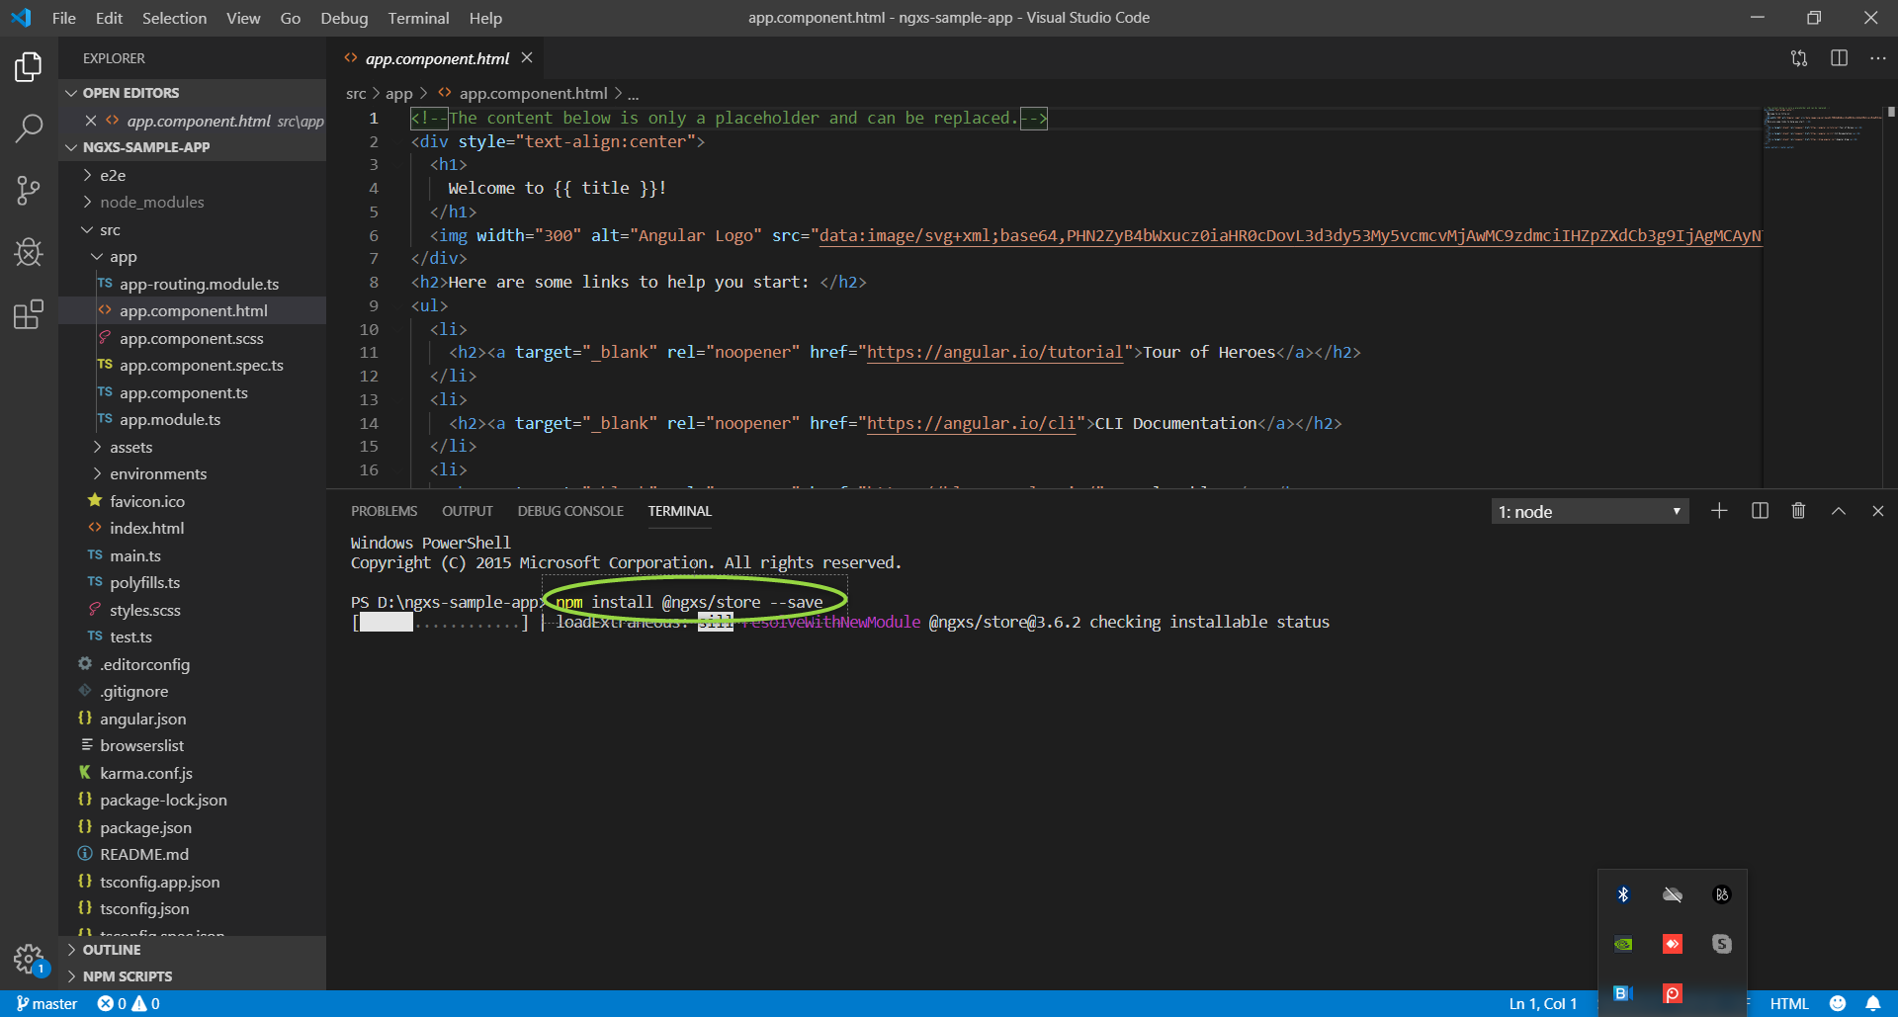

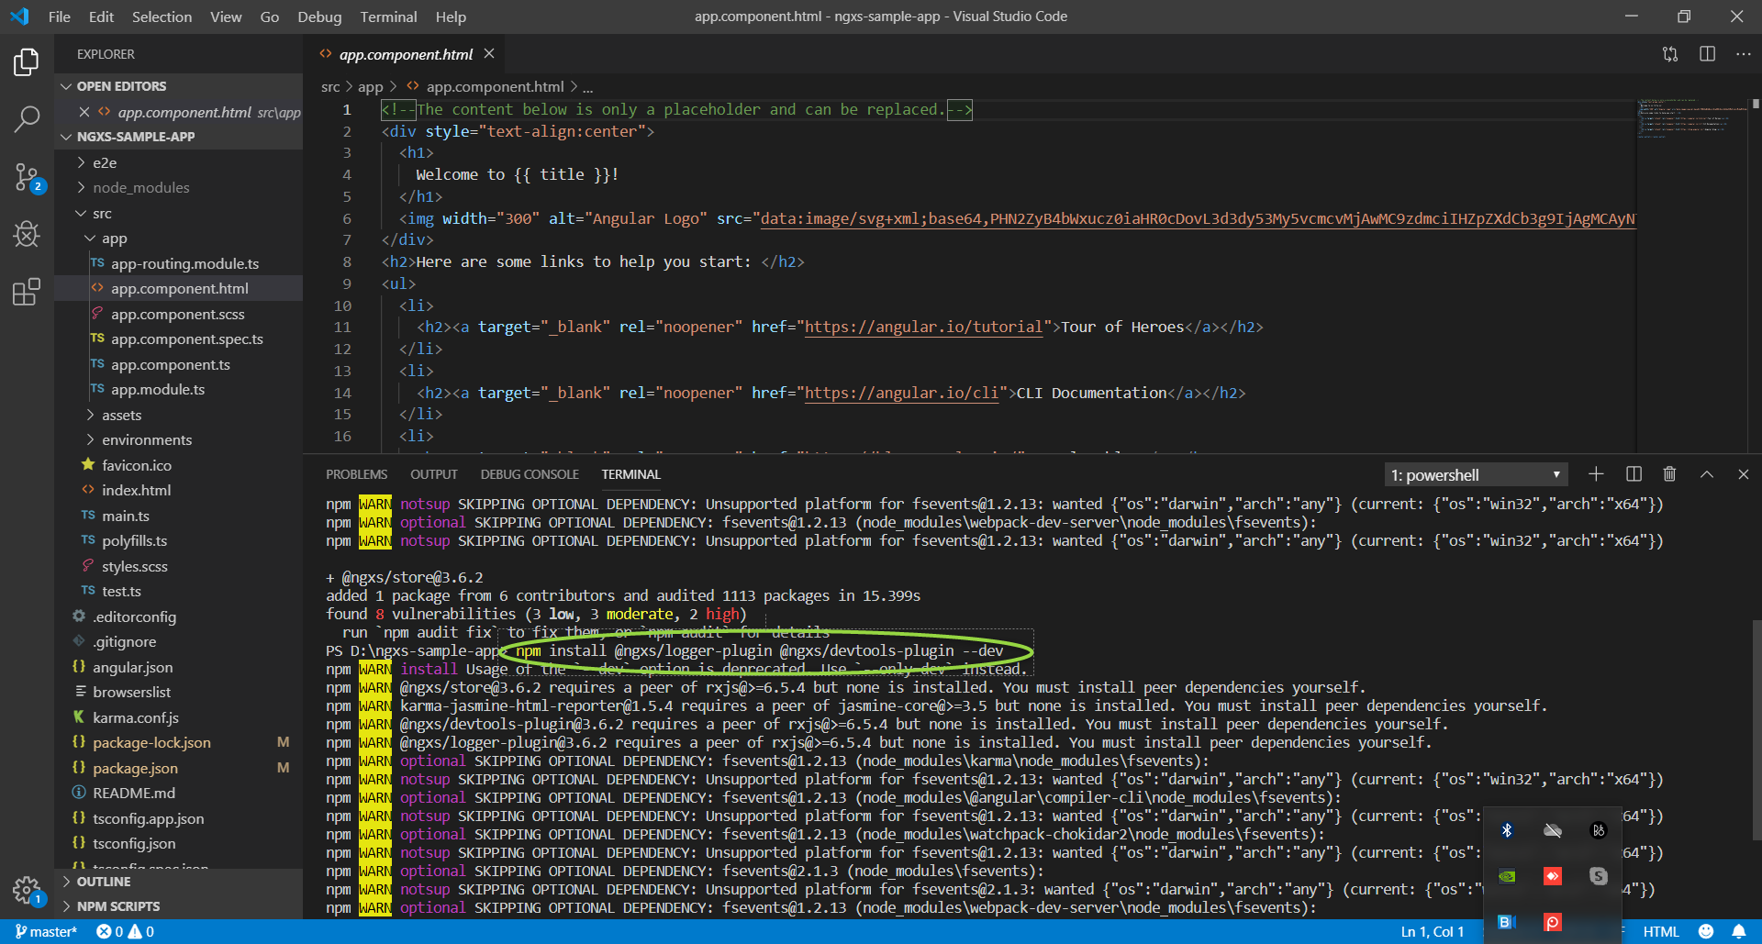

Then import these modules in **app.module.ts**,

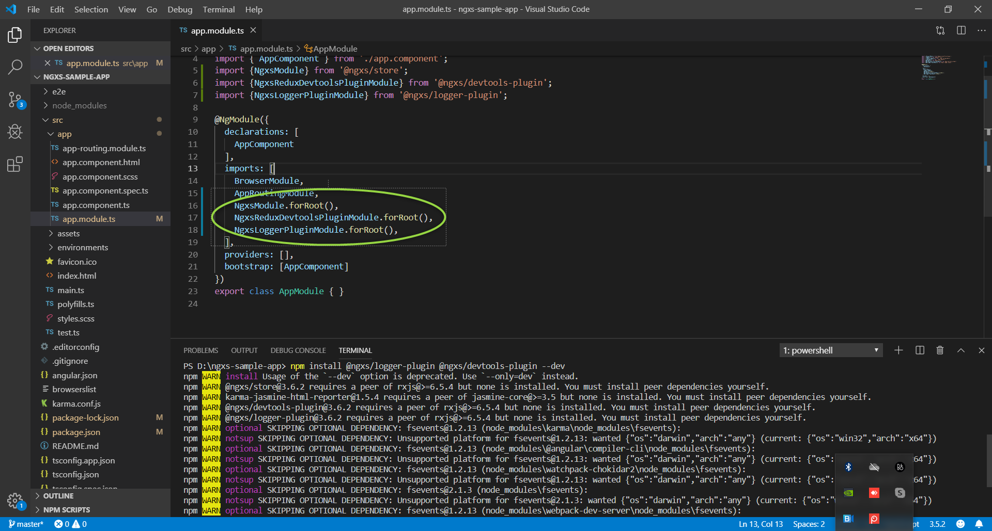

**Step 3:** Create Model

Inside src > app, create a new folder called models, inside that folder create a new file called EmployeeModel.ts

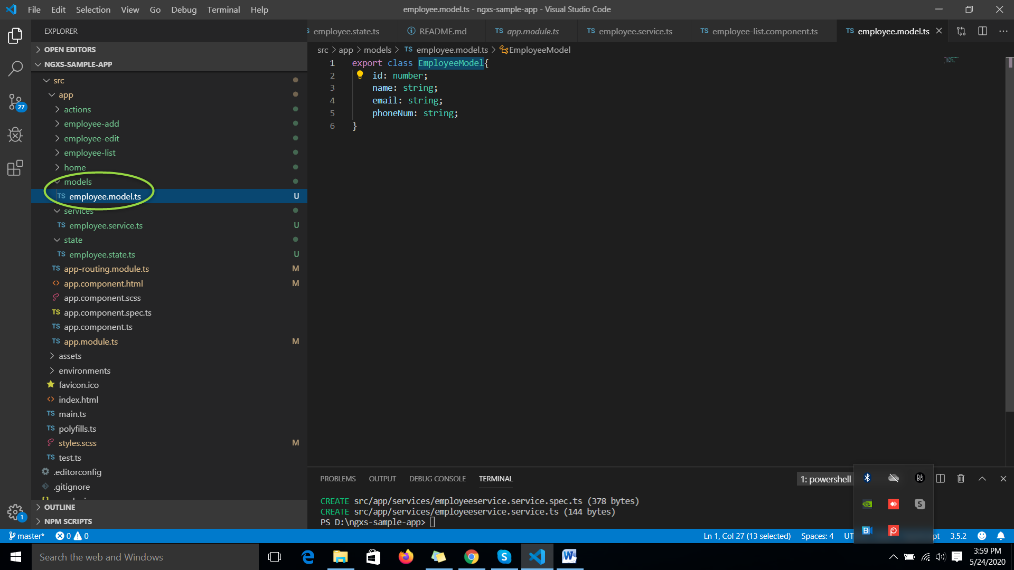

**Step 4:**Define Actions

Again create a new folder, **actions** inside src > app. Inside the actions folder, let’s create a new file **employee.action.ts.**We will be creating four actions for CRUD operation.

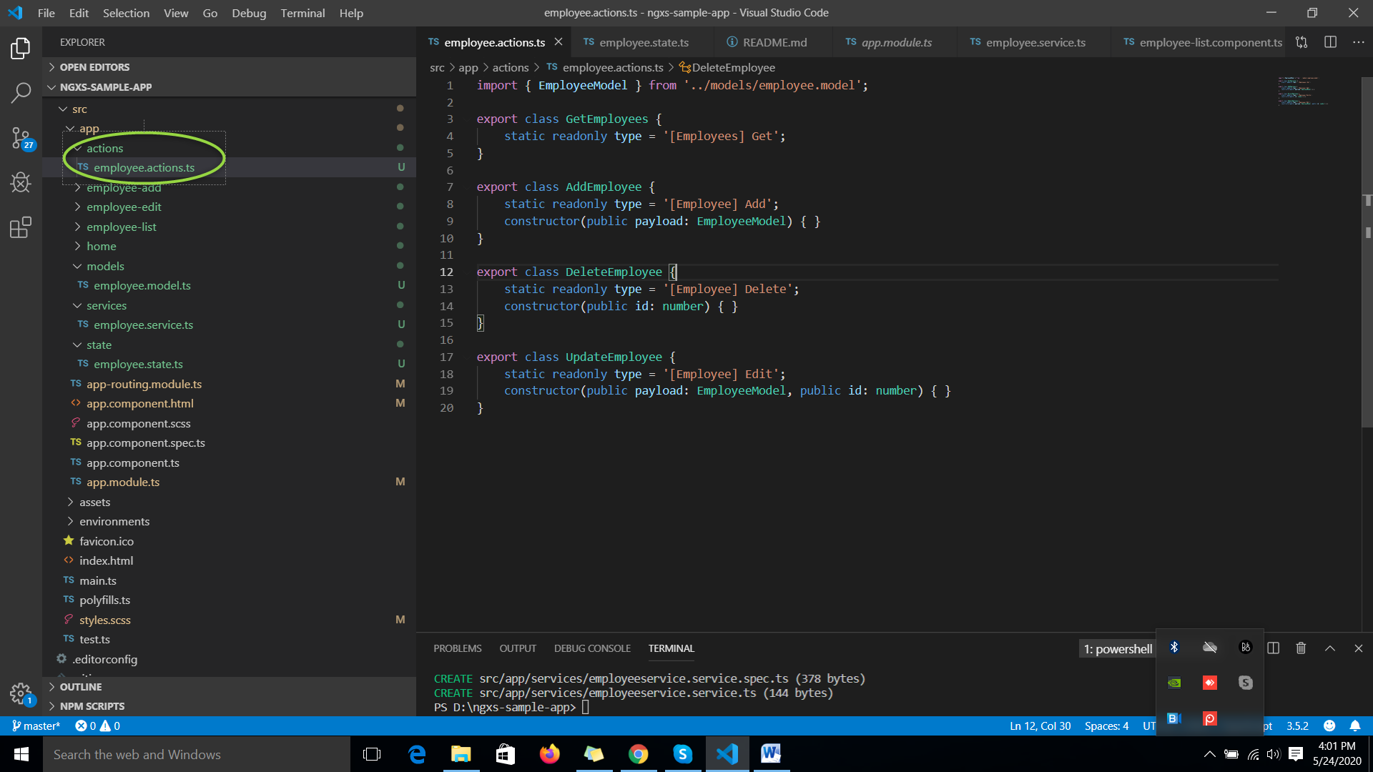

**Step 5:**Create components

Let’s create two components, a todo form which we will use to add/update todos and a todo list component to show the todo list. For quick prototyping, we will be using bootstrap. To install **Bootstrap 4**, use the following command

yarn add bootstrap  
or  
npm install bootstrap –save

Now, add the following line of code in **style.scss** file

@import "~bootstrap/dist/css/bootstrap.min.css"

After this let’s create the components,

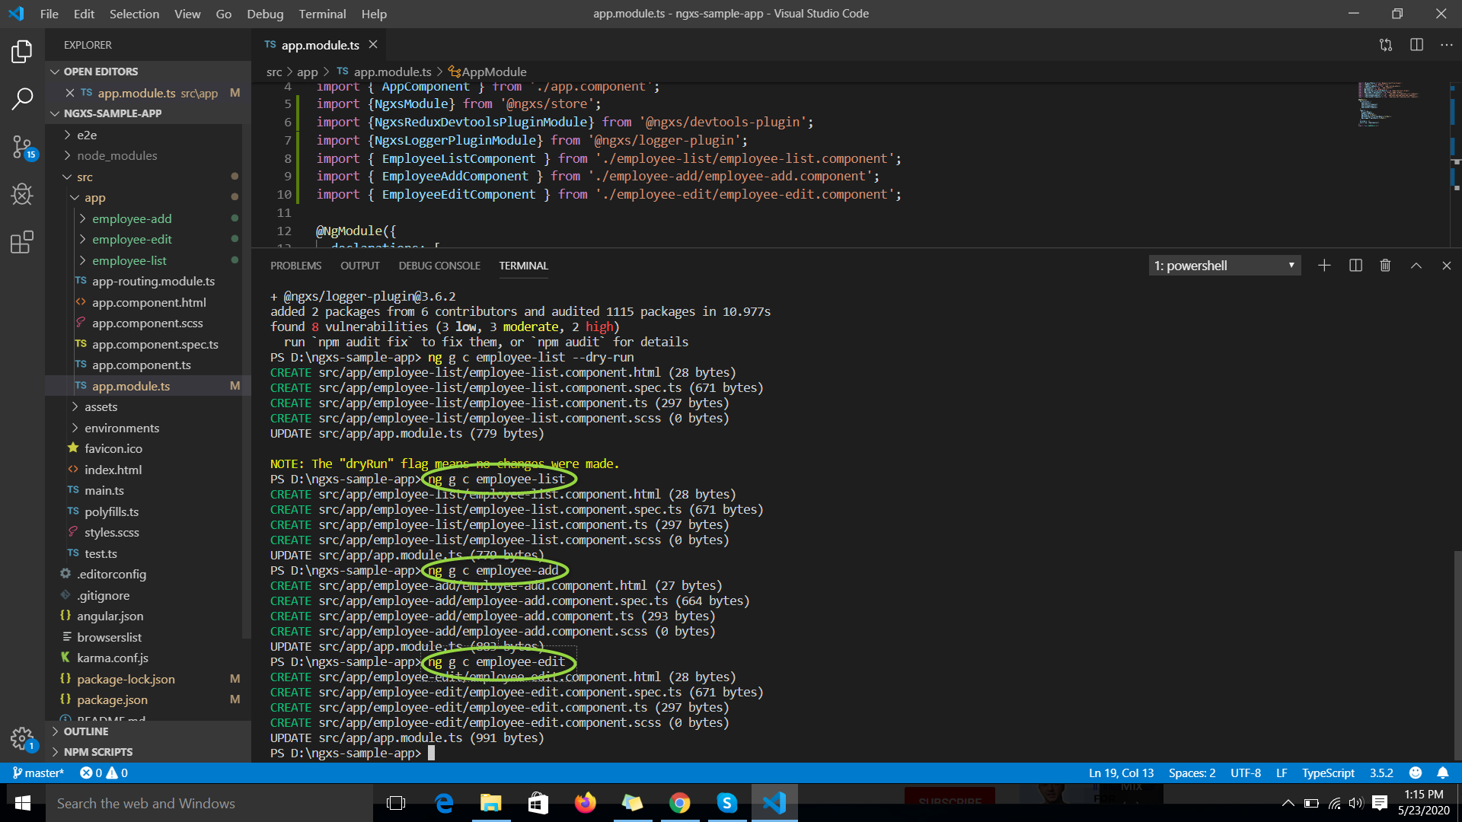

**Step 5:**Add some routes route module

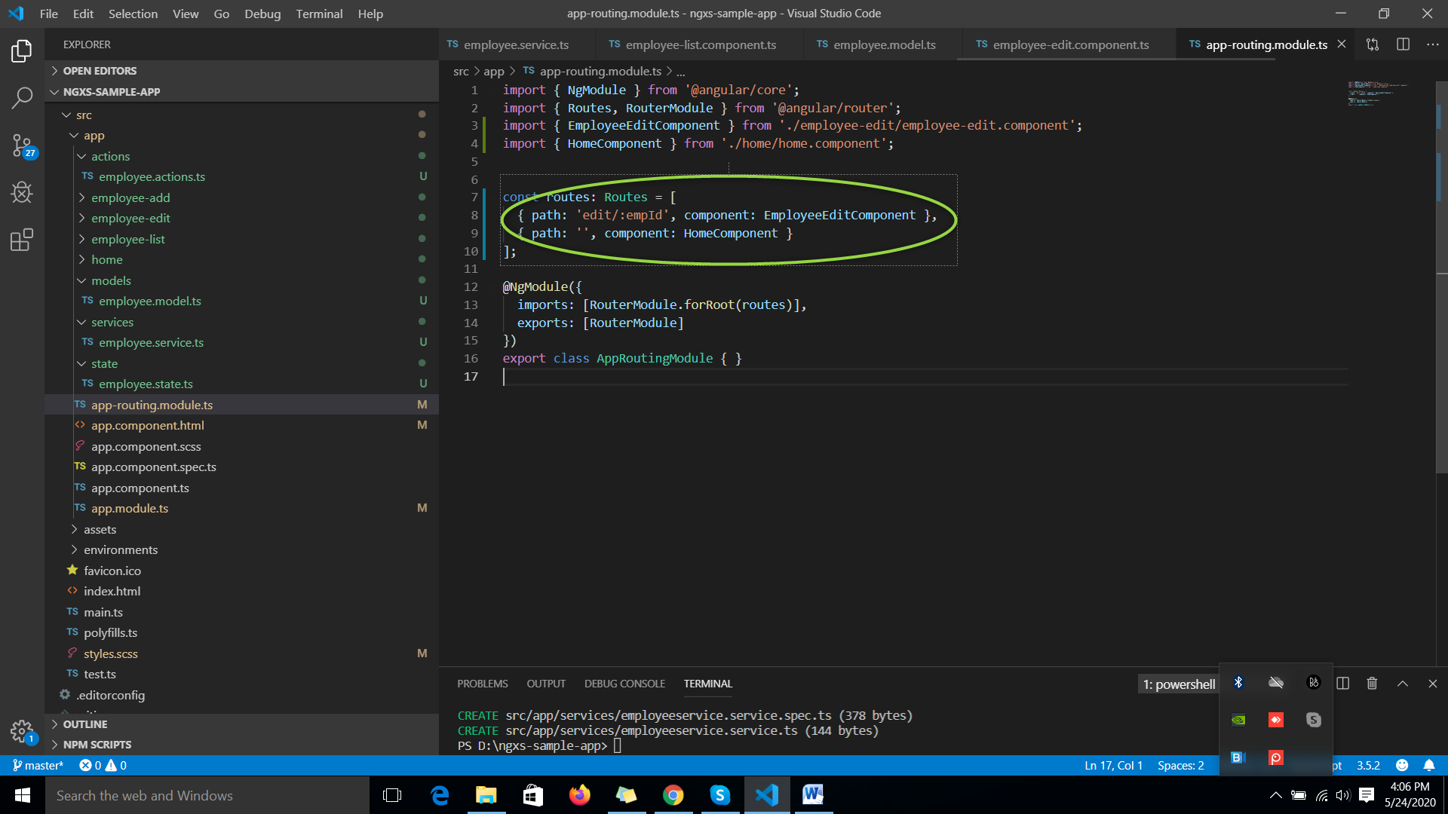

Now open the **app.component.html**file and add this code,

Add router outlet element.

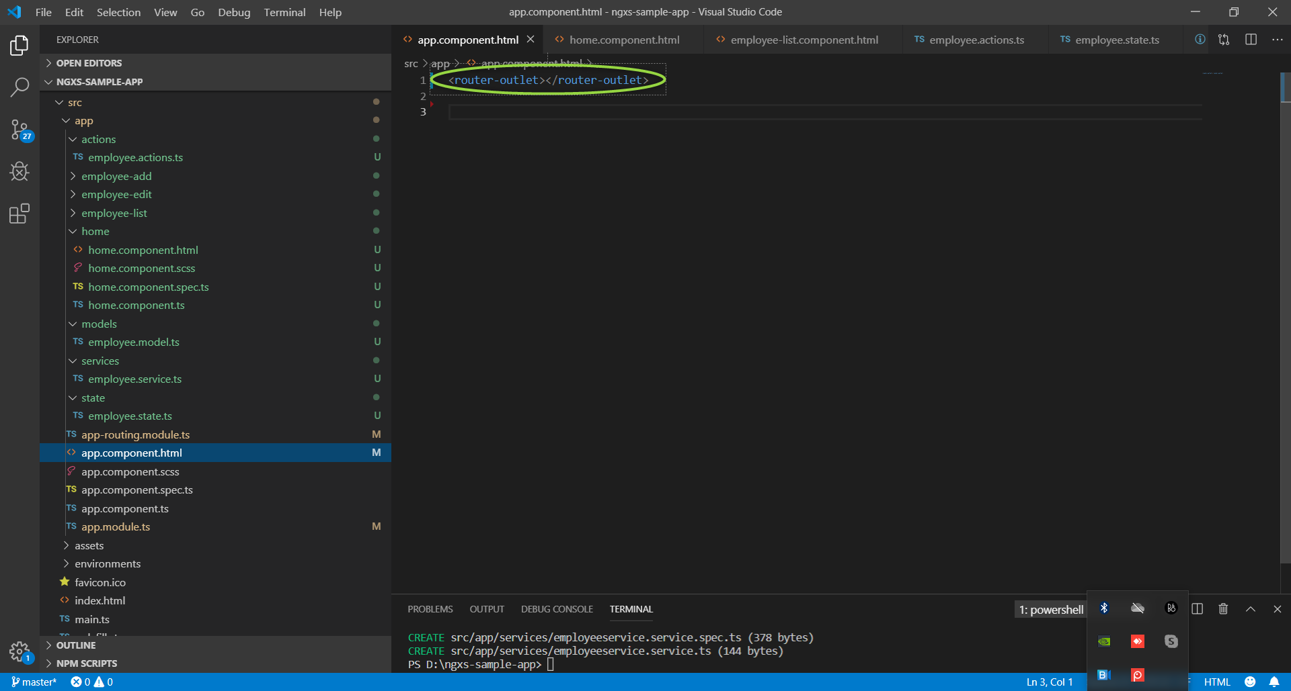

Now open the **home.component.html**file and add this code,

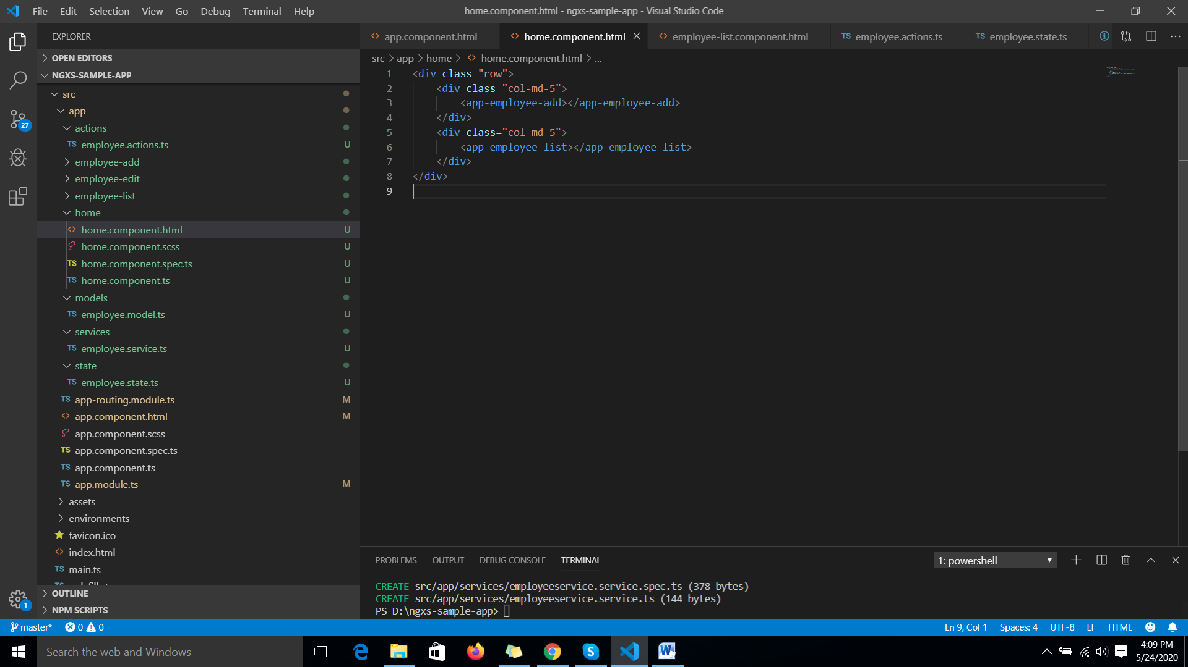

**Step 6:** Create a service

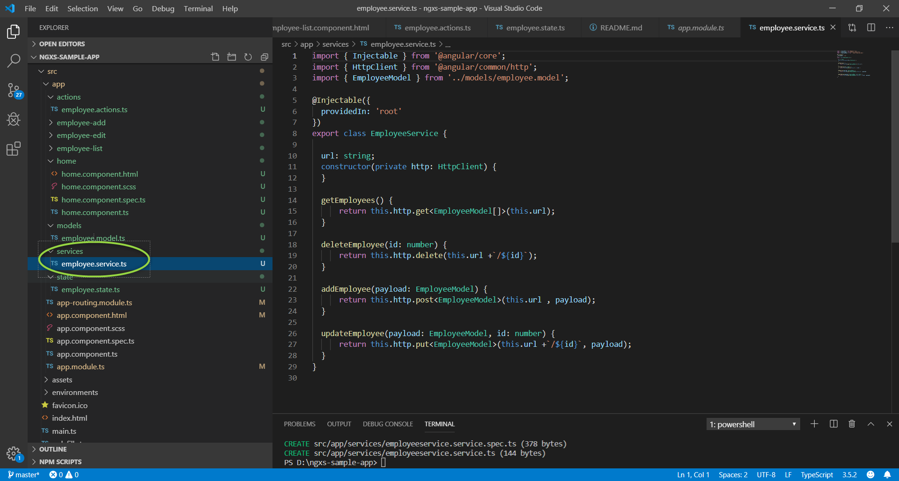

Since in this tutorial, we are making REST API calls to perform CRUD operations we need to import the Angular **HttpClientModule** in our app.module.ts, let’s also add **FormsModule** for the add employee component.

**Step 7:**Define a state

In NGXS, states are classes along with decorators to describe metadata and action mappings. So let’s create a **states** folder inside src >> app and inside that folder, create one file called **employee.state.ts**

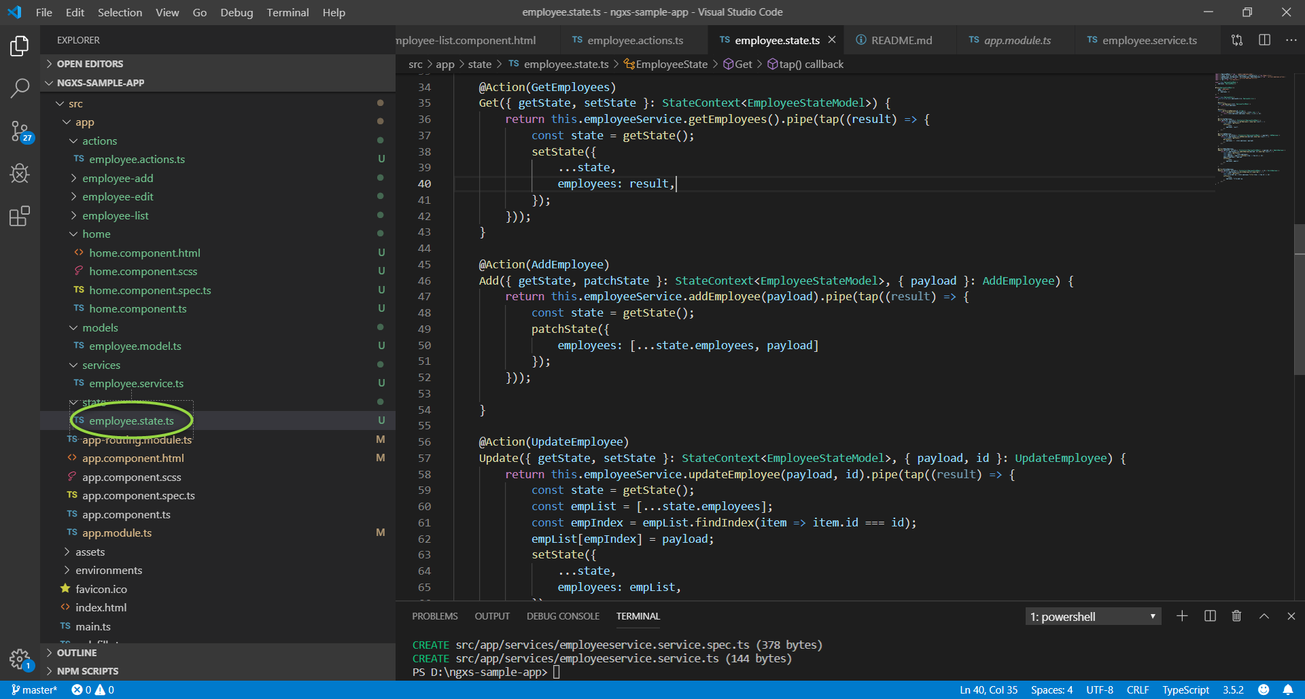

**Step 8:**Display the employee list

Add the following code in **employee-list.component.ts**

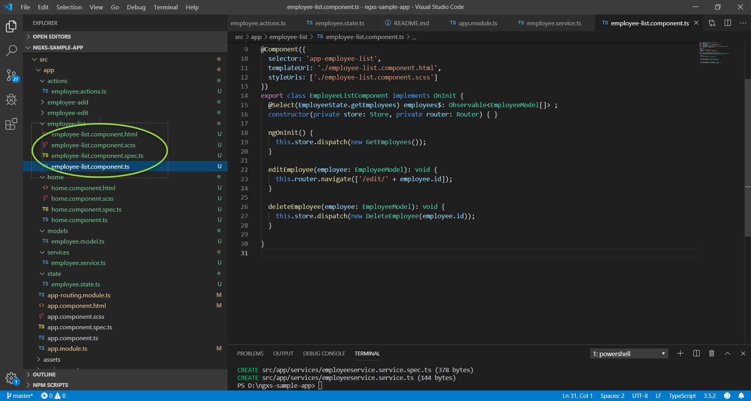

Also, add the following code in the **employee-list.component.html**

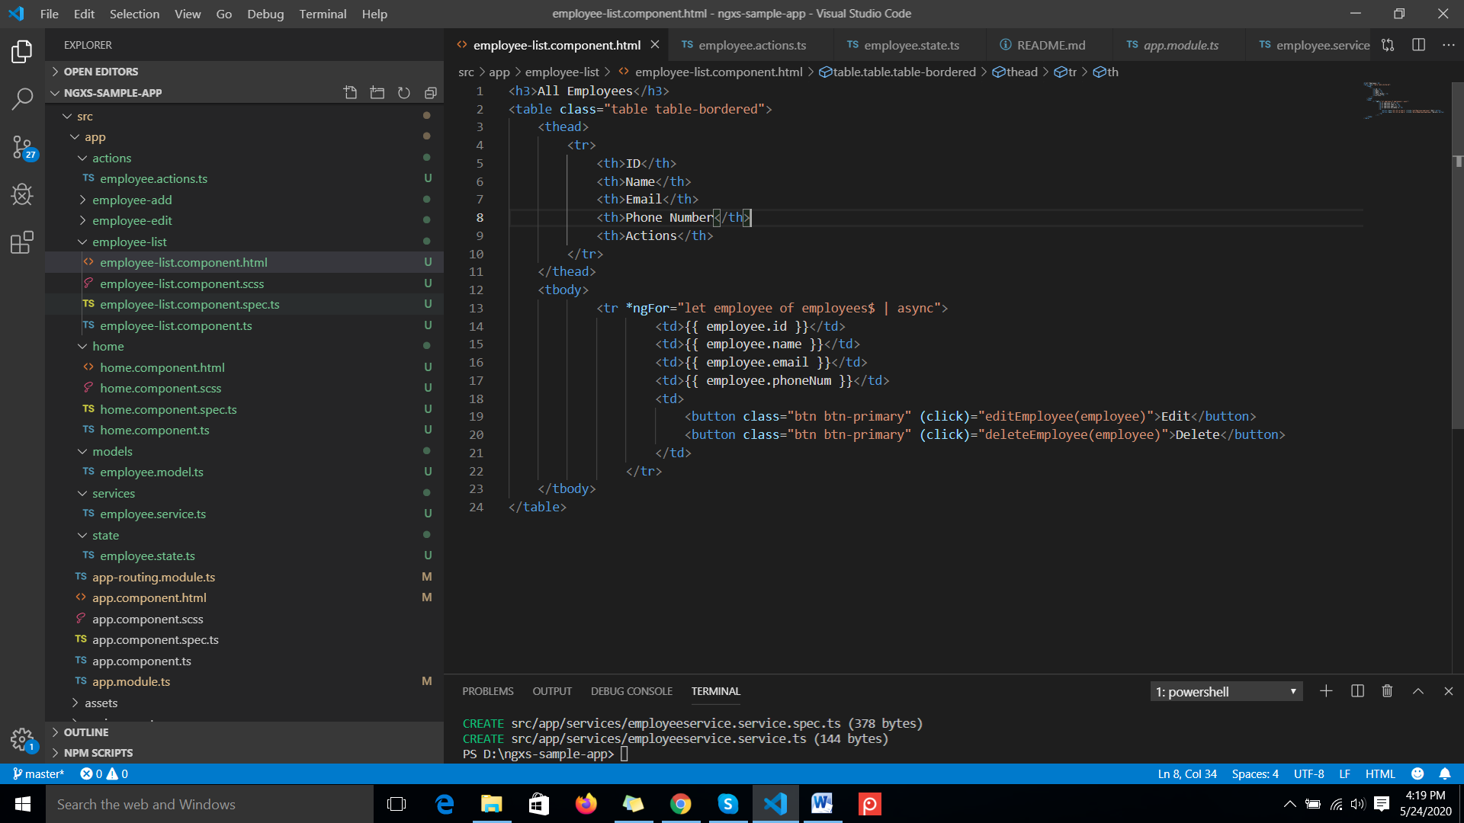

**Step 8:**Display the employee add

Add the following code in **employee-add.component.ts**

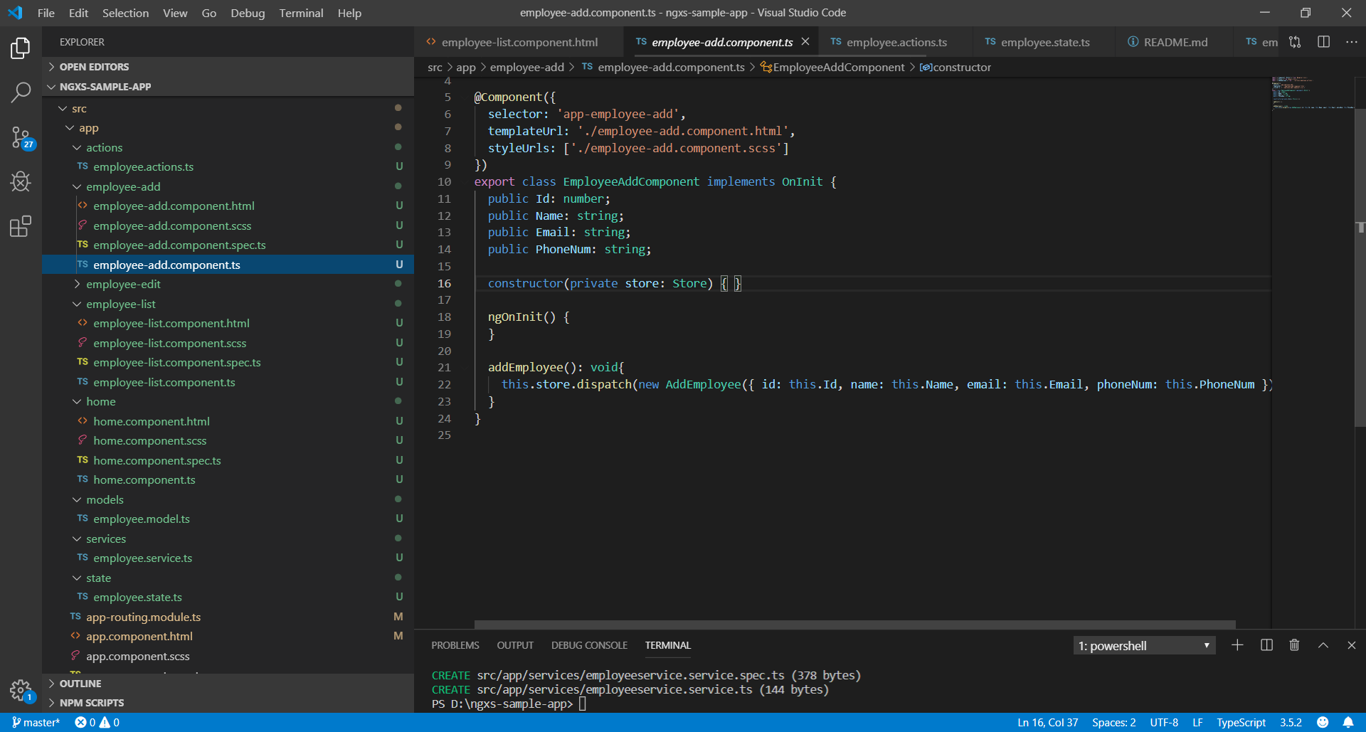

Also, add the following code in the **employee-add.component.html**

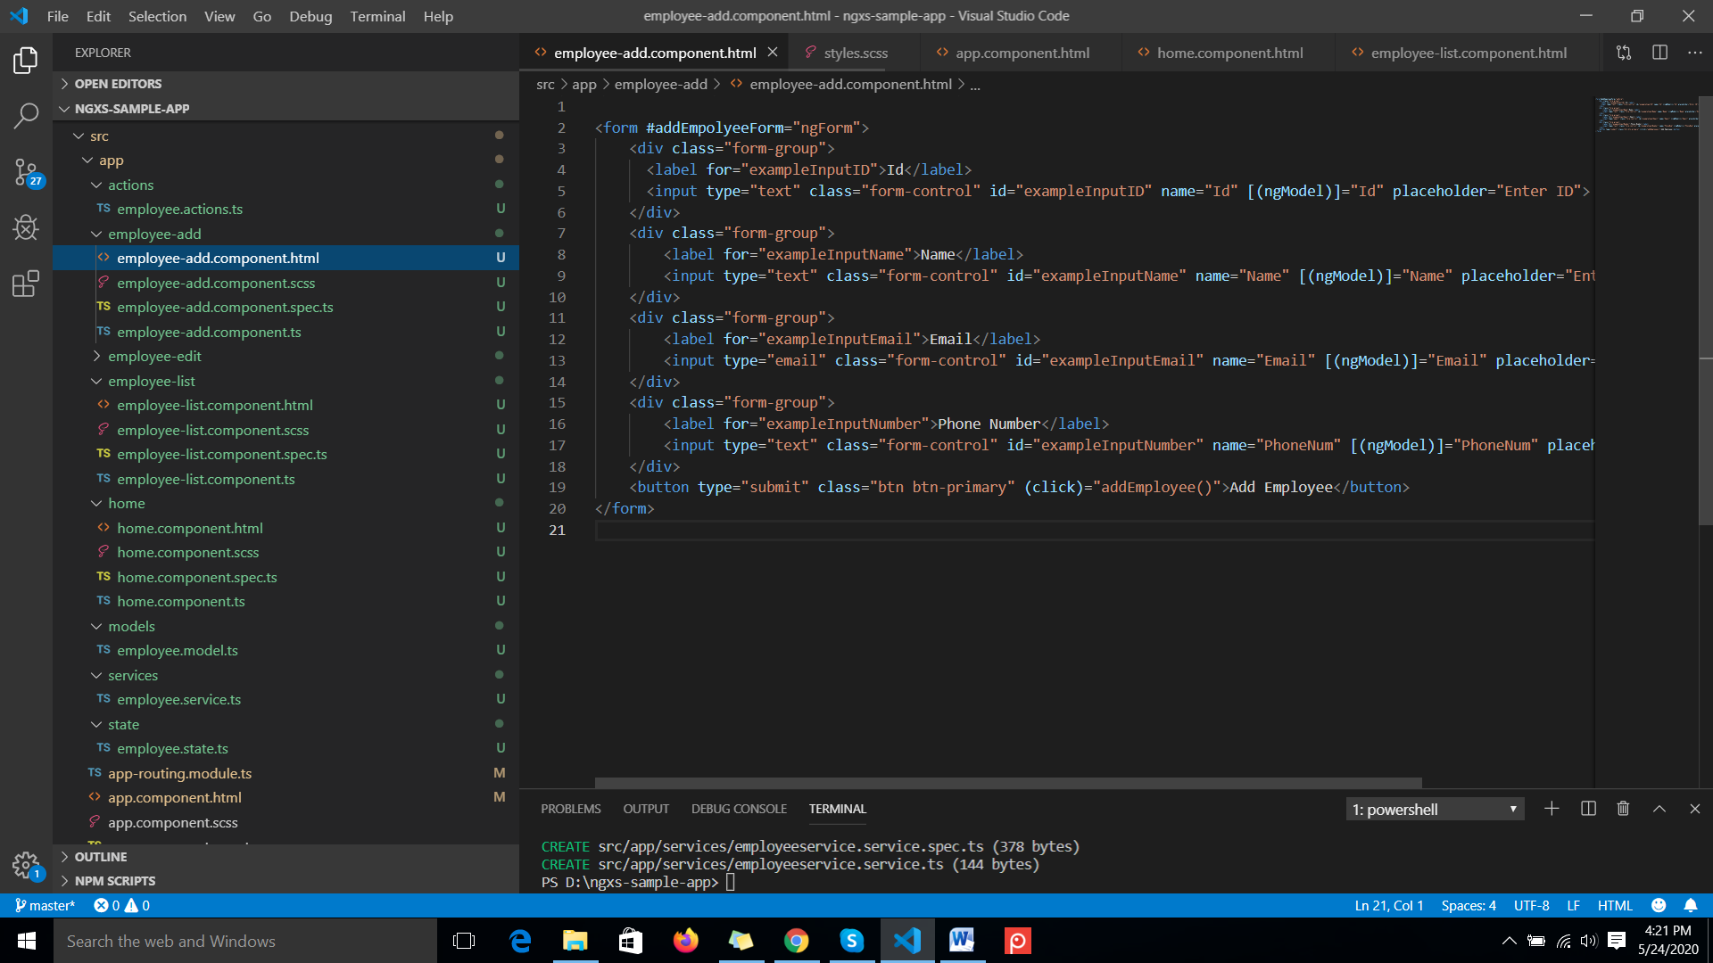

**Run : ng serve –o**

**And click on Add Employee it initiates an action**

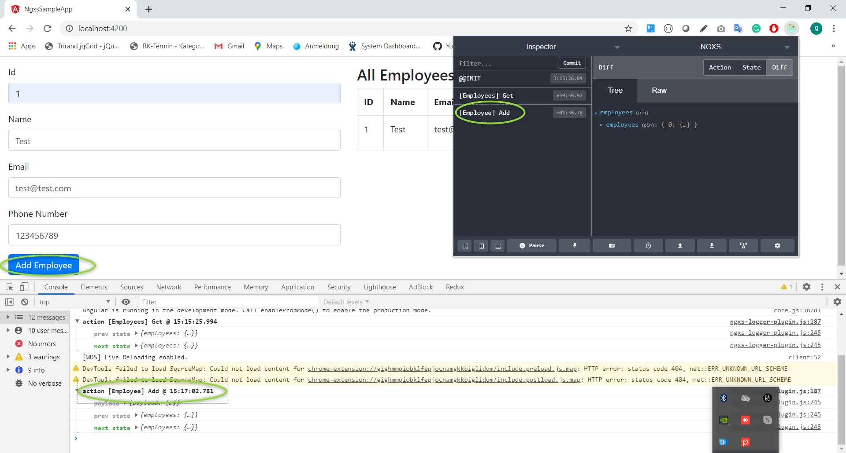

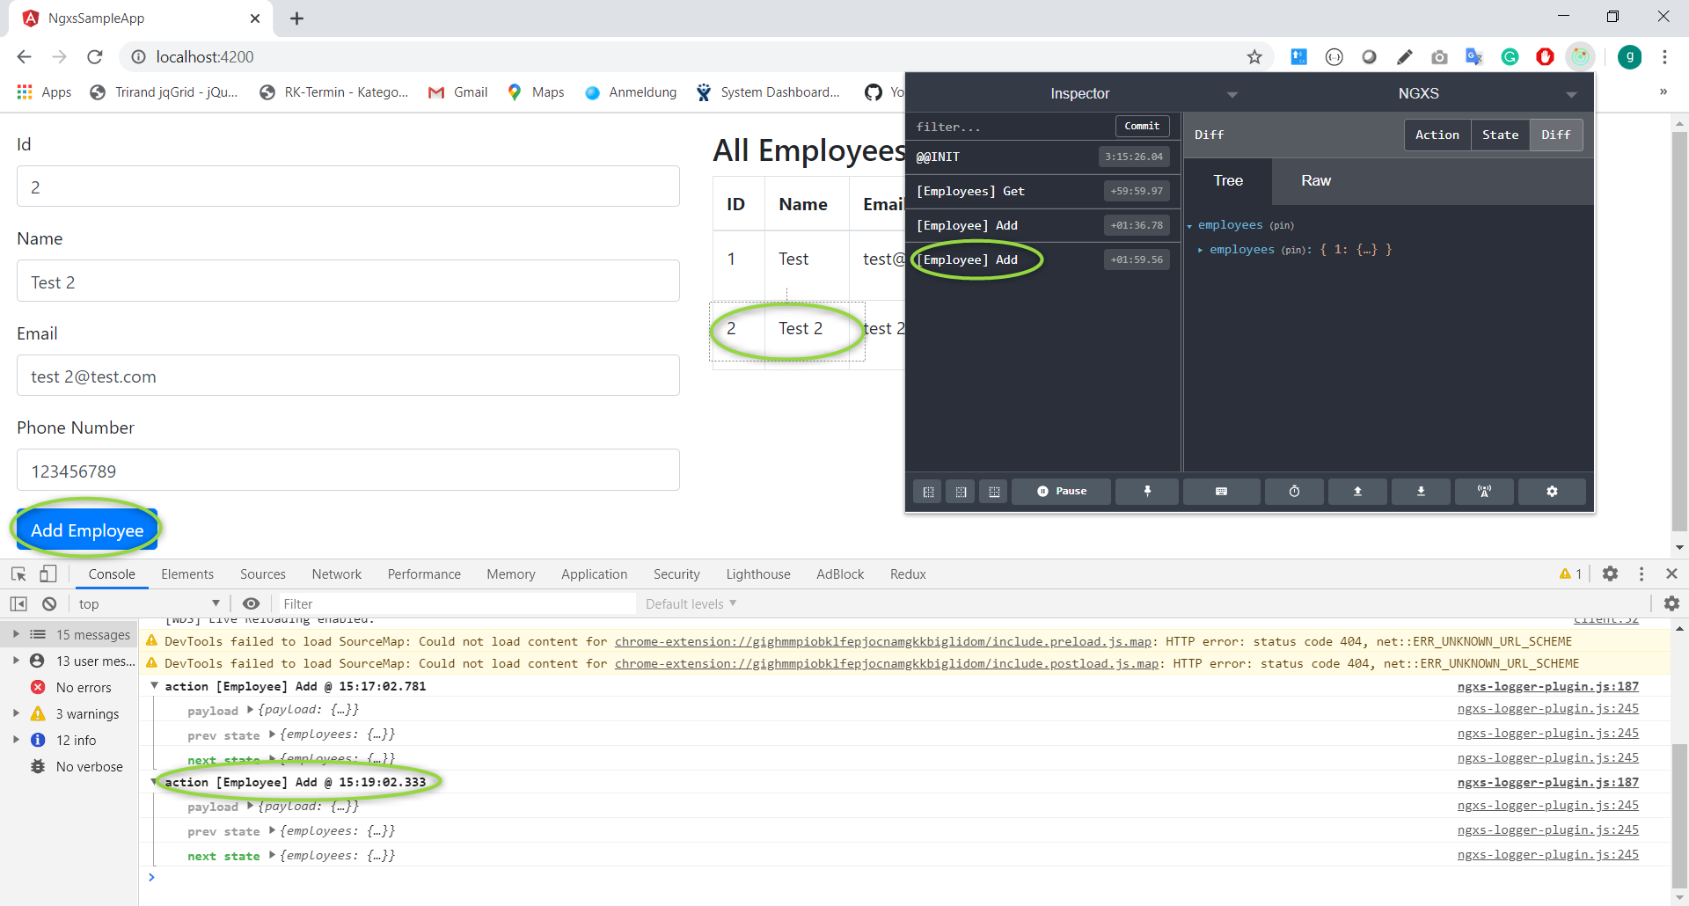

**We can see the employee data in store from chart as shown for this we need to have Redux dev tools chrome extension.**

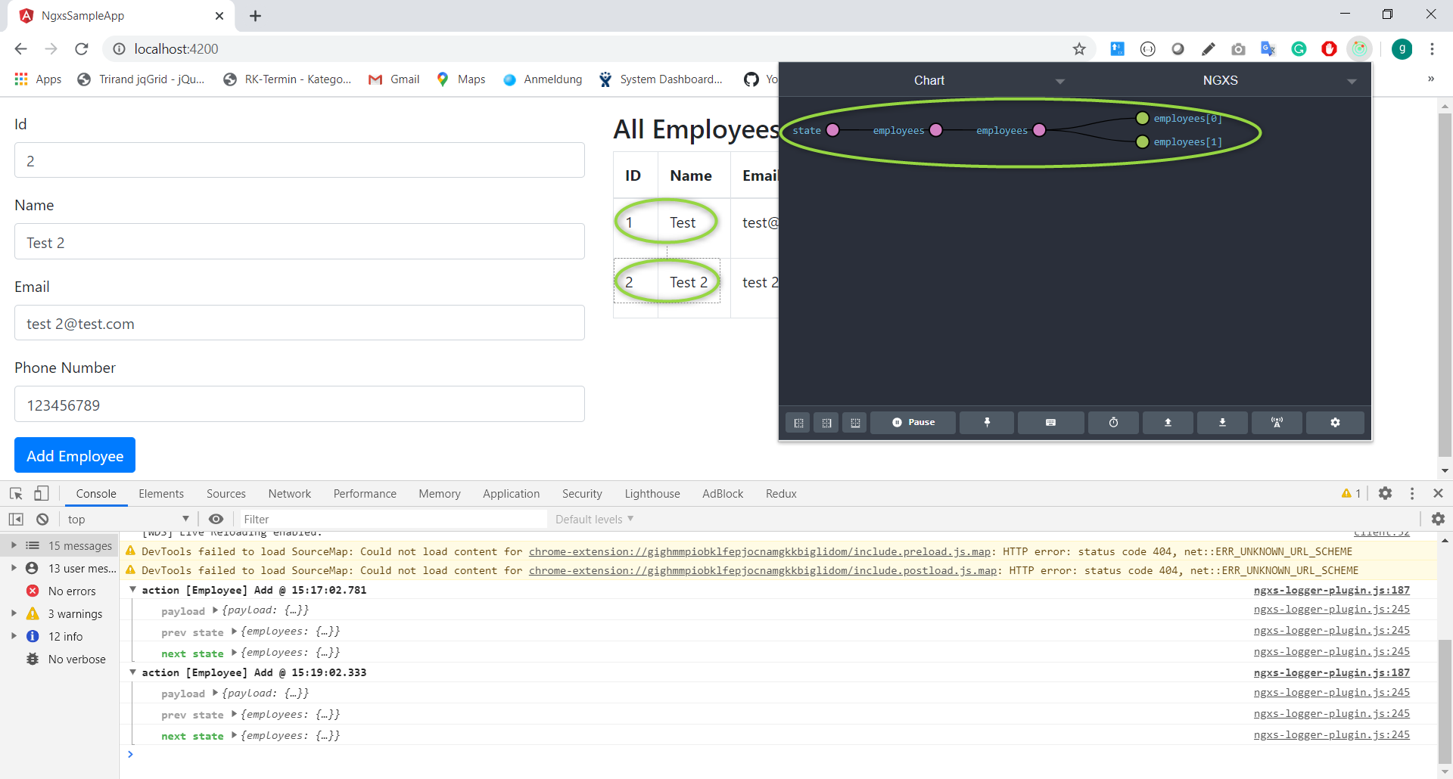

**Click on Edit button**

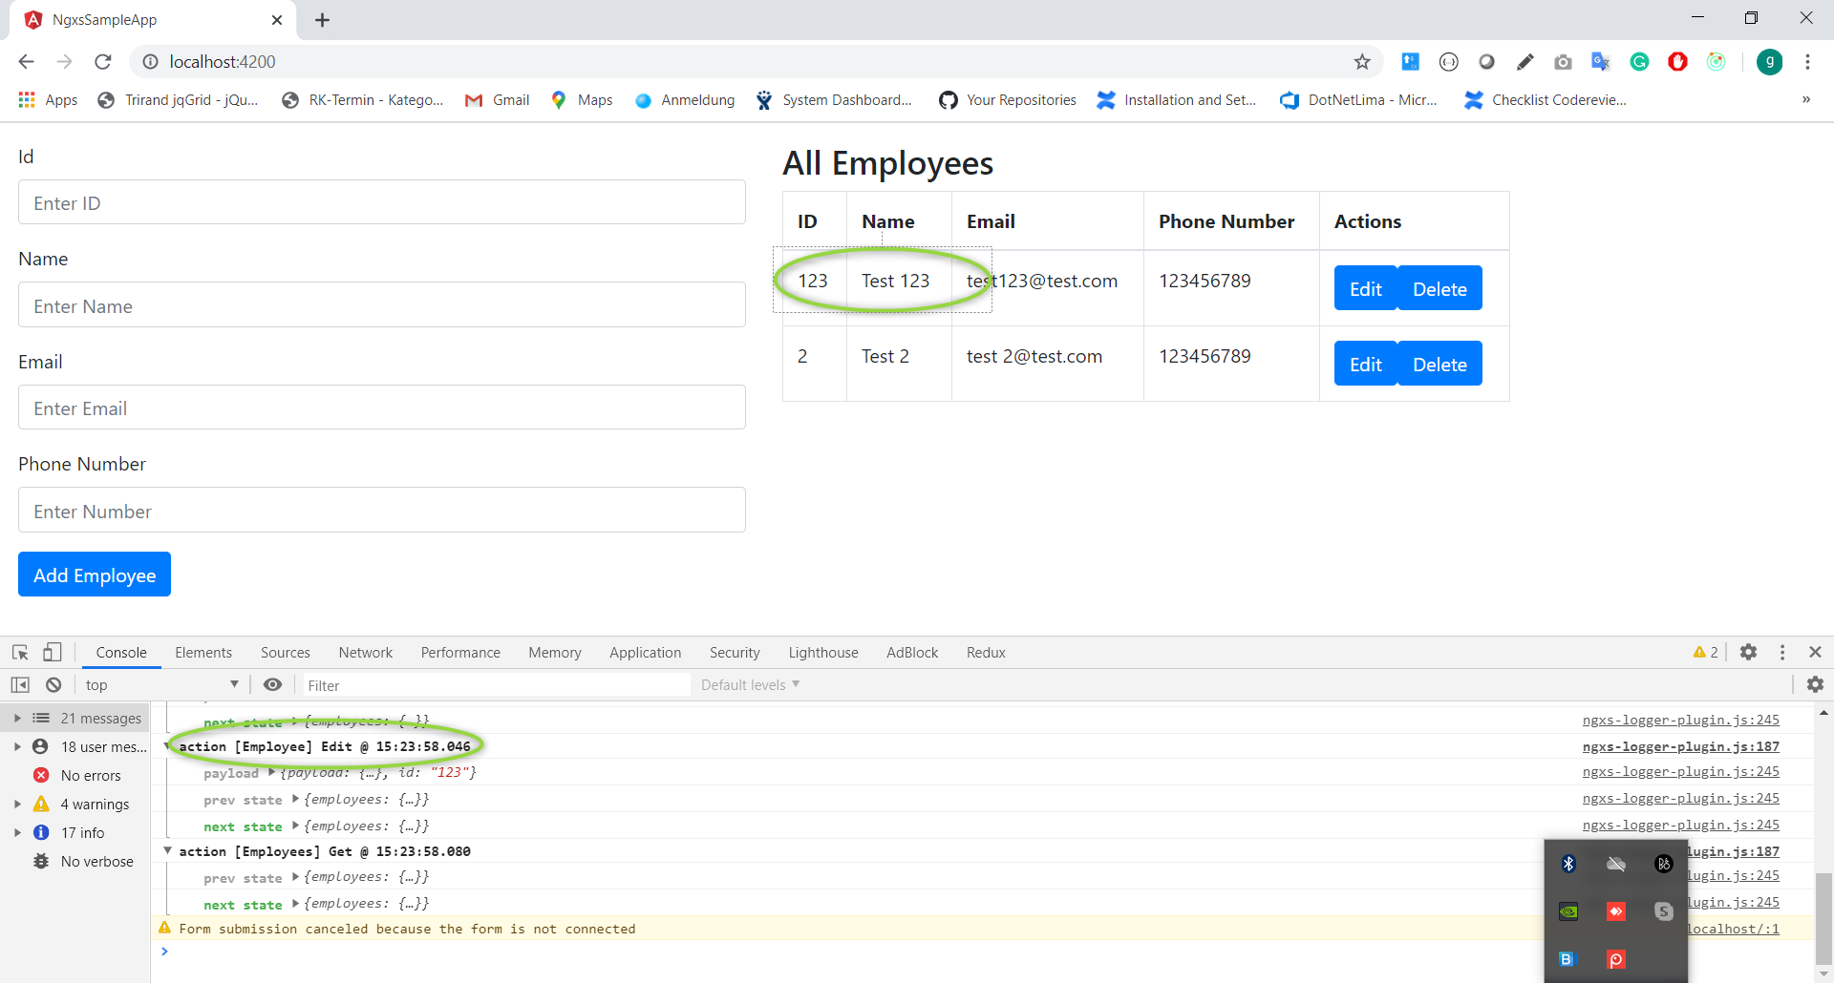

**Click on Delete button**

