**PROGRESSIVE WEB APP**

**\*\*\*\*\*\*\*\*\*\*\*\*\*\*\*\*\*\*\*\*\*\*\*\*\*\*\*\*\*\*\*\*\*\*\*\*\***

**PWA is just an app like other apps built with Web technologies.**

**PWA is available in offline also, and much faster while in online.**

**PWA can be installed on different platforms.**

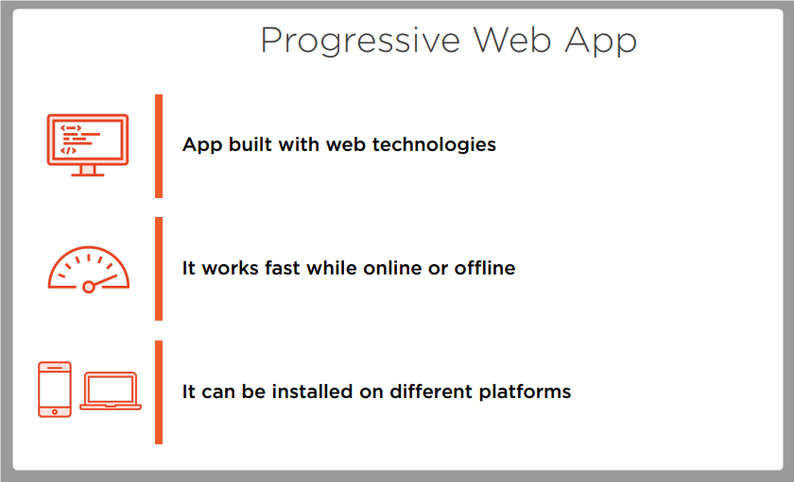

**App development approaches**

