|  |  |
| --- | --- |
| **EXP : 7**  **Date: 13/4/25** | **COOKIE TO STORE USER INFORMATION** |

**AIM:**

Write a Servlet program to  
store a user's preferences (like theme or language) using cookies. Retrieve and  
display these preferences on subsequent visits.

**CODE:**

**Cookie.html:**

<!DOCTYPE html>

<html>

<head>

<meta charset=*"ISO-8859-1"*>

<title>Insert title here</title>

</head>

<body>

<form method=*"post"* action=*/Gopica_krish/Cookie*>

<p>

<label>Theme: </label>

<input type=*"text"* name=*"theme"*>

</p>

<p>

<label>Language: </label>

<select name=*"language"*>

<option value=*"English"*>English</option>

<option value=*"Tamil"*>Tamil</option>

<option value=*"Hindi"*>Hindi</option>

</select>

</p>

<button type=*"submit"*>Save Preferences</button>

</form>

</body>

</html>

**Cookie.java:**

package com.session.servlet;

import java.io.IOException;

import javax.servlet.ServletException;

import javax.servlet.annotation.WebServlet;

import javax.servlet.http.HttpServlet;

import javax.servlet.http.HttpServletRequest;

import javax.servlet.http.HttpServletResponse;

/**

* Servlet implementation class Cookie

*/

@WebServlet("/Cookie")

public class Cookie extends HttpServlet {

private static final long serialVersionUID = 1L;

/**

* @see HttpServlet#HttpServlet()

*/

public Cookie() {

super();

// TODO Auto-generated constructor stub

}

/**

* @see HttpServlet#doGet(HttpServletRequest request, HttpServletResponse response)

*/

protected void doGet(HttpServletRequest request, HttpServletResponse response) throws ServletException, IOException {

String theme =request.getParameter("theme");

String Language =request.getParameter("language");

}

/**

* @see HttpServlet#doPost(HttpServletRequest request, HttpServletResponse response)

*/

protected void doPost(HttpServletRequest request, HttpServletResponse response) throws ServletException, IOException {

// TODO Auto-generated method stub

doGet(request, response);

}

}**GetCookie.jsp:**

<%@ page language=*"java"* contentType=*"text/html; charset=ISO-8859-1"*

pageEncoding=*"ISO-8859-1"*%>

<!DOCTYPE html>

<html>

<head>

<meta charset=*"ISO-8859-1"*>

<title>COOKIE</title>

</head>

<body>

<%

Cookie[] cookies = request.getCookies();

String cookieName = "Theme";

**if** (cookies != **null**) {

**for** (Cookie cookie : cookies) {

**if** (cookieName.equals(cookie.getName())) {

System.out.println(cookie.getName());

out.println(cookie.getValue());

}

}

}

%>

</body>

</html>

**OUTPUT:**

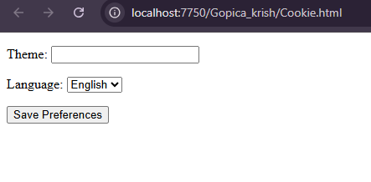



**RESULT:**

Handling user information using cookie is done using servlet successfully.