- Create user with name Techie and provide sudo access to user.
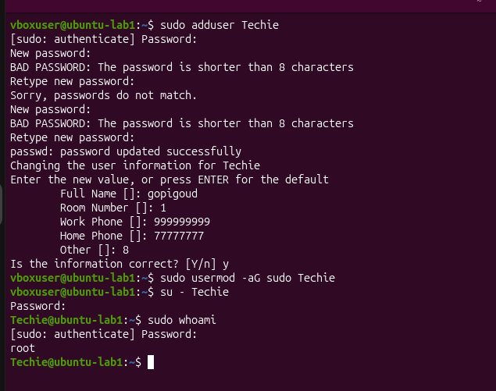
- Navigate to the home directory.
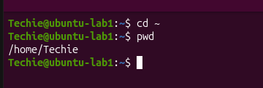
- Create a new directory.
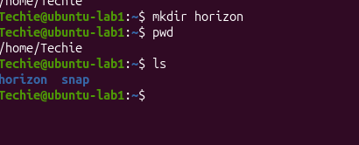

- List the contents of a directory.
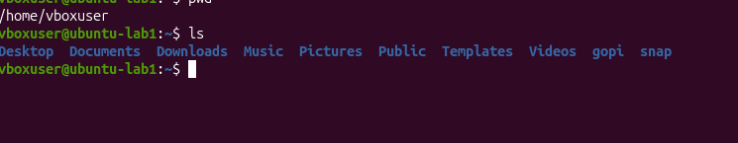
- Change the current directory.
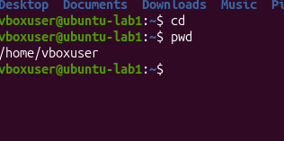
- Create a new empty file.
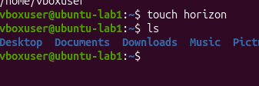
- View the contents of a file.
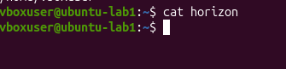
- Copy a file to another location.


- Move a file to another location.
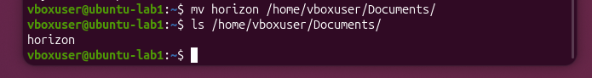
- Rename a file.
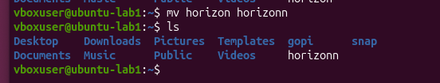

- Delete a file.
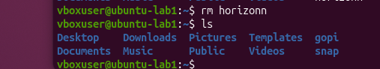

- Grant or revoke permissions on a file or directory.
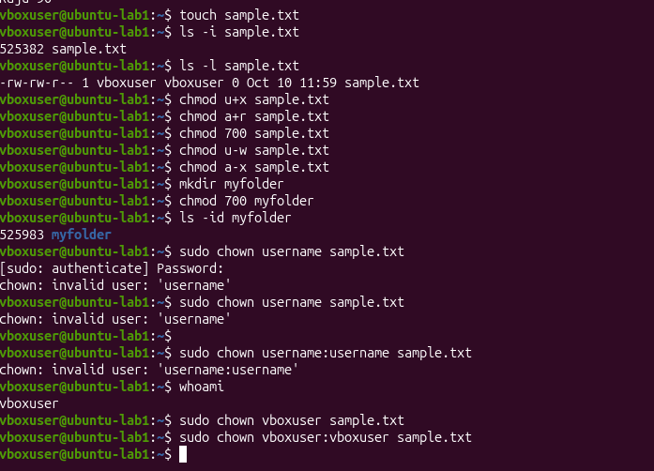

- View the current date and time.
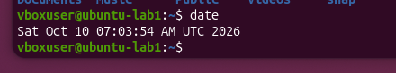

- Check the system uptime.


- View the running processes.
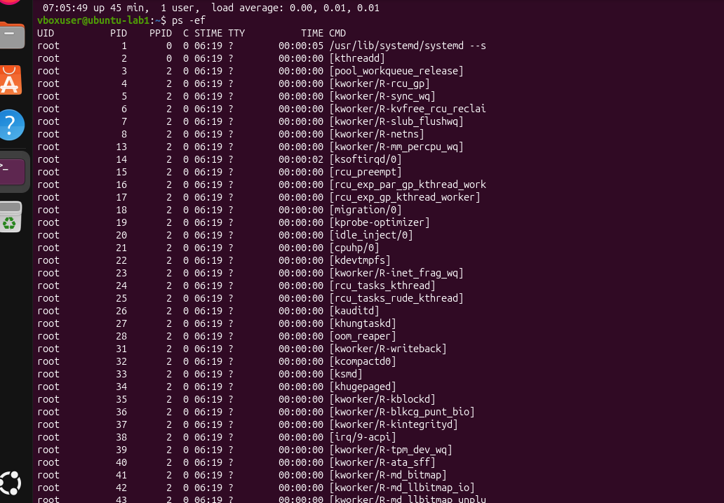
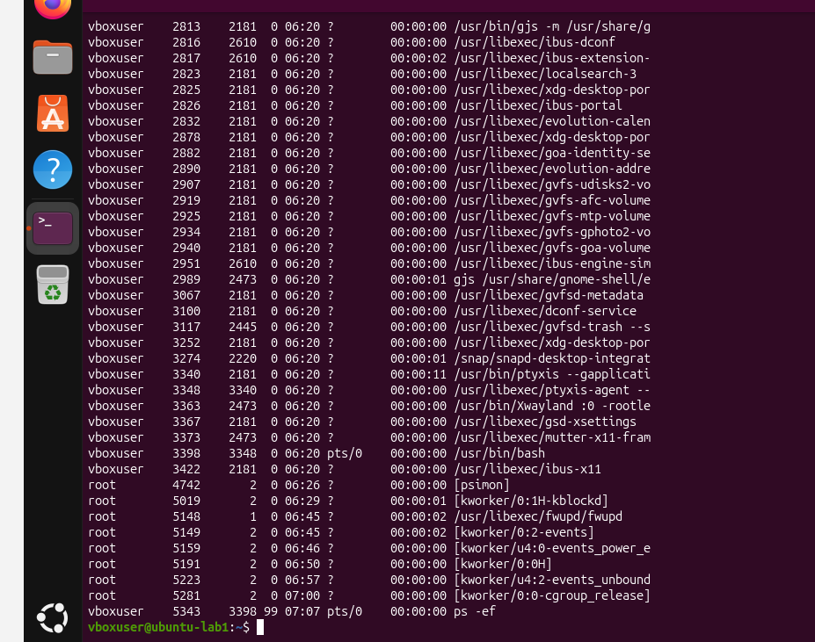
- Kill a running process.


- Install a package using the package manager (e.g., apt or yum).
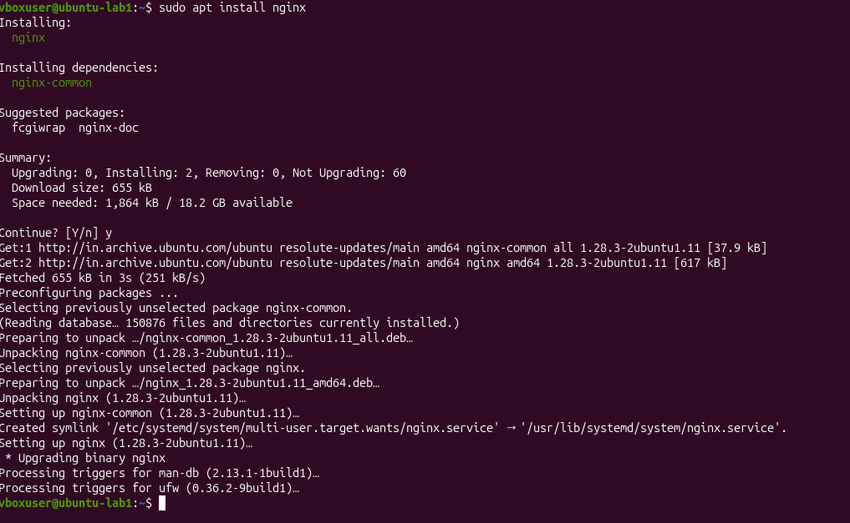

- Update the system packages.
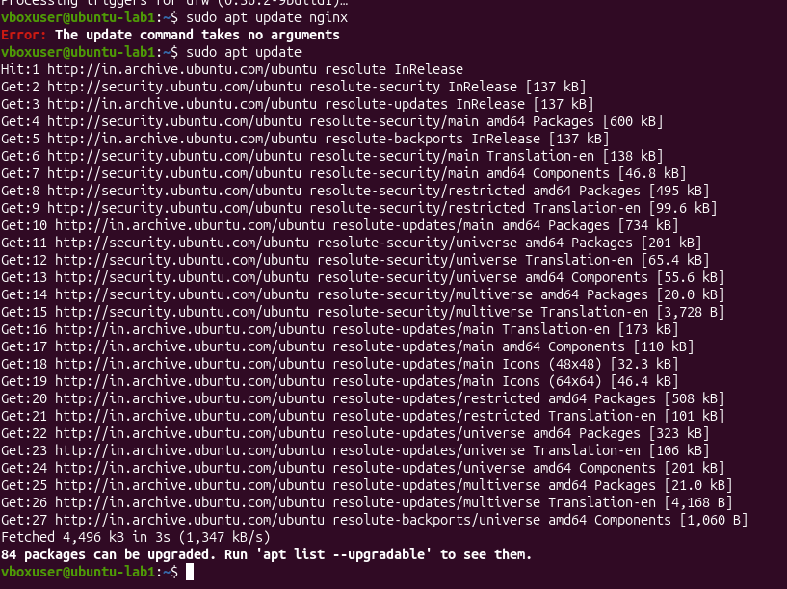

- Create a symbolic link.
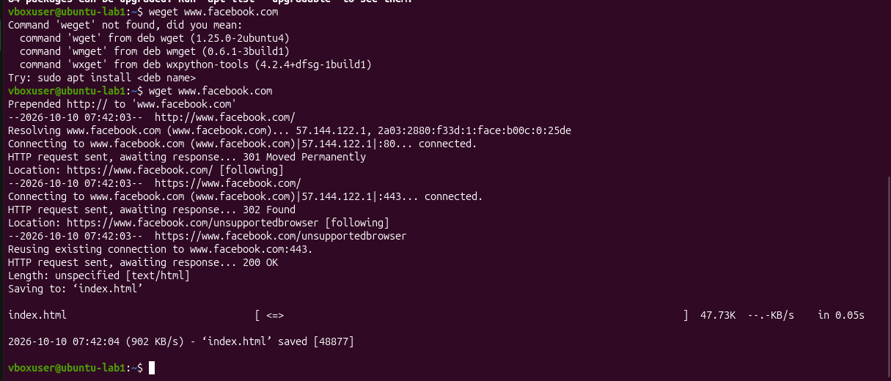

- Search for files using the find command.
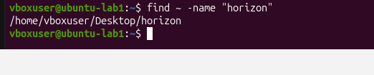

- Compress and decompress files using tar.
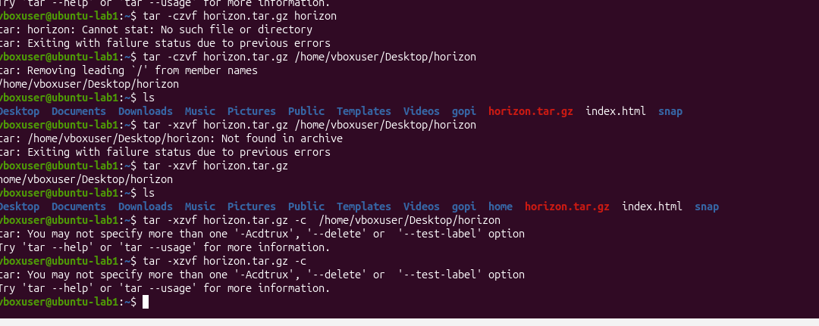

- Monitor system resources with top or htop.
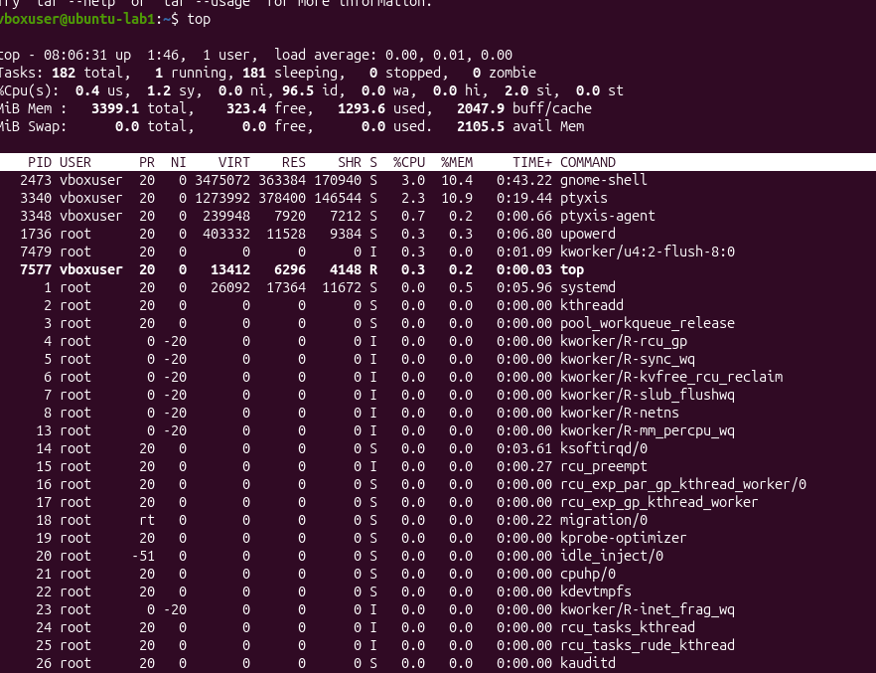
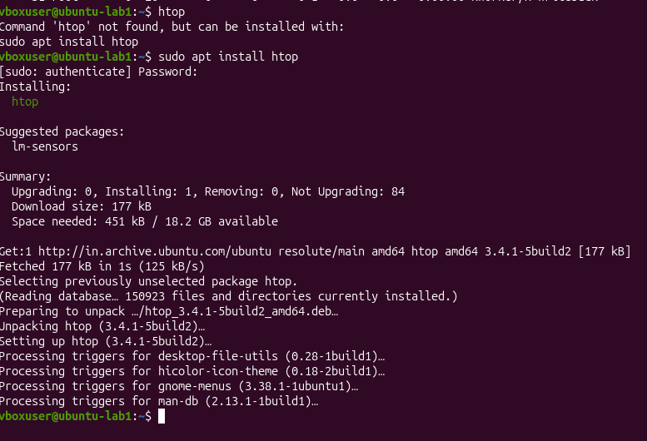

- Create and manage user groups.
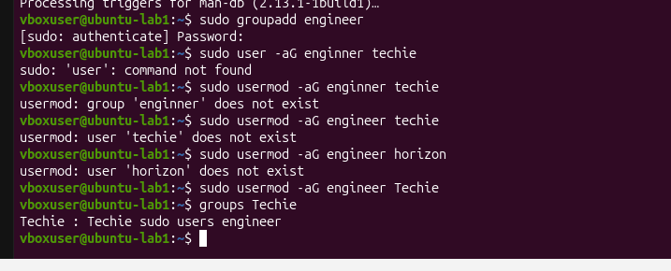
- Set up SSH password less authentication.
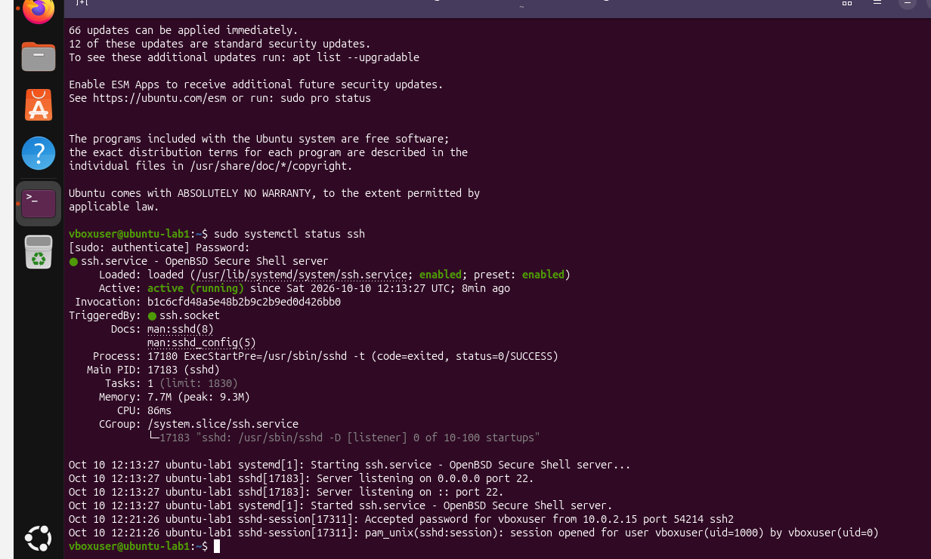
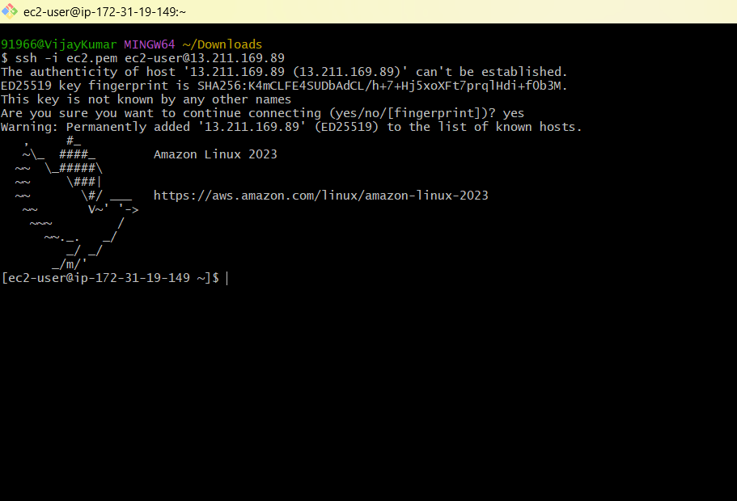
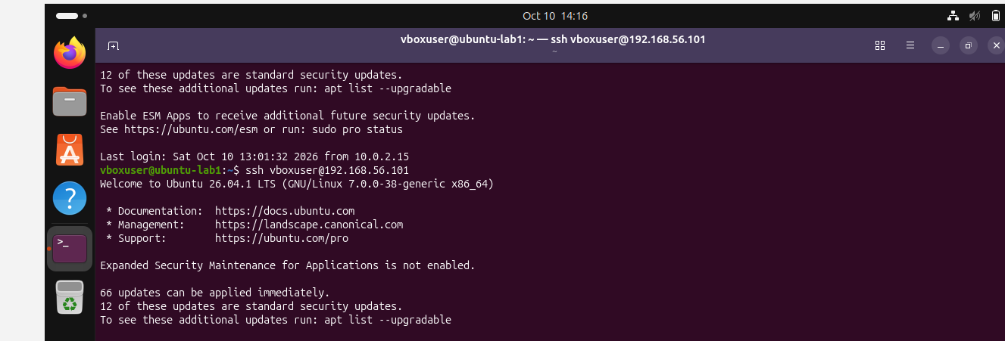

- Monitor log files using tail or grep.
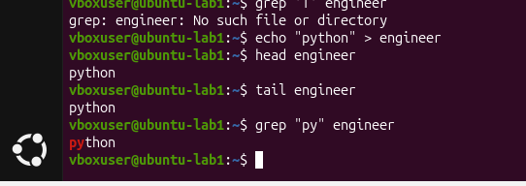

- Set up a web server (e.g., Apache or Nginx).
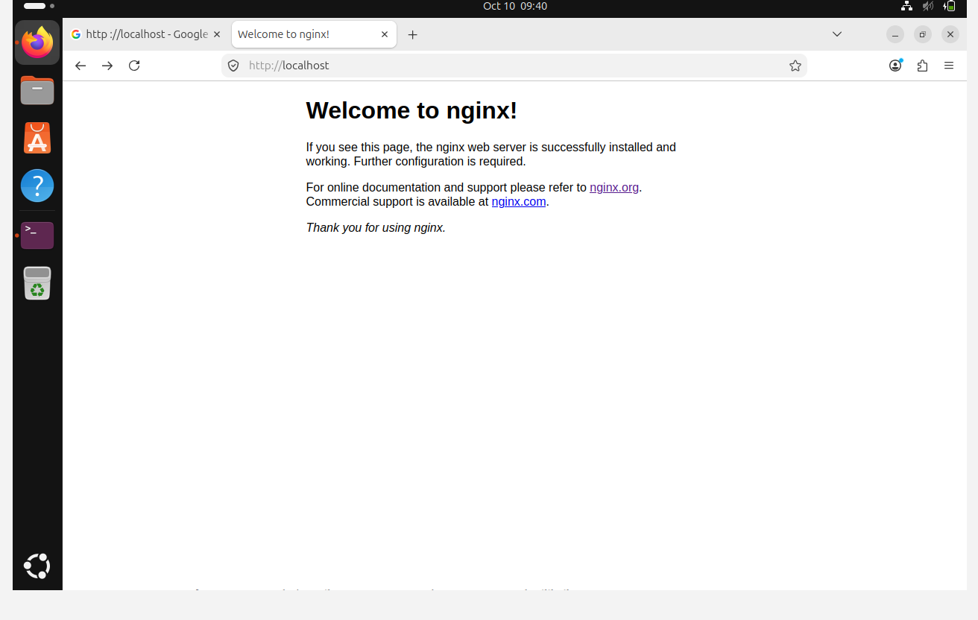

- Configure and secure a MySQL Database.
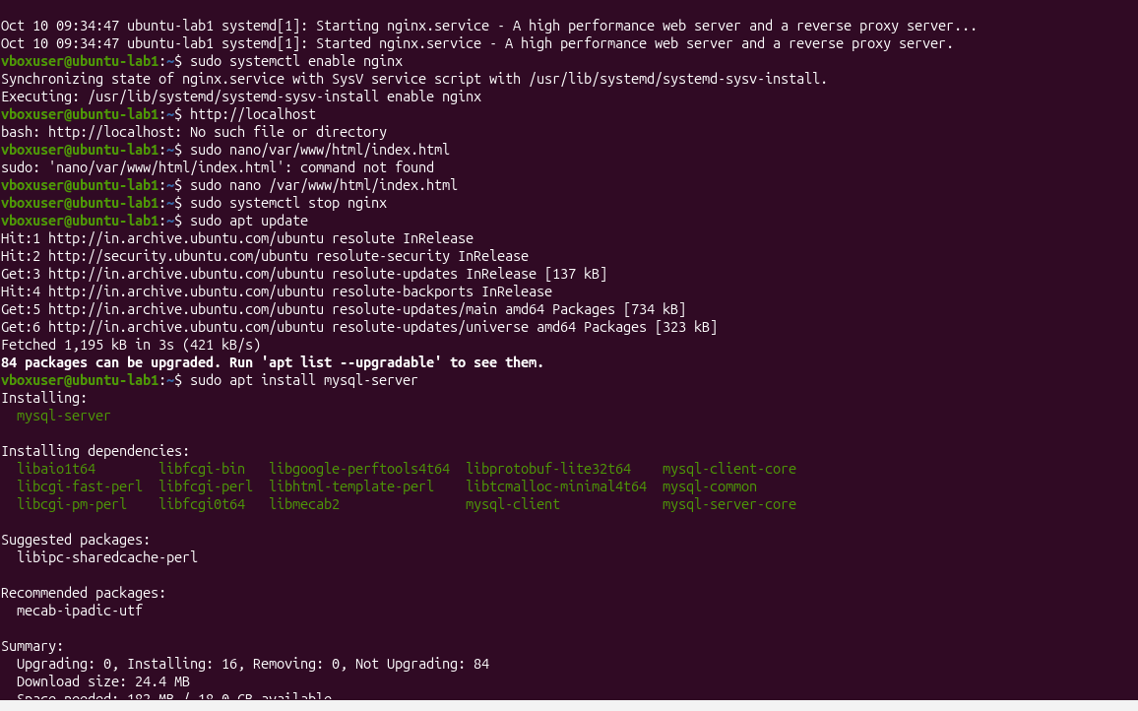
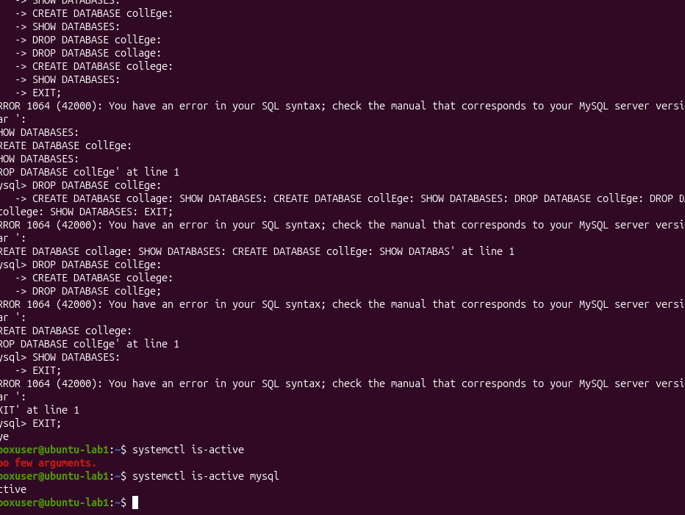

- Set up a Application Server (e.g.,Apache Tomcat)
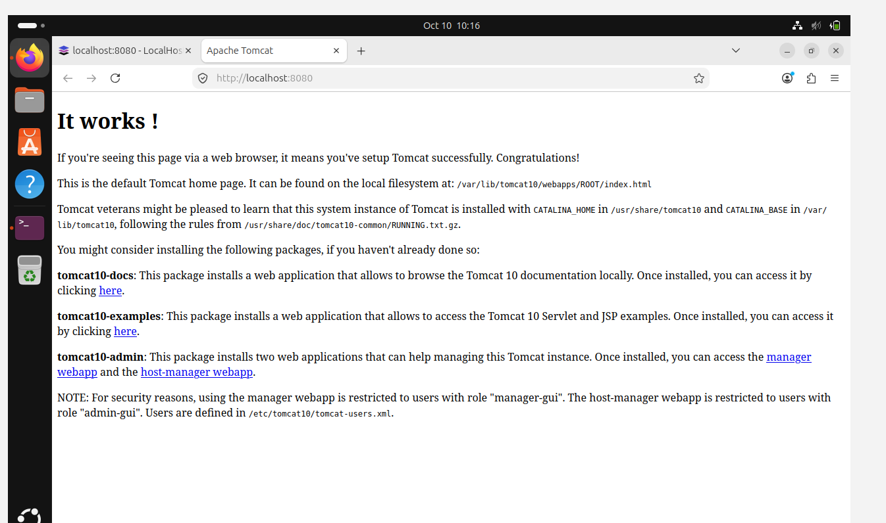

- create a service file for Apache Tomcat.(Should execute by using systemtctl command)
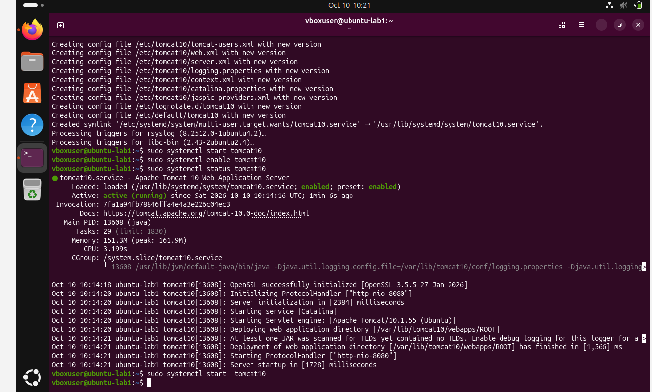

- Print specific columns from a delimited file.
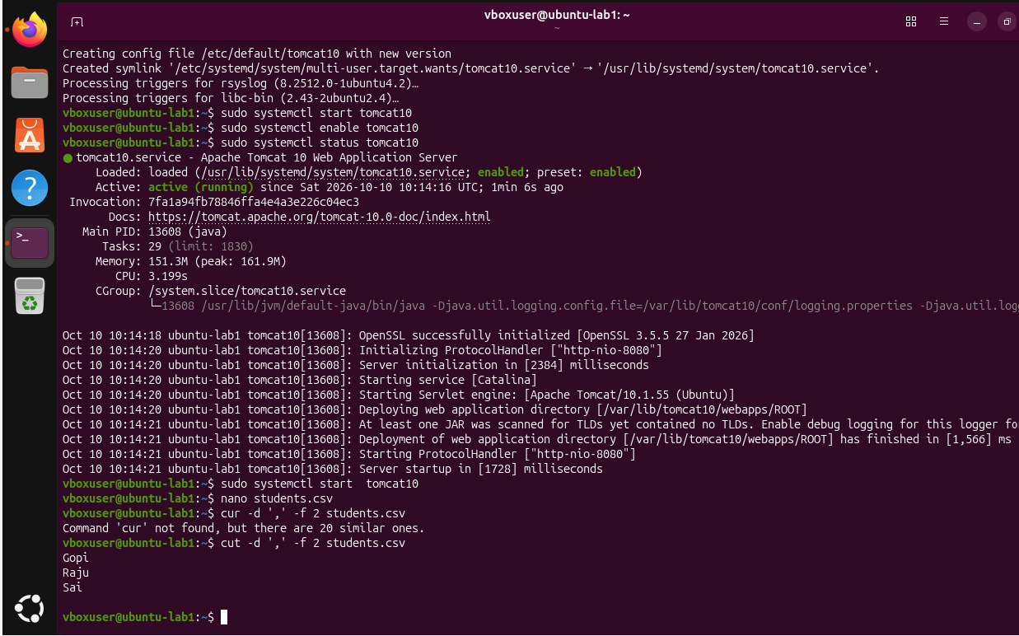

- Filter and print lines based on a specific pattern or condition.
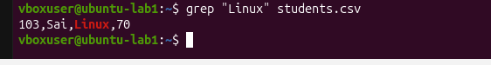
- Calculate and print the average, sum, or other statistics of a column.
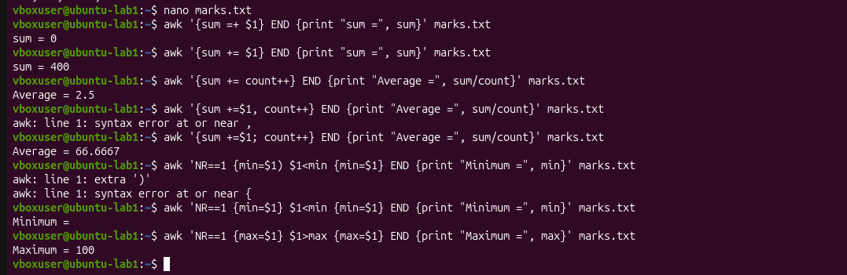

- Perform string manipulation, such as extracting substrings or changing case.
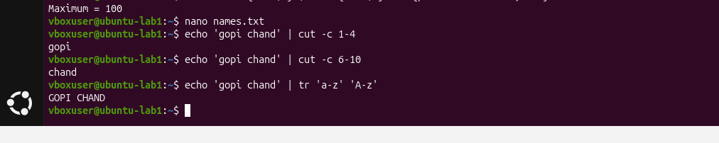
- Count the occurrences of a specific pattern in a file.
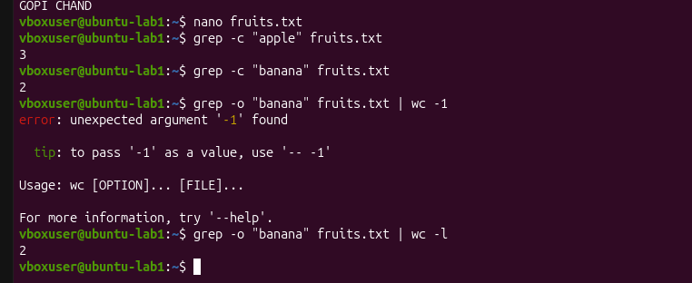

- Sort lines based on a specific field or column.
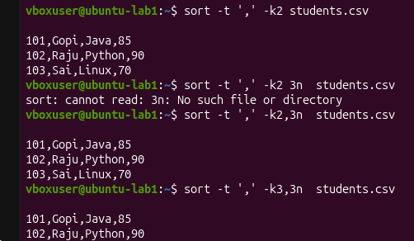
- Merge multiple files based on a common field or column.
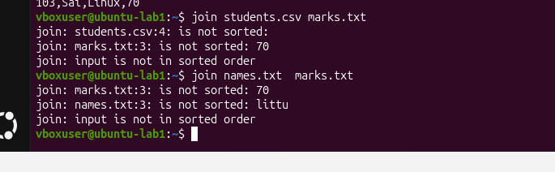

- Substitute text in a file using search and replace.
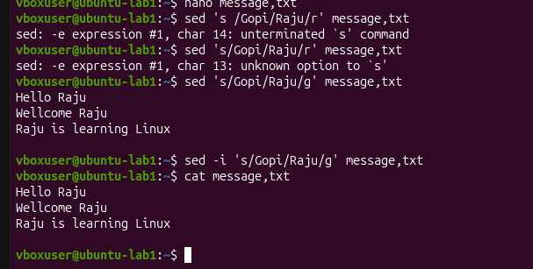

- Delete specific lines based on a pattern or line number.
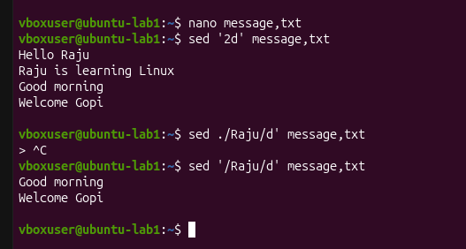

- Append or insert text before or after a specific pattern or line.
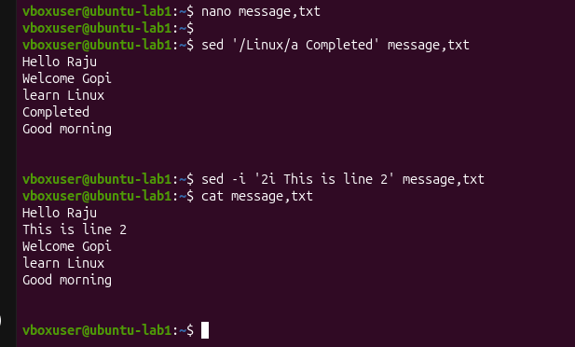

- Print only specific lines from a file.
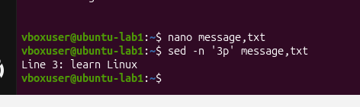

- Copy file from linux to windows machine
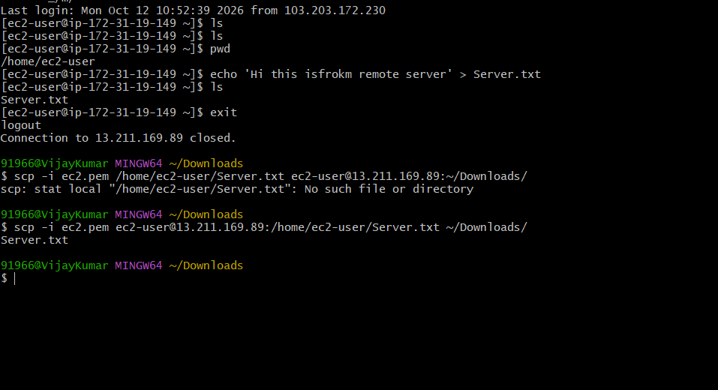
- 5 use cases for AWK and 5 use cases for sed
