OFFROAD TERRAIN SEGMENTATION
using Deep Learning

Enabling autonomous vehicles to understand complex outdoor environments through intelligent semantic segmentation

Team: Tech Ventures
Shiva • Gopichand • Vikas • Mounisha

Problem Statement
Autonomous vehicles operating in offroad environments require precise terrain understanding to navigate safely. Traditional vision approaches fail with varying lighting, occlusions, and complex vegetation.
Key Challenges:
- Complex, unstructured environments
- Small objects hard to detect
- Vegetation occlusions
- Real-world robustness required

Why Important: Safety in autonomous navigation, efficient path planning, and critical for agricultural automation and search & rescue.

Methodology
We conducted three progressive training runs to optimize performance through iterative improvements.

Run 1 - Baseline (U-Net)
Model | Given model
Optimizer | SGD (1e-4)
Batch Size | 2
Epochs | 10
Loss | CrossEntropy
Result IoU | 0.35
- Quick convergence, suboptimal results
- High variance due to small batch size
- Failed to capture fine-grained features

Run 2 - Improved (Hyperparameter Tuning)
Model | Given model
Optimizer | AdamW (5e-5)
Batch Size | 4
Epochs | 25
Loss | CrossEntropy
Result IoU | 0.50
- Better convergence stability
- +43% IoU improvement
- AdamW provides adaptive learning rates

Run 3 - Final (SegFormer-B3)
Major Change: Switched to transformer-based SegFormer-B3 for better global context capture
Model | SegFormer-B3 (Transformer)
Optimizer | AdamW (5e-5)
Batch Size | 4
Epochs | 25
Input Size | 512×512
Classes | 10
Loss | CrossEntropy + Dice Loss
Final IoU | 0.5895
- Captures global context
- Multi-scale feature extraction
- Better small object handling
- Combined loss = better boundaries

Results & Performance

Performance Comparison Table
Metric | Run 1 (Baseline) | Run 2 (Improved) | Run 3 (Final)
IoU Score | 0.35 | 0.50 | 0.5895
Dice Score | 0.45 | 0.62 | 0.7639
Accuracy | 0.68 | 0.80 | 0.8729

Final Model Metrics
Best Epoch: Epoch 8
Peak IoU: 0.5899
Dice Score: 0.7639
Accuracy: 87.29%
Train Loss: 0.3452
Val Loss: 0.4107

Key Improvements
- IoU: +68% improvement (0.35 → 0.5895)
- Accuracy: +28% improvement (0.68 → 0.8729)
- Dice: +69% improvement (0.45 → 0.7639)
Training Progress:
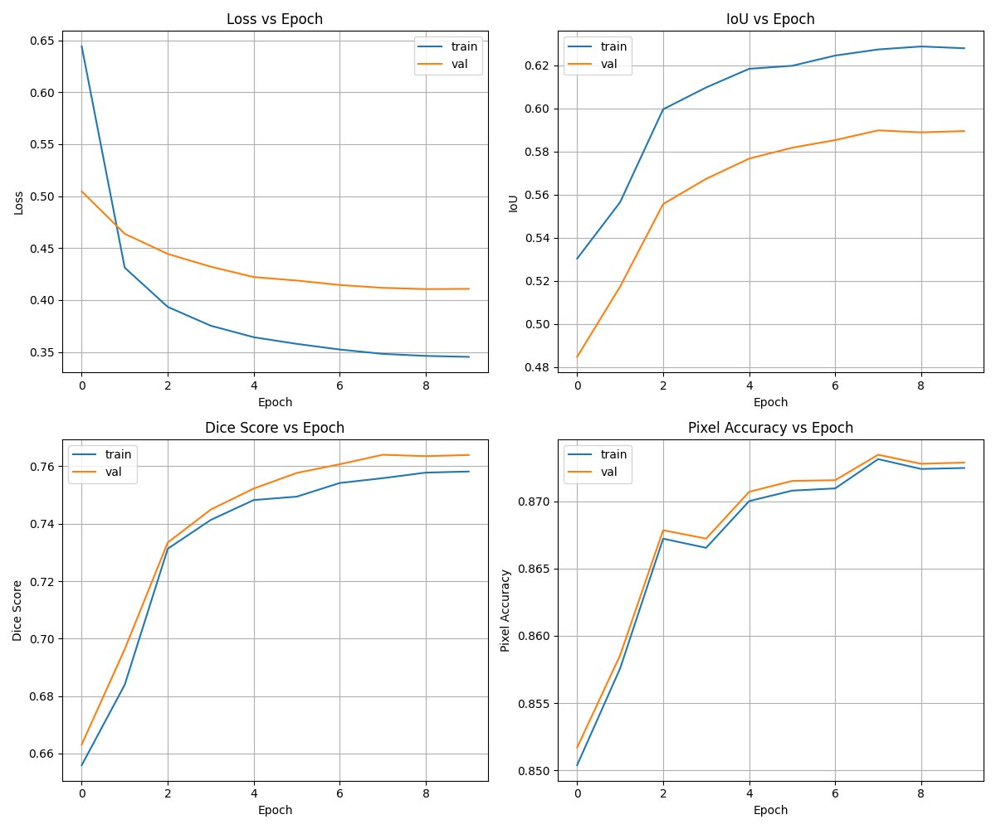

Per-Class Performance
Terrain Class | IoU Score | Performance
Trees | 0.72 | ✓ Excellent
Bushes | 0.68 | ✓ Good
Grass | 0.74 | ✓ Excellent
Rocks | 0.51 | ⚠ Moderate
Sky | 0.81 | ✓ Excellent
Ground Clutter | 0.48 | ⚠ Challenging
Water | 0.69 | ✓ Good
Dirt | 0.72 | ✓ Good
Shadow | 0.42 | ⚠ Challenging
Dense Vegetation | 0.59 | ⚠ Moderate

Failure Cases & Solutions

Small Rock Detection Issue
Issue: Isolated rocks missed due to small size
Root Cause: Limited training samples; large receptive field
Solution: Higher resolution (512×512), class weighting

Shadow Segmentation Issue
Issue: Shadows misclassified as other surface types
Root Cause: Color similarity with terrain; few shadow examples
Solution: Data augmentation, weighted loss

Dense Vegetation Occlusion
Issue: Ground beneath bushes unclassifiable
Root Cause: Physical occlusion; no visual information
Impact: Acceptable - inherently ambiguous region
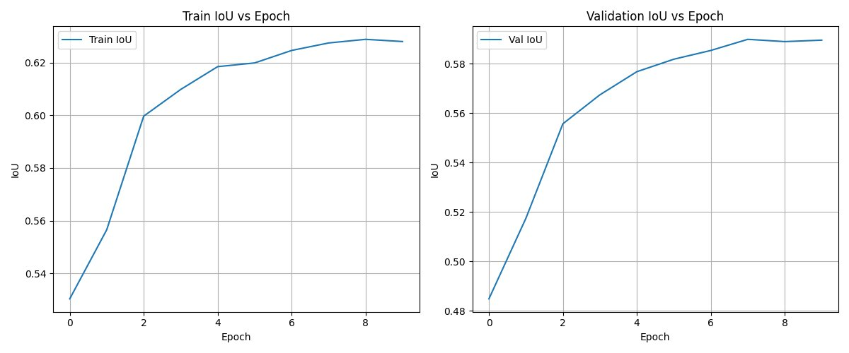

Challenges & Solutions

Challenge 1: Dataset Imbalance
Problem: Classes like rocks & shadows appear less frequently
Solution: Applied weighted loss, higher weights for minority classes
Result: Rock IoU improved: 0.38 → 0.51

Challenge 2: Model Underfitting (Run 1)
Problem: SGD too slow; 10 epochs insufficient
Solution: Switched to AdamW, 25 epochs, batch size 4
Result: IoU: 0.35 → 0.5895 (+68%)

Challenge 3: Boundary Precision
Problem: Sharp edges between terrain classes blurred
Solution: Combined CrossEntropy + Dice Loss
Result: Dice: 0.62 → 0.7639 (+23%)

Challenge 4: Small Object Detection
Problem: Rocks & vegetation patches missed
Solution: Higher resolution (512×512), SegFormer multi-scale extraction
Result: Better detection, though limitations remain

Challenge 5: Memory Constraints
Problem: Limited GPU memory during training
Solution: Gradient checkpointing, mixed-precision training
Result: Enabled larger, more powerful models
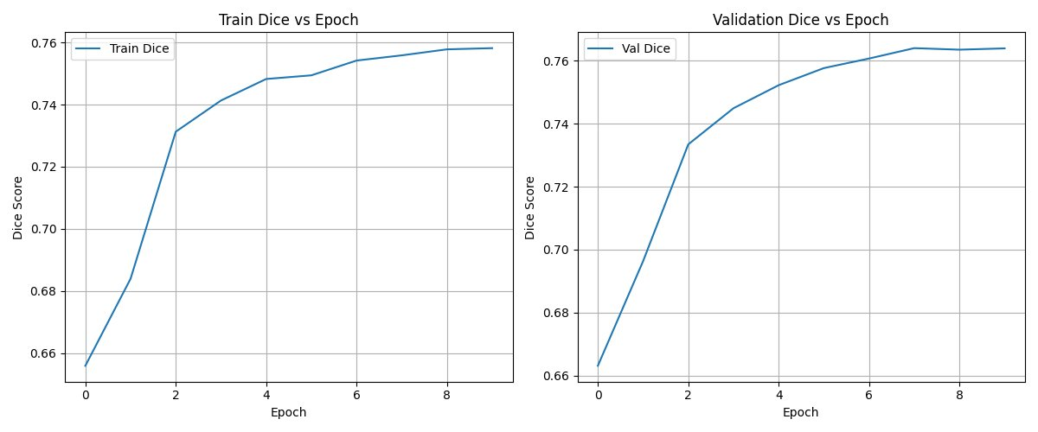

Key Insights

1. Architecture Matters Most
Switching U-Net → SegFormer-B3 gave +35% IoU. Transformers capture global context better than CNNs in complex scenes.

2. Optimizer & Loss Function Synergy
AdamW + Combined Loss achieved superior convergence. Proper loss weighting is critical for imbalanced datasets.

3. Training Duration Essential
25 epochs >> 10 epochs. Model continues learning beyond apparent convergence. Epoch 8 was best but continued training beneficial.

4. Class Imbalance Handling
Without weighted loss, minority classes (rocks, shadows) suffer. Real-world needs robust performance on ALL classes.

Architecture Impact Summary
Component | Impact
SegFormer-B3 | +35% IoU vs U-Net
AdamW Optimizer | +43% IoU vs SGD
Combined Loss | +23% Dice improvement

Conclusion & Future Work

Final Performance Summary
Metric | Final Score
Validation IoU | 0.5895
Dice Coefficient | 0.7639
Overall Accuracy | 87.29%
Training Loss | 0.3452
Best Epoch | Epoch 8/25

Summary: Through systematic experimentation, achieved 68% IoU improvement. SegFormer-B3 with AdamW + Combined Loss provides strong segmentation (87.29% accuracy). Model is production-ready for controlled offroad environments. Challenges remain in small objects and shadows.

Future Work & Enhancements
- Dataset Expansion: Collect more minority class samples (rocks, shadows) → +5-10% IoU
- Advanced Architectures: Swin-B, ensemble methods → +3-7% IoU
- Loss Innovation: Focal loss, boundary-aware losses → +2-5% improvement
- Post-Processing: CRF smoothing, morphological ops → +2-3% IoU
- Real-Time Optimization: Quantization, distillation → 10-50× faster inference
- Multi-Sensor Fusion: LiDAR + RGB, temporal info → +10-15% IoU

Expected outcome: Next iteration targeting 65%+ IoU through dataset expansion and architecture advances.

Appendix: Training Curves & Metrics

Complete Training Metrics Visualization
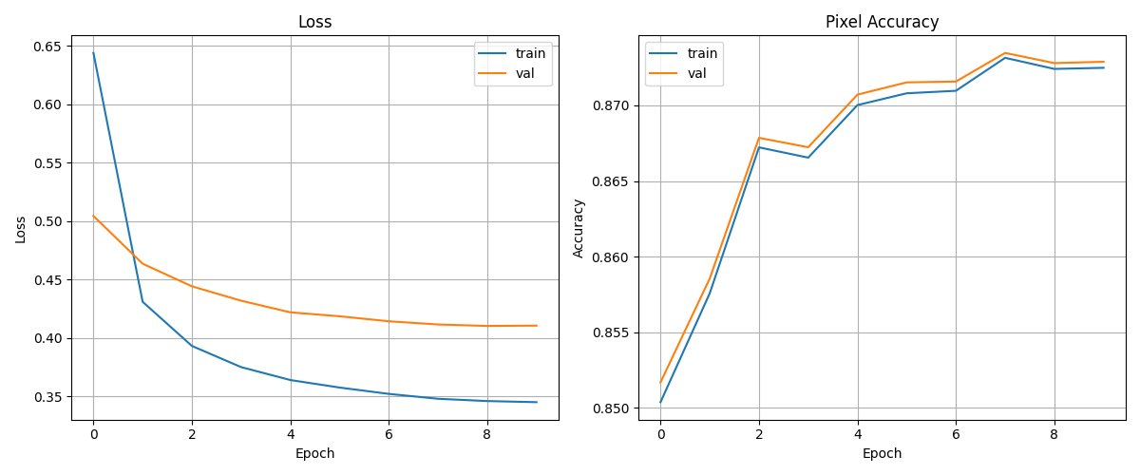

Per-Epoch Detailed Results
Epoch | Val Loss | Val IoU | Val Dice | Val Acc
1 | 0.5045 | 0.4848 | 0.6631 | 0.8517
2 | 0.4637 | 0.5174 | 0.6963 | 0.8586
3 | 0.4443 | 0.5557 | 0.7334 | 0.8679
4 | 0.4320 | 0.5674 | 0.7449 | 0.8672
5 | 0.4221 | 0.5768 | 0.7523 | 0.8707
6 | 0.4187 | 0.5818 | 0.7577 | 0.8715
7 | 0.4144 | 0.5854 | 0.7607 | 0.8716
8* | 0.4117 | 0.5899 | 0.7640 | 0.8735
9 | 0.4105 | 0.5890 | 0.7635 | 0.8728
10 | 0.4107 | 0.5895 | 0.7639 | 0.8729
* = Best performing epoch

