Classification & Separation of Whatsapp Images Using Machine Learning

In this project we are using CNN (convolution neural networks) algorithm to classify Whatsapp images to different categories such as Question Paper, Mark sheets, Printed papers, hand written papers and circular. CNN algorithm will get trained on above mention categories to build a classification model. This model can be applied on test images to predict image type.

To train CNN we have used same dataset given by and below showing that dataset images

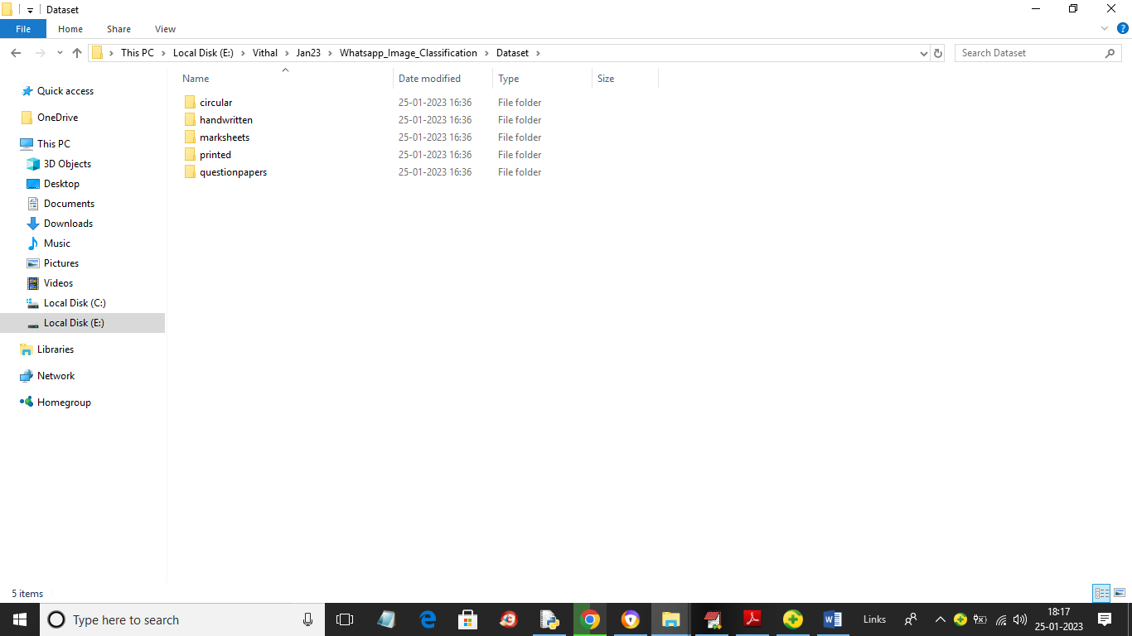

In above dataset folder we have 5 different types of images and just go inside any folder to view that type of image like below screen

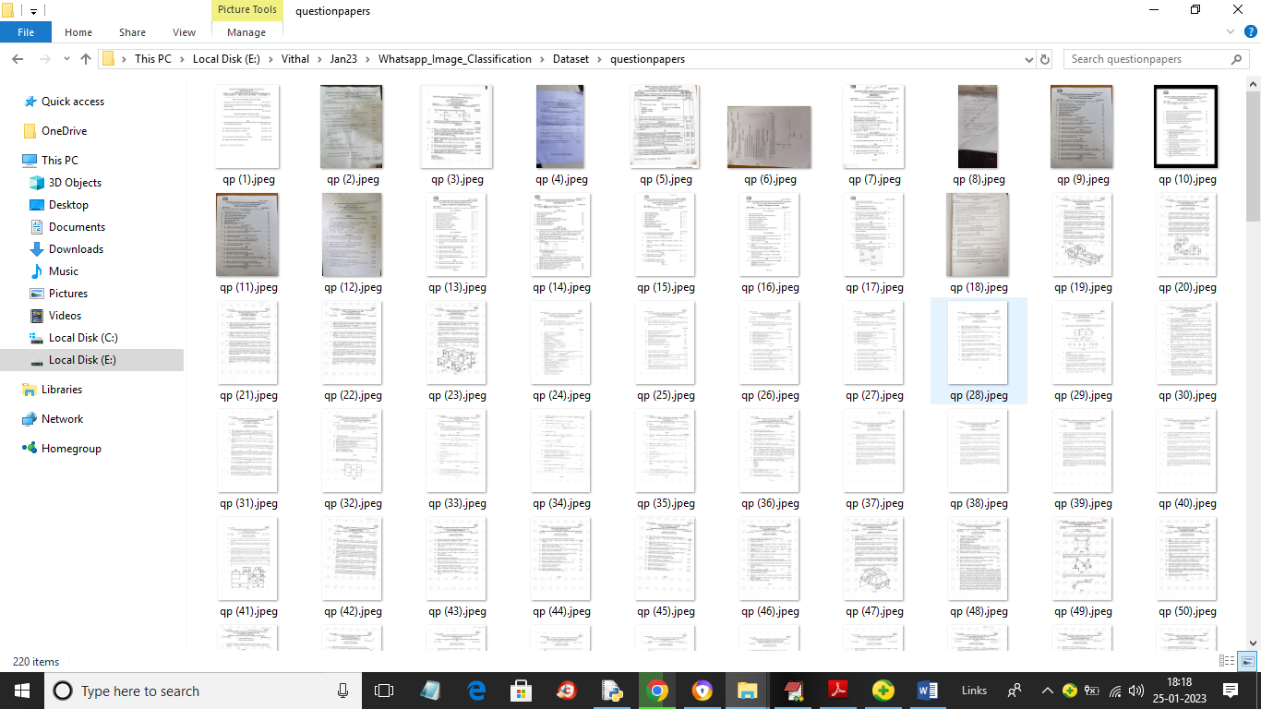

In above screen we can see some images from dataset and by using this images CNN will get trained

To implement this project we have designed following modules

1. Upload Whatsapp Image Dataset: using this module we will upload dataset to application and then read all images and categories from dataset
2. Preprocess Dataset: using this module we will resize all images to equal size and then normalize image pixel values and then shuffle the dataset. After processing all images will be split into train and test where application using 80% dataset for training and 20% for testing
3. Train CNN Algorithm: using this module we will input 80% dataset to CNN to trained a model and then 20% test images will be applied on trained model to calculate prediction accuracy
4. CNN Training Graph: using this module we will plot CNN training and loss graph
5. Whatsapp Image Classification: using this module we will upload test image and then CNN will predict or classify type of images.

Below screen showing CNN code to train a model

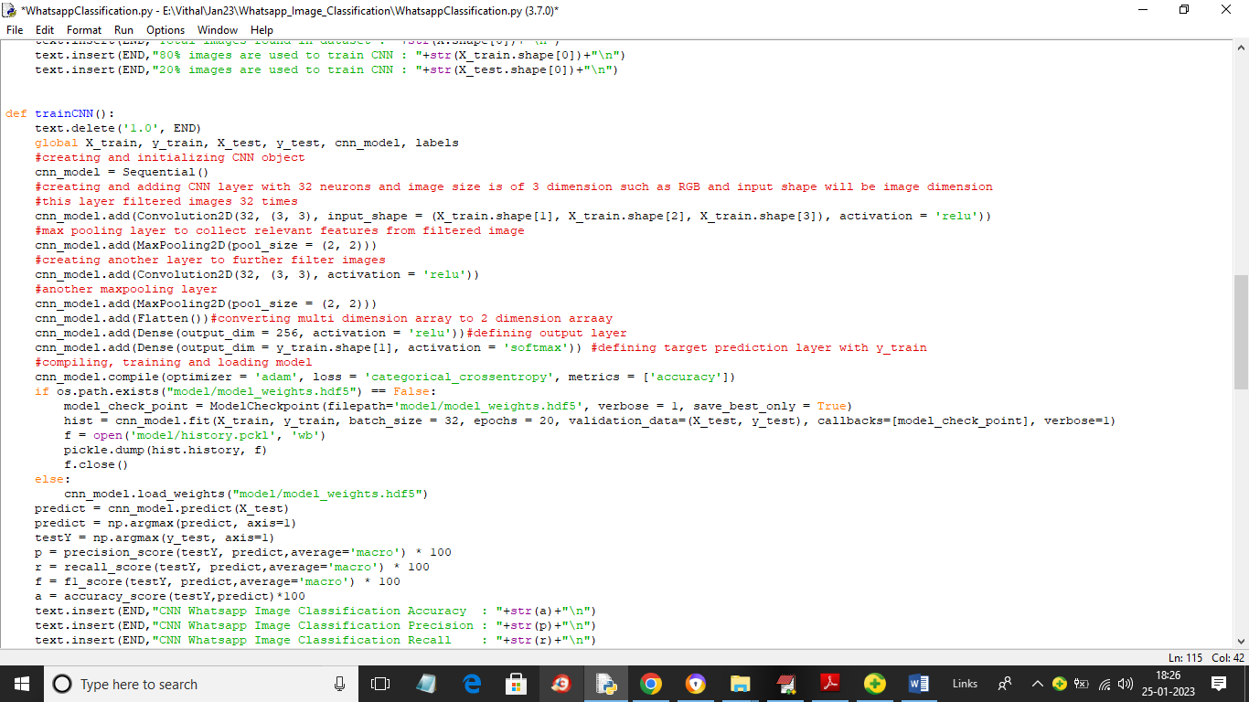

In above screen read red colour comments to know about CNN model training

SCREEN SHOTS

To run project double click on ‘run.bat’ file to get below screen

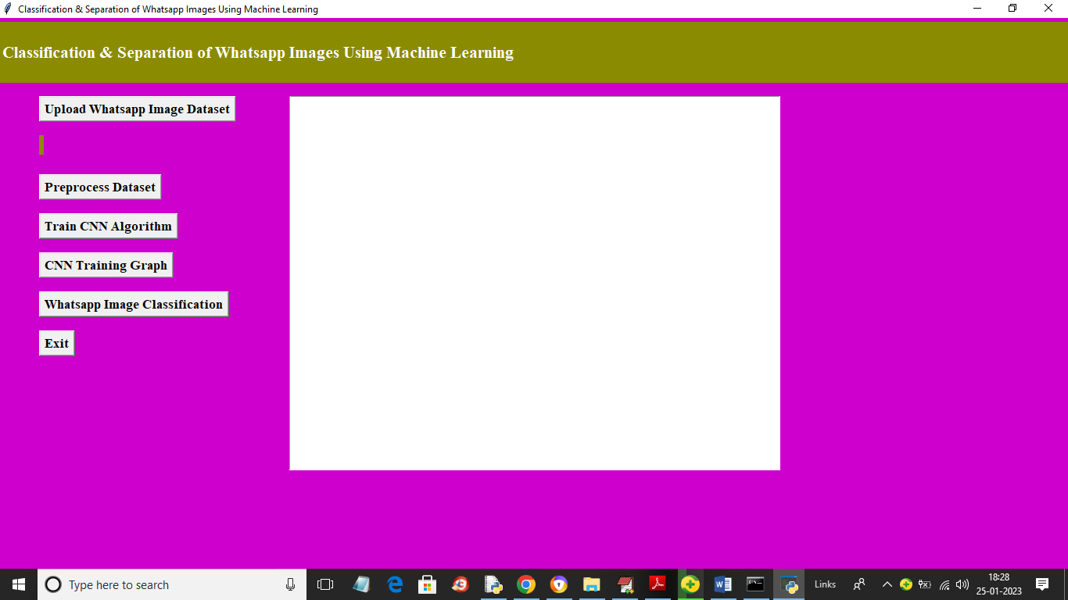

In above screen click on ‘Upload Whatsapp Image Dataset’ button to upload dataset and get below page

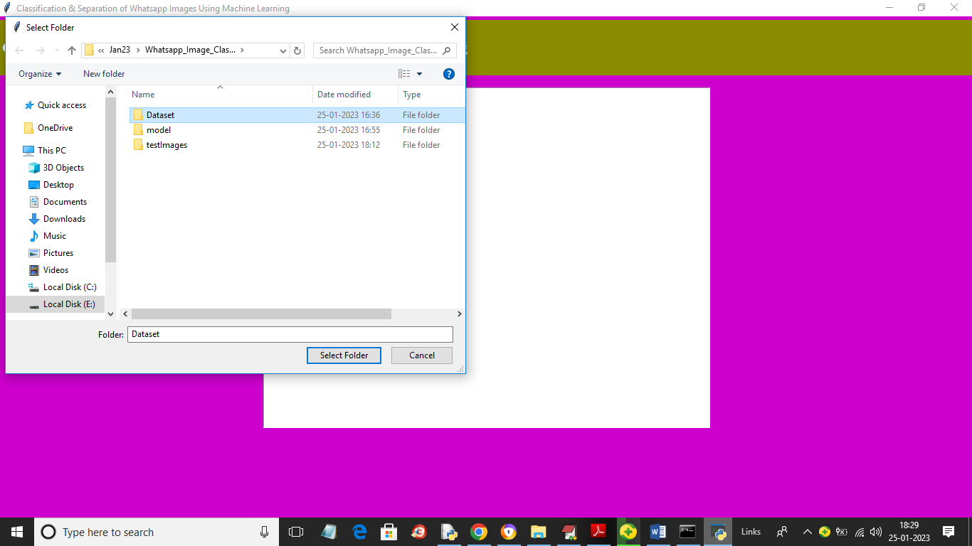

In above screen selecting and uploading ‘Dataset’ entire folder and then click on ‘Select Folder’ button to load dataset and get below page

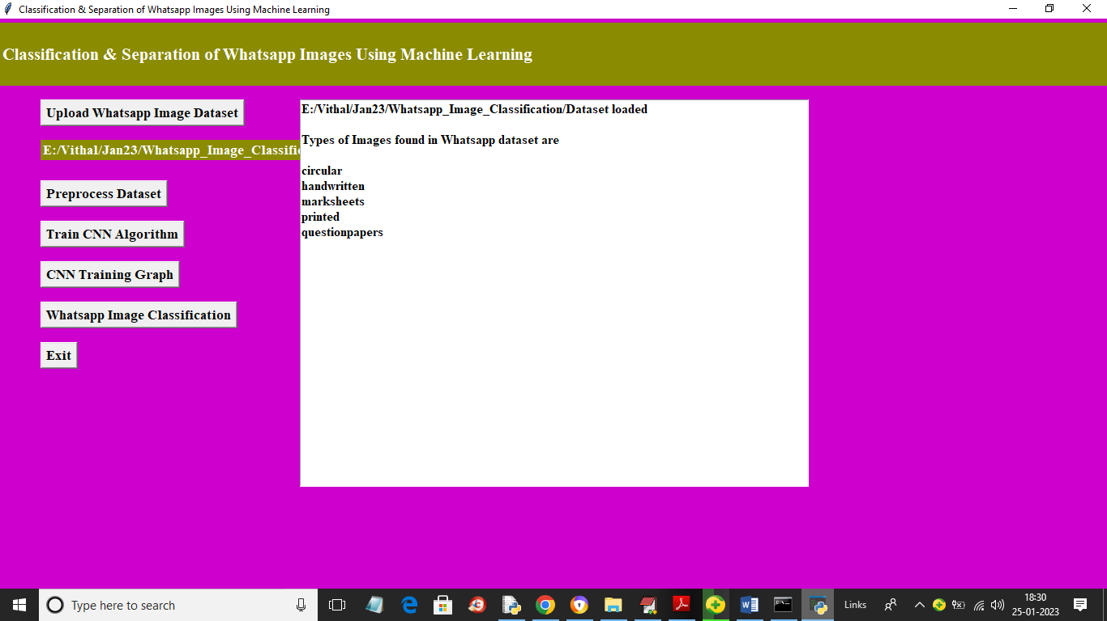

In above screen we can see dataset loaded and then we can see types of categories loaded and now click on ‘Preprocess Dataset’ button to resize, normalize, shuffle and split dataset into train and test

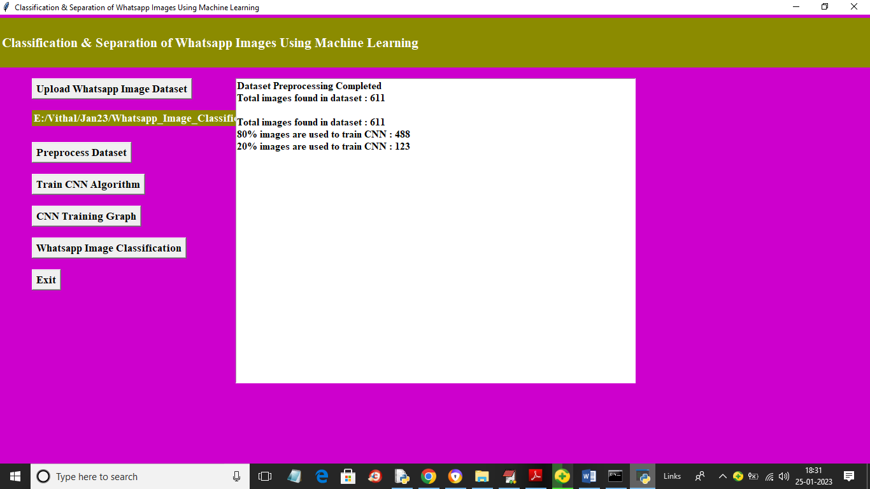

In above screen we can see application found total 611 images in the dataset and then process and then took 488 images for training and 123 images for testing a 80 and 20%. Now click on ‘Train CNN Algorithm’ button to train CNN and get below output

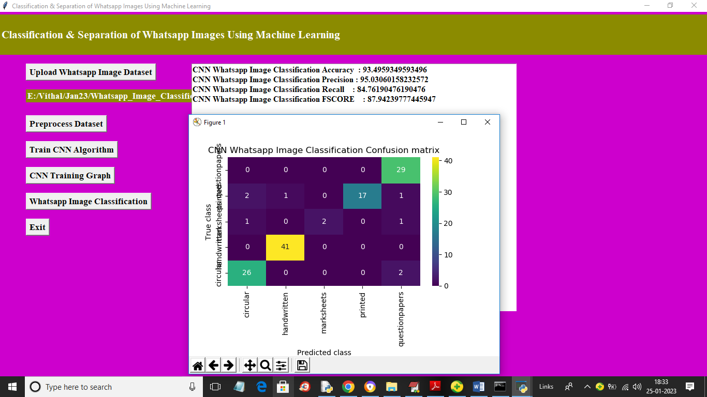

In above screen with CNN we got 93% accuracy and we can see precision, recall and FSCORE metric. In confusion matrix graph x-axis represents Predicted Labels and y-axis represents True Labels and all blue colour boxes contains INCORRECT prediction count which are very few and different colour boxes contains CORRECT prediction count which are high in numbers so we got 93% accuracy. Now click on ‘CNN Training Graph’ button to get below page

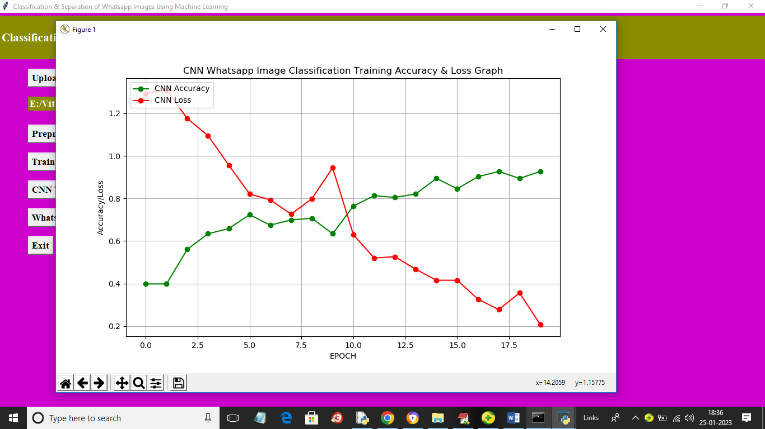

In above CNN training graph x-axis represents training epoch and y-axis represents accuracy and loss values. Green colour line represents Training Accuracy and red colour line represents Training LOSS and in above graph we can see with each increasing epoch accuracy got increase and reached closer to 1 and loss got decreased and reached closer to 1. Now close above graph and then click on ‘Whatsapp Image Classification’ button to upload test image and get classification output

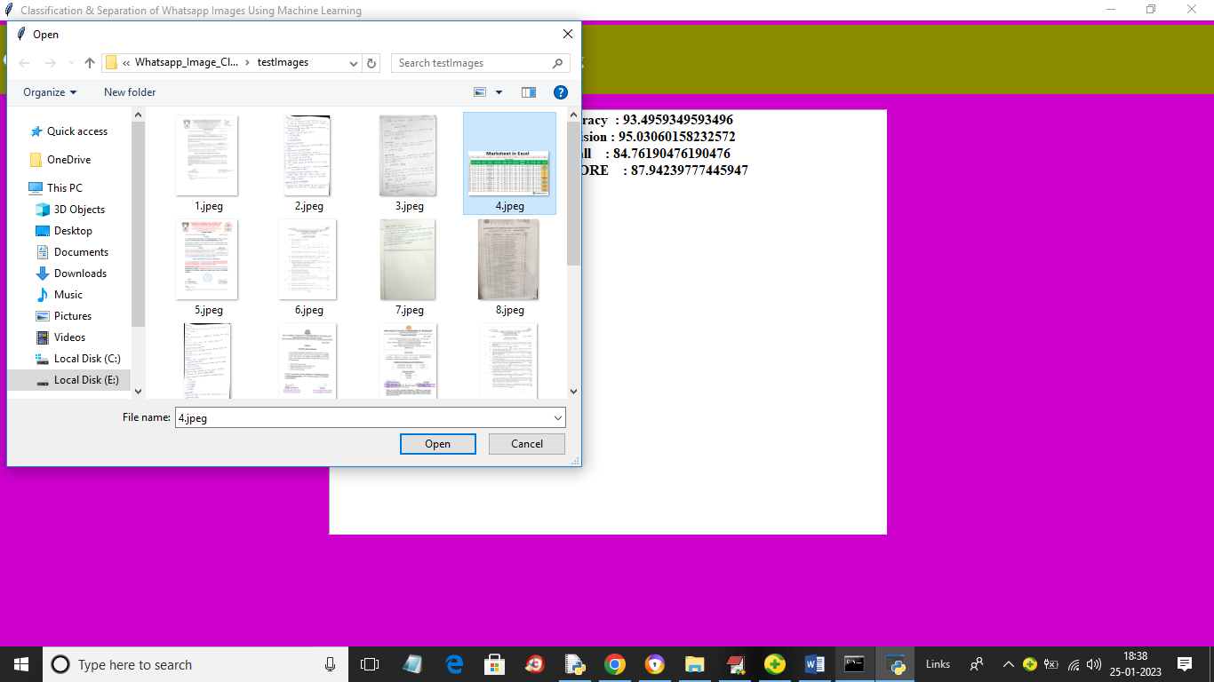

In above screen selecting and uploading 4.jpeg file and then click on ‘Open’ button to get below output

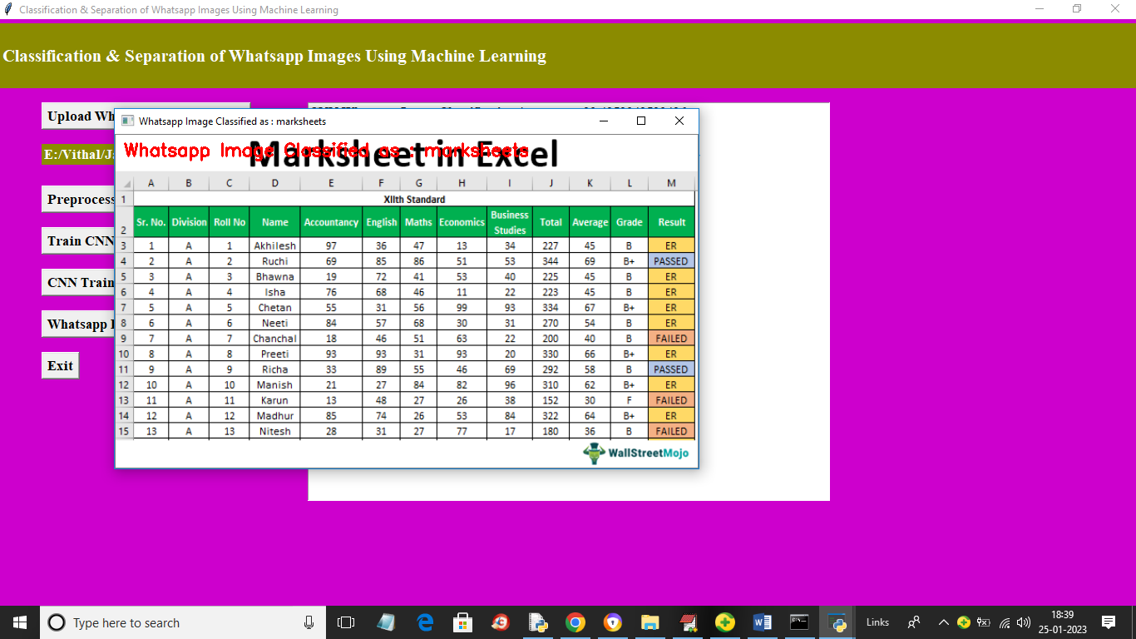

In above output image in red colour text or in image title you can see image classified as mark sheet. Similarly you can upload and test other images

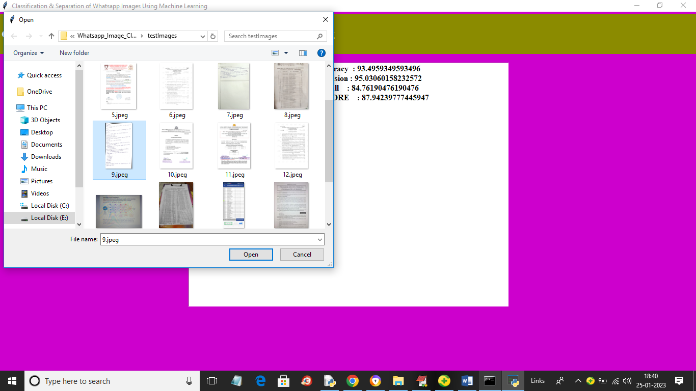

In above screen uploading another image and below is the output

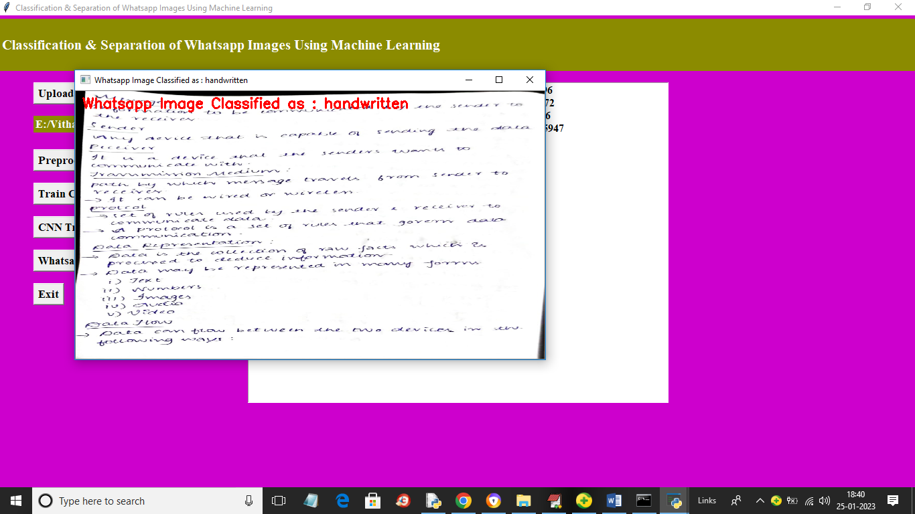

In above screen image classified as ‘hand written’

