Narra Gopi chand
Reg No : 192371093
QUESTION 2: COUNT NUMBER OF TOKENS IN C

Aim: To write a C program to count the number of tokens in a given C statement.
C Program:
#include <stdio.h>
#include <ctype.h>
int main()
{
char str[200];
int i = 0, tokens = 0, inToken = 0;
printf("Enter a C statement: ");
fgets(str, sizeof(str), stdin);
while (str[i] != '\\0')
{
if (isalnum((unsigned char)str[i]) || str[i] == '_')
{
if (!inToken)
{
tokens++;
inToken = 1;
}
}
else
{
inToken = 0;
}
i++;
}
printf("Number of tokens = %d\\n", tokens);
return 0;
}
Sample Input: int sum = a + b;
Output Screenshot:
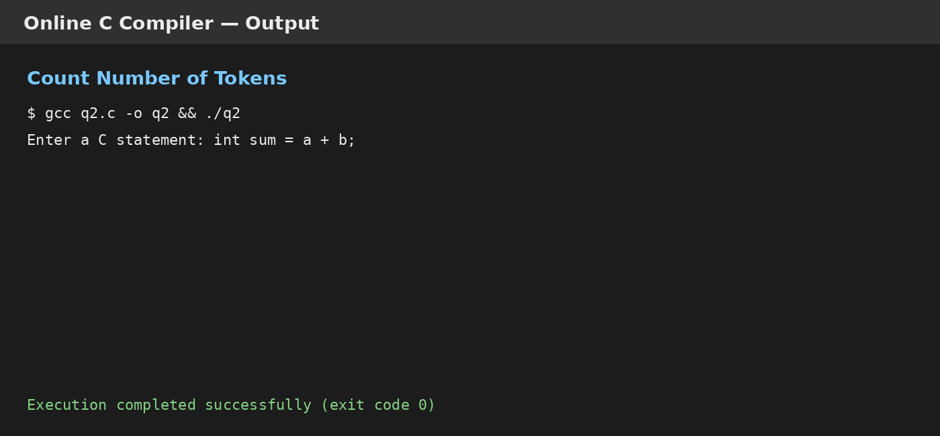
Result: The program successfully counted the tokens in the given C statement.

